The Pros and Cons of X-ray CT (Computerised-Axial Tomography) and MRI (Magnetic Resonance Imaging)

MRI and CT scanning are diagnostic techniques used in various clinical centres to produce 3D and cross-sectional images in all planes. In my opinion, MRI is preferential because it doesn’t involve patients getting bombarded with high energy radiation. So, obviously I consider it more advanced and safer. I mean, seriously, what are the chances of getting cancer from an MRI scan compared to the multiple x-rays passing through the body during a CT scan?
CT scan image of brain
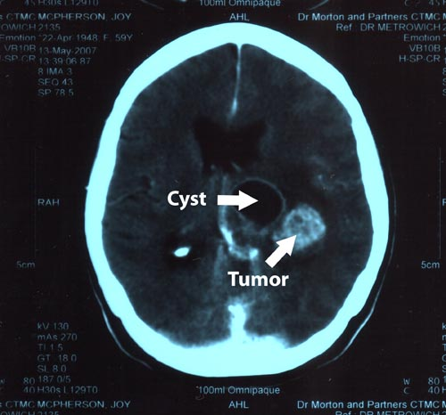
http://www.urbansoul.co.za/images/Tumor.jpg

A CT scan takes anything from fifteen minutes to an hour depending on areas of the body being scanned so it’s helpful in emergencies. It’s convenient, cheap and useful for the imaging of bones, adjacent muscle tissue and fat. In addition, CT is used to guide biopsies; confirm the presence of tumours as well as their size and how spread out they are in the body; help doctors plan radiation therapies for cancer patients, and establishes whether a cancer has responded to treatment. It has almost no side effects and no radiation is left over after the scanning is complete.

Nevertheless, CT can cause lots of damage due to highly ionising radiation. This can cause permanent mutations in developing foetuses, which is why pregnant women are advised not to have a CT scan while pregnant. During one of these scans, several x-ray beams are transmitted simultaneously through the body at different angles. This gives a radiation dose of 110 millirems – nearly 20 times the dosage of a normal x-ray (6 millirems). This is enough to cause cancer.

On the other hand, an MRI is non-invasive, painless and much more effective than X-rays. It is used mainly for diagnosis, treatment and monitoring of cancers. It uses low energy non-ionising radio waves and a magnetic field, which is about 10,000 to 30,000 times stronger than the Earth’s, in order to detect the H-nuclei in the body. It is used to produce remarkably detailed images of internal soft tissue and bone; all internal body structures including the brain, spinal cord, eyes, ears, lungs and heart as well; all major blood vessels including capillaries and even shows blood flow.
MRI scan of vessels
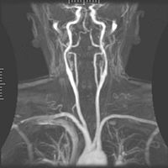
http://en.wikipedia.org/wiki/Magnetic_resonance_imaging

But, MRI only recently developed in 1977, so not as much is known about it in comparison to X-rays; especially its long-term side-effects. X-rays were discovered by Roentgen in 1895, 102 years ago. MRI machines are small and narrow so they’re not suitable for claustrophobic and fat people particularly because a scan takes an hour. Consequently, the person must be sedated. People who have MRI scans are injected with a contrast dye so as to highlight specific areas of their body. However, minor allergic reactions to dyes have been observed. Also, patients wearing pacemakers or cochlear implants cannot have an MRI scan because the strong magnetic field in the machine causes surrounding electronic equipment to malfunction. Furthermore, although lots of detail is produced in an MRI image, a crack in a bone won’t show.

Overall, after having analysed the arguments for both imaging techniques, I still strongly believe that MRI is the healthier and more successful option. It is better to use something, which has no health risks and provides better imaging than something, which can give me cancer and eventually kill me. Do the benefits really outweigh the risks? I don’t think so.

Number of Words – 543 words

Bibliography
http://inventors.about.com/library/inventors/blxray.htm#
http://en.wikipedia.org/wiki/Computed_tomography
http://www.netdoctor.co.uk/health_advice/examinations/ctgeneral.htm
http://www.netdoctor.co.uk/ate/generalhealth/205337.html
http://www.cancer.gov/cancertopics/factsheet/Detection/CT
http://www.blackcatsystems.com/GM/safe_radiation.html
http://www.ehealthmd.com/library/mri/MRI_when.html

