# Annex 4.4.4: Sub Board Agenda Template

Updated July 2021

The right-hand column includes points which can be included in the Chair’s Agenda as a prompt/reminder. These should be omitted from the standard agenda that is circulated to members of the Sub Board.

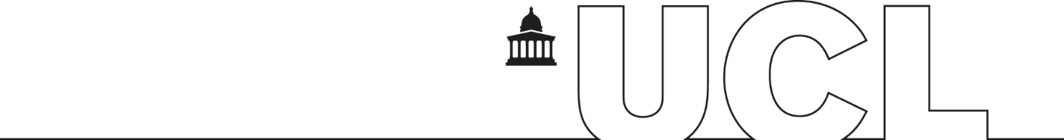

# SUB BOARD OF EXAMINERS

**<Name of Board>**

**<Date>, <Time>, <Location>**

# Agenda

|  | **Agenda** | **Notes for Chair’s Agenda**  **(delete this column from the formal agenda)** |
| --- | --- | --- |
|  | **Welcome, apologies and announcements** | * Introduce members * Confirm that the meeting is quorate * Remind members of confidentiality restraints pertaining to business of Board and results * Confirm that there are no conflicts of interest (e.g. a relationship to a student) from members of the Board * Give a brief report on the session’s examining procedures |
|  | **Report on preliminary meetings** | Where applicable, receive reports from pre-meetings, pre-boards, Academic Misconduct Panels etc that have a bearing on the decisions the board is about to make. |
|  | **Conduct of assessment** | Where applicable, report any significant changes to the assessment process relating to the results which are about to be considered, such as Covid 19 changes and any material irregularities that may have been addressed.  Relevant regulations: [Changes to the regulations for Covid-19](https://www.ucl.ac.uk/academic-manual/recent-changes/changes-academic-manual-covid-19) |
|  | **Module results** | Formal approval of marks.  Module Mark Report and Exam Board Statistics – Module Comparison Report to be tabled.  Relevant regulations: [Module Assessment](https://www.ucl.ac.uk/academic-manual/chapters/chapter-4-assessment-framework-taught-programmes/section-3-module-assessment) |
|  | **Progression and Award decisions** | Progression Summary and Classification Summary reports to be tabled.  Discussion to concentrate on students without a single clear outcome generated by the progression and award calculation. The Detailed Progression and Classification Reports for individual candidates can also be used to inform this discussion.  Relevant regulations:   * [Module Assessment](https://www.ucl.ac.uk/academic-manual/chapters/chapter-4-assessment-framework-taught-programmes/section-3-module-assessment) * [Progression & Award (inc Condonement)](https://www.ucl.ac.uk/academic-manual/chapters/chapter-4-assessment-framework-taught-programmes/section-6-progression-award) * [Classification](https://www.ucl.ac.uk/academic-manual/chapters/chapter-4-assessment-framework-taught-programmes/section-7-classification) * [Classification for UG students first enrolling in 2017-18 or earlier](https://www.ucl.ac.uk/academic-manual/chapters/chapter-4-assessment-framework-taught-programmes/section-15-classification-undergraduate) * [Deferrals](https://www.ucl.ac.uk/academic-manual/chapters/chapter-4-assessment-framework-taught-programmes/section-8-deferred-assessment) * [Resits and Repeats](https://www.ucl.ac.uk/academic-manual/chapters/chapter-4-assessment-framework-taught-programmes/section-9-consequences-failure) * [Interim Qualifications](https://www.ucl.ac.uk/academic-manual/chapters/chapter-4-assessment-framework-taught-programmes/section-10-interim-qualifications) |
|  | **Confirmation of the arrangements for results to be approved by the Faculty** |  |
|  | **Any other business** |  |
|  | **CLOSE** |  |

<Name>

Secretary to <xxx> Board of Examiners

<Job title>

<Date>