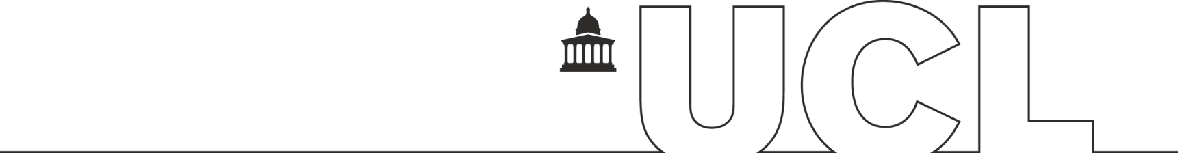
UCL STUDENT AND REGISTRY SERVICES

INVESTIGATORY VIVA REPORT FORM

This report is designed to be a supplementary form to the Academic Misconduct Report Form when an Investigatory Viva has been undertaken – see Section 9.5.3 of the Student Academic Misconduct Procedures (https://www.ucl.ac.uk/academic-manual/chapters/chapter-6-student-casework-framework/section-9-student-academic-misconduct-procedure#9.3)

If you have any queries or require further information, please contact academicregulations@ucl.ac.uk.

Date:

Panel Members:

Student name:

NOTES OF THE investigatory viva

Please include any notes or transcript a transcript from the Investigatory Viva including details of the questions raised and the answers provided by the student.

OUTCOME OF THE INVESTIGATORY VIVA

Contract Cheating

On the basis of the viva the Panel does/does not* consider there to be prima facie evidence of lack of authorship
Collusion

On the basis of the viva the Panel does/does not* consider there to be prima facie evidence of collusion

Reason(s) for the Decision:

*Delete as appropriate

Signed Date:

