BOOKING FORM

Av. Marechal Craveiro Lopes, 390, 1749-009 Lisboa - Portugal

T: +351 21 00 45 000 · F: +351 21 00 45 001

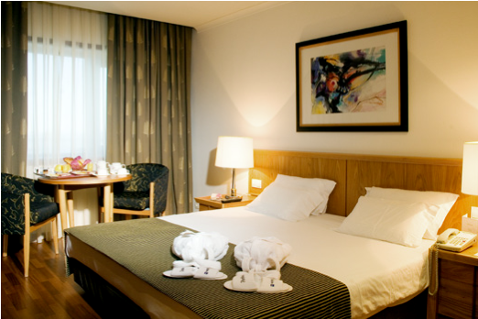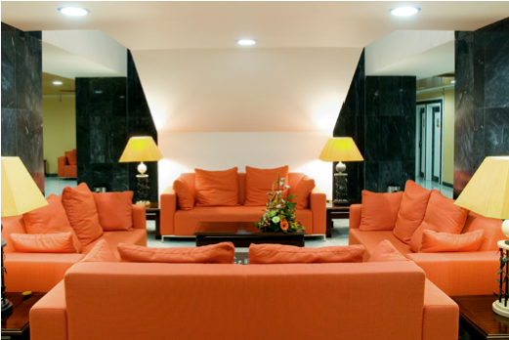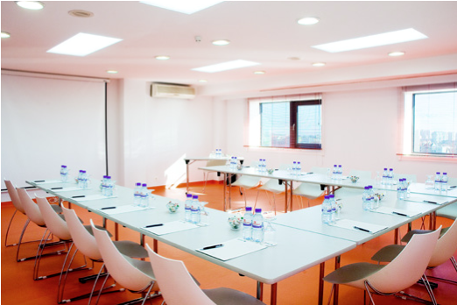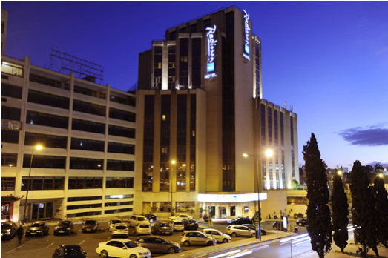

|  |  |  |  |
| --- | --- | --- | --- |
| **EVENT** | Behaviour Change Conference| 1-3 APRIL 2025 | | |
| **GUEST NAME** |  | | |
| **TELEPHONE** |  | **EMAIL** |  |
| **ARRIVAL DATE** |  | **ARRIVAL TIME** |  |
| **DEPARTURE DATE** |  | **DEPARTURE TIME** |  |
|  | | | |

**PLEASE FILL AND ADDRESS TO SALES CENTER**

**F:** 351 217962130 · **T:** 351 210046046

**Cristina Silva**: csilva@continentalhotels.eu

**Angela Almeida** angela@continentalhotels.eu

|  |  |  |  |  |  |  |  |  |  |  |
| --- | --- | --- | --- | --- | --- | --- | --- | --- | --- | --- |
| TYPE OF ROOM (please tick) | | | | | | | | | | |
|  | **STANDARD SINGLE ROOM (1 PERSON): 145 €** | | | | | | | | | |
|  | **STANDARD DOUBLE/TWIN ROOM (2 PERSONS): 155 €** | | | | | | | | | |
| Rates per room, per night, includes Buffet Breakfast, Wi-Fi Internet and VAT.  A tourist city tax for visitors is applied since 01 September 24; Lisbon’s City Hall charges a tax for each overnight stay in the capital, up to seven nights – 4 € per person/per night . | | | | | | | | | | |
|  | | | | | | | | | | |
| **IN ORDER TO GUARANTEE THIS BOOKING PLEASE PROVIDE US:** | | | | | | | | | | |
| CREDIT CARD DETAILS | | | | | | | | | | |
|  | **AMEX** | |  | **DINNERS** | |  | **MASTER CARD** | |  | **VISA** |
| **HOLDER’S NAME** | |  | | | | | | | | |
| **NUMBER** | |  | | | **VALID UNTIL** | | |  | | |
| **C.C.V. CODE** | |  | | | (last 3 digits printed on the signature strip of the card) | | | | | |
|  | | | | | | | | | | |

|  |
| --- |
| REMARKS |
| * Deadline for reservations – 02nd February 2025 * Cancellation – No charge until 72 hours prior to arrival – cancellations after this date the hotel will charge full stay on the credit card informed. * “No show “, will be charged full stay on the credit card informed. |