**Additional Leave Purchasing Scheme (ALPS) - Process to** **request in MyHR**

UCL employees are eligible to request to purchase up to an additional five days of annual leave per year (pro-rata).

If you have more than one assignment at UCL, you will only able to submit a request in MyHR for your primary assignment. Please refer to the [ALPS policy](https://www.ucl.ac.uk/human-resources/pay-benefits/staff-benefits/annual-leave-and-work-life-balance/additional-leave-purchasing-scheme) for the process to be followed for additional assignments, along with all other guidance.

**Creating a Request to Purchase Annual Leave**

From the MyHR main menu, navigate to UCL Employee Self Service > My Absence > Purchase Annual Leave.

**Purchase Annual Leave**

Click on ‘Create Request’

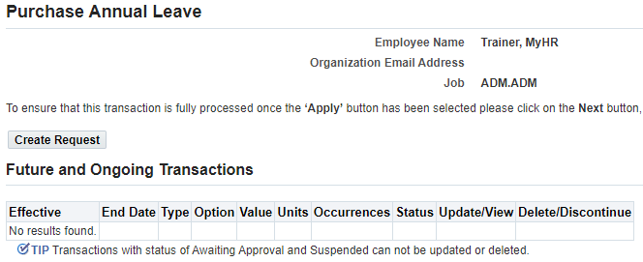

*Figure 1: Purchase Annual Leave: Create Request*

**Compensation Details**

* In the ‘Type’ field select ‘UCL Annual Leave Purchase Hours’

*Figure 2: Purchase Annual Leave: Compensation Details: Type*

**Details**

*Figure 3: Purchase Annual Leave: Compensation Details: Details*

Complete the following details:

* **Hours:** Enter the number of hours you wish to purchase, up to a maximum of 36.5 for full time employees. This number will be pro-rated for part time employees.
* **Start Date:** This will pre-fill with the beginning of the next leave year, and cannot be amended.
* **Expiry Date:** This will pre-fill with the end of the next leave year, and cannot be amended.
* **Notes:** Enter any notes to support the request.

Click on ‘Apply’ in the top right hand corner.

**Future and Ongoing Transactions**

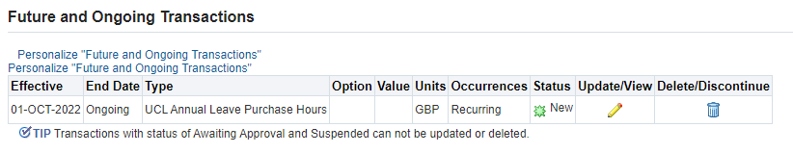

*Figure 4:* *Future and Ongoing Transactions*

This page will show any transactions that are currently in progress, including the one being completed, or any that have been approved for the future.

* Review the details and select one of the following options:
* Where the request needs amending click on ‘Back’ in the top right hand corner
* Where the request is to be cancelled click on ‘Cancel’
* Where the request is ready to be submitted click on ‘Next’ in the top right hand corner

**Please note:** Where ‘Save for Later’ is selected, the request will be saved in a pending status until this is re-opened and submitted or cancelled.

**Purchase Annual Leave: Review**

*Figure 5: Purchase Annual Leave: Review*

This page allows for a final review of the request which is to be submitted, including the name of the approver who will receive the request.

**Please note:** Do not add any attachments to the submission, as these will not be saved anywhere.

* **Comments to Approver:** Enter any comments to support the request for the approvers.
* Review the details and select one of the following options:
* Where the request needs amending click on ‘Back’ in the top right hand corner
* Where the request is to be cancelled click on ‘Cancel’
* Where the request is ready to be submitted click on ‘Submit’ in the top right hand corner

**Please note:** Where ‘Save for Later’ is selected, the request will be saved in a pending status until this is re-opened and submitted or cancelled.

The request has now been submitted for approval.