

**Meeting Report** from Stargardt’s Day 2017

Saturday 18th March 2017

etc.venues Victoria, 1 Drummond Gate, London

# Table of contents

Background 3

Stargardt’s Day 3

Stargardt’s disease 6

Stargardts Panel 7

Morning Presentations (10:45 to 12:00) 9

Welcome and introductions 9

What does current and future diagnosis and management of Stargardt’s disease look like? 11

What is already available to help me day-to-day with Stargardt’s disease? 13

Stargardts Panel Discussion (10:45 to 12:00) 16

Information Exchange (13:45 to 15:00) 18

What did you have to say? 21

Afternoon Presentations (15:15 to 16:20) 31

Gene and cell therapies for Stargardt’s disease – where are these at? 31

IPS cells for Stargardt’s disease - why recreate Stargardt‘s disease in the lab? 34

Is there a possibility of a drug therapy for Stargardt’s disease? 37

Insight sharing posters 40

Next steps 46

Feedback and evaluation 48

Speaker Biographies 50

Acknowledgements 59

# Background

## Stargardt’s Day

On Saturday 18 March 2017, the NIHR Moorfields Biomedical Research Centre* and UCL Institute of Ophthalmology hosted a meeting in London for people with Stargardt’s disease. The aim of the meeting was to bring together those affected by Stargardt’s disease, their families and supporters to:

* Meet one another and share both experiences as well as hints and tips for daily living
* Find out about Stargardt’s disease and some of the research being undertaken to address it from researchers and clinicians at the UCL Institute of Ophthalmology and Moorfields Eye Hospital
* Discuss what people feel should be the priorities for the future, with the opportunity to share these with clinicians, researchers and charities supporting people with Stargardt’s disease and their families

In attendance there were around:

* 30 adults and young people with Stargardt’s disease
* 36 parents, friends and supporters
* 26 researchers and clinicians from Moorfields and University College London (UCL)
* 9 charities and research organisations

**\* WHAT IS THE NIHR MOORFIELDS BIOMEDICAL RESEARCH CENTRE?**

It stands for: National Institute of Health Research (NIHR) Biomedical Research Centre at Moorfields Eye Hospital NHS Foundation Trust and UCL Institute of Ophthalmology.

We are one of 20 university-hospital partnerships around the UK that is funded by the research arm of the NHS - the NIHR. We are the only one dedicated to vision research. In areas of unmet need, we provide support to get new advances into clinical and surgical practice as quickly as possible to benefit patients.

Find out more at the: [NIHR Moorfields BRC website - www.brcophthalmology.org (web link)](http://www.brcophthalmology.org/)

## Stargardt’s disease

Stargardt’s disease - also known as Stargardt macular degeneration, fundus flavimaculatus and juvenile macular dystrophy - is an inherited condition that affects the light-sensitive layer at the back of the eye called the retina.

Stargardt’s disease is caused by a defect (or spelling mistake) in the gene ABCA4 (a biological instruction), which leads to degeneration of the photoreceptors (the light-sensitive cells required for vision) in a region of the retina called the macula, resulting in a progressive loss of sharp, central vision. There are some other rarer forms of Stargardt’s disease or Stargardt disease-like conditions which have other genetic causes.

Symptoms often appear in childhood and can include wavy vision, blind spots, blurriness, impaired colour vision and difficulty seeing in dim light. Currently, there are no treatments. However, research is ongoing to assess the potential for a range of novel interventions for this condition.

## Stargardts Panel

The idea for Stargardt’s Day came about when the parent of a recently diagnosed child contacted the NIHR Moorfields BRC looking for more information about organisations who offered support to families affected by Stargardt’s disease.

Looking back at many of the enquiries we receive for this condition we found others looking for similar information as well as wanting to know more about the condition and current research into treatments.

In the planning of this day we partnered with patients and family members to help us create an agenda that provided an opportunity for patients and families to meet one another and to get answers to their most important questions.

This day wouldn’t have been possible without the panel’s help and support.

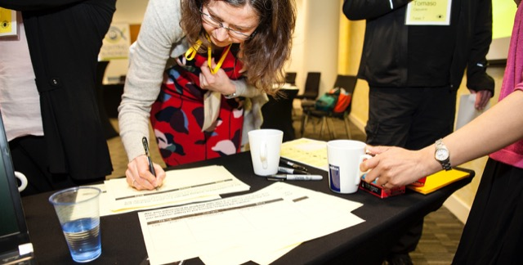

# Morning Presentations (10:45 to 12:00)

[Note: presentations are on YouTube (web link)](https://www.youtube.com/playlist?list=PLCIRUDWfCdBwLItX8aCATD4j_KpRiaAp2)

## Welcome and introductions

### By Professor James Bainbridge

SUMMARY: James introduced Stargardt’s Day and that despite there being several umbrella organisations who provide support to people with this condition (e.g. Macular Society, RP Fighting Blindness and Royal Society for Blind Children), we understand from people affected by this condition that there remains a need for more specific support and information about Stargardt’s disease.

James highlighted the instrumental role the Stargardts Panel had played helping to shape the meeting’s agenda and invited attendees to share their thoughts and opinions throughout the day around the topics under discussion.

James finished off by expressing that from conversations had earlier that morning, what those in attendance wanted to take away from the meeting were a sense of ‘hope’ and ‘power’.

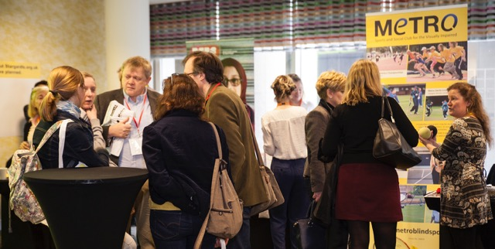

## What does current and future diagnosis and management of Stargardt’s disease look like?

### By Professor Andrew Webster

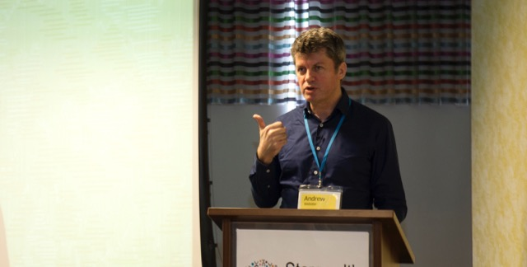

SUMMARY: Andrew introduced what Stargardt’s disease is, demystified what we know about the condition as well as discussed how doctors diagnose and monitor Stargardt disease in the clinic.

Stargardt’s disease impacts central vision. It is caused by spelling mistakes in the ABCA4 gene. It is a recessive condition, meaning you need to have inherited a changed ABCA4 gene from both your parents to develop the condition.

Stargardt’s disease is a spectrum of disorders, which means that two people with Stargardt’s might have different challenges with their vision. There are also some conditions which look like Stargardt’s disease but have a different cause.

When making a diagnosis we can check what gene is involved. We can also look at what is going on in the eye using advanced imaging and function tests. However, it is also extremely important to ask the patient what they experience.

## What is already available to help me day-to-day with Stargardt’s disease?

### By Dr Michael Crossland

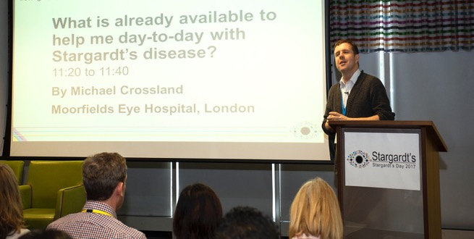

SUMAMRY: Michael works in the low-vision clinic at Moorfields mostly with children and young adults and discussed some of the apps and vision aids that are available now to help people with low vision. He discussed the importance of making things big, bright and bold so people can more easily visualise them.

Spectacles and magnifiers are still important to help people to see and are available through your local low vision services. Many people also make use of handheld and desktop electronic (CCTV) magnifiers.

Tablets and smartphones have also become import tools as the screens, cameras and computing power of these devices have become more advanced. They can now be used to magnify as well as to read text aloud and to get directions. There are also a variety of apps available which can help with colour recognition and identifying images.

There are a variety of newer wearable technologies in development as well like Orcam which can read text to you and Sightplus which can help magnify images.

These technologies vary in how good they are but they are getting better all the time. For some of these options there are also several funding schemes available.

(Note: For more specifics on the technologies and funding options please watch Michael’s presentation on [YouTube (web link)](https://www.youtube.com/playlist?list=PLCIRUDWfCdBwLItX8aCATD4j_KpRiaAp2).

Your own low vision services and patient support organisations may be able to provide additional information as well.)

# Stargardts Panel Discussion (10:45 to 12:00)

[Note: presentations on YouTube (web link)](https://www.youtube.com/playlist?list=PLCIRUDWfCdBwLItX8aCATD4j_KpRiaAp2)

### By Bhavna Tailor, Toby Evans, Ruby Luck and Robert McCann & facilitated by Rea Mattocks

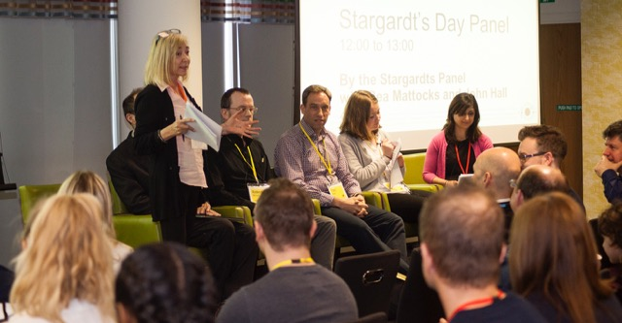

SUMMARY: The panel explored the life of people with Stargardt’s disease from childhood through to working age; their experiences of diagnosis, the impact of limited treatment options and the effect that Stargardt’s disease can have on daily life, employment and relationships.

Eighteen months on from her son’s diagnosis, Bhavna has begun developing a website specifically for people with Stargardt’s disease – a one stop shop giving information on the condition and symptoms, research and sign posting people to where they can get support.

There are plans to set up a register for people with Stargardt’s disease and Stargardt-like conditions. The register will help bring people together to support each other, raise money and bring together information on people’s genetics and the characteristics of their condition to aid research.

(Note: To find out more and get involved see page 40.)

# Information Exchange (13:45 to 15:00)

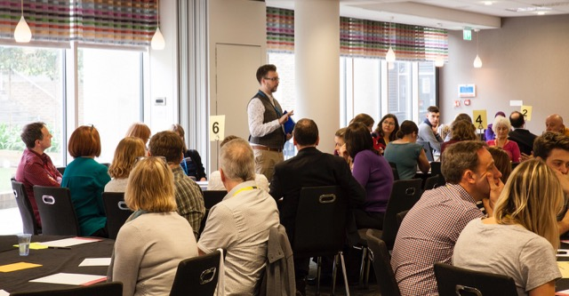

Information Exchange provided an opportunity for those attending to meet with organisations who are providing various kinds of support to people with Stargardt’s disease.

This was a chance for people to highlight what were the important current and future priorities for support; research and information sharing needed.

Participating organisations were:

* [Fight for Sight (web link)](http://www.fightforsight.org.uk/)
* [Macular Society (web link)](https://www.macularsociety.org/)
* [Metro Blind Sport (web link)](http://www.metroblindsport.org/)
* [NIHR Moorfields BRC (web link)](http://www.brcophthalmology.org/)
* [Royal Society for Blind Children (web link)](http://www.rsbc.org.uk/)
* [RP Fighting Blindness (web link)](https://www.rpfightingblindness.org.uk/home.php?home=yes)
* [Stargardt Patient Register & Website (web link)](https://stargardts.org.uk/)

(Note: find out more about these organisations by clicking on the links above)

There were two rounds of 30-minute discussion during the session. When registering for the day, attendees identified who they wished to speak with and everyone got to talk with at least one of their choices.

Prior to the day, several researchers and staff from Moorfields and the UCL Institute of Ophthalmology took part in a training afternoon to learn how to facilitate group conversations. They then helped to manage these discussions on the day so that they were as useful as possible and everyone involved could share their point of view.

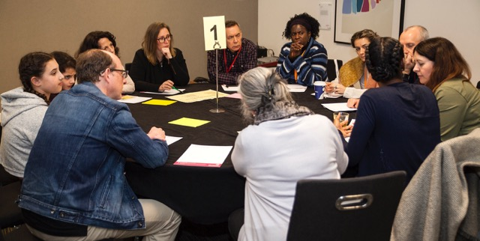

## What did you have to say?

Diagnosis experience:

* Many people had negative diagnosis stories; people described ‘not hearing anything else’ once they were told Stargardt’s disease had no cure and was untreatable
* People reported receiving either no information about support at the time of diagnosis or being unable to take this information in
* People said that no referral to any support / charity worker was offered, people felt left to seek their own information, mostly online, once the impact of the diagnosis had subsided
* People diagnosed later in life equated ‘no cure’ with ‘no point’ and said they hadn’t sort further information
* An ‘Information sheet’ on Stargardt’s disease and support that can be given to people at the time of diagnosis is needed
* Once Stargardt’s disease has been identified in a family, could there not be a choice of broader family screening (i.e. achieving diagnosis in advance of symptoms)
* Doctors and GPs need to be more aware of what information patients need

Confusion with Age-related Macular Degeneration (AMD):

* People found information relating to ‘macular degeneration’ tended to focus on AMD. Is this information useful for people with Stargardt’s disease as well?
* People were more aware of AMD and particularly for people diagnosed later in life, there is confusion that Stargardt’s disease is a type of AMD and ‘just’ part of getting older, which builds upon feelings of ‘no point’
* Some people who were younger when they were diagnosed were told that they had ‘macular degeneration’ (rather than Stargardt’s disease) and that this was unusual in young people. They reported that having this vaguer diagnosis made it easier to seek out information because it signposts you to more than the term ‘stargardts’

Support services and information:

* Those who had experience of the support offered by the organisations in attendance were very positive of them, the counselling and helpline services in particular
* However, many said they were unsure of where to go for information and support; online the search term ‘stargardts’ doesn’t necessarily find these organisations; much of the information found is often from the USA and can be USA specific
* It isn’t always clear from the name of an organisation whether they can help people with Stargardt’s disease or which organisations offer which kinds of support
* Stargardt’s Facebook groups are useful for engaging with others and getting immediate answers to your questions. Local support groups are also helpful
* Information in the form of case studies and FAQ’s are often more help and personal than an information leaflet; electronic formats like email are better so people can make use of screen readers
* Printed information must be in visually accessible formats including large fonts and spacing
* Suitably aged ‘role models’ and dedicated, appropriate support for school- and working-age people is needed
* It isn’t always clear where to find out about taking part in leisure and recreational activities for people with visual impairment – local council and sport development officers; online search for ‘blind sport’; physical education department of local schools etc.; local gyms and leisure centres are sources of information
* Some people worry about people being ‘singled out’ by joining special blind and visual impairment sports clubs
* Most recreational sports for people with visual impairment seem limited to big cities and not rural areas
* Could there be a card for people with visual impairment that can be shown to others to help explain you have low vision and provide key information about your condition?
* A resource dedicated to Stargardt’s disease that can help raise awareness of support organisations with accurate and up to date information would be welcomed; it should link to other organisations
* There is a fear of the ‘unknown’ and a need for a forum where people can meet others of a similar age or circumstance (e.g. children, parents etc.); share diagnosis stories; get help, support and advice from ‘mentors’ on their options now and at the next stage of life - school, work, dating etc.

Designing a patient register/website for Stargardt’s disease:

* These resources should provide an opportunity to meet others regularly, share stories that will help and inspire others, seek advice and support and information on supporting organisations
* They should aid in raising awareness of Stargardt’s disease and help with raising money
* The register should be open to people from abroad as well and should help with both clinical trials and developing tools and instruments to help people with Stargardt’s disease
* Is the term ‘Stargardts’ friendly enough for people? The society Foundation Fighting Blindness has a register called ‘My Reina Tracker’ which is catchy and doesn’t immediately suggest visual impairment
* Younger people should be involved in helping to design the website and inform specifically on what their needs are. Perhaps young people could have a dedicated resource just for them?
* Should the data of younger people on the register be treated differently to that of adults (i.e. anonymised)?

Priorities in research:

* More information is needed on the progression of the condition and what, if any, factors may accelerate or slow the progression – what could people do to help ‘control’ the condition themselves
* People’s priorities for research into restoring sight vs. slowing progression may depend on what stage your condition is at
* It is difficult to distinguish genuine clinical trials from ‘quackery’
* People with more advanced sight loss, who felt they have adapted well, were more concerned for the next generation
* Many are unaware that patients can offer a valuable contribution to research outside of clinical trial (e.g. giving blood samples to study)
* Doctors and GPs are often not up to date on research
* A reliable and consolidated source of information on research and legitimate clinical trials and studies, that is updated regularly, is needed

# Afternoon Presentations (15:15 to 16:20)

[Note: presentations are on YouTube (web link)](https://www.youtube.com/playlist?list=PLCIRUDWfCdBwLItX8aCATD4j_KpRiaAp2)

## Gene and cell therapies for Stargardt’s disease – where are these at?

### By Professor James Bainbridge

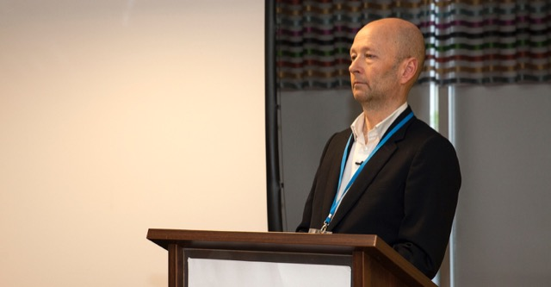

SUMMARY: James highlighted some of the challenges that need to be grappled with if gene and stem cell therapies are to be of benefit to people with Stargardt’s disease.

Stargardt’s disease affects the photoreceptors of the eye and the layer of supporting cells underneath called the retinal pigment epithelium. Both types of cell need to be considered when thinking about how to improve patient outcomes.

The principle of gene therapy is to put back the missing instruction into the cells that need it. In Stargardt’s disease this is a challenge because the ABCA4 gene is large; it is difficult to package it up and reliably deliver it into cells. Gene therapy also requires living cells to work, so in advanced disease where cells have died it is hoped that providing new cells grown from stem cells might be of benefit.

Research into new gene therapy and stem cell techniques are underway as are some early clinical trials into the safety of gene and stem cell therapies in Stargardt’s disease.

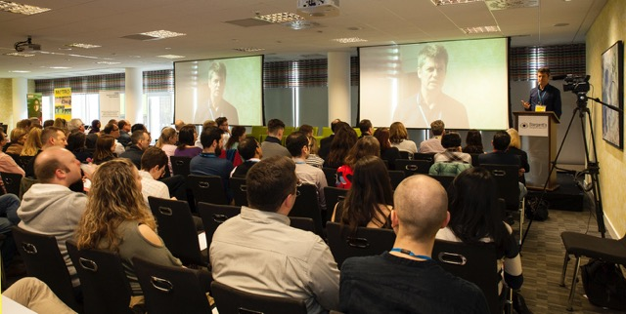

## IPS cells for Stargardt’s disease – why recreate Stargardt‘s disease in the lab?

### By Dr Anai Gonzalez-Cordero

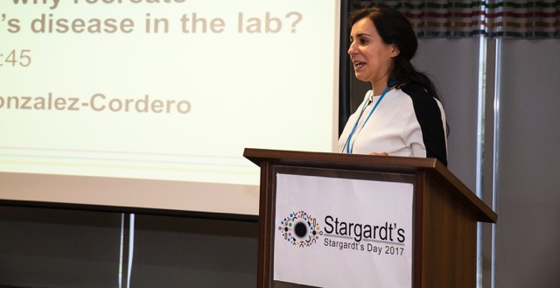

SUMAMRY: Anai introduced the research she is doing on stem cells. Stem cells can multiply indefinitely and have the potential to produce any other type of cell in the body, including retinal cells, when exposed to the right factors. In the stem cell clinical trials you may have heard about in the news, it is the retinal cells produced from stem cells that are transplanted, not the stem cells themselves.

Anai is working on a type of stem cell called an induced pluripotent stem cell or iPS cell. IPS cells are generated in a lab from tissue samples donated by patients. By taking a sample of tissue, such as blood, we can reprogramme these cells and turn them into stem cells. By exposing the stem cells to the right factors, we can turn them into retinal cells, essentially growing a mini retina in a dish. These retinas are not suitable to be transplanted into people but they tell us a lot about the way the retinal cells in the eye fit together and interact.

Animals models are important tools to help us to study diseases in the laboratory, however, these do not always perfectly mimic human diseases. The benefit of iPS cells is that if the starting tissue comes from a person with Stargardt’s disease then the stem cells we generate will carry the same genetic spelling mistake in the ABCA4 gene as the patient. This means that we can then grow cells in the laboratory that will hopefully mimic what is going on in the patient’s eye.

IPS stem cells therefore are a powerful tool to allow us to study how conditions like Stargardt’s disease progress in more detail and will help us to test how the retinal cells in a patient may respond to a new therapy.

## Is there a possibility of a drug therapy for Stargardt’s disease?

### By Dr Rupert Strauss

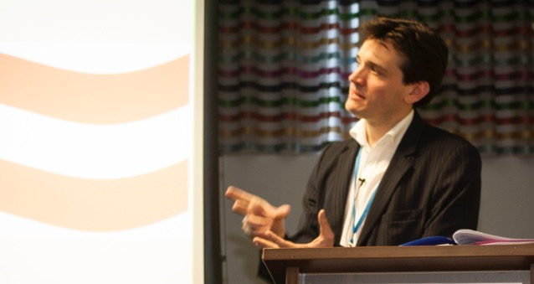

SUMAMRY: Could there one day be a pill to prevent or slow down the progression of Stargardt’s disease? Rupert discussed some of the research into drug-based therapies for Stargardt’s disease.

In Stargardt’s disease, patients accumulate higher concentrations of lipofuscin in the retina; a by-product of our normal visual function. Lipofuscin are the yellow-brown / fluorescent flecks you see in images of the retina. Around 50% of lipofuscin formation is due to Vitamin A. Higher levels of lipofuscin are thought to be toxic to the retinal cells so people with Stargardt’s disease are advised to avoid Vitamin A supplements.

Several compounds are being investigated to reduce accumulation of lipofuscin. One such compound is ‘Deuterated Vitamin A’ – a slightly modified form of Vitamin A. In the lab, feeding Stargardt’s disease mice ‘Deuterated Vitamin A’ has been shown to inhibit formation of lipofuscin.

Some early clinical trials of ‘Deuterated Vitamin A’ in people have been undertaken. It has already been shown that there are no severe side effects for people taking ’Deuterated Vitamin A’. Further studies will need to be undertaken to determine to what extent ‘Deuterated Vitamin A’ may benefit vision in people with Stargardt’s disease.

Another approach is the use of N-acetylcysteine, an antioxidant (a substance which inhibits oxygen damage in the body), that is already used to treat people who have taken an overdose of paracetamol. We know that the eye can be damaged by oxygen (known as oxidative stress). The role of oxygen damage and N-acetylcysteine is already under investigation in both retinitis pigmentosa and now Stargardt’s disease.

# Insight sharing posters

Throughout the day we had a series of posters posing important questions of interest to people with Stargardt’s disease. People’s responses are given below:

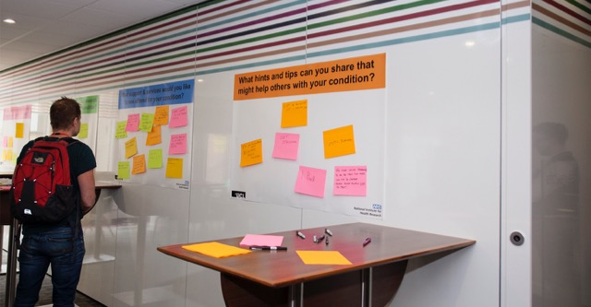

For more information relating to any of the suggested support technologies below do contact your local low vision services or patient support organisation.

Which organisations or resources have helped you and might help others?

(Note: each of these bullets will take you to a website.)

* [Blatchington Court Trust in Brighton (web link)](https://blatchingtoncourt.org/web/)
* [Henshaws Society for Blind People in Manchester (web link)](https://www.henshaws.org.uk/)
* [Kent Association for the Blind (web link)](https://www.kab.org.uk/)
* [Low Vision Clinic in Cambridge (web link)](http://www.cuh.org.uk/addenbrookes/services/clinical/ophthalmology/low_vision_advice_and_liaison_service.html)
* <Leonard Cheshire Disability and the Change100 internship programme for disabled students (web link)>
* [Macular Society (web link)](https://www.macularsociety.org/)
* <Oxford Association for the Blind (web link)>
* [RNIB (web link)](https://www.rnib.org.uk/)

What hints and tips can you share that might help others with your condition?

* If you enjoy playing music: sight read music reader
* CCTV readers
* Lots of magnification
* Get stronger
* Ipad
* The more you’re prepared to ask for help; the more you can do/achieve
* People almost always like to help!

What support & services would you like to see offered for your condition?

* Early support in dealing with the diagnosis
* More updates on what research is ongoing
* Help with transition to university and careers advice
* Occupational therapy and advice for university students on careers and support
* Guides/leaflets should be more user-friendly and easier to use
* Legal advice concerning reasonable adjustments at work - what are my rights?
* Better communications
* How to accept the diagnosis?
* New resources and gadgets!
* ‘I feel I am all alone and the only person in my village/town with this condition’
* Packages to support visually impaired people regarding mobile data. More data you have the more expensive it is.
* Free TV licenses

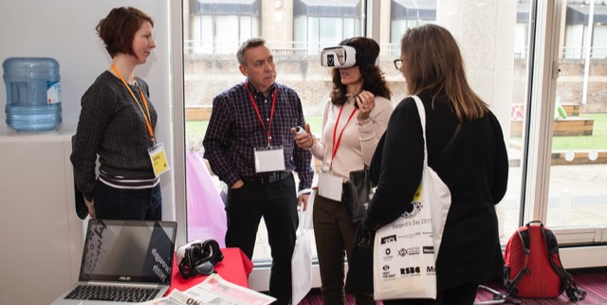

What questions would you like research to address in relation to your condition?

* Should I completely avoid eating Vitamin A?
* More information on what is being done
* How Stargardt’s progresses and what influences how quickly it develops?
* Have leaflets updating patients on clinical trials and future plans
* Clinicians should update more on what’s going on in the labs/clinic
* How fast/slow disease progress? Any model?
* Mechanisms of disease – mitigating and aggravating factors

# Next steps

* The Stargardts Panel have decided to continue working together to help support the Stargardt’s Community. Over the next year they will be developing the new website to act as central point of information on the condition and will be arranging new opportunities to bring people together to meet one another. To keep updated register at [Stargardts.org.uk (web link)](https://stargardts.org.uk/register)
* The Stargardt Patient Register is a longer-term project and currently discussions are happening to help set this up properly. Any updates about the register will be available via the Stargardts.org.uk website when available
* If you would like to get involved with the Stargardts Panel or if you have a question then you can [contact them through the website (web link)](https://stargardts.org.uk/contactfeedback)
* The discussions from Stargardt’s Day will be sent to all of the organisations and speakers from the day to make use of
* The prestigious ophthalmology magazine Eye News have written an article about Stargardt’s Day which will go out to their readership later this year.
* The NIHR Moorfields BRC will be presenting some of the findings from Stargardt’s Day later this year at a research meeting about the power of patient voices
* If you would like to receive any of the content from Stargardt’s Day in a different format, please contact Andi Skilton on [eye.info@ucl.ac.uk (email link)](mailto:eye.info@ucl.ac.uk?subject=Query%20about%20Stargardt's%20Day%202017)

# Feedback and evaluation

### 49 people completed our pre-event survey and 26 people completed our post event survey.

After the event:

* A third of people reported being more aware of where to go for information about Stargardt’s disease than they were before
* Around 40% more people felt that medical research into Stargardt’s disease was progressing

**From the day people said they got the following:**

* Opportunity to meet others; both patients and researchers
* Updates on research
* Knowledge of new devices / apps
* Knowledge of organisations to join for advice and support

For the future people wanted:

* More opportunities to meet others with Stargardt’s disease
* A specific resource for people with Stargardt’s disease providing information and linking to support
* More information on factors that speed up or slow down progression of Stargardt's disease
* Reliable sources of information providing updates on Stargardt's disease research
* More information from charities in how people can donate money to specifically support Stargardt’s research

# Speaker Biographies

### James Bainbridge

I am Professor of Retina Studies at University College London, a Consultant Ophthalmologist at Moorfields Eye Hospital and I am an NIHR Research Professor at NIHR Moorfields Biomedical Research Centre. I trained in medicine at Kings College, Cambridge and at St Mary's Hospital Medical School, London and at Moorfields Eye Hospital. I was the clinical lead for Europe’s first clinical trial for stem cell therapy for Stargardt’s disease and for the world's first gene therapy trial for inherited retinal disease.

### Michael Crossland

I am a Specialist Optometrist at Moorfields and an Honorary Senior Research Associate at UCL Institute of Ophthalmology. My interest is in child and adult low vision rehabilitation, using spectacles, optical and electronic magnifiers, and technical devices to maximise residual vision in people with visual impairment. My most recent research is in the use of iPads to help education of children with visual impairment. I am a committee member for the International Society for Low Vision Research and Rehabilitation and an examiner for the College of Optometrists.

### Toby Evans

I am Audit Manager at the National Audit Office in London and I am a Trustee of the Macular Society and committee member of the London Working Age Member group. I was diagnosed with Stargardt’s disease when I was a teenager. I qualified as a Chartered Accountant.

### Anai Gonzalez-Cordero

I am Research Fellow at University College London. My research is focused on investigating how we can grow different types of retinal cells in the laboratory from stem cells, and the best approaches to then transplant these cells into the damaged retina and encourage them to integrate properly to restore vision. I am also working with blood samples from people with Stargardt’s disease where I am turning blood into stem cells from which we can then grow a Stargardt’s affected retina in a dish to aid us in better studying this condition.

### Ruby Luck

I am currently working in retail but I am planning to go to University in October to study Politics and International Relations. I was diagnosed with Stargardt’s disease when I was 13. I enrolled in a research study at Moorfields Eye Hospital in 2014 to help researchers better understand the natural progression of the condition.

### Rea Mattocks

I am an independent consultant in the public health sector and I have been a Lay Advisor to the Royal College of Ophthalmologists since 2012. In these roles, I seek to promote and support efforts to build strong and mutually responsible relationships between patients and healthcare teams to improve overall patient outcomes. In 2005, I was diagnosed with Birdshot Uveitis. My experience of diagnosis and early treatment was not a smooth one, and so in 2009 I helped establish the Birdshot Uveitis Society to provide information and support for people with Birdshot and to champion for early diagnosis and research into the disease.

### Robert McCann

I am the Sheffield Royal Society for the Blind Equipment Centre Co-ordinator. I was diagnosed with Stargardt’s disease nearly 36 years ago, but I decided to ignore it as much as possible and wait for science to find a “cure”. In 2013, I became a participant in the ACT stem cell clinical trial being run at Moorfields to assess the safety of transplanting stem cells into the eye.

### Andi Skilton

I am a Senior Research Associate and part of the Patient and Public Involvement Team at the NIHR Moorfields Biomedical Research Centre. Our team supports patients, the public and researchers in holding conversations which aim to positively influence the direction of research; through the setting of research priorities and by ensuring that the design of research is acceptable and that the outcomes of research are truly relevant for society. Previously I worked in scientific communications within the pharmaceutical industry and I hold a PhD in Biochemistry.

### Rupert Strauss

I am a Consultant Ophthalmologist at the Department of Ophthalmology, Kepler University Clinic Linz (Austria) and an Honorary Fellow at Moorfields Eye Hospital. My research interests are in the study of the structure of the retina and how it changes as retinal disease progresses. My most recent research at Moorfields and previously at the Wilmer Eye Institute, John Hopkins University, Baltimore (USA) has been looking specifically into the progression of Stargardt’s disease and its impact on vision.

### Bhavna Tailor

I am a primary school Teacher in Hertfordshire. My 9-year-old son Ethan was diagnosed with Stargardt’s disease in September 2015. Initially, I found there to be a lack of support for the condition, which added to our feeling of devastation. Since then, I have been trying to do something positive and have been involved in a lot of fundraising for the condition and in raising awareness in the national news. I am currently in the process of designing a Stargardt’s website, which I hope will offer useful information, support and signposting for Stargardt’s patients and families.

### Andrew Webster

I am a Consultant Ophthalmologist at Moorfields Eye Hospital and Chair of Molecular Ophthalmology at University College London. I trained in Cambridge, Iowa City and at Moorfields. I oversee a large clinical practice at Moorfields supporting patients and families with inherited retinal disease and I supervise a group of investigators at the UCL Institute of Ophthalmology.

# Acknowledgements

Thank you to:

* everyone who attended; it really was all of you who made this day what it was
* the staff, clinicians and researchers from NIHR Moorfields BRC, UCL Institute of Ophthalmology and Moorfields for their hard work
* [Katherine Cowen Consulting (web link)](http://www.katherinecowan.net/2.html) who provided facilitation training for the day
* [Moorfields Eye Charity (web link)](https://www.moorfieldseyecharity.org.uk/) and [GiveVision (web link)](http://www.givevision.net/) who came along to share what they do
* the staff at [etc.venues Victoria](https://www.etcvenues.co.uk/venues/victoria) (web link) who helped make the day so memorable