How to make a bead-net dress

By Janet Johnstone

Fabric

* Beads (cylinder beads 1.5 to 3cm long and round beads)
* Shells drilled with holes for threading (optional)
* Strong polyester thread natural or cream and a long needle

Cylinder beads may be difficult to find so use your imagination to think of an alternative. Here are some suggestions:

1. Drinking straws cut to size.
2. Make your own beads from modeling clay such as Fimo or Sculpey.
3. A bamboo bead curtain for hanging across a doorway provides a good economical source of cylinder beads. Carefully dismantle it and saw the lengths of bamboo to the correct size cylinder beads. Some bead curtains are already painted with scenes so just group the colours together for your bead-net design.
4. A good place to look for beads and buy them cheaply in bulk is the Bead Shop, Covent Garden, London or mail order from [www.beadshop.co.uk](http://www.beadshop.co.uk).
5. Shells for the fringe. Rather than attempt to drill holes into bought shells, look for shell necklaces or flowerpot hangers in your local charity shop. The shells are ready to use and someone else has drilled the holes for you.

Make a plan on paper of the beading design. Calculate the number of beads you will need and their position.

Instructions

1. The dress can be made either as a tube or alternatively worked on flat and sewn up when it is completed with an opening down the centre back to achieve a better fit. Start with the band of vertical beads that goes under the breasts. Take a measurement around the chest below the breasts and add on extra to ensure that the tube dress can be pulled off over the head and shoulders. The skirt and shoulder straps are attached to it. Using 2 needles and one thread (thread a needle on to either end of the thread) sew the beads together as diagram 1. Use the longest length of double polyester thread you can manage (2 –3 metres). If you run out of thread before you finish tie another length on using a surgeon’s knot. When you have completed the band knot off the two ends together with a surgeon’s knot.  
   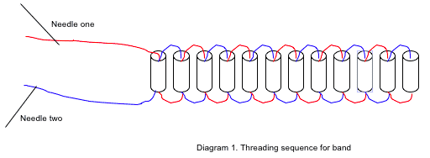
2. For extra strength sew the beaded band onto a strong petersham band that has been covered with white fabric (linen preferably).  
   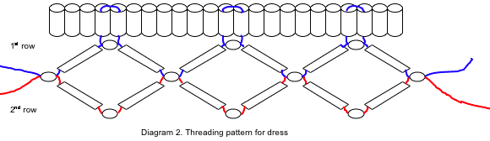
3. To make the skirt. Sew the first row of cylinder beads interspaced with round beads.
4. Using one needle and a double thread (as long as possible) thread on one round bead, one cylinder bead and one round bead. Attach this to the vertical beaded band by running up one vertical bead and down its neighbour and come through the top round bead. Make a knot to hold this pattern in place and thread on one cylinder bead, one round bead, one cylinder bead and one round bead. Measure along the vertical beaded band or count them and run the thread up a vertical bead and down its neighbour and back through the top round bead like before. Knot the thread to hold this pattern in place and remember to pull the thread tightly as you go.
5. The second row and subsequent rows are made using the same method as the first but attach the new row through the bottom row of round beads as shown Diagram 2 and knot as you go.
6. The shell fringe. Thread the shells and alternate with one or more tiny beads on to a double thread and attach to the last row of the dress.
7. The straps are made in the same way as the dress. You may find it easier to use shorter cylinder beads and pin the first row of beads to a corkboard or sheet of thick polystyrene to keep the work under tension and straight. Make up two individual straps and sew each to the top edge of the band of vertical cylinder beads at the front and the back.
8. To store your dress. Lay it flat in a box. Remember not to sit down when you wear the bead-net dress or the beads will break.  
   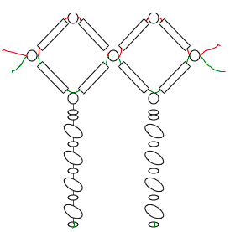

[museums@ucl.ac.uk](mailto:museums@ucl.ac.uk)

[UCL Museums and Collections](https://www.ucl.ac.uk/museums-collections/) www.ucl.ac.uk/museums-collections