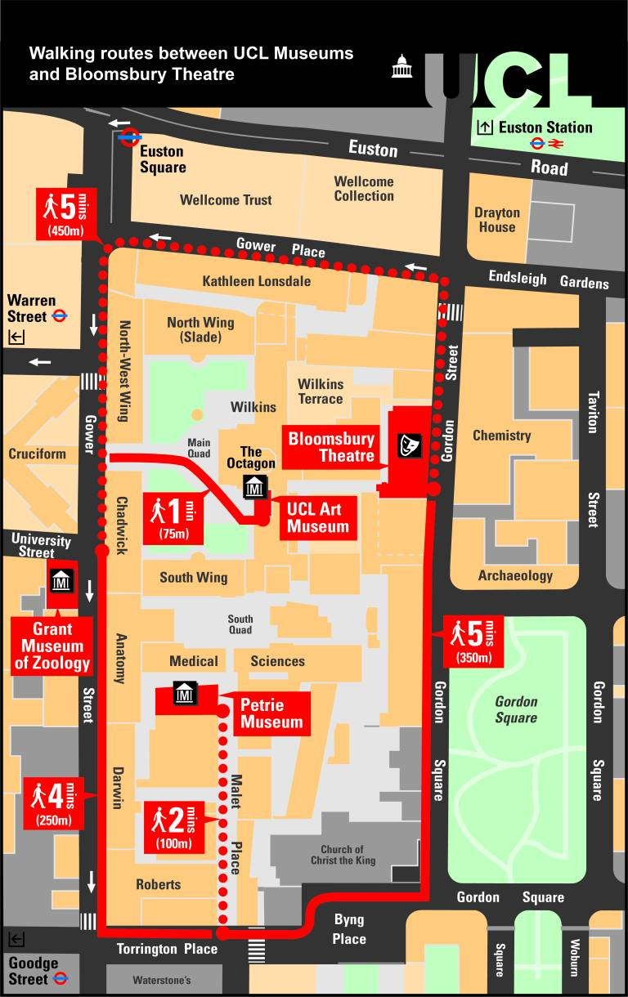

Walking routes between UCL’s museums and the Bloomsbury Theatre