To be sent to: continuing UG and PGT students
Date: 29 May 2024
Subject line: Central assessments are finished: what’s next?

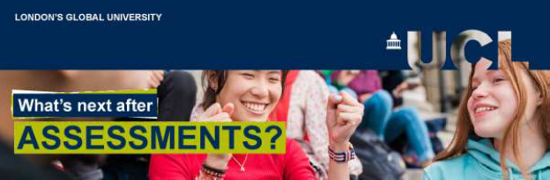

Hi [student’s first name],

Congratulations!
The Central Assessment Period is over! We hope you can breathe a sigh of relief and take time to look after yourself as you wait for your results.

What you need to know

Results day is Thursday 4 July
Your assessment results will be emailed to your UCL email address on 4 July.
You may receive your results at a different time to other students on this day, as our systems send the emails in large batches. Any results displayed on WISEflow before 4 July are provisional.
If you are disappointed with your results, Student Support and Wellbeing Services can offer some advice and help.

Late Summer Assessment
For students who need to sit deferred or failed assessments, the Late Summer Assessment period takes place from 19 August – 6 September. The examination timetable will be shared with those students on 22 July.
Some assessments organised by your department may not appear on this timetable. If this affects you, your department will advise you about the details.
Key dates
Results day: 4 July
Late Summer Assessment timetable released: 22 July
Late Summer Assessment period: 19 August – 6 September

Your preferred modules
If your programme offers a choice of modules, you will have already submitted your module preferences for the next academic year.
You will receive an email in mid-July letting you know if you have been accepted on your preferred modules. You will also be able to view your selections in MyStudies on Portico. Your department will also contact you if you are required to change a module.
Your timetable for the next academic year will be shared with you in July.
This is a busy time for departments, and they will only be able to confirm the status of your modules until mid-July, so we appreciate your patience until then.

Compulsory modules
If your programme has only compulsory modules next academic year, visit the UCL Module Catalogue to find our more.
Button: Find out more about module selection

Support for postgraduates over the summer
Writing your dissertation this summer can seem like a daunting task. The UCL Academic Communication Centre is here to help. The Centre offers one-to-one tutorials, courses, webinars and writing retreats to support you through the whole process.
UCL Library Skills is another key resource, especially for literature searching and referencing.
The Research and Writing Skills for Dissertations Moodle course will also help you develop the skills for approaching this work.

Need support?
The Exams and Assessments Hub contains all regulations, guidance and support resources you need for your centrally managed assessments.
Student Support and Wellbeing Services are here to help if you're struggling with any health, disability or wellbeing issues.
Find an archive of these emails on the Exams and Assessments Hub.

Wishing you every success with your results,
UCL Central Assessment Team

