To be sent to: final year UG and PGT students
Date: 29 May 2024
Subject line: Central assessments are finished: what’s next?

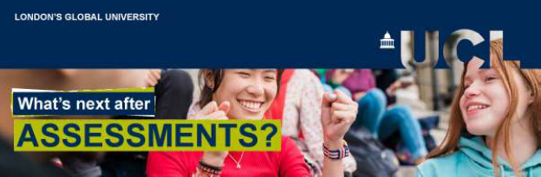

Hi [student’s first name],

Congratulations!
The Central Assessment Period is over! We hope you can breathe a sigh of relief and take time to look after yourself as you wait for your results.

What you need to know

Results day is Thursday 4 July
Your assessment results will be emailed to your UCL email address on 4 July.
You may receive your results at a different time to other students on this day, as our systems send the emails in large batches. Any results displayed on WISEflow before 4 July are provisional.
If you are disappointed with your results, Student Support and Wellbeing Services can offer some advice and help.

Late Summer Assessment
For students who need to sit deferred or failed assessments, the Late Summer Assessment period takes place from 19 August – 6 September. The examination timetable will be shared with those students on 22 July.
Some assessments organised by your department may not appear on this timetable. If this affects you, your department will advise you about the details.
Key dates
Results day: 4 July
Late Summer Assessment timetable released: 22 July
Late Summer Assessment period: 19 August – 6 September

Support for postgraduates over the summer
Writing your dissertation this summer can seem like a daunting task. The UCL Academic Communication Centre is here to help. The Centre offers one-to-one tutorials, courses, webinars and writing retreats to support you through the whole process.
UCL Library Skills is another key resource, especially for literature searching and referencing.
The Research and Writing Skills for Dissertations Moodle course will also help you develop the skills for approaching this work.

Your journey with UCL continues
Graduation ceremonies this year will take place in July and September at the Royal Festival Hall.
Button: Graduation ceremony FAQs
Attendance at graduation ceremonies is optional. Your degree will be valid, and a hard copy of your degree certificate will be posted to you within three months of being awarded your degree. A digital award certificate may be available sooner.
Button: Information on award certificates

Joining UCL’s global alumni community
For almost two centuries, our community has shaped the modern world, and worked to find solutions to its grand challenges.
If this week marks the end of your programme, our alumni team will be in touch with you over the summer about ways for you to become an active member of our vibrant community of over 300,000 former UCL students.
You can also explore a range of benefits and professional development support available to you now, as well as guidance from UCL Careers for up to three years after completing your course.
Button: Our alumni community

Need support?
The Exams and Assessments Hub contains all regulations, guidance and support resources you need for your centrally managed assessments.
Student Support and Wellbeing Services are here to help if you're struggling with any health, disability or wellbeing issues.
Find an archive of these emails on the Exams and Assessments Hub.

Wishing you every success with your results,
UCL Central Assessment Team

