Shape UCL | Student Academic Representative Guide 2022
Office of the Vice-Provost (Education & Student Experience)

Contents
Introduction 3
Your Shape UCL Board 4
Getting started 5
Engaging with student feedback posts 8
Using Shape UCL to support your Staff-Student Consultative Committee (SSCC) 11
Removing content 13

Introduction
Shape UCL is a space where students, academic representatives, and staff can collectively raise, discuss, and resolve academic and general experience issues.
The platform allows students to discuss and vote on matters they’d like to escalate to departmental staff for attention. This enables the department to consider and, where appropriate, promptly address these concerns and for students to see the decisions and actions taken.
How Shape UCL works:
- Students share feedback on their experiences by creating a feedback post on their board. This can be about an issue they are facing, asking a question, sharing praise, or suggesting a new idea. The content of the post is not visible to staff at this stage.
- Students engage with other students' feedback posts by voting and commenting, allowing them to see whether their feedback has resonated with others.
- Student Reps connect with their peers by reviewing, responding, moderating, and escalating important topics to staff in their department. Reps do this by moving the post to the Open section of the board.
- Staff can now see the feedback post and provide an initial response and further updates to students as their feedback moves from the In Progress to the Closed section of the board.
- The Together We Changed section shows notable changes in the department or improvements to its programmes. This is where students and staff can review how their feedback and actions taken have helped Shape UCL.
Through using Shape UCL:
- Students can help inspire change within their faculty, department, and programme through their feedback.
- Reps can connect with their peers and staff by escalating important topics.
- Staff can create greater visibility and transparency around the decisions and actions taken in their department.
- All parties engage in constructive dialogue and identify good practices to help build a sense of community.

Your Shape UCL Board
This is where students, Reps and staff interact with feedback that students raise. The Board area is split into two sections Private and Public, with several tabs that run along the top.
Board name – is usually the name of your department displayed at the top of your screen.
Private Feedback – this is where students raise and discuss feedback by creating feedback posts. Once a post has received sufficient votes and comments or cannot be dealt with by students, the Reps escalate it to the Public area. While staff do not have access to the Private area, they can see how many feedback posts have been created, what programme it relates to, how many votes/comments it has received, and the year of study of the author.
Public Feedback – this is where staff members review the escalated feedback, comment, and update students as they progress feedback from the initial Opened column to In Progress and eventually the Closed column. While posts remain open, students can elaborate or provide further context through additional comments. They can also like or report responses that breach the Community Guidelines. Only staff members can move or close feedback posts in this area.
About – this contains essential guidance, along with further information and links. There are four sections:
- Welcome & House rules: the bullet points reference the Community Guidelines
- Feedback categories: VPESE have created a standard set of “core” categories, but Board Admins can create additional ones
- Further advice, helpful links: VPESE have added a few essential links
- Rep & staff response times: these are the times Reps and staff are expected to make an initial response by, and these can be edited by the Board Admin
This page is managed by a Board Admin (usually a member of professional services staff).
Archive – after 90 days, a closed feedback post will be automatically archived in this section.
Members – lists all the staff, students, and Reps with access to your board.
Together We Changed – this page lists feedback posts that led to a notable change or improvement in a programme, or the department. This page lets students see the value of their feedback and how the community of staff and students have made positive changes in response.

Getting started
Accessing Shape UCL
You can access Shape UCL using your usual UCL credentials via – https://ucl.unitu.co.uk/
Adding a profile picture
Help students and staff identify you and make the platform more personable, by adding a profile picture. Once signed in, click Settings in the top left corner of the screen underneath your name:
- In the Account section click Profile picture to upload a photo to your profile.
Managing your notifications
Email notifications are by default enabled for all New Feedback Posts created on your board. If you are receiving too many emails, click Settings, and adjust these to one of the following in Notifications:
Notifications for new posts created by students on the same programme:
- Disable both New Feedback on my board, and New feedback from students in my year and enable New feedback from students on my course.

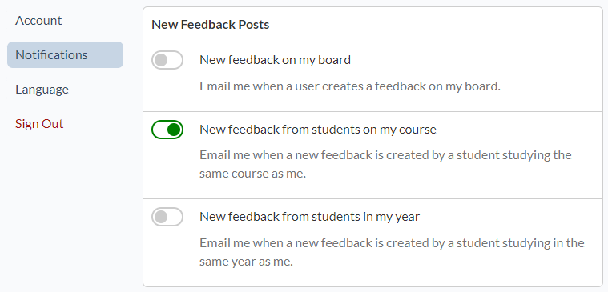
Notifications for new posts created by students in the same year of my programme:

- Disable New Feedback on my board and enable both New feedback from students on my course and New feedback from students in my year.

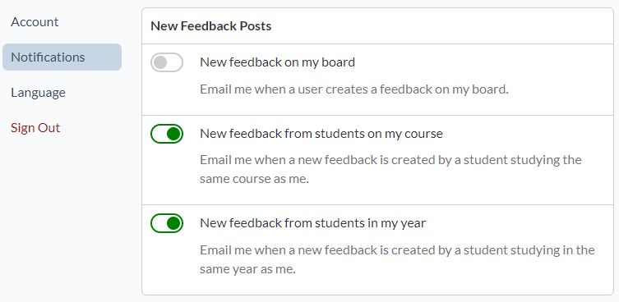

Notifications for new posts created by students in the same year:

- Disable both New Feedback on my board and New feedback from students on my course and enable New feedback from students in my year.

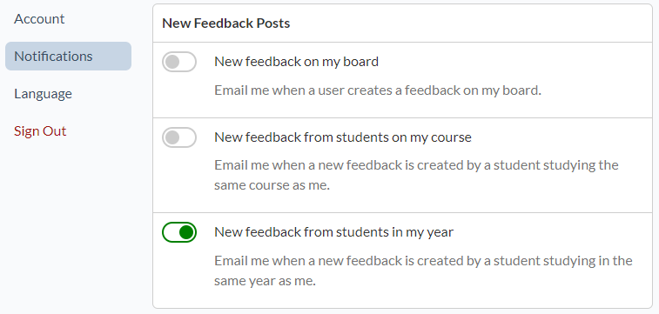

You should check the other notification categories to review what is currently enabled. The Weekly Digest provides a handy summary of the activity that has taken place over the past week.
Creating an introductory post
Introduce yourself to your fellow students, by creating a new post. This will help students be aware of who you are, your role as a Rep on the platform, and encourage other students to post their own feedback. An example post has been provided below:
- Click Request Feedback > Select the Feedback Type > Question
- Title: Meet your Student Academic Representatives
- Details:
I’m [Rep name], one of your [level e.g. first-year / postgraduate as appropriate] Student Reps. I’m writing to introduce myself and let you know my role is to help you get your voice heard by staff and drive improvements to our education experience.

The Shape UCL platform gives you the opportunity to share ideas, ask questions, raise issues and give praise. Your Shape UCL posts will be reviewed by Reps and the relevant ones will be shared with staff in our department.

Please add a comment below and let me know what’s currently working well for you and anything you’d like to see change.

Any other Reps can also introduce themselves in the comments.
- Category: Other
- Audience: Entire Board
Creating a feedback post
A feedback post is a great way to start the conversation on Shape UCL. If no one has posted on your board yet, why not start things off. This can be an idea you have or an issue other students have made you aware of. You can raise a question on behalf of other students or start off a praise post to let staff know where teaching has been particularly good. Seeing Reps and staff take the lead encourages students to engage with the platform and post their feedback.
Some examples:
Praise: A feedback post is a great way to start the conversation on Shape UCL. If no one has posted on your board yet, why not start things off. This can be an idea you have or an issue other students have made you aware of. You can raise a question on behalf of other students or start a praise post to inform staff about where students have received excellent teaching. Seeing Reps and staff take the lead encourages students to engage with the platform and post their feedback.
Issue: Hi everyone, I've had students stop me on campus, send me emails, and WhatsApp messages about problems with Seminar Room B. Let's use this post to record the issues, so staff know the difficulties this room is causing us! I've been told the room is too hot, the thermostat doesn't work, the window doesn't open, and there aren't enough seats (despite being a room for 25). Anything else?
Question: A few people have suggested that lockers are made available for students in our building. It would be great if there was a locker facility for students to put their clothes, books, etc, in. If you agree, then please upvote or consider adding a comment below, and if there is sufficient support, I'll raise this as a question at the next SSCC.
Idea: Hi there, what do people think about the department inviting alumni back to speak to current students? I think it would be interesting to hear about their experiences completing the programme and how they’ve built their careers in our subject area. Let me know what you think by adding a comment below!

Engaging with student feedback posts
Provide a response
When engaging with student feedback posts, it's crucial to provide an acknowledgement within the expected Rep response time (on the About page). This demonstrates to other students who have yet to create a post that if they have a concern, a Rep will respond.
In your response, you can also ask the original poster to clarify an issue, signpost them towards help, or even ask other students to contribute to the discussion.
Some examples:
- Sorry to hear about the problems with the resources on the Moodle page. Have you tried emailing the administrator/module leader about this?
- You can get help with this at the Student Enquiries Centre. Check this page for their walk-in hours.
- Thanks for sharing your idea! What do other students think about this suggestion? Please vote or use the comment section below to give your feedback.
- Thanks for raising the issue about the facilities in the laboratory. Have any other students experienced any other issues with these?
Consider leaving posts open to gather additional student votes and comments to gauge student feeling on an issue before deciding whether to escalate to staff for a response.
Teamwork
If there are only several Reps on your board, consider sharing the task of responding to posts amongst yourselves, responding as and when you see a new post. If you're on a large, busy board with 10+ Reps, consider focusing on posts for your programme, year group, or area you represent.
If you’re unsure what to do with a post, discuss the matter with other Reps or your Lead Department Rep. Think about contacting staff who manage your board or the Student Union for more advice. Or use the Shape UCL Reps Teams group as a sounding board to see what Reps from other departments think or what approach they might take.
Closing a post
Sometimes, you or other students can resolve a post by providing an answer. These might be about opening hours to buildings on campus, where to find particular resources on or offline, submission deadlines or other general queries.
After a short time, to ensure students have seen the response and to reduce the number of open posts, you should close the post through the following steps:
- Open the feedback post you want to close
- Click the Choose an action button > Select Close from the drop-down menu
- In the Close feedback pop-up enter the Resolution in the freetext area e.g. guidance for the coursework submission in on the Assessment page on the Department’s Moodle page / Moodle is back online / the library is still closed for building works
- Click Close feedback
The post will move from the list of Raised feedback to the Closed section of the Private Feedback column. It can still be accessed if the same query is raised, and you can refer students to the response. If the post was closed by mistake, select Re-Open from the Choose an action button, and it will reappear in the Raised feedback.
Moderation
Help keep the platform a constructive and professional space by ensuring student posts and comments focus on issues and ideas and not on individuals.
Constructive feedback and reasonable criticism made courteously are welcome. If a feedback post makes a valid criticism but drifts into the personal criticism of a staff member, add a comment advising the author to edit their post and to keep things factual.
While sarcasm or banter might be considered a “grey area”, these comments are often counterproductive. If left unchecked, they can encourage similar comments, which continue to lower the tone and discourage other students from contributing.
Refer students to the About page on your board which contains links to student guidance and the Community Guidelines. There is more detailed guidance on removing content in the last section.
Escalating a post
In most cases, you will need to move a feedback post into the Public feedback area for staff to resolve or provide a response. To do this, click and drag the post to the Opened column.
The Publish Feedback pop-up screen will open:
If the feedback post you’re about to escalate has received no votes or just several, the platform will issue a prompt to check this wasn’t a mistake. The full text can be viewed in the What does this mean? drop down. While there isn’t a minimum threshold for escalating a post, some feedback might benefit from more votes and comments to show other students share the same view.
- Share an Update (Optional): you can use this area to post an update to students, thanking them for their feedback and saying that you’re moving the post to the Open area. Or, if a post has various views expressed in the comment section, you can try and summarise student opinions for the staff member.
- Post follows the Content Policy (tickbox): this essentially acts as a moderation reminder to ensure the post adheres to Unitu’s (the platform provider) Content Policy and UCL’s Community Guidelines. As good practice, check that the comment thread also adheres to these policies.
- Notify audience: select from a dropdown menu which students should receive an email notification that the post was escalated.
What happens next?
Opened column: This is essentially a "holding" area for staff to review and assign feedback to the appropriate staff member.
In Progress column: Staff are making progress and might provide additional detail or a timeframe for who will make a response or decision, whether that's from another member of the department, a committee, or elsewhere in the Faculty.
Closed column: The feedback has reached a resolution, and staff will provide a response or explain why a change wasn’t possible.
Together We Changed: Based on the student feedback, staff were able to make a change. Together We Changed is an area of the board where students can explore the changes made through a collaboration between students, their reps and staff on Shape UCL.

Using Shape UCL to support your Staff-Student Consultative Committee (SSCC)
Staff-Student Consultative Committees are a vital tool in making changes in partnership with students and provide students reassurance that their feedback is valued. Several departments have shared with us how they use the platform to support their SSCC process.
A common approach is to create a standing item on the SSCC agenda for Shape UCL. At the meeting itself, a Board Admin will usually give a verbal report on the feedback raised on the platform since the last meeting.
Another approach we’re piloting this year is to truly embed Shape UCL into the SSCC process through the following steps:
Prior to the SSCC meeting
Create an “SSCC call to action post” in the Private area of the board, asking students what they want to raise to staff. An example has been provided below:
- Suggested Feedback Type: Question
- Title: Staff-Student Consultative Committee on [date] – what do you want to raise with staff?
- Details:
The department’s Student Reps will be meeting staff in our SSCC on [date], which is an important forum for making decisions and changes.
I plan to raise [add a couple of questions or issues here], but would really like to hear from you all on what we should discuss at the meeting.
Please share your thoughts on what’s going well, what could change and any questions you’d like me to put to staff in the upcoming meeting.
- Suggested Category: SSCC
- Audience: Entire Board

At the meeting
Ensure the Chair has provided you with sufficient time to present the feedback raised from your “SSCC call to action post”. Take a note of the actions assigned to these topics so a summary can be posted on Shape UCL.
After the meeting
Create an “SSCC recap / summary post” in the Private area of the board, to give students an update. An example has been provided below:
- Suggested Feedback Type: Question
- Title: Key updates from Staff-Student Consultative Committee
- Details:
Hi all,
I’m getting in touch to share some updates from the SSCC meeting that I attended on [date]. The topics discussed included [give a couple of examples]. The outcome of the discussions was [provide detail].

On the questions raised around [insert questions], staff responded that [add detail].

Staff will share the action points from the meeting soon, so please look out for those.
- Suggested Category: SSCC
- Audience: Entire Board

The staff SSCC Co-Chair should follow up with students with a concise summary of the discussions and action points from the session. This only needs to be a few bullet points highlighting the key feedback from the meeting and how the department plans to respond. Staff are recommended to post this on Shape UCL as this will generate a notification email to let the whole cohort know.
Where possible, staff are recommended to convert SSCC actions into posts on Shape UCL. This gives students better visibility of the issues raised, and staff can give transparency into how the decision was reached. Another advantage is that when a change is possible, this is directly communicated to the relevant students on the platform and stored in the Together We Changed section.

Removing content
All users are encouraged to familiarise themselves with the new Community Guidelines, and report inappropriate content when they see it. However, only Reps and staff members (in the Public area) can remove these. As staff and Reps have the same moderation controls on the platform, they are jointly referred to as moderators.
In some circumstances, removing entire posts or comments from the Private (student) area will be necessary, and the steps required are provided below.
- See it, sort it!
If you see something that doesn’t feel right, don’t leave it there. Help keep Shape UCL a positive and safe space by moderating breaches in the Community Guidelines as quickly as possible. Leaving rude, offensive or aggressively written comments open for too long has a disruptive effect and can put off other students or staff (if escalated to the Public area).
The process to remove a post or comment is the same. You will firstly need to create a report:
- Click the … icon, next to the comment > Click Report >
This will bring up the Report this Content pop-up screen:
- Please select your reason for reporting this content: by using the drop-down list
- Please enter any information that may help the moderator: as you will be moderating this you can simply use this area to summarise why you’re removing this comment
- Click Submit
- In the left-hand side of the screen, under Moderation click > Reported Content
In the Reported Content screen, you will be able to review a table of all reported content for your board, under the following headings:
- Time Reported: the date report was made.
- Feedback Status: where the reported comment or post is on the board.
- Reported Content: a clickable link to the reported content.
- Reason for Report: rude, offensive, abusive, disruptive, breaches Unitu Content Policy.
- Current location: usually the name of your board.
- Feedback ID: a tag created by Unitu to identify the post.

- Find the Reported Content on this table (usually at the top) and click View Content.
- You can read the content that has been flagged and use View Context for further context.
- In the top right-hand corner of your screen, you will be required to Take Action.
- Select the appropriate action, Remove this content (with no strike), Remove this content (with a strike), then click > Close this Report.
- This will bring up the Close this Report screen:
- Please select your reason for removing this content: by using the drop-down list
- Please give a short explanation for your decision: inform the student that their post or comment fell below the standards expected on Shape UCL and why. This will usually be a breach in the Community Guidelines, so provide a link to them in your explanation as a reminder.

If the offending comment breached Unitu’s Content Policy, Dignity at UCL or the Code of Conduct for Students, include a link to the relevant policy. Removing the content (with a strike) might be a more appropriate reprimand and strikes are covered at the end of this section.
Once the report is closed the content will automatically be removed, and the author of the content will be informed of the reason you’ve given to remove it. They will not be informed which Rep removed their content.
- Reported content
Students are encouraged through their guidance and the Community Guidelines to be active participants in helping to keep Shape UCL a safe space. They can do this in both the Private or Public areas of the board, by clicking the flag icon next to a comment or post.
After flagging content, they will complete the same Report this Content form to help moderators understand their concerns.
Any content reported in the Private area will result in Reps receiving an email notification to review this report.
Reported content can be managed through the same steps on the previous page:
- In the left-hand side of the screen, under Moderation click > Reported Content
In the event you disagree with the content that has been reported, you can select the Don’t remove option, where you will be required to Give a short explanation for your decision form, which the report-ee will receive.
- Issuing a strike | Three strike policy
For serious breaches of the Community Guidelines, Unitu’s Content Policy, Dignity at UCL or the Code of Conduct for Students a Strike can be issued alongside removing the offending content.
- The first strike issued is effectively a “yellow card”. A warning is issued via email to the student explaining why their comment or post was removed, and that a strike was issued in conjunction with that. Unitu has noted that most students quickly adapt their behaviour following this action.
- A second strike issued to the same student will result in them instantly losing the ability to post anonymously.
- In the event a student receives a third strike, their account will be suspended, and they will lose access to Shape UCL. This student will then be put in contact with staff members at VPESE.
To date no UCL student has ever received three strikes.

