**Invitation to submit an expressions of interest for to create a new artwork for World Space Week 2025.**

As part of UCL’s Gaia Public Programme, we are marking World Space Week 2024 by announcing the artist selected from an open call for expressions of interest this work will be presented at World Space Week 2025 at UCL East Marshgate building.

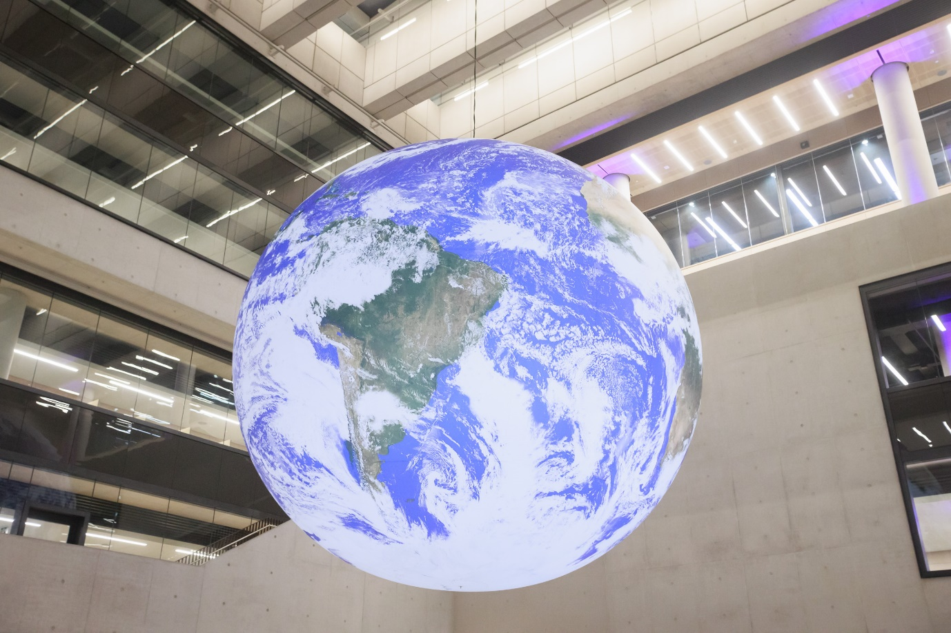

**About World Space Week**

World Space Week is an international celebration of science and technology, held annually from 4-10 October. For 2024, World Space Week’s theme is ‘Space and Climate Change’.

Visit the [World Space Week website](https://www.worldspaceweek.org/about/ ) to find out more.

**About Gaia Public Programme**

The Gaia Public Programme is a cultural programme of performances, talks and specially commissioned arts projects which interrogate the many challenges that our planet and humanity faces, while celebrating the potential for future living.

Drawing on themes including the impact of climate change, mass migration, technological advancements such as AI, sustainability and community action, the programme brings together artists, communities and UCL East’s research, in an accessible arts-led public programme.

1.8 million times smaller than the real Earth, Gaia is a permanently installed artwork which embodies UCL as London’s Global University and is located in the atrium at UCL East Marshgate.

Artist Luke Jerram designed Gaia for people to ‘see the Earth as if from space; an incredibly beautiful and precious place. An ecosystem we urgently need to look after – our only home’.

Creating a sense of the ‘Overview Effect’, first described by author Frank White in 1987, the experience includes a feeling of awe and renewed sense of responsibility for the planet, as well as a profound understanding of the interconnection of all life.

Inspiring a new public programme at UCL East, Gaia acts as a visual reminder of our place on this planet, and our collective need to protect it.

[Find out more on the UCL East website.](http://www.ucl.ac.uk/ucl-east/get-involved/ucl-east-campus-art-collection/gaia-public-programme)

This project is managed by UCL East’s Public Art and Cultural & Community Engagement team, and you can see examples of their work on Instagram [@ucleastengage.](https://www.instagram.com/ucleastengage/?hl=en)

**About UCL East Marshgate**

UCL East Marshgate is part of the UCL East campus in the new East Bank in the Queen Elizabeth Olympic Park in Stratford, London. The building, designed by architects Stanton Williams, opened in September 2023, and is home to 4,000 students and 700 staff. Schools and centers include Robotics and Autonomous Systems, School for Creative and Cultural Industries, People and Nature Lab, the Institute of Making, and The Bartlett. Further information can be found on [the UCL website.](http://www.ucl.ac.uk/ucl-east/study-and-research)

**Artist Brief**

We are looking for artists to create a site-responsive public-space performance, event, intervention or exhibition, at UCL East Marshgate for World Space Week 2025.

We are looking for artists and collectives who are:

* from across all artistic disciplines – dance, live art, music, theatre, literature, spoken word, visual arts etc;
* experienced in both, or either:
  + co-creation and engagement with communities in east London;
  + interdisciplinary collaboration with academic research;
* experienced in creating work for public spaces and non-traditional environments;
* based-in, or have links to, East London.

We are looking for expressions of interest relating to Space, including (but not limited to) the Overview Effect, Afrofuturism, future space living and climate change.

We are in a constant process of reflecting on the inclusion and equity of our work and so are particularly interested in partnerships which include in their co-design individuals or groups who represent those who are frequently under-represented and excluded from culture and academic research. For us this means including but not exclusive to non-graduates, disabled, D/deaf and neurodiverse people, LGBTQ+ people, people from Black, Asian and Minority Ethnic backgrounds, especially women.

**Budget**

Artist Commission Fee: £5,000

Production Budget: £10,000    
(excl. Participation/engagement costs. Managed by UCL Cultural & Community Engagement Team)

**Timeline:**

Applications open: Monday 22nd July– Wednesday 4th September

Deadline for Expression of Interest: 10am, Wednesday 4th September

Shortlisting: Thursday 5th – Friday 13th September

Interviews of Shortlisted Artists: Thursday 19th September

Appointment of Artist: Monday 23rd September

Public Announcement of World Space Week 2025 Commission: Friday 4th October

R&D: October 2024-September 2025

Public Outcome: World Space Week, 4-10 October 2025

**Expression of Interest**

Please send Expressions of Interest to [public.art@ucl.ac.uk](mailto:public.art@ucl.ac.uk) by Monday 2nd September 2024.

Please send one pdf document which includes:

* Name of Artist / Collective / Company applying
* Contact Information
* Links to examples of past work (max 3)
* Names of 2 referees
* One-page document which outlines your response and approach to the brief

We also welcome proposal submissions in alternative formats, such as video and audio, with a maximum length of 3 minutes.

Please contact us at [public.art@ucl.ac.uk](mailto:public.art@uck.ac.uk) if you have any access requirements.