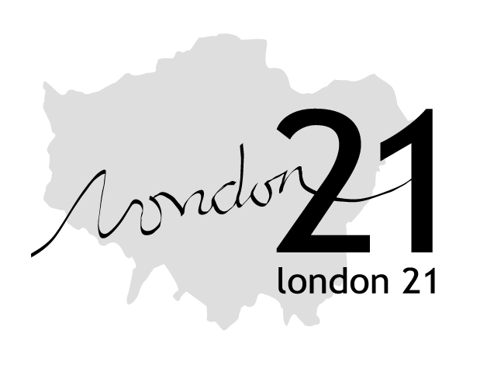  Mapping Change for Sustainable Communities |   

Putting local communities on the map
East London and the Thames Gateway are facing big changes in the coming years. If local people and communities are going to have an influence on what may happen then they need to know what is planned, to understand how any proposed changes may affect them and to feel confident about making their voices heard. Currently many communities don’t have the means to assess and influence decision-making processes.
Many people feel excluded and alienated from the changes that are going on, and if they do go to meetings they report that discussions are too technical and time-consuming. This leads to a situation where many people and groups simply don’t get involved.
That’s a problem for everyone. It leads to developments that don’t meet local needs and don’t benefit from local knowledge. Getting people involved is good sense for everyone. This new project aims to make getting involved a little easier and lot more effective.

What is the project?
Mapping Change for Sustainable Communities is a collaborative project working with communities in East London and Thames Gateway. It will use Internet-based maps to show people what is planned for their neighbourhood, and offer people training and support so that they can develop and use these maps themselves.
The same maps can also show the areas that people are worried about (due to crime, fly-tipping or pollution) and also show what’s being done by local communities and what people want to celebrate. A text message system linked to the maps will offer people up-to-date information about events and meetings in their area, meaning that people won’t miss out on what’s happening because they don’t hear about it.
The project will work with four community groups in the East London and Thames Gateway region. Each community group will develop their own ‘online’ community map reflecting their issues and priorities. Local people will identify their own issues and will be trained in using the relevant technology. The project will offer them access to planning information and advice and lead to a web-based map which they can maintain and develop. Later on in the project, we will open up the system to more communities and allow the creation of many more local maps.
A workshop will be held in each community and will contain various components relevant to different ages and interests. Some of these include:
- Planning information and support from Planning Aid for London
- Emotional mapping – the use of innovative systems to record people’s reactions to their local environments
- A system where local people can receive information about local development/environment issues and events via SMS messages to their mobile phone
- How Internet-maps can be used to share information among the community
At the end of the project each community will have their own map and website that can help them to communicate with new and existing members, increase the outreach of their group and enable the community to organise themselves to deal with development projects

The map and website
The proposed on-line resource and supporting work will help build the knowledge, skills and confidence of local communities and other stakeholders. The main map will cover:
- Major new development plans, with links to the websites of relevant local authority and developer etc.
- Local stakeholder organisations
- Local environmental and social projects
The precise content of the maps will be decided by local people who will be supported to develop them. For major developments they will enable anyone to track what is planned, at what stage the plans are, and how they can become engaged. The main Map will be a resource for those living in and visiting the area.
Supporting resources (especially from Planning Aid for London) mean this will become a one-stop shop for anyone interested in the state of their community. The website will be a lasting resource for the communities, hosted by London 21 and developed by them and other organisations and local communities.

Who will do the work?
This work will be delivered by a team. This includes people from University College London (UCL), the London 21 network, the community themselves and other project partners including the London Thames Gateway Forum and Planning Aid for London.
The map will be based with London 21 who will support it into the future. London 21 is an environmental grassroots network of over 1500 people and organisations in Greater London. London 21 is a registered charity in operation since 2000 and run several projects. These include work on Environmental Inequalities (measuring the quality of local environments), support for Black and Minority Ethnic Groups working on environmental issues as well as the London Green Map. This is an interactive map of green events and organisations all over London and is the basis for the interactive maps in this project. For further information please visit www.london21.org.
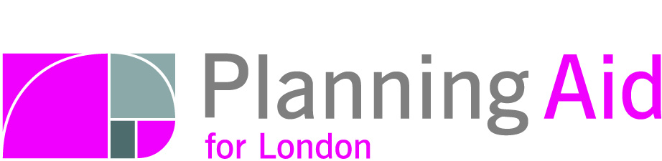


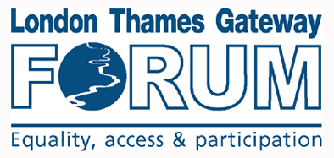
Why use mapping?
www.london21.org www.planningaidforlondon.org.uk www.suscom.org www.ucl.ac.uk www.biomapping.net www.ltgf.co.uk
Mapping is a powerful way to visually represent information. It helps to draw new links and ideas.
The use of interactive mapping is common in academic and business communities but is still new for most communities. The London ’Green Map’ from which this will learn, was the world’s first public interactive on-line green map.
The use of ‘bio-mapping’ will show how subjective information can also be mapped, while the SMS text message system will offer information to a huge potential audience through mobile phones.
The regional map will be a valuable legacy of this work, as will the four local maps developed and owned by local communities.
Who is funding the project?

This project is supported by the UCL-led UrbanBuzz Programme, within which UEL is a prime partner. This is a 2 year programme that aims to develop new ways of delivering genuinely sustainable forms of development and community in London and the wider Southeast region. For more information please visit www.urbanbuzz.org.

Want to know more?
For further information, please contact Louise Francis, Mapping and Development Project Officer at London 21 on 020 8968 4603 or by email communitymaps@london21.org

