UCL
Education & information support division
information systems



Access 2003

Forms and Reports

Document No. IS-008 v2
Contents
Creating Forms 1
Creating a new form 1
Viewing a form in design view 2
Creating a user-defined form 3
Creating a user-defined form 4
Changing The Look of Your Form 5
Moving and resizing 5
Formatting a form 8
Adding and removing controls 8
Changing the tab order 10
Properties 11
Form properties 11
Field control properties 12
Subforms 14
Mainform and subform using the form wizard 14
Mainform with subform using the control wizard 16
Subform properties 17
Creating Reports 18
Create a report with the Report wizard 18
Viewing a report in Design view 20
Editing a Report 21
Changing the look of a report 21
Report and control properties 21
Grouping and Sorting 22
Viewing grouping and sorting properties. 22
Adding grouping and sorting to a report 23
Editing grouping and sorting 24
Adding Unbound Controls 25
Page numbering 25
Date and time 25
Other Reports 26
Creating a user-defined report 26
Creating labels 26
Getting Help with Access 28
Learning more 28

Introduction
This workbook has been prepared to help users who wish to create forms and reports for existing databases. It is aimed at those with some experience of using Access databases and an understanding of database design.
This guide can be used as a reference or tutorial document. To assist your learning, a series of practical tasks are available in a separate document. You can download the tasks and accompanying files and the examples files used in this workbook from the IS training website at: http://www.ucl.ac.uk/is/documents/

Creating Forms
There are many different types of forms that can be created in Access. These include data entry forms, dialog boxes and switchboards. In this guide we will be focusing on data entry forms.
A data entry form can create a more user-friendly interface for viewing, editing and entering data than the default Datasheet view of a table. In a datasheet you see all the records together organised into rows and columns but you cannot necessarily see all the data in all the fields. A form allows you to see one record on the screen at a time and enables you to see all the data in all the fields relating to that record. A form allows you to view objects such as pictures or graphs and to create larger boxes to view data in fields such as memo fields. Forms also allow you to format your data in different ways and to organise data in a record into sections to make it easier to read.

Creating a new form
Forms can be created ‘from scratch’ in Design view. This is known as a user-defined form. A form can also be created using the form wizard. Once a form has been created using the wizard it may be customised to suit your needs.

Creating a form using the form wizard
- From the Database window, select forms in the objects list.
- Double click Create Form by Using Wizard.
- Select the table on which you want to base the form on in the tables/queries box.
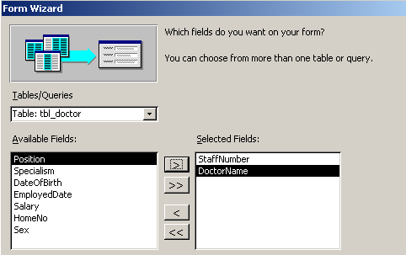
- Select the fields that you want in your form from the Available fields list on the left:
- Click the button to move the field to the Selected Fields box on the right.
- Click the button to move all Available Fields to the Selected fields box.
- Click either the or buttons to remove Selected fields.
- Click Next.
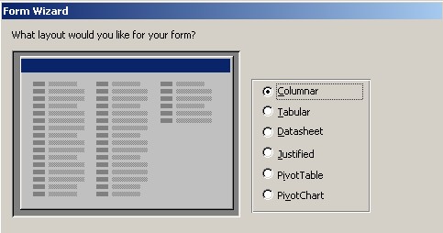
- Select a layout for your form. Click on Columnar, Tabular, Datasheet or Justified.
- Click Next.
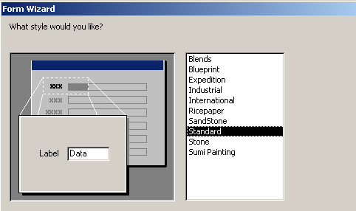
- Select a style for your form.
- Click Next.
- In the final box, type in a name for your form and then click Finish.
- Your new form will be displayed on your screen in Form view with the details of your first record displayed.

Viewing a form in design view
Form view is the view in which you use a form to display and edit data. You can view and customise the design of the form in Design view.
To switch to Design view in your form:
- Click on the Design view button on the toolbar.

To return to Form view and see the form with data displayed:
- Click on the Form view icon on the toolbar.

Sections
The form consists of three main sections which are marked out with a grid:
Detail This is the main part of the form which contains the form controls (see overleaf).
Form header Anything placed in this area of the form will appear at the top of each form.
Form footer Anything placed in this area of the form will appear at the bottom of each form.

Controls
Each of the fields you selected using the form wizard is represented by two controls in the detail section of the form, one of which is a label (which gives the name of the field) and the other of which will depend on the data properties of the field. These include:
Text boxes For Text and Memo fields
Combo boxes For Lookup fields
Check boxes For Yes/No fields
Labels are known as unbound controls because they are not linked to a data source. The field boxes are known as bound controls because they are each linked to a specific field and will display data from that field. When you create a form using the wizard, labels are transparent by default, and therefore have the same background colour and/or pattern as the form, and bound controls are white by default.

The Toolbox
The Toolbox enables you to add new controls to your form. The Toolbox is displayed by clicking on the toolbox button on the toolbar. The buttons you will need for performing the functions covered by this guide are shown in the diagram below:

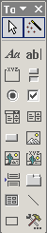
Add a rectangle
Add a picture
Control wizard on/off button
Add a subform or subreport
Add a text box
Add a label
Add a combo box
Add a line

Creating a user-defined form
The easiest way to create a form is by using the wizard and then customising the form as illustrated above. However, you can also create your own, user-defined form from scratch:
- In the Database window, select the Form tab.
- Click on the New button.
- The New form dialog box will be displayed.
- Select Design view.
- Select the table you want to base your form on and then click OK.
- Access will create a blank form with only the detail area visible.
- You can now:
  - Resize the form as appropriate (see Changing the size of a form on page 5).
  - Add fields to your form from the field list (see Adding fields to a form on page 12).
  - Move, resize and format field and label controls (see Moving and resizing controls and Formatting controls on pages 7 and 10).
  - Add Unbound controls using the Toolbox (see Adding and removing controls on page 10).
  - Add Headers and Footers to your form (see Headers and footers on page 6).

Changing The Look of Your Form
Once you have created a form using the wizard, you can make simple changes to it by resizing it and moving and resizing the controls on it. You can change the appearance of the form and its controls by changing the background, fonts and borders. You can also add additional elements to the form such as labels (headings), headers and footers, pictures, lines and rectangles.

Moving and resizing
The form can be made larger and the controls moved around to create more space and make the form more readable. Controls can also be organised into logical groups and resized to make the data or labels more visible.

Changing the size of a form

Changing the height of the Detail section (extending it vertically)
- Move the mouse over the border between the Detail and Footer sections of the form to where a double-headed arrow appears. Click and drag the border upwards or downwards to reduce/increase the height.

Changing the width of the form
- Move the mouse over the right-hand edge of the form to where a double-headed arrow appears. Click and drag the border left or right to reduce/increase the width.

Headers and footers
Form headers and footers appear at the top and bottom of a form when you are in Form view and at the beginning of a printed form. Any controls placed in a header stay on the screen when you scroll down a form. Use a form header and footer to display a title for the form, instructions for using the form, or command buttons that open related forms or carry out other tasks.

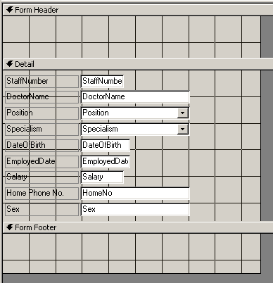
Header bar
Footer bar
Click and drag here to resize the footer
Click and drag here to resize the header
Click and drag here to resize the detail section
Click and drag here to change the width
To display a form header and footer:
- From the View menu, select Form Header/Footer.
- New sections appear at the top and bottom of the form. Anything placed in these areas will be displayed at the top and bottom of the form.
To change the size of the header or footer sections:
- Move the mouse over the lower edge of the header or footer area until a double-headed arrow appears. Click it and drag upwards or downwards to reduce/increase the size of the header or footer.
Helpful hint:
If you have created a form using the wizard, a form header and footer will already be displayed but the heights of these sections of the form will be zero, (i.e. no grid area will be created for them and only the header and footer bars will be visible). Click and drag the lower border of the header or footer bars to increase their size.
You can only add both a header and a footer. If you do not want both, you can size the one you do not want so that it has no height (i.e. a height of zero).

Page headers and footers
Page headers and footers appear at the top and bottom of each printed page. They do not appear in the Form view. Page headers and footers are viewed and resized in a similar way to form ones.

Moving and resizing controls
To move, re-size, delete or format controls, you must first select the control or controls you wish to change and then apply the appropriate changes.

Selecting and moving controls
Select label
Resizing handles
Select field control
Selecting and moving a field with its label:
- Unless they have been ‘detached’, a field control is normally linked to its label and the two can be moved together:
- Click on the field control to select it.
Small black boxes known as handles will appear around the control.
- Move the mouse over the centre of the left-hand border of the field control (not the label) until a black hand appears (see below). Click here and drag the controls to the desired location on the form.

Selecting and moving a label or field control separately:
- Click on the control you wish to move to select it.
- Move the mouse over the top left-hand corner of the control until a hand symbol with a pointing finger appears (see below). Click here and drag the control to the desired location.
Selecting and moving several controls (field or label) together:
- Select one control using any of the methods above.
- Hold down the Shift key and click on any other controls you wish to select. Release the Shift key.
- Move the mouse over the centre of the left-hand border of any of the field controls you have selected until a black hand appears. Click here and drag all the controls to the desired location on the form.

Moving controls to different sections
To move a control to a different section of your form you may need to cut and paste it, rather than drag it to the new location.
Helpful hint:
If a label is ‘detached’ from its field control after it has been moved to another section of the form, the two controls can no longer be selected together by clicking with the black hand symbol as described above. They can, however, be selected using the Shift key as you would to move any two controls on a form.

Resizing labels and fields
- Click on the control to select it.
- Move the mouse over a handle on the control so that a double-headed arrow appears (see below). Click here and drag to resize.
Helpful hint:
You can select more than one control using the Shift key as described in Selecting and moving controls above and then resize one of the controls using the method above. This will resize all the controls by the same amount.

Formatting a form

Formatting controls
Controls can be formatted to change the appearance of the text or the control itself by using the Formatting toolbar:
Alignment
Font formatting
Control Name
Font
Fill, Font and Line colour

- Select the control or controls you wish to change.
(To select more than one control, click on one control, hold down the Shift key and then click on any other controls you wish to select.)
- Click on the appropriate formatting feature on the toolbar (see above) to make the changes you require.
Helpful hint:
You can only apply font formatting and alignment settings to the whole of the text in a control.

Changing the background colour
- Click on the area of the form you wish to format.
- Use the Back/Fill Color button to change the colour.

Adding and removing controls
New controls can be added to your form. These can be unbound (i.e. not containing data from your database) such as text labels or features such as lines, shapes or pictures. They can also be field controls which are bound and contain data from specific fields in the database. These are added to your form using the toolbox.

Creating a label
You can create new labels to add headings to a form or to create subheadings for different groups of fields. You can also use them to add instructions for users of a form.
- Click on the Toolbox icon on the toolbar to display the Toolbox if it is not already displayed.
- From the Toolbox, click on the Label tool .
- Click and drag on your form to draw a label box.
- A flashing cursor will appear in the box. Type the text you wish to include and then click outside the box.

Editing the text in a label
You can change the text which appears in a new label you have created or a label created by the form wizard.
- Click on the label to select it.
- Click within the border of the label. A flashing text cursor will appear.
- Type additional text or edit the text using the keyboard as usual.

Adding other unbound controls to a form
You can add other controls such as lines, rectangles and pictures to your form to create visual impact, divide up areas of the form etc. To do this:
- Click on the Toolbox icon on the toolbar to display the toolbox if it is not already displayed.
- Click on the toolbox item you want to add to your form (see The Toolbox on page 3):
Add a line
Add a rectangle
Add a picture (you will be asked to browse for a file location)
- Click and drag an area on your form to draw the item.

Adding fields to a form
If additional fields are added to the table or query on which the form is based, you may wish to add these to the form itself.
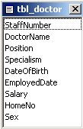
- Click on the Field List icon on the toolbar to display the field list if it is not already displayed:
- Click and drag the appropriate field onto the form.
Helpful Hint:
To update the properties of a field control to match those of the field it is bound to, delete the existing field control and add it again from the field List. Note that this will move the field to the end of the tab order (see Changing the tab order on page 13).

Deleting a control
- Click on the control to select it.
- Press the Delete key on the keyboard.

Changing the tab order
When you use the Tab key to move around a form, it may miss out new fields and other controls that you have added. If you have reorganised your controls, this new order will not be reflected in the tab order.
To change the order:
- With the form displayed on your screen, switch to Design view.
- From the View menu, select Tab Order.
The Tab Order dialog box will be displayed:
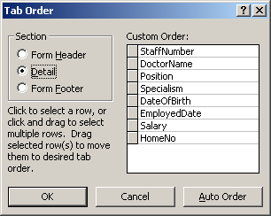
Field Selector box
- Click on the grey Field Selector box to the left of the field name to select it.
- Click and drag the field to the new position you require using the Field Selector box.
Helpful hint:
You can select more than one field by selecting one and then holding down the Shift key while selecting additional fields.

Properties
Each section and control on a form, as well as the form itself, has a set of properties which can be displayed and edited to change the way that part of the form will look and work. There are several ways to display properties:
- Double click on the section or control
- Right click on the section or control and select Properties from the menu.
- Click on the section or control and click on the Properties icon on the toolbar.
The Properties window will be displayed. Once this window is displayed it will remain on the screen until you close it. Selecting a different section or control will change the Properties window to display its properties.

Form properties
To open the Form properties dialog box:
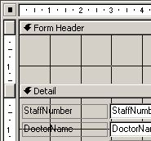
- Click on the Select form button in the top left corner of a form so that a black box appear in the centre of it:
Select form button (form is selected)

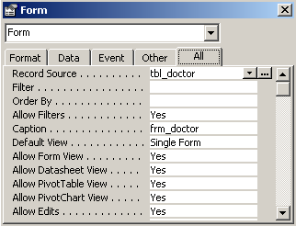
- Click on the Properties button on the toolbar.
The Properties window will be displayed:
- Properties are divided into four sections, with the All tab displaying the full list. Select the All tab and scroll through the list to view the options.

Some of the more useful properties you may wish to change are given below:
Caption
This is the text displayed in the Title bar of the form in Form view. Change the Caption by typing in a new one.
Default view
Forms made using the form wizard are usually created to display one form (one record) on the screen at a time. Changing the default view from Single Form to Continuous Forms using the drop-down list enables you to view more than one record at a time.
Order by
This determines the default sort order of records in form view. By default, the wizard will order the form by the primary key. You can type in a different field to order by that field.

Changing the data displayed by a form

Form record source
The record source of a form is the table or query the form is based on. You can view the record source of a form under the Data tab of the Property window. Change the record source by choosing a different table or query from the drop-down list.
Helpful hint:
If you change the record source of your form, the field controls will no longer work if the same fields do not exist in the table or query, which is the new record source for your form.

Field control properties
When you create a form using the wizard, or add a new field to an existing form (see Adding fields to a form on page 12) many of the properties of bound (field) controls will be determined by the field properties of the field they are bound to. The field properties are determined by the design of the table.
If you change the field properties of a field in table Design view, the properties of the field control you have already created on your form will not necessarily be updated to reflect these changes. However, any restrictions placed on the data allowed in a particular field will always be applied because when you enter data in a form it is passed to the relevant field in the table.
Similarly, you can change some of the properties of a field control on a form and this will not affect your table design. However, you cannot make any changes to the properties of a control which would be inconsistent with the underlying data source to which the control is bound.

Data properties
Data properties can be seen under the Data tab of a field control’s Property window (note that labels and other unbound controls do not have any data properties).

Control source
This is the field to which the field control is linked. The Control source drop-down list will only display a list of fields which are available in the table or query that is the record source of the form.
Other data properties, such as Input Mask, Default Value, Validation Rule, Validation Text and Row Source work in the same way as the field properties in table Design view.

Format properties
Some of the format properties (under the Format tab of the Property window) determine the look of the control itself (size, colour etc.). However, you can use the Format property and the Decimal Places property to control the date and number formatting of controls where applicable.

Other properties

Name
If you have used the Form wizard to create a form, the name of the control is usually the same as the field name. However, if you add a field from the field list, it may have a different name based on the type of control it is (e.g. Combo1). The name is useful if you wish to refer to the value in a control in formulae etc.

Helpful hint:
The type of a selected control is displayed on the Title Bar of the properties window. For example, the properties window below is for a Text Box:
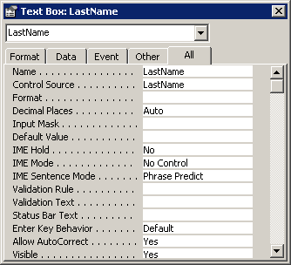

Subforms
When tables have been linked together, it is possible to create a form that will show the information that has been linked together. A Subform is a form within a form. The primary form is called the Mainform and the form within the form is called the Subform.
- The Mainform is usually created from a table that forms the one side of a one-to-many relationship.
- The Subform is usually created from a table that forms the many side of a one-to-many relationship.
- Example of a Mainform with a Subform using the datasheet style:
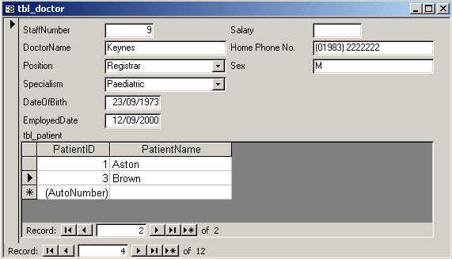
The Mainform is based on tbl_doctor and the Subform on tbl_patient. Only related patient records for the doctor currently displayed (Keane) are visible in the Subform.

Mainform and subform using the form wizard
This option creates two new forms with one appearing as a subform within the other.
With the relevant database open on your screen:
- Create a form using the form wizard and add the appropriate fields from the table on which you wish to base your Mainform on
- In the table/queries box, change the table in the drop-down list from the Mainform table to the one on which you want to base your Subform.
- Select the fields you want to include on your Subform so that they are added to the Mainform fields already selected (see overleaf).
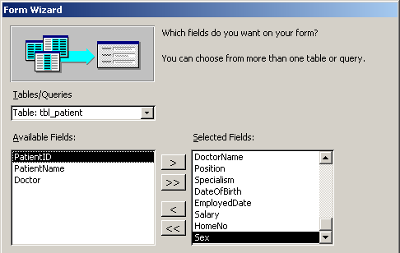
You should now have added the fields you want to include in both your Mainform and your Subform.
- Click Next.
- Ensure the Mainform is selected in the box on the left, and the Form with subform(s) option is checked:
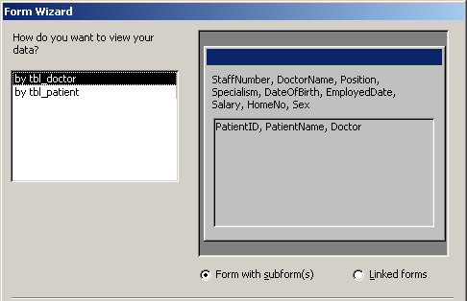
- Click Next.
- In the next dialog box, choose a layout for your Subform.
Select either Tabular or Datasheet, and click Next.
- Choose a style for your Subform, and click Next.
- In the final dialog box, type in a name for your Mainform and Subform, and click Finish.
Your new form will appear on your screen. Use the Navigation Bar at the bottom of the form to view the data on the Mainform. Notice that the data on the Subform changes too.

Mainform with subform using the control wizard
Subforms can be created without using the form wizard. The following method uses the control wizard to add a Subform to an existing form.
- You will need two forms, based on tables that are linked together. Create the two forms if necessary.
- Open the form you want to use as the Mainform in Design view.
- Ensure the Detail area of the form is big enough to enable you to place a Subform on it. Make it bigger if necessary.
- Ensure the Toolbox is displayed (see The Toolbox on page 3) and the control wizard button is switched on.
- From the Toolbox, click the Subform/Subreport button .
- Position the mouse over the form and draw a rectangle where the Subform is to appear.
- In the Subform/Subreport wizard dialog box, select the forms options.
- Select the form you want to use as your Subform from the drop-down list and click Next.
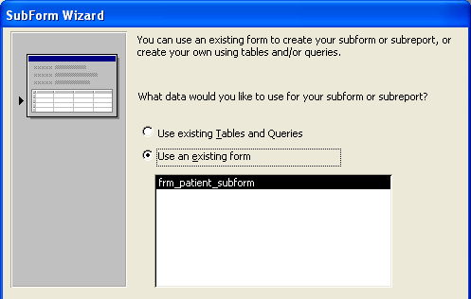
- In the next dialog box, select Choose from a list, and select an appropriate link from the list offered before clicking Next..
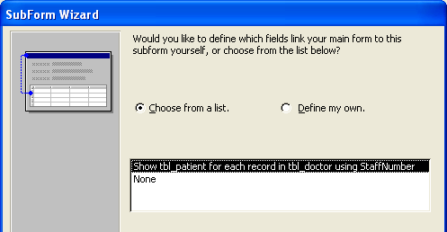
- In the final dialog box, type in a name for your Subform and click Finish.
Once you have created your Subform, you can check it in Form view and resize the Subform area if necessary.

Subform properties
Once you have created a Subform you can view and edit its properties if necessary. These are the properties of the Subform as a control on your Mainform. Click on the border of the control to select it. Click on the Properties icon on the toolbar to view the properties for the Subform and select the All tab:

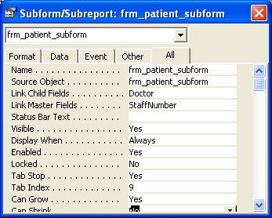
The Name given to the Subform
The Form which the Subform displays.
The Child field: the field in the Subform which links it to the Mainform
The Master field: the field in the Mainform which links it to the Subform
Helpful hint:
Note that you can view the form properties (as opposed to the control properties) by clicking on the form Selector box and then viewing the properties window.

Creating Reports
A report is an effective way to present your data in a printed format because you have more control over the appearance of everything on the report.
Most of the information in a report comes from an underlying table, query, or SQL statement, which is the source of the report's data. Other information in the report is stored in the report's design.
To illustrate your reports, you can add images. To further enhance your reports, you can produce charts from the data held in the tables of your database. Reports can also be used to create mailing labels.

Create a report with the Report wizard
Using the Report wizard is the simplest and fastest way to create a report. The Report wizard speeds up the process of creating a report because it does all the basic work for you. In the first screen of the Report wizard, you can pick the fields you want to include in your report. These fields can be from one table or from multiple tables.
When you use the Report wizard to create a multiple-table report, Access creates an SQL statement behind the report. The SQL statement includes the information about which tables and fields to use. You can also create a query which includes fields from one or more tables and base your report on this. There must be a relationship between the tables in order to create one report from them.
- From the Database window, select reports from the Objects List and double click on Create Report by Using wizard or
- Click on the New button in the Database window and from the dialog box, select Report wizard and click OK:
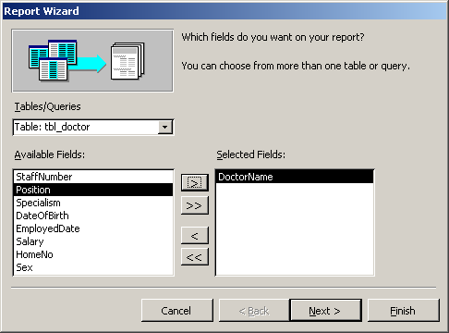
- Select the table or query on which you want to base your report from the table/queries drop-down list. The fields from the table or query will appear in the Available fields box.

- In the Available fields box, select the fields that you want to include in your report and click on the arrow button to move the selected fields to the Selected fields box on the right. Click Next:
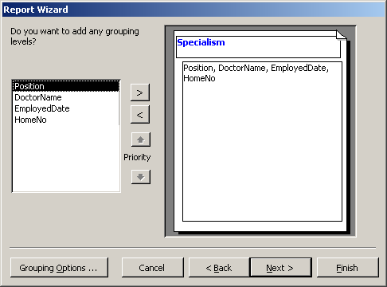
- You can apply Grouping Levels to your report if your wish. Try the different options. Click Next when you are happy with the layout.
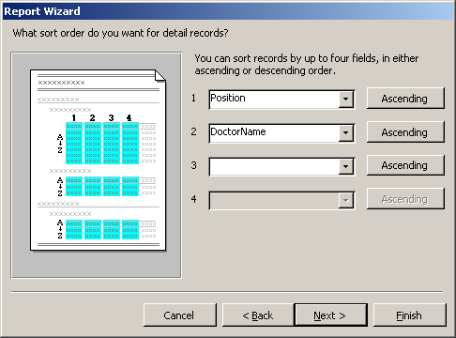
- You have the option to sort by up to four fields, in either Ascending or Descending order. Select the fields you want to sort on, if necessary, and click Next.
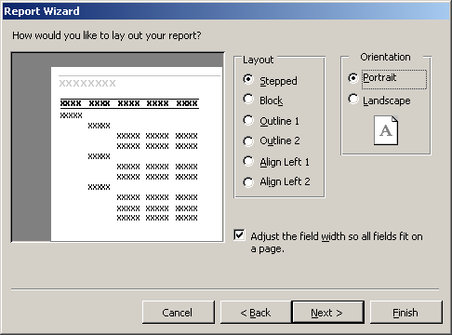
- Choose a layout for your report and select an appropriate page orientation. Click Next.
- Select a style for your report. Click Next.
- In the final Report wizard box, type in a title for your report and click Finish.

Previewing a report
Once a report is created, it is displayed in a Preview screen. To view an existing report, select Report in the Object List in the Database window, select the report you want to preview and click Preview. The report is displayed in Print Preview.
When you position the mouse pointer over the page it becomes a magnifying glass. Click once to zoom in, click again to zoom out from the page. Use the navigation bar at the bottom on the screen to view other pages.

Printing a report
- Preview the report as explained above.
- From the File menu, select Page Setup.
- Set the Margins on the Margins tab and select the page Orientation and Paper Size on the Page tab and click OK.
- From the File menu select Print, enter the appropriate pages and number of copies and click OK.

Viewing a report in Design view
Print Preview is the view in which you view a report as it will be printed. You can view and customise the design of the report in Design view.

Sections
Like a form, a report consists of sections which are marked out with a grid:
Detail: The main part of the report which contains report controls (see Sections, p3)
Report Header: Anything placed here will appear at the top of the report.
Report Footer: Anything placed here will appear at the bottom of the report.
Page Header: Anything placed here will appear at the top of each page of the report.
Page Footer: Anything placed here will appear at the bottom of each page of the report.
The report, page headers and footers can be turned on and off from the view menu.
Helpful hint:
Group headers and footers may also be visible if you added Grouping Levels to your report (see Grouping and Sorting on page 30 for more information).

Controls
These are similar to those on a form (see Controls on page 3 for more details).

The Toolbox
This is similar to the one available in form Design view (see The Toolbox on page 3 for details).

Editing a Report

Changing the look of a report
Once you have created a report using the wizard you can make simple changes to it in a similar way to making changes to the look of a form. See the following sections of this document for more details:
- Change the size of the report (see Changing the size of a form on page 6)
- Add report headers and footers (see Headers and footers on page 6)
- Move and resize controls (see Moving and resizing controls on page 7)
- Format controls (see Formatting controls on page 10)
- Change the background colour (see Changing the background colour on page 10)
- Add and remove controls (see Adding and removing controls on page 10)

Additional note: selecting and moving controls on reports
In reports, the field labels are often placed in the Page Header of the report rather than the Detail section. This is so that the label appears once at the top of the page (like a table column heading) rather than being repeated for each record. This separates the label and its associated field control. (see Moving controls to different sections on page 9 for details of how this affects moving the label and its field).

Additional note: moving a label to a header
You can add a field to a report from the field list as you would in a form (see Adding fields to a form on page 12). By default, the field control and its label will be added to one section. If the field label should be in a header section (e.g. the page or group header) you will need to move the label:
- Click and drag the appropriate field from the field list onto the Detail section of the report.
- Click on a blank area of the form to remove the selection from the field.
- Select the label only by clicking on its top left-hand corner.
- Remove the label from the Detail section using the Cut command.
- Click on a blank area of the header to select it.
- Use the Paste command to paste the label into the header section.
- Click and drag the label to the desired position.
Helpful Hint:
If you accidentally cut both the label and the field control, use the Undo command and try again!

Report and control properties
Report and report control properties are viewed in the same way as form and form control properties.

Report properties
To view or change the Record Source and Caption properties (see Form properties on page 14).

Control properties
These work in the same way as field control properties (see Field control properties on page 15).

Grouping and Sorting
You can sort the records in a report by up to ten fields. Creating multiple sort levels effectively groups your records by each field. For example, if you sort a report containing doctors by specialism and then by position and then by doctor name, all the doctors of a particular specialism will be grouped together and within each of these groups they will be grouped by position and then within each position they will be sorted in order of doctor name.
You can sort records by setting properties in the Sorting and Grouping box. In addition, if you set the group header or group footer property to Yes for a particular field, Access adds a group header and group footer to the report. By placing the field control of that particular field in its group header you can create a heading above each group.

Viewing grouping and sorting properties.
- Open the report in Design view.
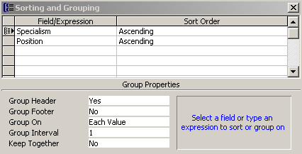
- Click on the Grouping and Sorting icon on the toolbar.
The Grouping and Sorting window appears.
Field with Group Header
Sort Order
Group properties

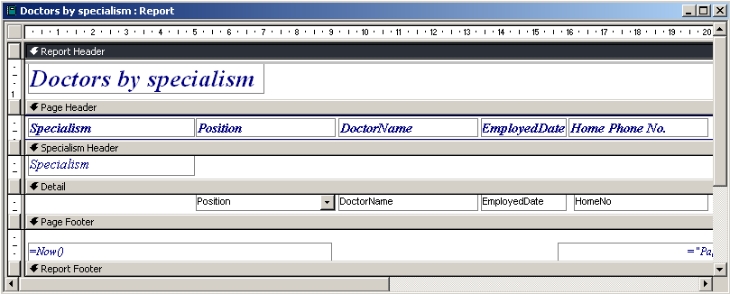
Report with specialism group header (design view)
Specialism
Group Header
Specialism
field control

Report with specialism group header (preview)
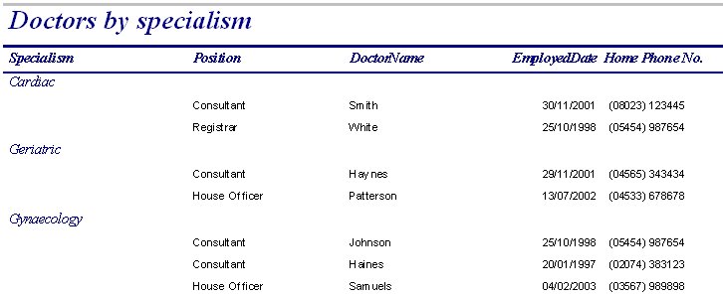
Within each Specialism, records are sorted by Position.
Specialism
Group Header

Group properties
Sort order
- Fields are sorted in the order they are entered in the field list. In the example above, records are sorted first by Specialism and then by Position. All doctors with the same specialism (e.g. Cardiac) will appear together and within each specialism they will be sorted by position. The specialism groups will be in alphabetical order.
Group header
- Fields with group header set to Yes will have a header added for that field. So, in the example above, a header is added to the report for specialism. If the Specialism field control is placed in the group header a heading will appear at the top of each specialism group with the name of the specialism (e.g. Geriatric).
Group on and group interval
- Fields can be grouped on a range of values rather than a specific value. So, for example, grouping could be added to a surname field to group by first letter or to a date field to group by month.
Keep together
- If this property is set to whole group, all fields in a particular field group will appear on one page on the report and won’t be split over two pages. In a multiple column report, this also prevents groups splitting across columns.

Adding grouping and sorting to a report
- Open the report in Design view.
- Click on the Sorting and Grouping icon on the toolbar to display the dialog box.
- Click in the Field/Expression box and, from the drop-down arrow, select the field you want to group on.
- Select Ascending or Descending in the Sort Order box.
- Set the group header and group footer to Yes in the Group properties section.
- To keep each group together on one page, set the Keep Together property to Whole group and close the Sorting and Grouping dialog box.
- Two new sections appear on the report, the Group Header and the Group Footer.
- Place the field on which you are grouping in the new header area. Resize the header if necessary.
Helpful hint:
If the field exists in the Detail section of the report, you can cut and paste it into the Header and move it to the desired position.

Editing grouping and sorting
If you create a report using the Report wizard, Access will automatically group headers based on the grouping levels you set and will also add the sorting order you defined in the wizard. The field controls are automatically listed left to right in the sort order you chose, with any field controls with group headers being placed in their appropriate headers.

Removing a group header
Cut and paste the field control from the Group Header to the Detail section.

Adding a group header
See the instructions in Adding grouping and sorting to a report above.

Changing the sort order
In the Grouping and Sorting dialog box, select the field you want to move and click and drag it to the new position. You will then need to re-arrange the order of the field controls on your report (left to right) to reflect the new order.
Helpful hint:
The form wizard will automatically add different formatting to Group Header fields. You will need to change the formatting of controls to reflect any changes you make.

Adding Unbound Controls
Page numbering and date and time controls are unbound because they are not ‘bound’ or linked to any fields in your database tables. These controls can be added to any section of your report or form but are usually placed in the headers or footers. Once they have been created they can be moved, resized or formatted like any other unbound control.

Page numbering
Page numbering can be added to your reports. The numbering can be positioned in the header or footer. You can just insert just the page number, or the page number and the total number of pages, e.g. 3 of 9.
- In Form or Report Design view, select Page Number on the Insert menu.
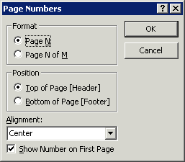
- In the Page Numbers dialog box, select the Format, Position, and Alignment for the page number. For alignment, the following options are available:
Left - adds a text box at the left margin.
Center - adds a text box centred between the left and right margins.
Right - adds a text box at the right margin.
Inside - adds text boxes at the left and right margins. Odd page numbers print on the left and even page numbers print on the right.
Outside - adds text boxes at the left and right margins. Even page numbers print on the left and odd page numbers print on the right.

- To show a number on the first page, select the Show Number On First Page check box.

Date and time
Like page numbering, date and time controls can be added to any section of your form or report.
- In Form or Report Design view, click in the appropriate section of your form or report.
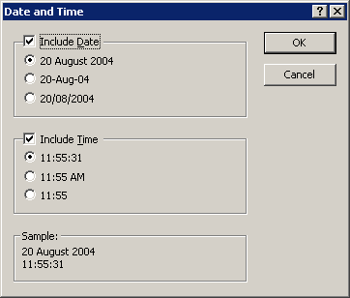
- Select Date and Time from the Insert menu.
- In the Date and Time dialog box, tick the appropriate boxes to include either the date and the time or just the date or time.
- Use the options beneath the Date and Time check boxes to select how you wish the date/time to appear.
- Click OK.

Other Reports

Creating a user-defined report
The easiest way to create a report is by using the wizard and then customising the report as illustrated above. However, you can also create your own, user-defined report from scratch:
- From the Database window, select the Report tab.
- Click on the New button.
- The New Report dialog box will be displayed.
- Select Design view.
Access will create a blank report with a Detail area and Page Header and Footer visible.
Helpful hint:
When you create a user-defined form, Access will prompt you to define the record source (i.e. the table or query on which you wish to base the form). However, when creating a report you need to use the Report properties window to specify the record source (see Form record source on page 15).
You can now:
- resize the report
- add fields to your report from the field list
- move, resize and format field and label controls
- add additional unbound controls using the toolbox
- add grouping and sorting to your report
See Editing a Report on page 28 and Grouping and Sorting on page 30 for more details.

Creating labels
The Report wizard can be used to create printer-friendly pages of labels quickly and easily:
- From the Database Window, select reports from the Objects List and click on the New button.
- Select Label wizard, choose the appropriate table or query from the drop-down list below it and click OK:
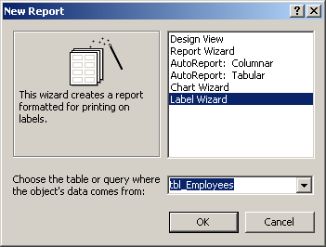
- Select the appropriate label manufacturer and size from the list provided and click Next.
- Choose appropriate font formatting for your labels and click Next.
- Select the fields you wish to include in your labels, adding spaces and using the Enter key to create new lines where necessary. Additional text can be added by typing it in – this text will be repeated on each label. In the example below, the text ‘Department code:’ has been added. Click Next.
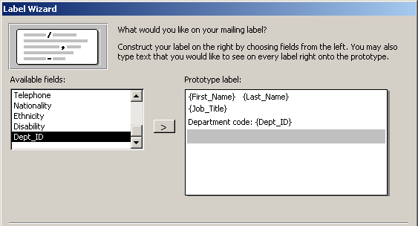
- Choose which fields you would like to sort by. You can choose multiple fields. In the example below, the labels will be listed by Dept_ID and then within each department by Last_Name and then First_Name. Click Next.
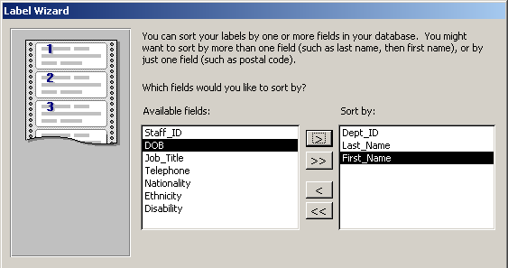
- Name the report and choose See the labels as they will look printed to open them in Print Preview:
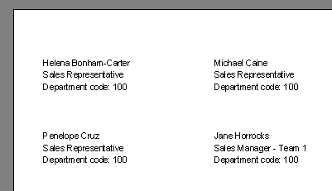

Getting Help with Access
As well as the context-specific help which you can call upon any time you are working with Access (press the F1 key for help with the feature you are working on), there are a number of other resources available to you.

Learning more
Information Systems publishes documents and runs courses to accompany this one as detailed below:
Overview of databases | This 1.5hr course is for those new to databases and is designed to explain the difference between a database and a spreadsheet and to illustrate how you can decide which is most appropriate for your work.
Using Access 2003 databases | This 3hr course will provide an introduction to the main features of Access, and enables you to enter data and extract simple information from an existing database.
Creating Queries in Access | This 3 hr course is aimed at existing users of Access who will learn how to use a variety of criteria and parameters in Queries to extract specific data from one or more Tables. They will also learn how to perform calculations and group data in Queries.

Open Learning Centre
Database development and advanced Access support – this training is delivered in the Open Learning Centre and is intended for those who wish to obtain training, on an individual or small group basis, in specific features in Access or for those who need help designing a database. Please let us know your previous levels of experience, and what areas you would like to cover, when arranging to attend. You will need to book a session in advance at www.ucl.ac.uk/is/olc/bookspecial.htm and sessions will last for an hour or possibly longer, depending on availability. See the OLC Web pages for details of times and how to book at www.ucl.ac.uk/is/olc

Online learning
There is also a comprehensive range of online training in Access 2003 available via TheLearningZone at: www.ucl.ac.uk/elearning

