UCL
Education & information support division
information systems



Access 2003

Using Access
Databases

Document No. IS-002 v2
Contents
Introduction to Microsoft Access 2003 1
Databases and database objects 1
Microsoft Access features 3
Getting help 4
Working with database objects 5
Opening a database 5
Opening objects 5
Saving in Access 6
Copying database objects 7
Closing a database 7
Renaming database objects 8
Grouping database objects 8
Data navigation and entry 9
Data navigation 9
Data entry 12
Data selection and editing 14
Selecting data in tables 14
Selecting data in forms 14
Editing data 15
Copying and moving data 15
Deleting records 16
Using the undo facility 16
Customising datasheets 17
Changing the appearance of a datasheet 17
Re-organising data 18
Sorting records 20
Locating data 21
Using Find and Replace 21
Filtering records in a table or form 23
Criteria 25
Learning more 27
Getting help with Access 27
Courses and Support 27

Introduction
This workbook has been prepared to help you start using Access 2003 databases for data entry and for extracting simple information. It is not intended for those who wish to develop databases from scratch.
Please note that the skills covered in this workbook are a prerequisite for the Developing databases in Access, Forms and Reports in Access and Creating and understanding Queries in Access courses.

How to use this guide
This guide is intended for use as a reference document. It may also be used for self-paced study if used in conjunction with the exercises specifically designed for this course which contain a series of practical tasks in relation to each section of this workbook. It is recommended that you try each of these tasks as you progress through the guide, to assist your learning. The exercises document and associated files are available to download at: www.ucl.ac.uk/is/documents/

Introduction to Microsoft Access 2003

What is a database?
A database is a collection of related data. There are many everyday examples of databases such as: an address book containing names and addresses of friends and families; a card file holding details of business contacts; a filing cabinet holding last year’s financial reports. All these are stores for data, or in other words databases.

What is Microsoft Access?
Access is a software application for managing databases. Access enables you to store, retrieve, organise and analyse data stored in a database.

Databases and database objects
An Access database can be perceived as a file in which different database objects can be stored.
The most fundamental object is the table object: this is where the data is stored in the database. The other database objects, listed below, are tools that allow the user to manipulate the data held in the table.
- A query is a tool that allows the user to request specific data to be gathered from the database.
- A form provides the user with an alternative interface for entering, editing and viewing data.
- A report is a tool for producing formatted printed output from the database.
- A macro is an Object that allows the database to be automated without the need for programming.
- A module is an Object that stores Access code written by the user.
In this course we will be looking at the table, query, form and report objects.

Tables, fields and records
A table is a collection of related data.
Tables organise data into columns (called fields) and rows (called records) as shown below. Each record relates to a single entity (in this example, to a single customer); and each field is used to store a particular piece of information about that customer (in this example, the company name, contact name etc.).
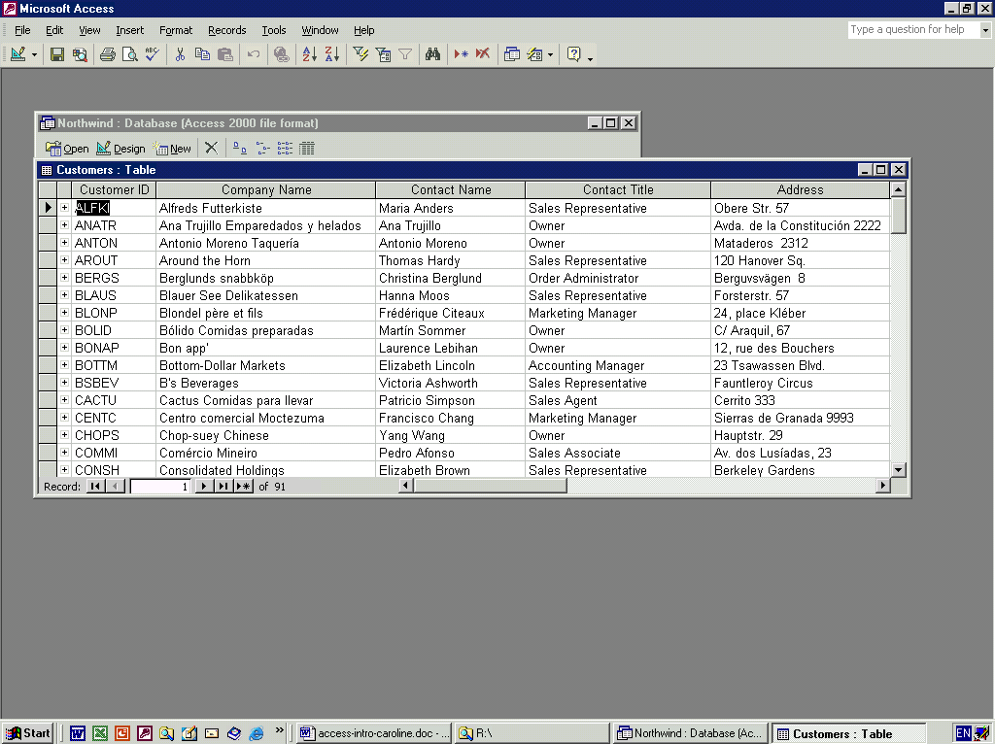
Fields
Records

The Database window
When you open a database, the Database window will show you the various objects (tables, queries, forms, reports, macros and modules) that make up that database.
This window acts as the control centre for the database and is the focal point for all operations involving opening, closing and creating new objects.
Helpful hint:
The Database window remains open at all times. Closing this window will close the database.
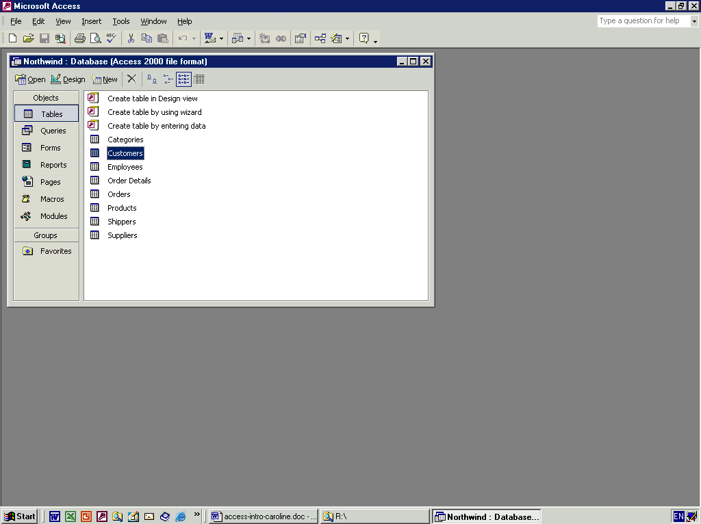
Objects list

WebCT  Vers

Word XP

Word XP AutoSummarize Function  Version 1  July 2003

AutoSummarize Function

ne 2003

WebCT  Version 1  June 2003

WebCT  Vers

Word XP

Word XP AutoSummarize Function  Version 1  July 2003

AutoSummarize Function

ne 2003

Groups bar

WebCT  Vers

Word XP

Word XP AutoSummarize Function  Version 1  July 2003

AutoSummarize Function

ne 2003

WebCT  Version 1  June 2003

WebCT  Vers

Word XP

Word XP AutoSummarize Function  Version 1  July 2003

AutoSummarize Function

ne 2003

Objects bar

WebCT  Vers

Word XP

Word XP AutoSummarize Function  Version 1  July 2003

AutoSummarize Function

ne 2003

WebCT  Version 1  June 2003

WebCT  Vers

Word XP

Word XP AutoSummarize Function  Version 1  July 2003

AutoSummarize Function

ne 2003

Objects bar

Word XP

Word XP AutoSummarize Function  Version 1  July 2003

AutoSummarize Function

ne 2003

WebCT  Version 1  June 2003

WebCT  Vers

Word XP

Word XP AutoSummarize Function  Version 1  July 2003

AutoSummarize Function

ne 2003

Relationship button

Relationships
The tables in a database may be linked to each other by the creation of relationships between specific fields in the database. These relationships can be viewed in the Relationships window:
- Ensure that the Database window is the active window.
- Select Relationships from the Tools menu
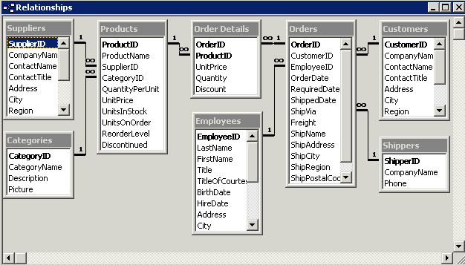
- A new window will open, showing the existing relationships in the database:

Microsoft Access features

Toolbars
The menu commands, in the main Access window, and the built-in toolbars change as you move between different windows in Access, i.e. they are “dynamic”, changing with the current view. The active window determines which commands are available. At times, because the toolbars are linked to specific objects, some of the buttons on the toolbar will appear greyed out. When this occurs these buttons are not available. When you are working with a database it is possible to view the toolbars of your choice at any time:
- From the View menu select Toolbars and then select Customise from the submenu.
The Customise window appears.
- Click in the boxes to mark the toolbars you wish to show.
- Click Close.

Helpful hint:
There is much duplication among the different toolbars.
As you move the mouse pointer over the buttons on a toolbar, a box called a Tool Tip displays the name of each button.

Shortcut menus
Access 2003 offers a number of context-sensitive short-cut menus, which may be accessed by right-clicking the mouse.

Status bar
The Status bar at the bottom of the screen displays status messages on the left and locking keys on the right. The table below describes the abbreviations used to indicate which lock keys are active.

Locking Keys

CAPS | The Caps Lock is on
NUM  SCRL | The Num Lock is on  The Scroll Lock is on
OVR | The Overtype mode is on

Getting help
There are several ways to obtain help from within Access: the Help pane and the Ask a Question list are described here. In Microsoft Office 2003, the online help features have been embedded into the task pane on the right-hand side of the window, which allows a more intelligent and up-to-date help function.

The Help pane
- Help pane – Use Help | Microsoft Office Access Help to display the Help pane in the task pane area as shown. Select the type of help facility you require from the Assistance, Table of Contents or Microsoft Office Online links.
- Assistance – to enter questions in the box labelled ‘Search for:’. Sub topics based on your response will be shown below. The corresponding help pages will be displayed in a pop-up Microsoft Office Online Help window.
- Table of Contents – to find instructions about broad categories, organised like a book’s table of contents. As you chose top-level contents you can see a list of more detailed subtopics from which to choose. The resulting help pages display in the right of the Help window.
- Connect to Microsoft Office Online – to locate specific topics, provide online training and tutorials. You can click the links to go to the Microsoft Office Online Help pages. The online training will be very helpful if you want to learn the office applications systematically. Also, the online community allows you to interact with real people, ask questions and provide answers, or take part in the online discussions. Alternatively use: http://office.microsoft.com/en-gb/default.aspx.

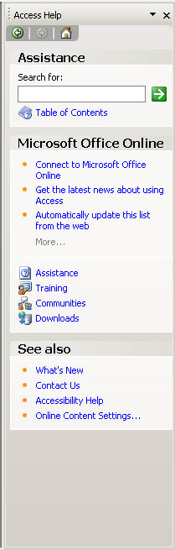
Assistance
Table of contents
Microsoft Office Online

The Ask a Question list
This box is displayed in the upper right corner of the Access window. You simply enter a question in plain English and press Enter.

Working with database objects

Opening a database

- From the File menu select Open .
- Select the file you want to open (check that you have selected the correct drive and folder if you cannot see the file you require) and click on OK.
The Database window for the database you have chosen will appear.
Helpful hint:
Only one database can be open in a particular Access session. Access will automatically close any other open databases when you open another database.
Click on the relevant object type in the list of objects (Tables, Queries, Forms, Reports etc.) on the left-hand side of the Database window to see examples of the different types of objects available (see The Database window on page 2).

Opening objects
Each object you open in a database appears as a separate window, each with a separate taskbar button. The Database window itself also appears as a separate window in this way.

Opening a table
- Click on Table in the list of objects in the Database window (see The Database window on page 2).
- Select the table required by clicking on it and then click on the Open button
or double-click on the table name.
The table opens in Datasheet view.

Opening a form
- Click on Form in the list of objects in the Database window.
- Select the form required by clicking on it then click on the Open button or double-click on the form name.
The form will be opened in Form view.

Opening a report
- Click on Report in the list of objects in the Database window.
- Select the report required by clicking on it and then click on the Open button or click on the report name.
The report will be opened in Print preview.

Views
Objects can be opened in two or more views. The Design view is used for creating and modifying objects. The other views vary according to the type of object. All the objects we will be working with use these other views for viewing data.
Opening an object, as detailed above, opens them in the default view for navigating, entering or modifying data. In the case of a table, this is the Datasheet view. To open an object in Design view, click on the Design View button.
Design view Creating and modifying objects. Viewing an object in Design view is like sitting at a workbench surrounded by useful tools. This view can be used for all the objects.
Tables, Queries and Forms object views:
Datasheet view Looks like a table with grid lines dividing data into rows (records) and columns (fields) (see Tables, Fields and Records on page 1).
Pivot Table view / Pivot Chart view In these views, you can dynamically change the layout of a form to analyze data in different ways. You can rearrange row headings, column headings, and filter fields until you achieve the desired layout. Each time you change the layout, the form immediately recalculates the data based on the new arrangement.
SQL view: Shows queries in Structured Query Language (for Query objects only).
Form view: Each record appears on a separate page (for Form objects only. See below).

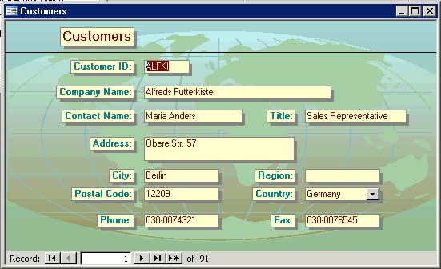

Saving in Access
The Save command is accessed as in other Microsoft Office applications, i.e. via the File | Save command or using the button or Ctrl + S. However, it works slightly differently in Access.
Access automatically saves the data in a record when the focus leaves it. In other words, Access saves a record’s data when you move to a new record; close the active form, table or database; or exit Access.
The Save command does not save data. It is used to save and name new database objects, such as Tables, Forms and Queries. It is also used to save the design, layout, or structure of a database object and replace any previous version.

Save As command
The File | Save As command can be used to save a new database object or to save a copy of the active database object under a different name. You cannot use the Save As command to create a copy of the entire database. To make a copy of a database you must locate the database file using Windows Explorer or My Computer and copy and paste the database to a new location.

Copying database objects
As well as being able to use the Save As command to create copies of objects, you can also create copies of objects using the Copy and Paste commands:
- Right-click on the object you wish to copy.
- Select Copy from the pop-up menu which appears.
- Right-click on a blank area of the database window.
- Select Paste from the menu.
- Type a name for the copied object and click OK.

Closing a database
It is always good practice to close any objects in a database when you have finished working on them and before closing the database. Access does not allow more than one database to be open at a time.
Helpful hint:
The Close command in the File menu closes the active window.

Closing an object
- Switch to the object (e.g. a form or table) window.
- From the File menu select Close or click on the Close button in the top right-hand corner of the window.
You may be prompted to save any changes before closing the file. This refers to any changes you made to the layout of the datasheet or form.

Closing the database window
- Switch to the Database window.
- From the File menu select Close or click on the Close button in the top right-hand corner of the window.
Helpful hint:
Closing the Database window at any time will close the database and any objects that are open.

Renaming database objects
Database objects can be renamed from the Database window:
- Right-click on the object you wish to copy.
- Select Rename from the pop-up menu which appears. The object’s name will be selected and editable.
- Type the new name for the object.
- Press the Enter key to confirm the new name.

Helpful hint:
1. An object cannot have the same name as an existing object of the same type.
2. An object cannot be renamed while it is open.

Grouping database objects
You can organise different types of Access objects into a Group. For example, you can put a form and the queries or tables it is based on into one group. You can also create a group for the forms and reports that you use most often; when you click the icon for that group, both the forms and the reports appear in the object list in the Database window.
A Group consists of shortcuts to the database objects that belong to it. Adding an object to a group does not change that object's original location and all objects of a particular type will still appear when you click on that object type in the object List. For example, when you click on tables in the object list, all tables will be displayed even if they are also part of a group.
Deleting a database object shortcut from a group does not delete the object itself. For example, if you delete a form shortcut from your group, and then click Forms under objects in the Database window, that form still appears in the list of all forms.
There is a group already set up for you named Favorites, but you can create as many of your own groups as you wish.
To create a group:
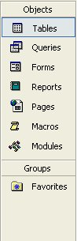
- Press F11 to switch to the Database window.
- If groups aren't displayed, click the Groups bar in the column on the left-hand side of the Database window (see picture).
- Right-click anywhere above the Groups bar, and then click New Group on the shortcut menu.
- Type a name for your group in the New Group Name box.
The new group will appear in the Groups list under the Groups bar.

To add an object to a group:
- Locate the object you want to add.
- Drag and drop the object onto the group name.

Data navigation and entry

Data navigation
This section looks at some of the different ways to navigate through your data. Differences between form and table navigation will be highlighted in this section.
To follow the steps below, you first need to open a form in Form view or a table in Datasheet view. See Opening Objects for more details.
As you move from record to record in a table, the current record is indicated by the record selector symbol and the current field is selected (highlighted in black) or the cursor appears in the field.

Using Go To
This allows you to move straight to the first, last, next, previous, or a new record.
- From the Edit menu select Go To.
- Select the option you require from the submenu.

Using the mouse
You can use the mouse to scroll up and down or left and right within the datasheet using the scrollbars and then to click on the relevant field.
Scroll buttons to move left and right in the Table
Scroll buttons to move up and
down in the Table

Helpful hint:
This function is only available in tables. In forms, the scrollbars are used to view parts of the form which
are not visible if the form is too large for the window.

Using the navigation bar
One of the most efficient ways to move between records in large databases is with the navigation buttons in the lower left-hand corner of the window:
Previous record
First record
Next record
New record

Last record

Click here (or press F5) and type the record number you want and press Enter.

Using the keyboard
You can use various keys on the keyboard to move around the datasheet or form:

Keys | Table action | Form action
↑  ←  ↓  →, Tab,  Enter | One field at a time:  Field above  Previous field  Field to the right  Next field  Next field | One field at a time*  Previous field  Previous field  Next field  Next field  -
End  Home | Move to last field in current record.  Move to first field in current record.
Ctrl + End  Ctrl + Home | Move to last field in last record.  Move to first field in first record.

Helpful hint:
When viewing a form in Form view, the order of movement between fields is governed by the tab order which forms part of the Form design.

Navigation and Editing modes
There are two modes available in the Datasheet view, Navigation mode and Editing mode.
Navigation mode
In Navigation mode, the cursor keys on the keyboard will move you from cell to cell, selecting the entire contents of each cell (see below).
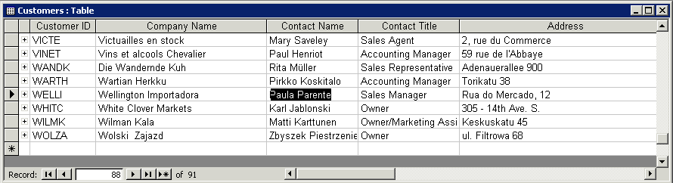

Editing mode
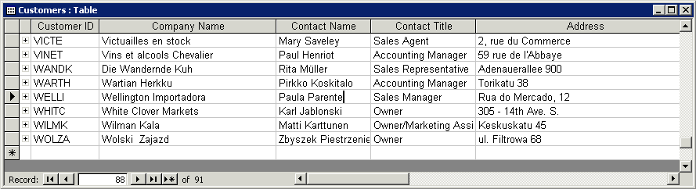
In Editing mode the insertion cursor appears, and the same keys will move you from character to character within a cell (see below).

You can switch between the two modes whilst in a particular cell:
To switch to Editing mode:
- Press F2 or
Click in the cell with the mouse
To switch to Navigation mode:
- Press F2 or
In a table, use the keyboard to move to another cell.

Data entry
This section covers techniques for entering new records in forms and tables.
To follow the steps below, you will first need to open a form in Form view or a table in Datasheet view. See previous sections for more details.

Adding a new record
Every form or datasheet has a blank record which follows the last existing record. If there are no records, the blank record is the only record. This blank record is reserved for new data.
There are a number of ways to navigate to the new blank record at the end of your data including:
- Click on the New Record button in the Navigation bar (see Record selector symbols below) or
- From the Edit menu select Go To and then New Record or
- From the Insert menu select New Record.
Type your data in the first field and press Tab to move to the next field. The record selector symbols change as you work. (See Record selector symbols below for a key to the symbols).
Repeat the step above until you reach the last field. Pressing Tab from the last field automatically moves to the first field of the next record and automatically saves the record.

Helpful hint:
In the case of Autonumber fields, press the Tab key twice to move to the field and on to the next field. Access will automatically create the value in this field. See Primary Key fields under Data Types overleaf for more details.

Record selector symbols
Access displays the following symbols in the record selector (the grey area to the left of each record):
Indicates the current record.
Indicates the blank new record.
Indicates the current record when it is being edited (changed).

Helpful hint:
Depending on the design of the form, the record selector symbol may not be visible.

Saving a record
As you move from one record to another, the data in the previous record is automatically saved. This also applies if you leave the record at any time, for example if you use the mouse to click on a non-adjacent record.

Quitting a record without saving
You can use the Esc key to cancel the current entry if problems arise when inputting data, for example if you receive an error message or make a mistake.
- Press once to leave the current field without saving any changes.
- Press twice to leave the current record without saving any changes.

Data types
The data you may enter in a specific field will depend on the data types and properties of the field. The following information covers some of the common restrictions. Access will display an error message dialog box if you try to break the data entry rules.

Primary key fields
Each record in a database must have a value which is unique to that particular record. This ensures that the record is uniquely identifiable. For example, if the Employees Table had two employees with first name John and last name Smith, the Employee ID would act as a unique reference or ID number. This is known in database terminology as a primary key.
In some cases, this field might be set to be an Autonumber. In this case, Access automatically creates a number to identify the record, starting from the number ‘1’ and working upwards, never using the same number twice. When entering a new record, Autonumber fields can be ignored: Access will automatically create an Autonumber as soon as you begin entering data in the record.

Foreign key fields
These are fields which are linked to a field in another table in order to create a link or relationship to records in that table. For example, the Orders Table contains a CustomerID Field which must contain a CustomerID from the Customers Table. This enables us to know which customer has placed the order and what their details are. It many cases, data entry in a Foreign key field is limited to a value in the field it is related to. In the example above, the CustomerID field in the Orders Table must contain an existing CustomerID from the Customers Table and no other values may be entered.

Date/time fields
Data entered in these fields should be in a standard date or time format, e.g. 31/10/04 or 16:30.

Drop-down lists
Some fields may be set up as drop-down lists known as combo boxes. In this case, you can select an item from the list by clicking on the drop-down arrow or you can type in your entry and Access will offer to complete the entry for you. In some cases the field may be set up to restrict data entry to the drop-down list, in which case you must choose one of the entries on the list.

Required fields
The property for a field may be set to be required, in which case the field can not be left blank.

Data selection and editing

Selecting data in tables
This section describes how to select all or part of the records in a table. Areas that have been selected are highlighted in black. Once an area has been selected it can be edited or deleted as described in the next sections.
To follow the steps below, you will first need to open a table in Datasheet view. See Opening Objects for more details.

Selecting a single record
- Click on the Record Selection button (see below)
Or
- From the Edit menu select Select Record.

Selecting multiple records
Click and drag the pointer down across the record selectors as required (see below).
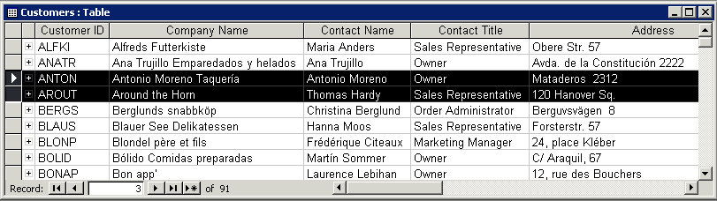
Table selector button
Record selector button

Selecting all records
Position the pointer on the Table Selector button at the top left corner of the table (see above) and click to select the entire table.

Selecting a cell
Position the pointer at the start of the field and, when the pointer is shaped like a white cross, click with the mouse.
Notice that the complete cell, not just the cell contents, is selected.

Selecting data in forms
To follow the steps below, you will first need to open a form in Form view. See previous sections for more details.
To select a record:
- From the Edit menu select Select Record or
- If it is visible, click on the Record Selector button at the left-hand side of the form (see Record selector symbols section).
To select all records:
From the Edit Menu select Select All Records

Editing data
This section covers making changes to existing data in a table or form. When completing the following section, refer to the section on Data navigation, particularly Navigation and Editing modes (page 16).

Part of a field
To replace part of the contents of a field:
- Navigate to the field using any method.
- If you are in Navigation mode (i.e. the contents of the field is selected):
Switch to Edit mode by pressing the F2 key.
- Navigate to the part of the cell you wish to modify and modify the data using the keyboard as detailed below:
Keys to move/edit data within a field in Edit mode
Delete  Backspace  ← / → | Remove one character to the right.  Remove one character to the left.  Move one character left/right.
Ctrl + ← | Move one word to the left.
Ctrl + → | Move one word to the right.
End | Move to the end of the line.
Home | Move to the beginning of the line.

Entire field
To replace the entire contents of a field:
- Navigate to the field using any method except the mouse.
The contents of the field will be selected.
- Type to replace all existing data in the field.
Helpful hint:
If you use the mouse to click in the field, the cursor will be displayed (Edit mode). Press F2 to select the contents (Navigation mode).

Copying and moving data

Single field or part of a field
You can copy and paste all or part of the contents of a field just as you would in any other Microsoft Office application:
- Click and drag the mouse across the text to select all or part of a field.
- If you are in Navigation mode the entire contents of the field will already be selected.
- From the Edit menu select Copy to copy data or Cut to move data.
- To insert the text, move the cursor to a new position, or to replace existing text, select any text you wish to replace.
- From the Edit menu select Paste .

Copying an entire cell
- Select the entire cell (see Selecting a cell on page 23).
- From the Edit menu select Copy to copy the cell.
- Select another cell.
- From the Edit menu select Paste.
Helpful hint:
It is not possible to Cut and Paste an entire cell.

Whole record(s)
You can copy and paste one record or multiple records, either to append as new records in your table or to replace existing records.
- Select the required record(s) (see Selecting data in tables section for more details).
- From the Edit menu select Copy to copy the record(s).
- To replace existing records, select the records you wish to replace, or to append the record, click on the New Record selector.
- From the Edit menu select Paste.
Helpful hint:
When replacing multiple records, there must be the same number of records in the copied selection and the records being replaced.

Deleting records
- Select the required records.
- From the Edit menu select Delete or use the Delete key on the keyboard.
- Click on the Yes button in the dialog box which appears to confirm the deletion.
Helpful hint:
Once you have deleted a record or group of records, you will not be able to retrieve it. For this reason Access displays a warning message when you delete records.

Using the undo facility
Access provides the facility to undo the last change made to the data. The Undo feature is available in the Edit menu. The command may vary according to the change just made e.g. Undo Typing, Undo Current Field, Undo Current Record, Undo Saved Record. Note that, for some operations (deleting records is one example), the Undo facility is not available. However Access will warn you if what you are about to do is irreversible.
- From the Edit Menu select Undo or use the toolbar button .

Customising datasheets

Changing the appearance of a datasheet
You can change the appearance of a table in Datasheet view to make it easier to read and to distinguish one table from another.

Changing the font
When you change the font in a table, the whole table will be affected by the change. It is not possible to change the font for selected text.
- From the Format menu, select Font to display the Font dialog box.
- Choose the Font, Font style, Size, Effects and Colour required.
A sample preview is shown in the Sample box.
- Click OK to confirm your selection and close the dialog box.

Gridlines, cell effects and background colour
The following changes to the datasheet can all be achieved from the Datasheet Formatting dialog box.
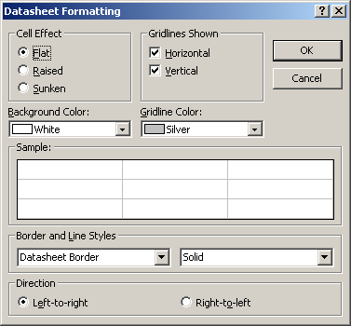
From the Format menu, select Datasheet. The Datasheet Formatting dialog box will appear as shown below:
To hide or display gridlines:
Ensure the Cell Effect option is set to Flat.
You can then choose to display just the horizontal gridlines, or, just the vertical gridlines, or neither. Select or deselect the relevant check boxes.
To change the colour of your gridlines:
Click the drop down arrow button to the right of the Gridline colour box and click on your choice of colour.
You can scroll up or down to reveal more colours.

To add cell effects:
You can enhance the look of your table by selecting Raised, or Sunken from the Cell Effect section.
To change the colour of your background:
Click the drop down arrow button to the right of the Background Colour box and click on your choice of colour. You can scroll up or down to reveal more colours.

Re-organising data
There are a number of ways to reorganise data to make records easier to view. This section covers customising the layout of a table and sorting records.
You can move columns, adjust column width and row height, and freeze or hide column display in the Datasheet view. You may also sort the contents of two or more adjacent columns.

Selecting a column or columns
Click on the Field Selector of the column to select one column (as shown below).
To select multiple columns, click on the first column’s field selector and, without releasing the mouse button, drag the pointer across the field selectors of the other columns required.
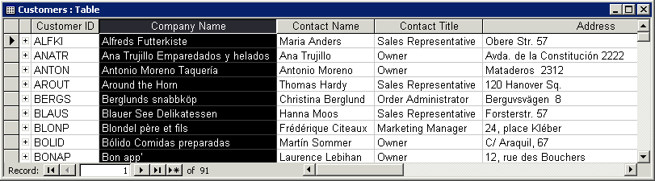
Helpful hint: only adjacent columns can be selected simultaneously.
Customer ID
Field Selector

Moving columns
- Select the column or columns you wish to move.
- Click and drag left or right to the new position.
A bold vertical bar appears to show the position of the column as you drag.
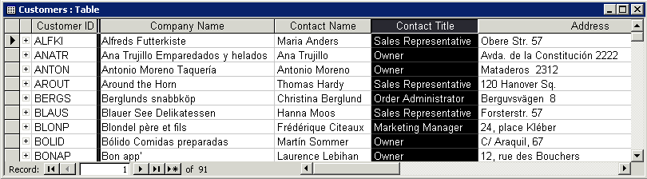
- Release the mouse button when the vertical bar is in the position you require for the field.
Bold vertical bar indicates new position

Changing column width or row height
Navigate to any cell in the column or row to be changed or select the columns to be changed.
Menu method:
- From the Format menu select Column Width or Row Height.
- The Column Width or Row Height dialog box appears displaying the current dimension.
- Type the new width/height required and click OK.
Note that changes to row height affect all rows.
Mouse method:
- Position the pointer in the border to the right of the column to be changed (or in the lower border of the row to change the row height). The pointer changes shape to a double–headed arrow.
- Click and hold down the left mouse button, drag the pointer to the height or width required and release the mouse button.

Column width best fit
- Position the pointer on the right border of the column heading, as above.
- Double-click the left mouse button. The width will be set automatically to fit the widest cell entry currently visible on screen.
Please note, that no best fit method is available for row height.

Freezing and unfreezing columns
In a large Table when all fields cannot be viewed on the screen at one time it is possible to freeze columns so as to prevent them from scrolling off the screen.

Freezing columns
- Select the columns to be frozen.
- From the Format menu select Freeze Columns.
The frozen columns will automatically be moved to the far left of the table.
If no columns are selected when you select this command, Access freezes the column containing the insertion point.
Helpful hint: To move a column which has been frozen it must be unfrozen first.

Unfreezing columns
From the Format menu select Unfreeze All Columns.

Hiding or showing columns
It is also useful to be able to hide columns, to make it easier to focus on the fields (columns) of particular interest.

Hiding a column
- Select the column(s) to be hidden.
- From the Format menu select Hide Columns.

Showing hidden columns
- From the Format menu select Unhide Columns.
- Tick in the columns boxes to be unhidden (displayed) as shown left.

Sorting records
Records in a table or form can be sorted using the Records menu or the toolbar buttons.

Sorting records in a table
In a datasheet you can sort by two or more adjacent columns in a single action. Access always sorts records starting with the left-most column.
- If necessary move a column or columns so that they are in the correct sort order (left to right).
- Select the column or columns you wish to sort on.
- From the Records menu select Sort.
- Select either Sort Ascending or Sort Descending .

Example
The example below shows the Customers Table sorted first by Contact Title (Primary Sort) and then by Company name (Secondary sort) in ascending order. Customers are sorted alphabetically by Contact Title so that all customers with the same contact title appear together. Within each set of records with the same contact title, records are sorted by company name.
Helpful hint: The Contact Title field has been moved so that it is to the immediate left of the Company Name field.

Sorting records in a Form
In a Form you can sort by one field only:
- Click in the field you want to sort by in any record.
- From the Records menu select Sort.
- Select either Sort Ascending or Sort Descending.

Locating data
In a small database, data may easily be located by navigation, but in a larger database a search method is required. Access provides three methods for finding data:
Find: used to locate a record that matches certain values
Filters: used to extract temporarily records matching specified criteria
Queries: again used to extract records matching specified criteria, but they can be saved and re-applied.
This section covers using the Find function and creating Filters in both tables and forms. Differences between the two will be highlighted where relevant.

Using Find and Replace

Locating data using Find
- From the Edit menu select Find .
- The Find dialog box will be displayed
- Type what you are looking for in the Find What box (see below).
- Click on the Find Next button.
- Repeat the step above to scroll through all matching records.
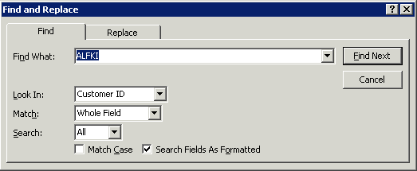

Other options in the Find dialog box
Look In: Allows you to specify which part of the database to search (select the field name to search the field or the table or form name to search all records).
Match: Allows you to specify whether to match Whole Field (the entire contents of the Find What box must exactly match the entire contents of the field) or Any Part of Field (contents of the Find What box must exactly match any part of the field) or Start of Field (the contents of the Find What box must exactly match the beginning of the field).
Match Case: Tick this to find only records where upper and lower case letters match corresponding letters in your Find What box.
Search: Specify whether to search Up (records previous to the current record), Down (records following the current record) or All.

Replacing field contents
It is possible not only to search for your data but also to replace that data with an alternative. This allows changes to be made quickly and easily.
- From the Edit menu select Replace.
The Replace dialog box will be displayed (see below). Notice the similarities with the Find dialog box.
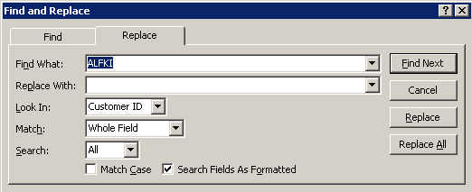
- Complete the dialog box as for the Find dialog box (see previous page) to specify the text you wish to find.
- Enter the new text (with which to replace the text in the Find What box) in the Replace With box.
- To replace specific instances of the search term:
- Use the Find Next button to scroll through your records.
- For each item you wish to change, click on Replace.
To replace all instances of the search term:
- Click on Replace All.

Helpful hint:
Use the Replace All command with extreme caution. You cannot undo the Replace All command.

Filtering records in a table or form
Filters and queries are tools that can be used to create a custom view of your data that includes or excludes records according to specific criteria. A Filter can be used to temporarily change the set of records you are viewing while a table or form is open.
Unlike the Find function, which only operates on one criterion, Filters enable you to generate lists of records based on several criteria in one or several fields.

Filter by selection
This Filter displays only those records that have a specific value in a particular field.
- Click in the field containing the value you want to find.
- From the Records menu select Filter and then Filter by Selection .
Only records which contain the same value in the same field as the one you selected will be displayed and all other records will be hidden.
Example
Click in the Surname field of a record where the surname is ‘Smith’ and then use the Filter by Selection command. Only records with the word Smith in the Surname field will be displayed.

Helpful hint:
When records are filtered, ‘(Filtered)’ appears next to the total number of records at the bottom of the datasheet or form.

Filter excluding selection
This filter excludes records that have a specific value in a particular field.
To apply this filter, follow the instructions for Filter by Selection (above) but select Filter Excluding Selection from the Filter submenu.

Filter by form
Here you select values in the required fields to filter data in several fields.
- From the Records menu select Filter and then Filter by Form, or click on the toolbar button .
- A blank datasheet (when filtering a table) or form (when filtering a form) will appear with a Look For tab at the bottom.
- The filter form will usually display the most recent criteria entered. To ensure that all previous criteria have been cleared before creating a new filter, select Clear Grid from the Edit menu, or click on the toolbar button .
- Type any criteria you want to match in the relevant fields. Typing criteria in more than one field will mean that records will have to match all the criteria you enter.
- To add alternative criteria that the records could match, click on the Or tab at the bottom of the form or datasheet. A second form or datasheet will appear for you to enter additional criteria.
- From the Filter menu select Apply Filter/Sort, or click on the toolbar button .
The records that match the criteria you have specified will be displayed.

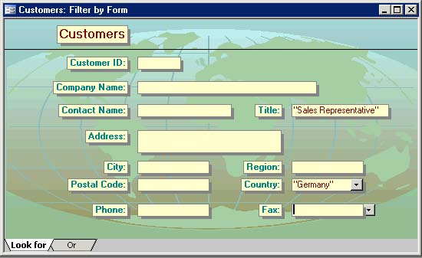

Example
- Click on object forms and open the form Customers.
- Use Filter by form from the Records menu.
- Type ‘Sales Representative’ in the title field and ‘Germany’ in the country field (see the screen capture above).
- Click on the Or tab and type ‘UK’ in the country field.
- Apply the filter.
- This Filter will display sales representatives from Germany and all customers from the UK.
Helpful hint:
Access automatically places double quote marks “” around criteria text. For more information about using criteria, see Criteria on page 39.

Removing a Filter
From the Records menu select Remove Filter/Sort or use the toolbar button .
All records are displayed.

Helpful hint:
Filters are temporary and are not saved with the table or form.

Criteria
Given below are a range of some of the possible criteria that can be used in queries and filters. This is by no means an exhaustive list – see Access Help for more information.
Note that in certain fields it is only possible to define criteria matching the data type in that field. For example, it is only possible to specify a particular date or range of dates in a date field and to specify a particular number or range of numbers in a number field. Access will warn you if you attempt to enter an inappropriate criterion in a field.

Dates and numbers
To find records matching a specific date or number or a range of dates or numbers:
To find: | Type: | Example | Displays:
Exact match | [date or number] | 14/02/03 | 14/02/03
Greater than | >[date or number] | >100 | 101 and up
Less than | <[date or number] | <100 | up to 99
Greater than or equal to | >=[date or number] | >=14/02/03 | after and including 14/10/03
Less than or equal to | <=[date or number] | <=100 | up to and including 100
Within an inclusive range | between [date or number]  and [date or number] | Between 1 and 5 | 1, 2, 3, 4, 5

Text
To find records which contain certain text (a particular word or words or combination of letters).
To find: | Type: | Example | Displays:
Exact match | [text] | Cat | Cat
Text begins with [text] followed by any letters. | [text]* | Ca* | Cat and Canary
Text occurs anywhere within the field | *[text]* | *Sales* | Assistant Sales Agent, Sales Manager etc.

Null fields
To find records for which a certain field is blank:
Type ‘Is Null’ in the relevant field.
To find only records for which a certain field contains data (isn’t blank):
Type ‘Is Not Null’ in the relevant fields.

Exclusion
To find fields which don’t match certain criteria add Not to the front of the criteria.
This can be used for text, dates or numbers.

Examples
Not *Manager*:Finds records for which a field doesn’t contain ‘Manager’ anywhere in the field.
Not 14/10/03: Finds records for which a field doesn’t exactly match the date 14/10/03.

Acceptable syntax
Access automatically places double quote marks “” around text and hash # symbols around dates entered in the criteria line, but numbers are not changed. Access will also add the word “Like” to any expressions including an asterisk *. To save time when creating queries it is more usual to leave out these symbols and allow Access to add them.
To ensure that Access recognises dates correctly, they should always be written in an acceptable format. Access recognises dates in a number of formats but it is recommended to use dd/mm/yy (e.g. 25/12/03) or dd/mm/yyyy (e.g. 25/12/1795) as standard.

Learning more

Getting help with Access
As well as the context-specific help which you can call upon any time you are working with Access (press the F1 key for help with the feature you are working on), there are a number of other resources available to you.

Courses and Support

Workbooks and central trainer-led courses for UCL staff
Information Systems publish documents and run courses for staff to accompany this one as detailed below:
Overview of databases | This 1.5 hr course is for those new to databases and is designed to explain the difference between a database and a spreadsheet and to illustrate how you can decide which is most appropriate for your work.
Developing databases in Access | This 3 hr course introduces the concepts of database design and teaches users of Access how to design tables, set field properties and create relationships between tables.
Forms and Reports in Access | This 3 hr course teaches users of Access how to design and modify their own Forms for data entry and how to create and modify simple Reports.
Creating Queries in Access | This 3 hr course is aimed at existing users of Access who will learn how to use a variety of criteria and parameters in Queries to extract specific data from one or more Tables. They will also learn how to perform calculations and group data in Queries.

These workbooks are available for students at the Help Desk.

UCL staff Open Learning Centre
Database development and Advanced Access support - This training is delivered in the Open Learning Centre and is intended for those who wish to obtain training, on a individual or small group basis, in specific features in Access or for those who need help designing a database. Please let us know your previous levels of experience, and what areas you would like to cover, when arranging to attend. You will need to book a session in advance at http://www.ucl.ac.uk/is/olc/bookspecial.htm and sessions will last for an hour or possibly longer depending on availability. See the OLC web pages for details of times and how to book at http://www.ucl.ac.uk/is/olc

On-line learning
You can continue to expand your knowledge of Access by using the on-line learning provided for UCL staff and students. See the Learning Zone web pages for full details of how to register and use this facility at http://www.ucl.ac.uk/elearning

