UCL
Education & information support division
information systems

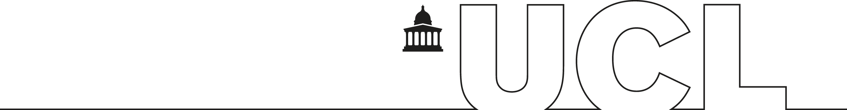

Dreamweaver MX 2004

Creating and Maintaining Websites

Part two

Document No. IS107
Contents
Hyperlinks 1
Linking to content on the same page 1
Advanced images 2
Inserting images into a table 2
Image placeholders 2
Linking from thumbnails to larger images 3
Advanced properties of images 3
Editing an image 4
Using image maps 4
Creating a photo album 5
Stylesheets 6
Overview 6
The CSS language 6
Editing CSS in Dreamweaver 7
Attaching stylesheets 7
Detaching stylesheets 8
Creating new stylesheet commands 8
Applying custom styles to your page 10
Editing stylesheet commands 10
Auto-create styles 10
Advanced CSS topics 11
Templates 13
Overview 13
Applying a template 13
Creating a template 15
Editable regions 16
Image placeholders 17
Adding a “last updated” date 17
Updating a template 18
Stylesheets and templates together 18
Detaching a page from a template 18
Group-managing a site 19
Check In/Check Out 19
Integration with Fireworks, Flash and Word 20
Integration with Fireworks MX and Flash MX 20
Using Microsoft Word generated Web pages 20
Tables 22
Nested tables 22
Terminology 23
Appendix 1 24
Setting up your remote folder at UCL: 24
Connection settings 24
Learning More 25
Getting help with Dreamweaver 25

Introduction
This workbook follows on from “Creating and Maintaining Webpages Part One”. As mentioned in Part One it is recommended that anyone working with websites using Dreamweaver should attend both Part One and Part Two in order to produce and maintain professional looking websites.
This guide can be used as a reference or tutorial document. You can download the tasks and accompanying files and the example files used in this manual from the IS web site at: www.ucl.ac.uk/is/documents/

Hyperlinks
Most of the link types are covered in Creating and Maintaining Webpages Part one workbook – the only type not covered, which is described below, allows you to link to predefined sections on the same Web page.
Helpful hint:
You should save the page you are working on before you create hyperlinks.

Linking to content on the same page
When possible, long pages that require a lot of scrolling should be avoided by splitting the content over several separate Web pages. If it is necessary to present all the content on one page, it is a good idea to divide the page into sections and then provide links at the top of the page to each section. A link back to the top can then be inserted from each section, so users can quickly return to the page navigation. This saves the user having to waste time scrolling up and down the page to find a specific section of content.
To insert a link to a particular point on the same page you first need some way of identifying that point. This is done using “named anchors”. Creating these named anchors and then linking to them is a straightforward process:

Creating a named anchor
- Select the point on the page to be linked to.
- From the Insert menu select Named Anchor. The following dialog box is displayed:
- Type in a relevant name for the anchor and click on OK.
- The anchor point will be marked by an icon in the design area, as shown on the right.
- Clicking on this icon will show you the anchor’s name in the Properties Inspector and allow you to change it if necessary.
Helpful hint:
Because anchors act as links it is best to stick to the rules associated with file names – i.e. all lower case, no spaces and no odd symbols.

Creating a link to a named anchor
- Select the text or image that will act as the link.
- In the Properties Inspector, click in the Link box.
- Type in a hash (#) followed by the name of the anchor. For instance, to link to the anchor in the previous example, if you had named the anchor coffee, you would type: #coffee in the link box.
- Alternatively, you can use the target icon to click and drag to create an anchor link. Instead of dragging the target to a file, drag it to the yellow anchor symbol in the design area.
- Linking to an anchor point on another page is also possible. Insert the link to the page as usual, then in the link box simply append a hash and the name of the desired anchor point. So to link to the coffee anchor on a page named recipes.htm the link box should contain: recipes.htm#coffee
Helpful hint:
Normally when clicking on an anchor link the page is scrolled so the anchor point is moved to the top of the page, however, this is not possible when the anchor point is set near the bottom of the page and the browser can’t scroll any further down. In this case if you want the anchor point to appear at the top you will need to insert several paragraph breaks at the bottom of the page to make room for the page to scroll further.

Advanced images
Images are an almost integral part of Web page design. Not only are they used as content, but images can also serve as links, just like text. The Web supports three types of image formats:
- JPG files (normally photos)
- GIF files (often logos, images with large areas of flat colour or images with very few colours such as line-art)
- PNG files (a format that combines some of the merits of JPGs and GIFs).

Inserting an image from the Insert Bar
- Position the cursor at the point where you wish the image to be placed.
- Click on the Insert Image icon on the Insert Bar. The Select Image Source dialog box is displayed.
- Locate the image that you wish to insert and click on OK.

Inserting images into a table
Inserting images into tables is similar to inserting images elsewhere on a Web page. Position the cursor at the point in the table where the image is to go, and click on the Insert Image icon on the Insert Bar.

Image placeholders
Placeholders are useful in a couple of situations: if you’re waiting for an image to be prepared but want to get on with positioning elements on the page, and when you’re not sure how big you want an image to be.
- Click at the point where you want your image to be inserted.
- Go to the Insert menu | Image Objects | Image Placeholder.
A menu will pop up asking you to define the image’s properties (most of these will be carried across to the final image when it is inserted):
- Name: This is a name which identifies the image within the Web page. Each image on the same page should have a unique name.
- Width and Height: These define the size of the placeholder. If you know the size of your image enter its width and height here.
- Color: This is simply the colour of the placeholder. If you know the overriding colour of the final image use a matching colour here so you can see whether the image is likely to clash with colours on the rest of the page.
- Alternate text: A very important property, which is used to describe the content of the image, thus rendering it meaningful to those who can’t see it – i.e. those using text only browsers or screen readers.
Once you have defined these properties, click on OK and your image placeholder will have been created. A box will appear at the selected point allowing you to continue laying out the rest of your page’s content. This placeholder can also be resized until you are happy with its dimensions – you can then use these dimensions to resize the final image in a graphics editing package so that it fits your layout perfectly.
When you want to replace the placeholder with the final image, simply double-click on the placeholder and navigate to the desired image file. Note that the dimensions of the final image override those of the placeholder, so if these don’t match, the final image’s dimensions will be used.

Linking from thumbnails to larger images
If you need to display a series of large images you should avoid putting too many on the same page, otherwise the page will take a long time to load, perhaps to the point that the user becomes impatient and decides not to wait. A better alternative is to create smaller versions of the images (often referred to as thumbnails) and insert these onto a page. You can then link from the thumbnails directly to the full size images or to a page that contains the image.
Thumbnails can be created by resizing the images in software such as Macromedia Fireworks or Adobe Photoshop. Some software will allow you to create thumbnails from multiple images in one go, while others will require each image to be resized separately.
Helpful hint:
When creating thumbnails, make sure you name your files appropriately, in order to distinguish between the thumbnails and the originals. For example, for an original image called holiday.jpg, you might want to name its thumbnail holiday_small.jpg, then rename the original holiday_large.jpg. It’s also a good idea to organise your thumbnails and full size equivalents into separate folders within your site.
Once your thumbnails are ready insert them into your page using the normal method of adding images: click on Insert | Image on the menu bar or from the Image icon on the Insert Bar, and browse to the thumbnail image from the appropriate folder. Once you have added the thumbnail to your page, select it, and in the Properties Inspector, for the Link property, use the Browse for File or Point to File buttons to choose the original (larger) version of the same image, or a Web page that contains the full size image.

Advanced properties of images
When an image is selected, by default the Properties Inspector will appear in a collapsed state, as shown below:
However, when you click the expand arrow at the bottom right, the Properties Inspector will expand to show more advanced properties, as shown below:
These include properties and tools for creating and defining image maps, as well as other advanced properties. While we will cover image maps in the next section, the other properties are as follows:
- V Space – This creates space around the top and bottom of the image.
- H Space – This creates space around the left and right sides of the image.
- Target – This property applies to image maps (and links) and is addressed in the next section.
- Low Src – In some cases, the image you are using may have a large file size. Using the Low Src property, you can choose another significantly smaller image to load in its place when the Web page first loads, while the main image is still loading. In the meantime, the smaller image acts as a placeholder.
- Border –This allows you to set a border around the image in pixels.
- Align – This aligns the image in relation to other elements on the same line or in the same paragraph. The two most likely to be useful are Left and Right which can be used to wrap text around an image.
- The three horizontal align buttons align the image, and any other content on the same line, to the left, centre, and right side of the page, respectively.

Editing an image
There are new features in Dreamweaver MX 2004 which allow you to edit an image in Dreamweaver rather than in a specialist graphics application such as Photoshop.
The edit options are highlighted below:
Edit – This opens up your image in the default image editing package (probably Microsoft Photo Editor).
Optimise in Fireworks – To edit the image for the use of Fireworks (beyond the scope of this course).
Crop – You edit images by reducing the area of the image. Usually you will want to crop an image to place more emphasis on the subject of the image, and remove unwanted aspects surrounding the center of interest in the image.
Resample – Adds or subtracts pixels from resized JPEG and GIF image files to match the appearance of the original image as closely as possible. When a image is resampled, pixels are added to or removed from the image to make it larger or smaller. Resampling an image to a higher resolution typically causes little loss of quality. Resampling to a lower resolution, however, usually causes a drop in quality.
Brightness and contrast – Modifies the contrast or brightness of pixels in an image. This affects the highlights, shadows, and midtones of an image. You typically use Brightness/Contrast when correcting images that are too dark or too light.
Sharpness - Adjusts the focus of an image by increasing the contrast of edges found within the image. When you scan an image, or take a digital photo, the default action of most image-capturing software is to soften the edges of objects in the image. This prevents extremely fine details from becoming lost in the pixels from which digital images are composed. However, to bring out the details in digital image files, it is often necessary to sharpen the image, thereby increasing edge contrast, and making the image appear sharper.

Using image maps
Image maps allow you to use a single image to link to multiple pages (and to named anchors as well). To achieve this hotspots are defined on the image and each of these is then given a link property. To avoid confusion it is important to ensure the image has clearly defined areas that can act as links and that these areas make it clear what they’re likely to link to. For example the image may be a map of the world with each continent acting as a link to pages relevant to people in those areas.
The tools for creating image maps are conveniently located on the Properties Inspector when you select an image on your page, as shown below:
Rectangular, Oval and Polygon hotspot tools

pointer hotspot

With an image selected, to insert a hotspot, click on an appropriate shape (Rectangular, Oval, or Polygon). Then for rectangles and ovals simply click and drag to create the hotspot. For polygons click at several points around the desired area (think of it as ‘joining up the dots’) and a hotspot will be created. Several hotspots can be created in the same image though it is best to avoid overlapping hotspots.
The Pointer Hotspot Tool has several functions. It is used: to select a hotspot and adjust its properties; to
move a hotspot by clicking and dragging inside the hotspot; to resize a rectangular or oval hotspot by clicking and dragging on its control points; and to edit the position of existing points in a polygonal hotspot.

With a hotspot selected, the Properties Inspector will change allowing you to enter several properties:
- Link – Enter a link as you would normally. This contains a hash symbol by default because image maps are more commonly used to link to named anchors, but any kind of link (to internal or external Web pages, documents, e-mails etc.) can be used.
- Map is similar to the name property for images, in that it assigns a name to the image map.
- Target allows you to define where you want to display the page you have defined in the Link property. The most useful options is _blank, which will cause the link to open in a new browser window. The other options are related to the use of frames.
- Alt – It is essential that you insert some Alternative text for each hotspot in order to ensure that users of text–only browsers or screen readers know where the link will take them.

Creating a photo album
Creating a ‘Web photo album’ by hand can take time but there are quicker ways of achieving this. Both Dreamweaver MX2004 and Photoshop Elements have tools to create online photo albums automatically (though Dreamweaver does require that Macromedia Fireworks is also installed so this won’t work on WTS).
Detailing the use of these tools is beyond the scope of this workbook, but it is relatively straightforward. To launch the tools:
In Dreamweaver MX2004 – Commands | Create Web Photo Album
In Photoshop Elements – File | Automate | Web Photo Gallery

Stylesheets

Overview
Stylesheets are used to define how a document such as a Web page should appear.
You will have learnt previously how to create a Web page, with h1 headings, h2 headings, paragraph text, and so forth. These will by default have taken on the standard appearance for HTML headings and paragraphs. With stylesheets, we can define the global appearance of pages across our whole site, for example, that h1 headings should be green and centred on the page, or that each Web page should have a one-inch margin.
Advantages of using stylesheets include:
- A set of styles can be defined in a stylesheet file, and can then be applied to any number of separate Web pages. This is a huge advantage, because it makes website maintenance much easier. A change to a single file can update the visual presentation of every page in a website, making it easy to maintain a consistent appearance.
- One set of commands can apply when a Web page is displayed onscreen, and a different set of commands can apply when a Web page is printed. In other words, a Web page may appear with dramatically different formatting when printed out.
- The content of a Web page can be completely separated from its presentation. The Web page contains the content, and the stylesheet contains all the presentation information. This makes it more straightforward to update content without affecting presentation, and vice versa.
- People who have difficulties reading ordinary Web pages can opt to use their own stylesheet instead of the one you have specified. Their stylesheet might ensure that the text is large enough to read, or that the combination of background colour and text colour is one that makes it easier for them.

The CSS language
The language used for stylesheets is CSS, which stands for Cascading Style Sheets. The style commands in CSS are cascading in a number of ways:
- Firstly, CSS formatting commands cascade down in that their specifications apply according to the point at which they are specified, and can be overridden by later commands. If we had a CSS command saying “all h1 headings should be green and centred on the page”, and immediately afterwards a CSS command saying “all h1 headings should be blue”, then the “green” part of the first command would be overridden. The “centred on the page” part of the first command would not be overridden – it would cascade down, meaning that all h1 headings would be displayed as blue and centred on the page.
- Secondly, CSS commands cascade in terms of the specificity of the command. If we have one command which says “all paragraphs should be in the Arial font”, and one which says “all paragraphs of class 'cpara' should be in Courier font”, then the second command would win out when deciding how a paragraph of class 'cpara' should be formatted, because it is more specific.
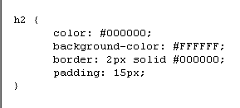
CSS commands are normally stored in a file with the extension .css – this is actually a simple text file, and you can create and edit CSS with any text editor. A CSS command typically looks like this:
This example specifies formatting for level-2 headings (h2). It sets the font colour to black and the background colour to white, specifies that these headings should have a 15-pixel-thick area of padding around them, and a solid black border around.
Dreamweaver has many built-in features for working with stylesheets, and for most purposes you do not need to type CSS commands yourself. From this point on we will be using Dreamweaver’s CSS facilities where possible.

Editing CSS in Dreamweaver
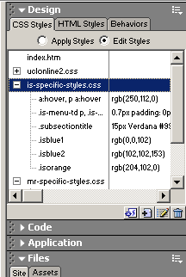
In Dreamweaver you can edit CSS files directly – if you double-click on a CSS file, Dreamweaver will open it for editing as if it were a normal text file. More commonly, you will use Dreamweaver’s CSS features while working on a Web page.
Dreamweaver’s Design panel allows you to edit the styles that are in use in the Web page you’re currently editing. Make sure the Design panel is visible, that the CSS Styles tab is selected, as shown below.

Dreamweaver’s Design panel
In the example on the right, the Web page we are editing has three CSS files attached. The entry for the second CSS file is expanded, showing the style commands it contains.
Alternatively, you can see stylesheet options in a dialog box, by choosing the menu option Text | CSS Styles | Edit Style Sheet as displayed below:
In this document we will be using the first of these methods (i.e. the Design panel).

Attaching stylesheets
Often you will be working on a new or existing Web page, and will want to apply stylesheet commands which are already defined in a CSS file located in your website.
To attach a stylesheet to a Web page you are currently editing:
- Right-click on the Design panel and choose Attach Style Sheet. A dialog box appears for you to choose which stylesheet file to attach. See opposite:
- Navigate to the folder containing the style sheet file.
- Select the file from the list of files (stylesheet files end in the extension .css).
- Click Select.
The name of the newly-attached stylesheet will appear in the Design panel, and the Web page’s appearance will be updated to reflect the commands contained in the stylesheet.

Detaching stylesheets
To detach a stylesheet from a Web page, right-click on its name in the Design panel and choose Delete (see opposite).

Important:
Choosing Delete in the Design panel does not delete the stylesheet file! It detaches it from the current Web page.

Creating new stylesheet commands
To create a new CSS rule, right-click on the Design panel and choose New CSS Style.
The New Style dialog box appears:
The set of three Selector Type options in the middle of the dialog box allow you to choose what the new command should apply to:
- Class (can apply to any tag): this gives you a lot of flexibility in where the style will be applied. Rather than applying to a specific type of element in the Web page, you can apply a class style wherever you like. For example, you create a class called “rightaligned”, and specify that it should be right-aligned on the page; then you can apply this class to any item you wish to be right-aligned.
- Tag (redefines the look of a specific tag): this is the normal usage of CSS. It allows you to choose a HTML tag from the drop-down menu at the top of the dialog box, and the formatting commands you choose will apply to every occurrence of the tag in the document.
- Advanced (IDs, contextual selectors, etc) is less commonly used than the other two. It can be used for rollover effects – e.g. a link might change colour when the user positions their mouse on the link.
If you are familiar with HTML, you will probably know which HTML tag you wish to modify at any time. Otherwise you can use the following table, which shows the names of some of the common tags you might want to modify:
Tag Name | Description
a | A hyperlink
body | The body of the document – i.e. the whole visible area. Applying commands to this tag will affect, for example, the page margins, or the page background colour. You can also use the body element to specify the default font settings for the whole page.
h1, h2, h3, h4, h5, h6 | Heading text, for each of the six levels of heading available
hr | A horizontal rule
li | An individual item in a list
ol | An ordered (numbered) list
p | Ordinary paragraph text
table | A table
td | An individual cell of a table (“table data”)
tr | A row of a table
ul | An unordered (bulleted) list
You can also select whether to create an embedded style sheet command which can only apply to the current Web page (the option This Document Only), or a command stored in a separate file for multiple pages to use. If you choose (New Style Sheet File) you will be prompted to choose a filename for the new CSS file which will be created.
Once you choose OK, the CSS Style Definition dialog box appears, which provides you with lots of formatting options, grouped into categories. The most commonly used options come in the first Type category, such as font, size, and colour.
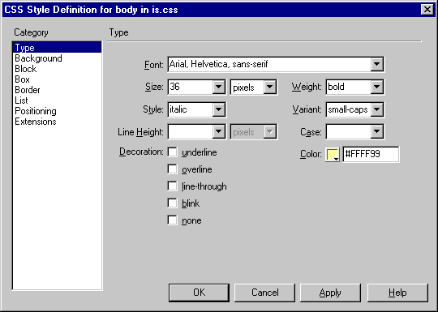
Choose the style options you wish to apply in this case, and click OK.

Applying custom styles to your page
If you have redefined a HTML tag – for example h3, the level 3 heading – then all your level 3 headings will automatically adopt the new style options you have chosen.
If you have chosen to create a custom style (class), then you can apply it to any part of your Web page as follows:
- Select the text/image.
- In the Properties panel, locate the CSS style drop-down menu (by default it should say “No CSS Style”).
- Choose the class name from this menu.
Dreamweaver will update the appearance of the selection to reflect the commands associated with the CSS class.
To remove a custom style, simply choose the No CSS Style option.
Helpful hint:
If you do not select any specific area of text, Dreamweaver will apply the class style to the entire paragraph in which the cursor is positioned.

Editing stylesheet commands
Editing CSS commands is very similar to creating new CSS commands.
Locate the command in the Design panel and double-click it – the CSS Style Definition dialog box (the same dialog box as depicted above) will reappear, and you can edit the style options.

Auto-create styles
When you manually edit text formatting properties in Dreamweaver it will automatically create a style for you based on those properties. You can manage and rename the auto-created styles, or indeed reapply then to other areas of text by clicking on the Style drop-down box in the Properties Inspector.

Advanced CSS topics

Stylesheets for printing
One incredibly useful feature of stylesheets is that different stylesheets can apply for different media – for example, one stylesheet for screen display, one stylesheet for printout.
The example below shows a Web page where this technique has been applied. In the printed version (on the right), the font appearance has been changed, and various elements of the Web page which are not useful when printed out (such as the search box, or the navigation menu) have been removed.
The same Web page, as displayed onscreen (left) and printed (right):

At the time of writing, Dreamweaver doesn’t have a graphical way of specifying that a stylesheet is for printing purposes. The most straightforward way to achieve the effect is to attach the stylesheets as usual, and then modify the HTML code a little. To specify that a stylesheet is for printing purposes only, we need to add the attribute media=“print” into the HTML code which attaches one of the stylesheets. In the example below, the Web page has two attached stylesheets, as indicated by the <link> tags, and the second of these tags has been modified to add the attribute media=“print”.

There are some CSS properties which are particularly useful for print. For example:
- display: none. You can specify that certain elements of the Web page should not be displayed, by setting the display property to none.
- page-break-before: always. This forces page breaks to be placed into the printed document. For example, if you specify this property for level 1 headings (h1), then the level 1 headings will quite naturally split the Web page into sections.

Text rollovers
CSS allows links to be displayed as text rollovers – meaning that the appearance of the link changes when the mouse cursor is positioned over it. Ordinarily you might want the background and foreground colour of the link to change, but any CSS property can be made to change on rollover.
Note: This effect does not work in older browsers, e.g. Netscape Navigator 4.
To make links appear as rollovers:
- Start to define a new CSS style, but instead of choosing Redefine HTML Tag or Make Custom Style in the New Style dialog box, choose the option Use CSS Selector.
- Click the arrow on the drop-down menu at the top of the dialog box (see below). Four options are available:
- a:active represents a link which is in the process of being followed (the user has clicked the link but the next Web page hasn't yet loaded).
- a:hover represents a link with the mouse pointer positioned directly over it – i.e. the rollover state of the link.
- a:link represents a link in its ordinary state.
- a:visited represents a link which has previously been visited by the user.
- To create a rollover link, therefore, we need to define a style for a:link, and one for a:hover, so that the two are slightly different.
- Define a CSS style for a:link.
- Now define a different CSS style for a:hover.
All links in the Web page now appear according to the style defined for a:link.
Preview the Web page in your browser and check that the rollover effect works.

Templates

Overview
Templates are most commonly used like headed notepaper. They allow you to create a design which will be used over and over again. You specify which elements are fixed – such as a departmental logo, a navigation menu, or a copyright notice – and which elements are editable.
Any changes made to the template file can be applied automatically to all Web pages based on that template. Using templates makes it easier to maintain a consistent design across your Web site and makes it easier to make minor changes to every page on the site very quickly.
Whereas stylesheets are a standard feature of the Web, templates are a design tool provided by the creators of Dreamweaver. They are not the same as templates used in other software such as Microsoft Word or Frontpage.

UCL Web templates
The UCL Web Unit produces and maintains a set of templates which you can download and customise to your own needs. This means that you can achieve a professional look integrated with other websites in UCL, very easily.
The UCL Web templates are covered in a separate document. The techniques described in this document will be helpful in understanding and using the UCL Web templates.

Applying a template

Applying a template when creating a new page
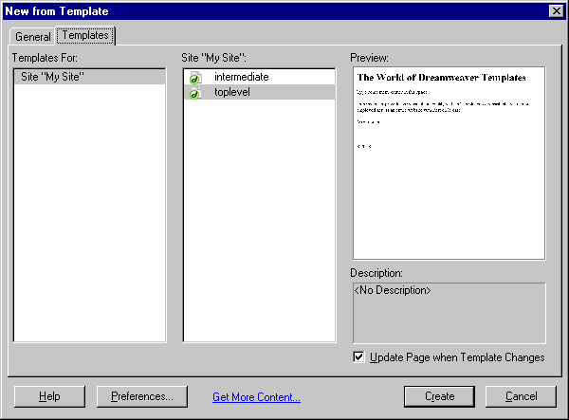
- Select File|New and select the Templates tab. Select your site name and all the available templates will be displayed, and when you select a template, a thumbnail preview is shown (see below).

- Choose the site that contains the template that you wish to use and then select the template file.
- Make sure the box marked Update Page when Template Changes is ticked.
- Click on Create.

Applying a template to an existing page
With the page open choose Modify | Templates | Apply Template to Page. The dialog box as shown opposite is displayed:
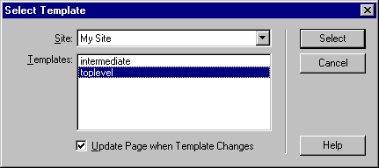
- Choose the template you wish to apply and click on Select.

Dreamweaver will, in most cases, present you with the following dialog box:
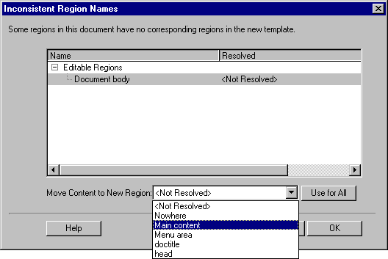
This means that Dreamweaver cannot guess exactly where in the template the content of your Web page should go. The main content of the Web page will ordinarily go in the section labelled main or body, depending on how the author of the template named the regions, so normally you should choose that option.
If you select Nowhere then the thus orphaned content will be discarded.

Creating a template
- Choose File | New, then select the General category and choose HTML Template.
- A blank template page will appear, which you can edit just as you would edit a normal Web page. Create all the elements that you wish to remain static and unaltered by the user, such as:
- Company/department name, logo, copyright notice
- Tables
- Pictures
- Blocks of text, standard formatting
- Page properties (e.g. background colour). Note that you may change the default Page Title, but this property will automatically remain editable, since it is a good idea for every page to have a unique and descriptive title.
As an alternative to steps 1 and 2, you can open an existing Web page which you intend to use as the basis for your template, and continue through the remaining steps below.
- From the File menu, choose Save as Template. A box will then appear listing all the templates already existing for your site, and prompting you to type a name for the template (see example opposite).
- Give the template a meaningful name and then choose Save.

If you used the latter method, you will notice that the document window’s title bar changes to reflect the fact that the document is saved as a template rather than an ordinary Web page, by the appearance of the text “<< Template >>” (see below).
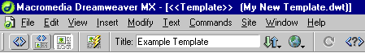

Editable regions
At this point the template has no editable regions – the entire document is fixed, which is not very useful. You need to specify which parts of the page can be changed, by specifying editable regions.

Creating an editable region
An editable region can be created from some content already appearing in the Web page (e.g. a piece of text saying “Enter main content here”), or can be inserted without any content. The procedure is almost the same whichever you choose.
- If you wish to make an existing region of text editable, select the text. Otherwise simply position the cursor at the position where the editable region is to appear.
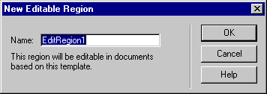
- Choose Insert | Template Objects.
- From the Template Objects menu select Editable Region. The following dialog box is displayed:
- Type in a name for the new editable region (this is used in the HTML source code) – the name must not have been previously used.
- Click on OK.
The editable region will be marked by a box labelled with the region’s name. Inside the box will be the selected text; if no text was selected the region’s name will be used.
New editable region
made from text
New editable region
Non-editable regions

Selecting tables as editable areas
Within a table, you can select single cells or the entire table as editable. You can also select one or more consecutive whole rows of the table. If you attempt to select any other set of cells, the selection will be expanded to include the full rows.

Locating editable regions
To see a list of editable regions within the current template:
- Select Modify | Templates.
- A list of editable regions is found at the foot of the Templates menu. Click on a region name and the cursor will jump to that point within the template.

Unmarking editable regions
To make a previously editable region non-editable:
- Select the region by either clicking its blue label or locating it as described above.
- Select Modify | Templates | Remove Template Markup.
That area is now non-editable. Any text which was previously editable will appear on the template and will have to be deleted separately.

Helpful hint:
Every template has an two editable regions which you cannot remove. These are ‘doctitle’, which allows users to modify the page Title, and ‘head’, which allows users to add code such as CSS style definitions into the page head section.

Image placeholders
If you want to reserve some space on your Web page for an image, but don’t want to specify which image until later, you can insert an image placeholder.
Choose Insert | Image Placeholder, and fill in the options in the dialog box which appears:
When you choose OK, a rectangle will appear in the Web page:

This rectangle can be replaced with an actual image at a later point. When inserting an image placeholder into your template, remember to place it in an editable region, so that it can be changed later.

Adding a “last updated” date
Dreamweaver has a useful function to insert the date/time into a Web page, and to update this date/time whenever you modify the document.
Simply choose Insert | Date, and the following dialog box should appear:
Choose the date/time format you wish to be displayed.
Make sure the box marked “Update Automatically on Save” is ticked.
This feature is not unique to templates – it can be inserted into any Web page. It’s a particularly useful element to insert into your template, so that all of your Web pages will be labelled with the date they were last updated.

Updating a template
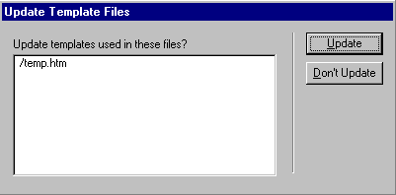
You can edit a template just as you would edit a normal Web page. Templates are kept in a folder named Templates within your local site and have the unusual file extension .dwt.
When you have made changes to a template, save it as normal (e.g. File | Save).
You will be presented with a dialog box similar to the example opposite:
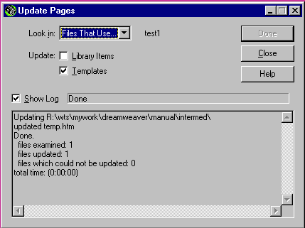
Here you are given the opportunity to update pages previously based on the template. If you choose to update the pages a dialog box similar to the example opposite will be displayed informing you of the pages that have been updated:
Once the updating process has completed, you can click Close to dismiss the dialog box.
Important:
During this process Dreamweaver updates the files in your local site, not on the remote site. If you want the changes to appear on the “live” version of your website, you will need to upload the updated files.

Stylesheets and templates together
Combining stylesheets and templates together can be very useful in creating a professional, unified appearance to your Web pages. When designing your template, you can create stylesheet commands from scratch, or attach an existing stylesheet to your template.
The styles that are applied to your template page will apply equally to the fixed elements and the editable regions. This means that, within your template, you can specify CSS formatting preferences for ordinary paragraphs and for the different types of heading, and that the formatting will apply to the paragraphs and headings that are typed into Web pages based on your template.

Detaching a page from a template
A page which is based on a template will normally be updated whenever the template is updated; additionally, it will prevent you from editing any of the fixed elements of the page.
If you wish to detach a page from its template, so that the whole Web page becomes editable again, choose Modify | Templates | Detach from Template.
Please remember that using this option means that any updates to the template will not be applied to Web pages which have been detached from their template.

Group-managing a site

Check In/Check Out
The Check In/Check Out feature in Dreamweaver enables multiple people in a team environment to manage a Web site's files. The Check In/Check Out option allows only one person to work on a file at a time, to prevent team members from overwriting each other's changes.
To use Check In/Check Out, all team members must enable this when they define their site in Dreamweaver.
Go to Site | Manage Sites, and choose the site to edit from the list.
- Go to the Remote Info Category.
- Ensure Enable file check in and check out is ticked.
- Tick Check out files when opening if you would like to see who has opened a file.
Check In/ Check Out options
- Enter your check out name and e-mail address so others know who is editing the file.Each team member defines a local root folder on their own filestore space (e.g. the R: or C: drive) and the remote server for your department. Team members access files by checking them out from the server. While a file is checked out by one team member, other team members should not access the file. A green tick will be placed next to the file in the Site window (shown right). This indicates to all that the file is checked out. Once a team member has finished working on a file, it is checked back in and becomes once again available to other team members.
Checked out file

To check in/out a file
Check out a file when you are editing it to ensure none else can access it:
- In the Site Files view, right-click on the file you want to check out and choose Check Out.
Check the file back in when you have finished editing the file:
- In the Site Files view, right-click on the file you want to check in and choose Check In.

Integration with Fireworks, Flash and Word
Dreamweaver MX is part of a suite of products known as Macromedia Studio MX. As a result, there are some useful features that integrate Dreamweaver with some of the other products in the suite. We will be looking at Dreamweaver’s integration with its graphics design counterpart, Fireworks MX, and its animation and vector graphics counterpart Flash MX.
Dreamweaver also includes a useful feature that allows you to work with Web pages generated by Microsoft Word. Word-generated Web pages are often composed of code that is relevant only to Word itself, thus making them less portable and editable in other applications. Dreamweaver can fix that.

Integration with Fireworks MX and Flash MX
Both Fireworks MX and Flash MX are used to create graphic content. Fireworks MX is primarily an image creation and editing tool specifically geared for creating images, image maps, and navigation menus for use on the Web. Flash MX is primarily geared towards the creation of animations and vector graphics. Since much of the content that is created using these packages can eventually be put on Web pages, Dreamweaver allows you to incorporate and set the properties of this content from within itself.
Dreamweaver allows seamless editing of images between itself and Fireworks MX. For example, if you have an image on your Web page, you can right-click on it and choose Edit With Fireworks. This will open up your image in Dreamweaver Mode in Fireworks. This means that once you are done editing the image, you will be able to click a button in Fireworks, which will automatically take you back to Dreamweaver and update the image to reflect the changes you have made. Conversely, when you create images, image maps, and navigation menus in Fireworks, you can easily incorporate them into Dreamweaver with a few clicks, and any HTML code generated by Fireworks (for image maps and navigation menus) is automatically transferred to Dreamweaver.
The same is true for content created with Flash MX. You can insert a Flash animation into your Web page using Dreamweaver, and set several properties from within Dreamweaver itself. If you right-click on it, and choose Edit with Flash, you can directly go into Flash, edit the file, and zip back to Dreamweaver all in a few clicks.

Using Microsoft Word generated Web pages
Microsoft Word allows you to save your documents as Web pages. However, in addition to generating standard HTML, Word also creates code that is relevant only to itself, and which may not be of any use to other design applications such as Dreamweaver. Therefore, Dreamweaver provides a facility to clean up proprietary Word code. However, be warned that after removing the Microsoft Word code, you may not be able to edit the Web page in Word – so, retain the original .doc file.
The easiest way to edit Word-generated Web pages and remove the Word-specific code, is to import your Web pages in Dreamweaver. This is done by clicking on File | Import | Import Word HTML and choosing the Web page you want to work on. Dreamweaver then opens the file and the Clean Up Word HTML dialog box automatically pops up. However, you can also just as well open the Web page normally, and then choose Commands | Clean Up Word HTML.
No matter which route you choose, you are presented with the same dialog box, shown above:
There are two views – Basic and Detailed. Here is an explanation of all the options in the Basic view:
- Clean up HTML from – Allows you to choose which version of Word your Web page was created in.
- Remove all Word-specific mark-ups – Removes all Word-specific HTML, including XML tags and other proprietary tags.
- Clean up CSS – Removes all Word-specific CSS (Cascading Style Sheets).
- Clean up <font> tags – Word tends to generate lots of <font> tags. This removes them and sets the default body text to a single size.
- Fix invalidly nested tags – Removes the <font> tags outside the paragraph and heading tags.
- Set Background color – Allows you to to set the background colour of your document (in hexadecimal values). Word sets the background colour to grey by default, while Dreamweaver sets it to white. You can set it to your liking.
- Apply Source Formatting – If you create a page in Dreamweaver and then look at its code by going to Show Code View, you will notice that Dreamweaver formats the code to make it easier to read, by using several formatting options. These include using different colors for certain elements, wrapping the code to a new line when it reaches the right margin, and generating all the tags in either lowercase or uppercase. Other formatting properties also apply. All these source formatting properties can be set in Edit | Preferences | Code Format. The Apply Source Formatting property allows you to apply those formatting options to the newly cleaned up Web page, which is a good idea.
- Show log on completion – When a Word-generated Web page is cleaned up by Dreamweaver, all the actions taken by Dreamweaver are recorded in a log file. Selecting this option displays the details about those actions and changes, when the cleanup operation is complete.
The Detailed view presents you with more options, which relate to the Clean up HTML from, Remove all Word-specific mark-ups, and Clean up CSS properties.

Helpful hint:
The new version of Dreamweaver – Dreamweaver MX 2004 – deals with importing content from Microsoft Office much better than its predecessors. The trick is to ensure you copy and paste from Office applications into Dreamweaver, rather than using the Save as HTML option in the Office application and then importing this file.

Tables
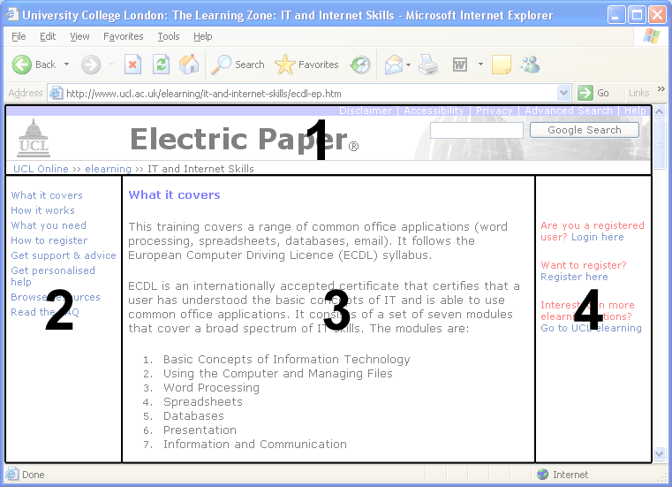
The basics of inserting and using tables are covered in the Dreamweaver MX2004 Part one workbook. However, tables are a powerful tool for positioning the content and managing the layout of a Web page; the major advantage being that you can position elements (graphics, text, etc.) very precisely. Have a look at the page below:
This page has a well-defined structure, and contains at least four separate sections:
- A header row – containing a logo, banner etc.
- The left column – which contains the site’s main navigation.
- The middle column – which contains the main content of the page.
- The right column – which contains additional links.
These four sections are actually divided up using a table that takes up the entire page. Section 1 is a row that spans the entire width of the table. The next row is split into three columns. The columns on the left and right are smaller columns, while the one in the middle is a larger column. Section 1 in fact contains a second table used to control the layout of the logos, title and search box.

Nested tables
Tables can be inserted within table cells (creating a ‘nested table’) and used to layout content within that cell. Further tables can be inserted within the cells of these nested tables, potentially allowing content to be positioned very precisely within the page.
This should however be approached with caution as it can be problematic on two levels: It can make it difficult to work out which table a cell belongs to, which can lead to difficulties when adjusting formatting such as cell padding, spacing etc. The underlying HTML code also becomes incredibly complex (making it difficult to work with) and this has a knock-on effect for users of screen readers – the order of things as they appear to sighted users on screen may not be how they are read out by the screen-reader, potentially leading to great confusion and making the page unusable.
Given these limitations it pays to use nested tables with restraint, avoiding excessive numbers of nested tables and perhaps compromising on layout if this will simplify things. In fact compromise and simplicity are a good approach when dealing with design – It’s important to remember that most Web sites are created to present information, and it pays to do so in a form that is accessible and usable by all rather than worrying about the intricacies of design.

Terminology
This is a list of some of the most common abbreviations and terms.
Abbreviation/Term | Longhand | Definition
www | World Wide Web | A collection of sites that offers various resources available through the HyperText Transfer Protocol.
Internet | - | A collection of sites and resources available through various network protocols – more wide-ranging than the WWW.
Browser | - | A program used to access websites and resources on the Internet.
URL | Uniform Resource Locator | An address to a website or resource on the World Wide Web.
HTTP | HyperText Transfer Protocol | A means of transferring data across the Internet – most often used by browsers.
FTP | File Transfer Protocol | A means of transferring data across the Internet – generally used for uploading files to websites.
Broadband | - | A transmission facility having a bandwidth sufficient to carry multiple voice, video or data channels simultaneously.
ADSL | Asymmetric Digital Subscriber Line | Broadband Internet connection.
Webpage | - | A Web page is an HTML file that has a specific URL and is accessible via the WWW.
Website | - | A collection of related Web pages and files linked together on a computer connected to the Internet.
Home page | - | The main page or first page of a Web site.
HTML | HyperText Markup Language | The main language used to write Web pages.
XML | eXtensible Markup Language | Another more advanced language used on Web pages.
CSS | Cascading Style Sheets | A method of applying consistent styling and formatting to Web pages and sites.
JPG / JPEG | Joint Photographic Experts Group (pronounced j-peg) | A format for compressing images (usually photographic).
GIF | Graphic Interchange Format | Another format for compressing images (usually images with flat areas of colour).
BMP | BitMap | A Windows image format which should not be used on the Web.
MPG/ MPEG | Moving Picture Experts Group (pronounced m-peg) | A standard for digital video and audio compression.
Frames | - | Frames divide Web pages into multiple, scrollable regions (these are no longer recommended).
database driven pages | - | Web pages whose content is derived from a linked database.
dynamic Web pages | - | Non-static Web pages – i.e. those that change depending on user input, may also be database-driven.

Appendix 1

Setting up your remote folder at UCL:

WTS users
If we were creating a website to be hosted by a Web hosting company, this company would create the root folder on the remote site for us. At UCL there is a program available via WTS called Publish Web Pages which establishes the remote site for you.
To use Publish Web Pages in WTS:
- From the Start menu choose Programs and Software O-Z.
- Run the Publish Web Pages program.
This program will ask for your user ID and password, and then establish your local site for you. Take care when entering your password, as nothing is echoed on the screen. If you do not have access to the Publish Web Pages feature, see the instructions below.

Non-WTS users
If you don't have access to the Publish Web Pages program available through WTS, then follow one of these sets of instructions to set up your remote folder at UCL. In each case the process will create a folder called html.pub in your home directory, and then ensure that it is world-readable (i.e. that it can be accessed by anyone using a Web browser).

Using UNIX on Socrates or a cluster Sun workstation
To create your html.pub directory in the root of drive R:, use the UNIX mkdir command:
mkdir html.pub
To publish your pages, use the UNIX reveal command. This will automatically make your html.pub and home directories world-readable. You can do this for a single file or a number of files:
reveal index.html
reveal *

Non-Managed computers
To create and make world-readable your html.pub directory from a non-UCL-Managed computer, you will need to use Telnet. (Users of Windows 95 and later will find Telnet in Start│Programs │Accessories.) Using Telnet, connect to socrates.ucl.ac.uk, login with your normal ID and password, and enter the following UNIX commands:
mkdir html.pub
chmod og+x $home html.pub
Don’t forget to logout to end your UNIX session.

Connection settings
These are similar to those used to access departmental pages except that the host directory should point to the folder you created in the process above (i.e. html.pub) and you use your personal UCL login and password:
Server Access: | Choose FTP from the list
FTP Host: | ftp.ucl.ac.uk
Host Directory: | html.pub
Login: | [Your Login]
Password: | [Your Password]

Accessing personal homepages
To view your uploaded pages from a browser use the following address: www.homepages.ucl.ac.uk/~yourlogin
To get the ~ (tilde) use: Shift+#
‘yourlogin’ is the login you used in your site definition.

Learning More

Central IT Training
Information Systems run courses for UCL staff, and publish documents for staff and students. Dreamweaver documents include:
Creating and Maintaining Webpages Part one | This course is for those new to web page authoring or to Dreamweaver who wish to explore the basic features of the software.
Creating and Maintaining Webpages Part two | This 3.5hr course is aimed at users familiar with Dreamweaver who want to use templates and stylesheets, and find out more about Dreamweaver.
Using forms in Dreamweaver | Additional workbook only, currently no course in this area.
UCL Templates | This course is aimed at users who need to make use of the UCL templates in their web pages

Open Learning Centre
- Dreamweaver Workshop – This training is delivered in the Open Learning Centre and is intended for those who wish to obtain training on specific features in Dreamweaver on a individual or small group basis. Please let us know your previous levels of experience, and what areas you would like to cover, when arranging to attend.
You will need to book a session in advance at: www.ucl.ac.uk/is/olc/bookspecial.htm and sessions will last for an hour or possibly longer depending on availability.
- See the OLC web pages for more details at www.ucl.ac.uk/is/olc.

On-line learning
There is also a comprehensive range of online training available via TheLearningZone at www.ucl.ac.uk/elearning.

Getting help with Dreamweaver
- Dreamweaver has a help system which you can call upon at any time while you are working on a Website. Select Using Dreamweaver from the Help menu to open Dreamweaver help.
- For WebCT users there are additional Dreamweaver courses. Details can be found at: www.ucl.ac.uk/learningtechnology/training
- There is an option on Dreamweaver's Help menu called Tutorials, which takes you through some of the more advanced Dreamweaver features in an interactive fashion.
- A Web search using a search engine such as Google (www.google.co.uk) can also retrieve helpful Web pages. For example, a search for CSS “style sheet” tutorial would return a useful selection of tutorials.
- The following faculties have a dedicated Faculty Information Support Officer (FISO) who work with faculty staff on one-to-one help as well as group training, and general advice tailored to your subject discipline.

- Arts and Humanities
- Engineering
- Maths & Physical Sciences
- Life Sciences
- Social and Historical Sciences
- Barlett

See the Faculty based support section of the www.ucl.ac.uk/is/fiso webpage for more details.

