UCL
Education & information support division
information systems



Excel 2003

Getting started
with Excel

Document No. IS-014 v3
Contents
What is a Spreadsheet? 1
The Excel environment 1
Terminology 2
Accessing commands 3
Moving around the worksheet 4
Help features 6
Getting help 6
Using a worksheet 7
Creating a new workbook 7
Opening a workbook 7
Entering data 7
Saving your work 10
Editing a worksheet 11
Selecting data 11
Copying and moving data 12
Deleting data 14
Undo and Redo 14
Find and replace 15
Formatting a worksheet 16
Changing column width 16
Assigning a number format 17
Formatting characters 18
Borders, patterns and colours 18
Aligning data 19
Preparing to print 20
Page setup 20
Print Preview 22
Printing a worksheet 22
Printing a worksheet 23
Learning more 24

Introduction
This workbook has been prepared to introduce you to the basic features of Microsoft Excel. It is aimed at those who have little or no knowledge of Excel, or who would like to revise basic topics. Formulae, functions, and other more advanced topics are covered in a range of other Excel courses. See our web pages for details.
This guide can be used as a reference or tutorial document. To assist your learning, a series of practical tasks are available.

Training files
If you wish to attempt the exercises contained in the exercise document and you are not using a training account, it is necessary to download the training files used in this workbook from the IS training web site at: www.ucl.ac.uk/is/documents/. Full instructions on how to do this are provided there.

Online resources
There is also a comprehensive range of online training in Excel available via The Learning Zone at www.ucl.ac.uk/elearning.

What is a Spreadsheet?
A spreadsheet (called a workbook within Excel) is a powerful application which can be used to store, manipulate, calculate and analyse data such as numbers, text and formulae. An analogy can be drawn between a spreadsheet and an accountant’s ledger. A ledger is made up of many pages, each page arranged into a series of rows and columns.
At its simplest level, a spreadsheet is used to enter numbers and perform simple calculations but the capabilities of Excel extend far beyond this. Excel provides a number of features including:
- Functions for mathematical, financial and other calculations.
- A selection of tools to facilitate “what if” type analyses.
- A Chart Wizard – to produce graphical representations of data held within workbooks.
- Graphics to highlight information in worksheets and charts.
- Database features which enable the sorting, filtering and analysis of information.
- Macros to allow the user to automate routines.
There are many different practical applications for which a spreadsheet can be used. The obvious ones are financial applications, such as maintaining budgets and accounts. Other applications include processing course marks, analysing results from experiments, and maintaining lists and audits.

The Excel environment
To launch Excel, from the Start menu select Programs and choose Excel. Your screen should look the same as the one below.
Task pane

A1
Row heading
Column heading
Formula bar
Title bar
Status bar
Sizing buttons

Help button

Formatting toolbar
Standard toolbar
Scroll bars
Menu bar
Name box (showing active cell)

Sheet tab

Note the Formula bar, Status bar and the Scroll bars. Take a moment to locate these on your screen.
It is possible to change the look of the default environment. A number of the view options can be changed from the Tools menu, under Options and View.

Task panes
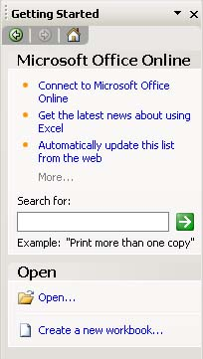
All of the Microsoft Office XP applications have a new feature called the task pane (visible in the right-hand part of the screen). This feature is a web-style command area which is an alternative to a dialog box, and allows you to carry out certain basic operations or choose selected options. Most Office 2003 applications contain a variety of task panes including: Getting Started, Help, Search, Clip Art and Clipboard.
Other Task Panes arrow
Getting Started – this task pane provides options for starting a new workbook or opening an existing one.
Help – this task pane provides options within Microsoft Excel Help (this is explained in more detail later on).
Search – this allows you to look for your information in Help, training, and templates as well as clip art and research.
Clip Art – this task pane is used for inserting images and Clip Art into your spreadsheet.
Clipboard – this task pane is used for copying and pasting multiple items into Excel, and between Excel and other Microsoft Office XP applications.

To display the task pane
If the task pane is not visible on the right-hand side of the application window, you can display it as follows:
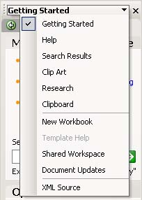
From the View menu, choose Task Pane. The task pane, as shown opposite, will display.

To change the task pane:
- Click on the Other Task Panes arrow to display the options shown opposite.
- Select the required option.
- Note that you can also use the arrows to go backwards and forwards to previously displayed task panes.

Terminology
Worksheet A grid divided into rows and columns
Workbook A collection of worksheets under one name
Columns Columns are referred to by letters (A, B, etc.)
Rows Rows are referred to by numbers (1, 2, etc.)
Cell The intersection of a row and a column. Referred to by column then row (A1, G7, etc)
Cell pointer/highlight The rectangular highlight in the workbook
Insertion point The short, black line within a cell, which is also used in editing
Range A cell, a rectangular group of cells (e.g., A4:A6 or A1:C6). Ranges can also be given names.
File A workbook saved to disk.

Workbooks and worksheets
On start up, Excel automatically loads a workbook, Book 1, as identified in the Title bar. This workbook is a file in which you work and store your data. Each workbook can contain a number of worksheets. The default workbook has three worksheets, each having a tab to mark the sheet (Sheet1, Sheet2, and sheet3).
A worksheet is a grid-like area divided into columns and rows. Columns are labelled A, B, C, etc., and rows numbered 1, 2, 3, etc. Each worksheet is made up of 256 columns and 65,536 rows.
A1
The intersection of a column and a row is known as a Cell.
Each cell on a worksheet can be uniquely addressed by its column letter followed by its row number (e.g. the first cell in the worksheet is A1). The active cell is now indicated by both the column and the row headings being highlighted.

Accessing commands
All commands may be accessed through the menu system, although some are also available though buttons on toolbars and through the task pane.

Task panes
Some commonly used commands are accessed through the task pane as described previously.

Menus
Commands may also be accessed through the Menu bar at the top of the Excel window.

Using the mouse
Click on the menu item on the Menu bar and click on the option you require in the drop-down menu.

Using the keyboard
There are two keyboard methods for accessing menu commands – using the Alt or Ctrl keys.
- Hold down the Alt key and press the letter underlined in the menu item. For example, to access the Edit menu press Alt+E.
- Use the Ctrl combinations where indicated in the menu. For example, use Ctrl+C to copy, Ctrl+V to paste, etc. Note: only some commands are available using the Ctrl key.

Shortcut menus
A number of shortcut menus can be accessed in Excel by clicking on the right mouse button. These menus are context sensitive and also dynamic.

Toolbars
Toolbars provide a shortcut route to many commands. Using the mouse, point and click on the required button. Different toolbars can be displayed and hidden at different times. By default the Standard and Formatting toolbars are displayed on the same line.
Standard toolbar
Toolbar options arrows
Formatting toolbar

Changing the toolbars displayed
- Select the View menu and then Toolbars.
- Click in the check boxes to select the toolbars required from the list. The Formula bar and Status bar can also be selected in the View menu.

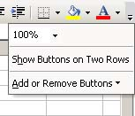
Adding buttons to a toolbar
- Use the Toolbar Options arrow at the right of the toolbar to access additional toolbar options.
- Choose the Add or Remove Buttons option to customise your toolbar. Note that once you have accessed a command from this list it will automatically be added to your toolbar.

Displaying toolbars on two rows
- Use the Toolbar Options arrow at the right of the toolbar to access additional toolbar options.
- Choose the Show Buttons on Two Rows option to display the Standard and Formatting toolbars on two separate rows.

Moving around the worksheet

Using the mouse
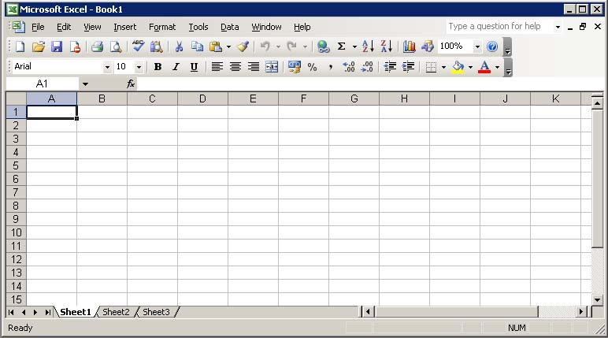
Use these scroll buttons to move from left to right in the sheet.
Use these scroll buttons to move up and down in the sheet.
Name box shows the active cell.

Use the scroll box to move more quickly through the sheet.
The pointer identifies the Active Cell.
Use these buttons to navigate between different worksheets.

Using the keyboard
Some of the more commonly used keyboard shortcuts are shown here. A more exhaustive list can be found in Help under Keyboard Shortcuts.

arrow or cursor keys ↑, ←, ↓, → | move one cell at a time up, left, down, right
Ctrl + Home | moves to beginning of worksheet
Ctrl + End | moves to last cell of current data region
Ctrl + ← | moves to the next cell left containing data
Ctrl + → | moves to the next cell right containing data
Ctrl + ↑ | moves to the next cell above containing data
Ctrl + ↓ | moves to the next cell below containing data
Home | moves to column A of current row
Page Up | moves one screen up
Page Down | moves one screen down
Alt + Page Up | moves one screen to the left
Alt + Page Down | moves one screen to the right

Using the name box
The name box displays the address of the currently selected cell. You can use it to jump to any cell.
- Click in the name box to highlight it.
- Type in the required cell number and press Enter.

Using the menu
From the Edit menu, choose GoTo, and type the cell address into the GoTo dialog box.

Help features
There are several ways to obtain help from within Excel: the Help pane and the Ask a Question list are described here. In Microsoft Office 2003, the online help features have been embedded into the task pane on the right-hand side of the window, which allows a more intelligent and up-to-date help function.

Getting help
From the Help menu, choose Microsoft Excel Help to display the help pane in the task pane area as shown. Select the type of help facility you require from the Assistance, Table of Contents or Microsoft Office Online links.
Assistance – to enter questions in the box labelled Search for. Subtopics based on your response will be shown below. The corresponding help pages will be displayed in a pop-up window (Microsoft Office online help).
Table of Contents – to find instructions about broad categories, organised like a book’s table of contents. As you chose top-level topics you can see a list of more detailed subtopics from which to choose. The resulting help pages display in the right of the help window.
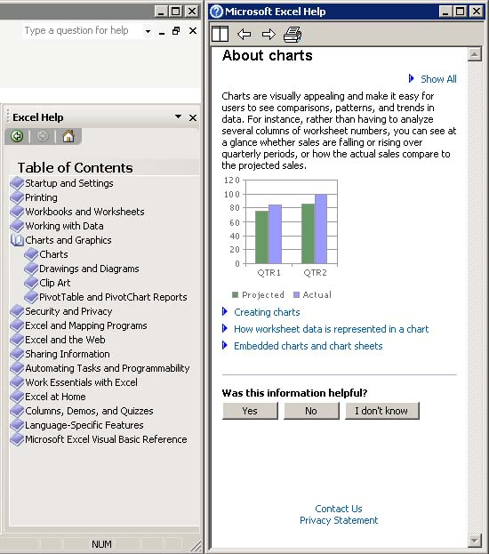
Microsoft Office Online – to locate specific topics, provide online training and tutorials. You can click the links to go to the Microsoft Office Online help pages. The online training will be very helpful if you want to learn the office applications systematically. Also, the online community allows you to interact with real people, ask questions and provide answers, or take part in the online discussions.
Auto Tile: Arranges the help window next to the main Excel window.
Back and Forward: To move to previously visited help options.
Print: To print the help information.

The Ask a Question list
This box is displayed in the upper right corner of the Excel window.
You simply enter a question in plain English and press Enter.

Using a worksheet

Creating a new workbook
From the File menu, select New, click the New workbook button on the toolbar, or select Blank workbook from the New workbook task pane or press Ctrl+N.

Opening a workbook
To open an existing workbook:
- Click on the Open workbook button on the toolbar, click on Open… in the Getting Started task pane, or press Ctrl+O. The Open dialog box will appear.
- In the Look In box, select the appropriate drive and folder.
Files in the current folder are displayed here.
Select the appropriate drive here – click on the arrow for the drop-down list and select.
Select the File type here – click on down arrow for the drop-down list.
- The files available are displayed in the window. Select the file required and click OK.

Entering data
Data are always entered in the selected cell. Position the pointer in the cell required before entering data from the keyboard.

Types of data
There are three types of data or information that may be entered into a worksheet:
Labels (text) | Normally text used for headings or in lists.
Values (numbers) | Raw data which are used in calculations (i.e. numeric data only). These include dates.
Formulae | Arithmetic or mathematical expressions.

Values can be in many different formats and it is important for display and calculation purposes that the correct format is used. Normally labels are left-aligned in cells, whilst values (numbers) are right-aligned.

Data entry techniques
For faster data entry, highlight the range in the worksheet where data are to be entered and use the navigation keys shown here to navigate more efficiently.
Tab | Enters data and moves right in the selected area.  The cursor wraps to the left at the end of the selected range.
Shift+Tab | Enters data and moves left in the selected area.  The cursor wraps to the right at the end of the selected range.
Enter | Enters data and moves down in the selected area.  The cursor wraps back to the top of the selected range.
Shift+Enter | Enters data and moves up in the selected area.  The cursor wraps back to the end of the selected range.
Ctrl+Enter | Enters the current data into all cells in the selected range.

Entering dates and times
Excel recognises dates and times typed in most common formats. When you type a date or a time Excel converts the entry to a number. The number represents the number of days from the beginning of the century to the date typed. Time is recorded as a fraction of a 24 hour day. Correctly entered dates appear in the Formula bar in the form dd/mm/yyyy (e.g. 29/01/1999) and hh/mm/ss (e.g. 1:30:00), regardless of how the cell is formatted.
If Excel does not recognise your entry as a valid date or time format, it is treated as text and, in an unformatted cell, will appear left-aligned.

Acceptable date formats | Acceptable time formats
31/12/97 | 14:53
31-Dec-97 | 14:53:35
31-Dec (the year from the system date is used) | 2:53 PM
Dec-97 | 2:53:35 PM
31/12/97 14:53 | 31/12/97 14:53
In any of these date formats you can use a /, -, or space to separate elements. | If the 12 hour clock is used, follow the time with an A, AM, P, or PM in either upper or lower case.

Date and time shortcuts
Ctrl+; | To enter the current date in a cell
Ctrl+Shift+; | To enter the current time in a cell
Ctrl+# | To format a date in the default date format
Ctrl+@ | To format a time in the default time format

Entering a series of numbers or dates
Excel makes it possible to generate automatically a series of numbers or dates using a facility called AutoFill. It also offers the flexibility to enable the user to customise their own number and text series.

Working with series
There are a number of time series that Excel will recognise:
Initial selection | Extended series
9:00 | 10:00, 11:00, 12:00
Mon | Tue, Wed, Thu
Monday | Tuesday, Wednesday, Thursday
Jan | Feb, Mar, Apr
Jan, Apr | Jul, Oct, Jan
January-96, April-96 | July-96, October-96, January-97
15-Jan, 15-Apr | 15-Jul, 15-Oct
1994, 1995 | 1996, 1997, 1998

Entering a series of data using AutoFill
- Enter the first item of data in the series.
Drag the Fill Handle down to extend the series.

- Select the cell.
- Drag the Fill Handle down or to the right to enclose the area you want filled with the series, and release the mouse when finished.
- The enclosed area fills with the series selected.

The AutoFill feature extends several types of series as shown below:

Initial selection | Extended series
Mon | Tue, Wed, Thu...
1-Jan, 1-Mar | 1-May, 1-Jul, 1-Sep...
Qtr3 (or Q3 or Quarter3) | Qtr4, Qtr1, Qtr2...
Product 1, Order | Product 2, Order, Product 3, Order...
text1, textA | text2, textA, text3, textA...
1st Period | 2nd Period, 3rd Period...
Product 1 | Product 2, Product 3...
1, 2 | 3, 4, 5, 6...
1, 3, 4 | 5.66, 7.16, 8.66...

Creating a linear series
Initial selection Extended series
- Enter the first two items of data in the series in adjacent cells.
1 | 2 | 3 | 4 | 5
2 | 4 | 6 | 8 | 10
100 | 90 | 80 | 70 | 60
- Select the two cells.
- Drag the Fill Handle down or to the right to enclose the area you want filled with the series, and release the mouse when finished.
- The enclosed area fills with the series determined by the first two cells selected.

Saving your work
From the File menu, select Save.
It is good practice to save your work at regular intervals. When saving a worksheet for the first time the Save As dialog box appears. This box prompts you to give the worksheet a filename and to select where the file is to be saved. The first time you use Save you should check where the file is to be stored.
On Managed and Cluster room PCs you have access to a number of different drives. The most important to remember is the R:\ drive which is your area on the network drive (staff also have access to the N:\ network drive). Files saved on either R:\ or N:\ will be secure and can be accessed from any Managed or Cluster room PC.
Select a drive here.
Enter your filename here.
To save your work on a floppy disk select the A:\ drive.

Naming your file
In the File Name box type a suitable filename. You are advised to avoid spaces in your filenames and to accept the default extension .xls. This is particularly important if you are sharing files with other users. Try to use meaningful names, so files can be more readily identified at a later date.

Saving
Once a file has been named you can use the Save command to update your file as you work on it.

Save As
Use the Save As command when you wish not to overwrite an existing file, but to save your work in a new file with a different name.
- From the File menu, click Save As.
- Select the required drive and folder.
- Enter the new filename and click Save.

Closing a workbook
It is always good practice to close a workbook when you have finished working on it – but don’t forget to save it first.
From the File menu, click Close.
Closing a workbook before it is saved calls up a dialog box prompting you to save any changes.

Exiting Excel
It is good practice to save and close your workbook before exiting.
From the File menu select Exit. When you have done this, wait as Excel closes down.

Editing a worksheet
Data can be edited using the Backspace (←) and Delete keys found on the keyboard.

Editing in the formula bar
- Position the pointer in the cell to be changed (the contents of the cell are displayed in the Formula bar).
- Click in the Formula bar and the cursor appears ready for editing.
- On completion press Enter or click on the Tick mark in the Formula bar.
Cancel button
Enter button
Function button

Editing in the cell
Cell contents of the active cell displayed in formula bar

Cursor appears in the cell ready for editing.

- Select the cell to be changed by clicking on it.
- Double click in the cell, or press F2 to edit it.
- Notice that the cursor appears in the cell ready for editing.
- On completion press Enter or click on the tick mark in the Formula bar to update the changes.
Helpful hint:
The menus are context sensitive. When you are editing a cell, certain options on the menus will be greyed out, as they are not available to you. Click outside the cell to return to normal mode before using the menus if necessary.

Selecting data
Before manipulating data in a worksheet, it is necessary to identify the data. This is done by selecting (highlighting) the required data, as explained below.

Selecting a cell
A single cell is selected by clicking in the required cell.

Selecting a block of cells
- Position the pointer over the top left-hand corner of the block.
- Hold down the left mouse button and drag the pointer over the desired area.
- Release the mouse button when the chosen area is selected.
Notice that once an area has been selected the range is highlighted on the sheet in reverse video (i.e. white on black) except the first cell, or active cell, in the range.

Selecting a column or row in a worksheet
- Click in the column or row heading.
Select all
Click here to select row 3.
Click here to select column C.
- The column or row will be highlighted.

Helpful hint:
You can use the Shift+Space keyboard shortcut to select an entire row, or Ctrl+Space to select an entire column.

Selecting all cells in a worksheet
Click in the Select All box, as shown in the figure above, or use Ctrl+A.

Copying and moving data

Copying data
- Select the cell(s) to be copied.
- From the Edit menu, select Copy, use Ctrl+C, or click the Copy button on the toolbar.
- Move the pointer to the new location with the mouse or the keyboard.
- From the Edit menu, select Paste, use Ctrl+V, or press Enter.

Moving data
- Select the cell(s) to be moved.
- From the Edit menu select Cut, use Ctrl+X, or click on the Cut button on the toolbar.
- The cells which have just been cut do not disappear but are outlined with a moving border.
- Move the pointer to the new location with the mouse or the keyboard.
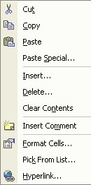
- From the Edit menu, select Paste, use Ctrl+V, or press Enter.

Helpful hint:
You can use the right mouse button to access the shortcut menus, where you will find the Copy, Paste and Cut commands.

Drag and Drop
You can move and copy cells by selecting and dragging them with the mouse. When you do this, you must ensure that you have the correct mouse pointer shape displaying before dragging and dropping.
When you select a cell or a group of cells, Excel outlines them with a heavy border. When the mouse is moved slowly over this border, it will display a white arrow which points up and to the left. This points to a black four-headed arrow – this is your drag and drop pointer and allows you to move and copy cells with the mouse.

To move
- Select the cells you want to move or copy.
- Point to the border of the selection.
- With the drag and drop pointer displaying, drag the selection to the upper-left cell of the paste area. You’ll see a fuzzy box, the same size as the selected block that will follow your mouse – when you release the mouse the selected cells will jump to their new location.
IMPORTANT
When you move cells to an area that already has data, Excel replaces the existing data with the data you are moving. See Insert paste below to see how to prevent data being overwritten.

To copy
- If you want to copy the selection, repeat steps one and two above, but hold down the Ctrl key before clicking and dragging. You will see a plus sign appear next to the mouse pointer to signal the fact that you are copying rather than moving.
- With the fuzzy box positioned where you want the copy, let go of the mouse first and then release the Ctrl key.

Insert paste
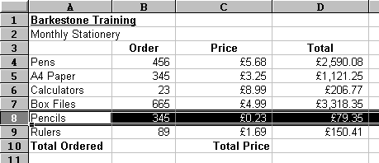Unless you use the Insert paste option, Excel will overwrite existing data with cells that you are moving or copying. There are occasions where you want to swap the positions of cells without overwriting what you already have.
In this example, you may want to move the selected cells up three rows so that Pencils are listed after Pens.

Inserting cells between existing cells
- Select the cells you want to move or copy.
- Point to the border of the selection.
- Hold down Shift (if moving) or Shift+Ctrl (if copying) as you drag. You’ll see a fuzzy line that you can position horizontally (between rows) or vertically (between columns). Release the mouse, then the keyboard. Your cells will jump to their new location.

Deleting data
- Select the cells to be deleted.
- Press the Delete key – on the keyboard or, from the Edit menu, select Clear and choose Contents.
Note: It is the contents of the cells and not the actual cells which are deleted. To delete cells see the next section.

Deleting rows and columns
- Position the pointer in a cell in the required row or column.
- From the Edit menu, choose Delete. The Delete dialog box appears.
- Choose Entire row or Entire column as required.
- Click OK.

Inserting rows and columns
- Position pointer in a cell in the required row or column.
- Click on the Insert menu and choose Rows or Columns.
Note: New rows are inserted above the pointer and new columns to the left of the pointer.

Undo and Redo
When you make a mistake or change your mind you can use the Undo command to reverse your last commands or actions. Redo repeats your last command or action.

Undo
Click on the Edit menu and choose Undo or use Ctrl+Z. The Undo command changes to show the most recent command or action. If the Undo command is unavailable the words Can’t Undo appears greyed out in the menu.
To reverse more than one action at a time, click on the drop-down arrow beside the Undo button, and then click the actions you want to undo.

Redo
From the Edit menu choose Redo.
If the Redo command is unavailable the words Can’t Repeat appears greyed out in the menu.

Find and replace
The find and replace functions in Excel 2003 are more powerful than in previous versions of Excel. By clicking on the Options >> button, the extended options appear. You can specify that you want only to match cells with the same case formatting as the text in the Find what box using the Match case tick box. You can also use the Format buttons to specify formats to search for, and formats to apply to the replacement.

The Within box allows you to search either a worksheet or workbook, and the Search box allows you to search either by row or column.

The Find All button is a powerful new tool which produces a list of matches, including their worksheet and cell location, and whether the cell contains a value or a formula. You can go to any of the matched cells simply by clicking in the list.

Formatting a worksheet
All worksheets start with a number of predefined formats. As you work you may need to change some of these formats to suit your own needs. In this section we will look at some of the more common formatting options available.

Changing column width
- Position the pointer in the column to be changed.
- From the Format, menu point to Column and Width.
- The Column Width dialog box appears displaying the default width.
- Type the new width in the Column Width box.
- Click OK.

Short cut method
- Position the pointer in the column heading to the right of the column to be changed.
- When the pointer changes shape to a double-headed arrow, click and hold down the left mouse button and drag the pointer to the width required and release the mouse button.
Current width is displayed.
The # symbol shows where columns are too narrow to display all the data.
Text will be hidden where there is insufficient room to display labels (see the full label displayed in formula bar).
Double-headed arrow appears as pointer is positioned in the border between two columns. Notice the dotted line which appears between the columns.

AutoFit
To set the column widths automatically:
- Position the pointer on the right border of the column heading as above.
- Double-click the left mouse button. The width will be set automatically to fit the widest cell entry in that column.

Assigning a number format
Excel applies a General number format by default; this format displays values exactly as they are entered into the worksheet. In this section we will see how we can specify different number formats.
- Select the cells you wish to format in the worksheet.
- From the Format menu select Cells. The Format Cells dialog box appears.
- From the Number tab select the category required (e.g. the Number category, as shown here).
- Specify the required format.
- For the Number format, you will need to enter the required number of decimal places.
- Click to select or deselect the Use 1000 Separator (,).
- Select the required display option for Negative numbers.

Formatting toolbar options
Some commonly used formats can be applied from the Formatting toolbar.
Button | Format | Example
 | Currency style | £9,999.00
 | Percent | 0.9 becomes 90%
 | Comma style | 9,999,999.00
 | Increase decimal | 9.00 becomes 9.000
 | Decrease decimal | 9.00 becomes 9.0

Removing cell formats
- Select the area where the format is to be removed.
- From the Edit menu, select Clear and choose Formats.
Alternatively reset the format style to General:
- From the Format menu, select Cells.
- Select the General category and click OK.

Number formats – keyboard shortcuts
Character format | Shortcut key
General | Shift+Ctrl + ~
#,##0.00 | Shift+Ctrl + !
0% | Shift+Ctrl + %
0.00E+00 | Shift+Ctrl + ^

Formatting characters
Excel has the same range of basic character formats as are available in the other Office applications.
Select the font size here.
Font tab selected.
Select the font type here.
Select the font style here.
Select Font style here
- Select the cells to be changed.
- From the Format menu, choose Cells. The Format Cells dialog box appears as shown opposite.
- From the Font tab, select the required settings. The Font type, Style and Size as well as Colour and other Effects can be selected, as shown on the right.

Button | Format
 | Font
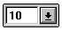 | Point size
 | Bold
 | Italics
 | Underline

Some commonly used formats can be applied from the Formatting toolbar.

Borders, patterns and colours
The appearance of the worksheet can be further enhanced with the use of borders and colour.
From the Format menu, choose Cells and select the appropriate tab, either Border, Patterns or Font.
Border
Fill color
Font color

Aligning data
By default Excel automatically aligns text to the left and numbers to the right of the cell. We can change these defaults by clicking on the relevant alignment button on the toolbar.
Left Center Right

Horizontal and vertical alignment
There are a number of different vertical and horizontal alignment options:

Horizontal alignment | General, Left, Center, Right, Fill, Justify, and Center across selection (Merge and Centre), and Distributed.
Vertical alignment | Top, Centre, Bottom, Justify and Distributed.
To set the alignment:
Alignment
Horizontal alignment
Vertical alignment
- Select the cells to be aligned.
- From the Format menu, choose Cells.
The Format Cells dialog appears as shown opposite.
- Choose the Alignment tab.
- Select the required options from the Horizontal and Vertical boxes.
- Click OK.

Merge and Center
This option allows you to centre a heading across a range of cells.
- Select the range of cells.
- From the Format Cells dialog box (see above) in the Text control section, choose Merge cells. (The cells are merged together as if they are one).
- To centre the text in the cells click on the Centre button.
- To undo Merge and Center formatting, select the area across which the data is centred, and in Format Cells dialog box, on the Alignment tab, choose General in the Horizontal box.
Helpful hint:
Using Merge and Center alters the way that ranges can be selected in the worksheet. In particular it can prevent simple operations like copying and pasting columns. For this reason it is best to merge and center only as a final step before printing.

More alignment options

Text control
Wrap text Choose this option to force text to wrap within a cell.
Shrink to fit This option will reduce the font size until the cell contents fit within the cell boundary.
Merge cells This option will merge a group of cells both across columns and down rows (see above).

Orientation
- Changes the orientation of cell contents to vertical.
- Sets the angle of text rotation in the selected cell.

Preparing to print
Before sending your work to the printer you should first check your page setup.
From the File menu choose Page Setup. The Page Setup dialog box appears.
There are a number of different sections in this dialog box – Page, Margins, Header/Footer and Sheet, which are discussed below. It is from the Page Setup dialog box that all changes to the printed copy can be made.

Page setup

Page tab
Select your choice of orientation here.
Choose to scale your worksheet or select Fit to to condense your worksheet to print on a set number of pages.

- Click on the Page tab.
- Set the required orientation by clicking on either Portrait or Landscape.
- Select Adjust to and set the required percentage of normal size,
or
select Fit To to condense your worksheet to print a specified number of page(s) wide by tall.

Margins tab
Check these options to centre the worksheet.
Set margins here.
- Click on the Margins tab as shown.
- Alter the Top, Bottom, Left and Right margins to the required size by changing the relevant values in the box,
or
click on the up or down arrow in the relevant box to change the specified size.
- In the Center on page section choose to centre the printed output Horizontally and/or Vertically on the page using the appropriate tick boxes.

Headers and footers
Headers and footers contain information like page numbers, the date of printing, the file name and descriptive text (such as a report name). You can choose from a predefined header or footer, or define your own. You can specify the alignment, use of text enhancement (i.e. font, bold, italics) and the inclusion of such things as dates and page numbers.

Creating your own header and footer
- In the Page Setup dialog box, choose the Header/Footer tab as shown here.
- Click on the Custom Header (or Custom Footer) button to display the Header (or Footer) dialog box as shown here.
Click here to choose a predefined header.
Use these buttons to display the Header or Footer dialog boxes.
- Enter the header (or footer) text in the Left, Center and Right sections as required.

- The header/footer can be formatted and/or automatic fields can be inserted using the buttons displayed.
A header or footer can have up to three segments or text boxes – a left aligned, centred and right aligned.
Header and Footer buttons
- When you have selected all of the required options, click OK.
Helpful hint:
With the exception of the Font button, all these buttons place fields in the worksheet header or footer. For example, clicking the Date button when customising the header will place a date field in the Header. The advantage of using fields is that they are automatically updated when the information changes. For example, if we use the File Name button to place a field in the footer and subsequently change the file name, this field will update automatically.
 | Font |  | File path
 | Page number |  | File name
 | Number of pages |  | Tab name
 | Date |  | Insert picture
 | Time |  | Format picture

Sheet tab
Different print options can be set on the Sheet tab as shown here. A Print area can be defined here. Print titles can be set, as well as whether to display Gridlines and/or Row and column headings, the Page order of multiple page printouts etc.
Use this when you always require a specific range to be printed.
Use to select the row labels and column titles to be repeated.
Use to select different print formats and settings.
Use to select the page order when printing large worksheets.

Print Preview
In order to view your work as it is going to appear when printed, it is necessary to preview the document. Always use the preview facility to check your work before sending it to the printer. This is particularly important when working with worksheets, to avoid printing unwanted sheets.

Using Print Preview
From the Page Setup dialog box, click Print Preview,
or
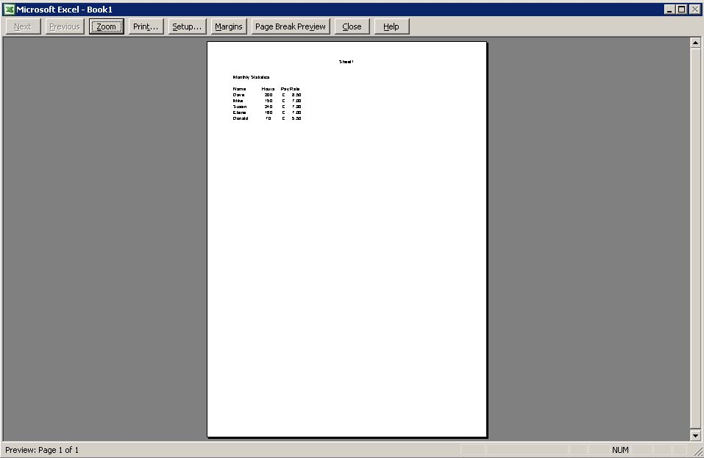
from the File menu, choose Print Preview.
The current page of the worksheet will be displayed as shown below.
Click here to navigate between pages.
Click here to zoom in and out

Click here to return to
the worksheet

Figure 8

Insert an executive summary or abstract at the top of the document

Highlight key points

Figure 9

Hide everything but the summary without leaving the original document

Use the AutoSummarize function to "create a new document" based on 20% of the original.
Print off the summary and score it The AutoSummarize dialog box

fluency of summary.
Create your own version, improving on the auto-summary without increasing the word length.

the [Ctrl] key while selecting the files.

Tip:

d down the [Ctrl] key while selecting the files.

Tip:

Figure 8

Insert an executive summary or abstract at the top of the document

Highlight key points

Figure 9

Hide everything but the summary without leaving the original document

Use the AutoSummarize function to "create a new document" based on 20% of the original.
Print off the summary and score it The AutoSummarize dialog box

fluency of summary.
Create your own version, improving on the auto-summary without increasing the word length.

the [Ctrl] key while selecting the files.

Tip:

d down the [Ctrl] key while selecting the files.

Printing a worksheet
The worksheet can be printed directly from the Preview window, or from the Page Setup dialog box.
From the File menu choose Print.
The Print dialog box appears as shown:
Choose what you wish to print here.

Text box

Text box

WebCT for Designers

ox

WebCT for Designers

ox

box

Print All or specify page range.

Printing a selected range
You may specify the range of what you want to print in the current worksheet using the Print range options.
Print what allows you to choose how many pages to print, or to print a highlighted selection, alternative sheets or the entire workbook.

Learning more

Central IT Training
Information Systems run courses for UCL staff, and publish documents for staff and students to accompany this workbook as detailed below:
Getting started with Excel | This 3hr course is for those who are new to spreadsheets or to Excel, and wish to explore the basic features of spreadsheet design. Note that it does not cover formulae and functions.
Getting more from Excel (no formulae or functions) | This 3hr course is for users of Excel who wish to learn more about the non-mathematical features of Excel and to work more efficiently.
Using Excel to manage lists | This 3hr course is for those already familiar with Excel and would like to use some of its basic data-handling functions.
Excel formulae & functions | This 3hr course is aimed at introducing users, who are already familiar with the Excel environment, to formulae and functions.
More Excel formulae & functions | This 3.5hr course is aimed at competent Excel users who are already familiar with basic functions and would like to know what else Excel can do and try some more complex IF statements.
Advanced formulae & functions | This 3.5hr course is aimed at competent Excel users who are already familiar with basic functions. It aims to introduce you to functions from several different categories so that you are equipped to try out other functions on your own.
Excel statistical functions | This course aims to introduce you to built-in Excel statistical functions and those in the analysis tool pack. The course covers major descriptive, parametric and non-parametric measures and tests.
Excel statistical formulae | This course covers best practise in constructing complex statistical formulae in spreadsheets using common statistical measures as example material.
Excel tricks and tips | This is a 2hr interactive demonstration of popular Excel shortcuts. It aims to help you find quicker ways of doing everyday tasks. This fast-paced course is also a good all-round revision course for experienced Excel users.
Pivot tables | Pivot tables allow you to organise and summarise large amounts of data by filtering and rotating headings around your data. This 2 hr course also shows you how to create pivot charts.
Advanced Excel – Data analysis tools | This course aims to help you learn to use some less common Excel features to analyse your data.
Advanced Excel – Setting up & automating Excel | Would you like to customise and automate Excel to perform tasks you do regularly? If you are an experienced user of Excel, then this course is for you.
Advanced Excel – Importing data and sharing workbooks | Do you share workbooks with others? Would you like to see who has updated what? Do you know how to import data from text files or databases? This course aims to show you how.

These workbooks are available for students at the Help Desk.

Open Learning Centre
- The Open Learning Centre is open every afternoon for those members of staff who wish to obtain training on specific features in Excel on an individual or small group basis. For general help or advice, call in any afternoon between 12:30pm – 5:30pm Monday – Thursday, or 12:30pm – 4:00pm Friday.
- If you want help with specific advanced features of Excel you will need to book a session in advance at: www.ucl.ac.uk/is/olc/bookspecial.htm
- Sessions will last for up to an hour, or possibly longer, depending on availability. Please let us know your previous levels of experience, and what areas you would like to cover, when arranging to attend.
- See the OLC Web pages for more details at: www.ucl.ac.uk/is/olc

On-line learning
There is also a comprehensive range of online training available via TheLearningZone at: www.ucl.ac.uk/elearning

Getting help
The following faculties have a dedicated Faculty Information Support Officer (FISO) who works with faculty staff on one-to-one help as well as group training, and general advice tailored to your subject discipline:
- Arts & Humanities
- The Bartlett
- Engineering
- Maths and Physical Sciences
- Life Sciences
- Social & Historical Sciences
See the Faculty-based support section of the www.ucl.ac.uk/is/fiso Web page for more details.
A Web search using a search engine such as Google (www.google.co.uk) can also retrieve helpful Web pages. For example, a search for "Excel tutorial” would return a useful selection of tutorials.

