UCL
Education & information support division
information systems



Excel 2003

Introduction to Formulae and Functions

Document No. IS-016

Contents
Creating simple formulae 1
Some common formulae 1
The order of precedence 1
Calculation with dates 1
Editing a formula 1
Copying formulae 1
Functions 1
Functions and arguments 1
The Sum function 1
Using the Insert Function 1
Function box 1
Precision formatting 1
Statistical & mathematical functions 1
Cell references 1
Absolute cell referencing 1
Making a reference absolute 1
Working with Names 1
Default names 1
Naming rules 1
Creating a Name 1
Defining names 1
Creating multiple names 1
Selecting names 1
Names in formulae 1
Applying names 1
Deleting Names 1
Paste List 1
Counting and totalling cells conditionally 1
SUMIF() 1
COUNTIF() 1
Understanding error messages 1
Typical errors and their causes 1
Viewing formulae 1
Learning more 1

Introduction
This workbook has been prepared to help you use Excel to do calculations using basic Excel formulae and functions. It is aimed at those who have a good understanding of the basic use of Excel for entering data. It assumes knowledge of moving around a worksheet, formatting cells, and controlling worksheet display and printing. These topics are all covered in the Getting started with Excel course. Details of more advanced functions can be found in the Excel – more formulae & functions course and workbook.
This guide can be used as a reference or tutorial document. To assist your learning, a series of practical tasks are available in a separate document. You can download the training files used in this workbook from the IS training web site at: www.ucl.ac.uk/is/documents

Creating simple formulae
Formulae allow the calculation of data or values. These calculations range from simple arithmetic (addition, multiplication etc.) to more complex statistical, logical and database functions.
You enter a formula by typing it in the cell where you want its result to appear. When you confirm entry of a formula, Excel will display the result on the worksheet, but the underlying calculation appears in the formula bar.
Formulae always start with an = (equals) sign.
Place the formula in the cell where the result is to be displayed.
Formulae should refer to the cell address not the contents of the cells,
i.e. to add the two numbers shown above the correct formula is:
=A1+A2
not
=10+15
- The result is displayed in the cell when the Tick button on the formula bar is clicked, or the Return key is pressed.
Click here to show the result or press Return.
- You can cancel a formula if necessary by clicking on the red X button on the formula bar or pressing the Esc key.
- When the contents of a cell referred to in a formula change, the formula automatically calculates and displays the new result.
I.e. if the value in cell A1 is changed to 15 in the example above, the formula automatically recalculates to display the result 30.

Some common formulae

Operator | Description | Excel Formula
+ | Addition | =A1+A2 add A1 and A2
- | Subtraction | =A1-A2 subtract A2 from A1
* | Multiplication | =A1*A2 multiply A1 by A2
/ | Division | =A1/A2 divide A1 by A2
^ | Exponential | =A1^A2 raise A1 to the power A2
% | Percentage | =A1 % express A1 as a percentage

These operations can also be combined together. For example:
=A1-A2/A1+A2)
or
=(A1+B2–D4)*50
Use brackets to ensure that the different parts of the formula are calculated in the correct order. For example =(3+2)*4 is not the same as =3+2*4.

The order of precedence
Excel evaluates operators following the conventional rules – it will apply the calculations in a formula in the following order:
BODMAS: Brackets Of Division Multiplication Addition Subtraction
( ) | brackets first
/ and * | division and multiplication
+ and - | addition and subtraction
Formula | Result
=3+2*4 | 11
=(3+2)*4 | 20

Take care to observe these rules when creating your own formulae.
Incorrect syntax will result in error.

Calculation with dates
Excel also allows you to perform calculations with dates. All dates are stored in Excel as sequential numbers. By default, January 1 1900 is serial number 1, and January 1, 2004 is serial number 37987 because it is 37,987 days after January 1, 1900. Excel stores times as decimal fractions because time is considered a portion of a day.
Because dates and times are values, they can be added, subtracted, and included in other calculations. You can view a date as a serial value and a time as a decimal fraction by changing the format of the cell that contains the date or time to General format.

Viewing dates as numbers
To view dates as numbers:
- Select the cell and click Cells on the Format menu.
- Click the Number tab, and then click Number in the Category box.

Calculating the difference between two dates
In the following example the date in cell B1 has been subtracted from the date in cell B2. The result in cell B3 has been formatted to display a number (the number of days between two dates) with no decimal places.

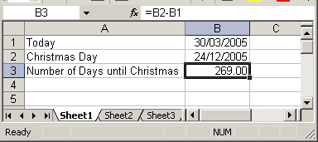

Editing a formula
- Double-click on the cell containing the formula. The cell will switch from displaying the result of the formula to the formula itself.
- Click the mouse over the part of the formula you wish to change to insert the cursor there. Type any new character or use the Backspace or Delete keys to remove characters.
- Press Enter to confirm your changes, or Esc to exit the cell without saving your changes.
or
- Move to the cell containing the formula you wish to change.
- The formula will be displayed in the formula bar.
- Click into the formula bar and make the necessary changes.
- Click on the green tick to the left of the formula to confirm your change, or the red cross to close the formula without saving your changes.
or
- Move to the cell containing the formula you wish to change and press the F2 key.
- Use the arrow keys to move the cursor to the edit position. Make your changes and exit the cell as explained above.

Copying formulae
Formulae can be copied using the Copy and Paste buttons in the same way as data can be copied in a worksheet.
- Select the cell containing the formula to be copied.
- From the Edit menu choose Copy (or use the Copy icon).
- Move the cursor to the new location.
- From the Edit menu choose Paste (or use the Paste icon).
Note how the cell references change as we copy the formula from cell A2 to cell B2 below left.
=A1 becomes =B1
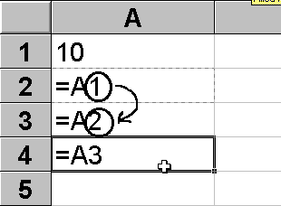
Note how the cell references change as we copy the formula from cell A2 to cell A3 below right.
=A1 becomes =A2
Notice how the reference changes by one row relative to its starting position.
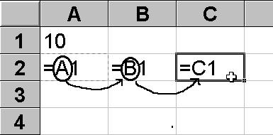
Notice how the reference changes by one column relative to its starting position.
When a formula is copied, it is applied relative to the new range.
Therefore, the formula =A1 will become =A2 when copied to the next row,
and the formula =A1 and will become =B1 when copied to the next column.

Using the fill handle
- Move to the cell that has the formula that you want to fill.
- Position your mouse pointer over the fill handle. It will change to a black plus.
- Drag the black plus down or right over the cells where you want your copied formula to generate results. You will see an outline around those cells.
- 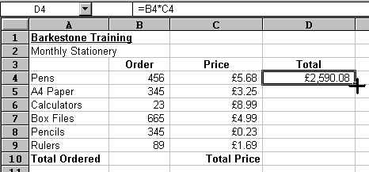Release the mouse when the outline includes all the cells where you want results.

Using keystrokes
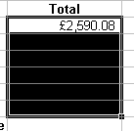You can fill a column or a row of formulae using the keyboard.
- Select the cell containing the formula to fill and the cells where you want to copy it.
- Press Ctrl+D to fill down.
or
Press Ctrl+R to fill right.
There are no keystrokes to fill up or left. Instead, repeat step one above and then click Edit on the menu bar, choose Fill and select the direction for the fill from the resulting sub-menu.

Functions
You have seen how to enter formulae to perform simple arithmetic operations on values in a worksheet. Excel also provides many built-in functions which automate a number of types of calculation. Functions are pre-programmed formulae – you are probably already familiar with the use of functions on a calculator (for example, the square-root function, trigonometric functions, logarithms etc.). Excel has more than 300 functions covering a range of statistical, mathematical, financial and logical operations. If you have many numbers in a group of cells that you wish to combine in a formula, typing the formula becomes laborious. Using a function offers a shortcut method.
Examples of the most commonly used functions include the Average function, which calculates the average of a group of cell values, the Sum function, which adds together a group of cell values, and the Min and Max functions, which determine the lowest and highest values in a group of cells.

Functions and arguments
Functions are usually written with the equals sign (=) followed by the function name and then parentheses containing the argument. Usually the argument just contains the range of cells which the function will operate on. For example, the Average function is written as:
= AVERAGE(A1:A4)
function name
argument
The argument of a function is placed in brackets. To specify a range of cells a colon is used between the first and the last cell address. For example, (A1:A4) will specify cells A1, A2, A3 and A4.

The Sum function
The Sum function is a useful function. It simply adds together a range of cell values. The formula:
=A1+A2+A3+A4+A5+A6+A7+A8
can be replaced by:
=SUM(A1:A8)
This adds up the contents of the cells A1 to A8.
- The function can be typed at the keyboard like any other formula.
- The function can be created with the Insert Function.
- The SUM function can be created using the AutoSum button (this is the easiest method).

AutoSum 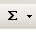
The AutoSum feature allows you to add all numbers in a contiguous row or column.
To use AutoSum:
- Click a cell below the column of numbers or to the right of the row of numbers.
- Click the AutoSum button on the Standard toolbar, and then press Enter.
Excel automatically guesses the range of cell references that you wish to sum (these can be amended if necessary).
Note: Always check automatically generated formulae before accepting them, as Excel doesn’t always guess correctly.

Using the Insert Function
If you know the name of a function, you can simply type it in together with the argument or range of cells you want to apply it to. However, an easy way to work with functions is to use the Insert Function.
- Position the cursor in the cell which is to contain the result, and from the Insert menu select Function or click the Insert Function button on the Formula bar.
- The Insert Function dialog box is displayed.
Using the Search for a function box, you can type a description of what you want to do. The Most Recently Used category often offers the most likely choices. Select an appropriate category. The functions in that category are shown in the lower half of the window.

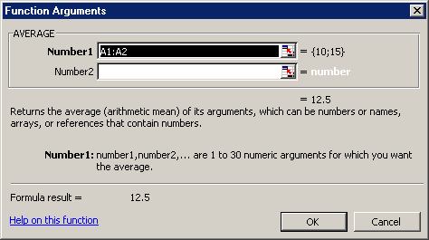
If in this example we choose AVERAGE and click on OK, the Function Arguments dialog box will display as shown below. It may well obscure the part of the worksheet you want to work on. However it can be moved simply by clicking and dragging anywhere in the grey shaded box. It can also be shrunk by clicking on the Shrink/Enlarge buttons.

Note that Insert Function guesses the range of cells to be used in the calculation (A1:A2 in the example). Click OK if this is correct. Alternatively type the range in, or highlight the cells required in the worksheet.
Notice that a moving border appears around the specified cells as the range is entered in the dialog box. Click OK.

You can view the completed formula by clicking in the cell, and looking at the contents of the Formula bar.

Function box
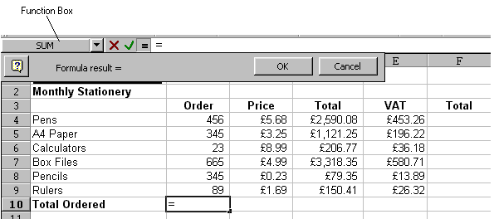The Function box groups the most commonly used functions for quick and easy access.
- Position the cursor where you want the function and type an equals sign into the cell.
- Excel displays the Function box to the left of the Formula bar. Click the drop-down list arrow to the right of the Function box to display a list of function names.
- Select the function you require by clicking its name from the list.
- 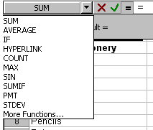If your function isn’t listed, click the More Functions option to access the Insert Function dialog box.
- Excel will place the chosen function on the worksheet in the selected cell. You can see the selected function being built on the Formula bar.
With some functions, Excel tries to guess which cells you want included as the function arguments. Click OK to accept Excel’s guess and confirm the function, or select the correct cells as described above.

Precision formatting
Care must be taken when working with formatted numbers. It is important to remember that formatted numbers, i.e. the numbers which appear on the screen, may not be the same as the value stored in the cell or the numbers used in calculations. The discrepancy can cause the results displayed to be different from the manually calculated answers.
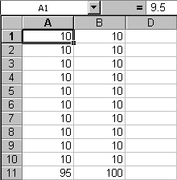
In the example opposite, there are two columns of numbers that appear to be the same. The first column adds up to 95 but the second column adds up to 100. Take a close look at the value stored in cell A1, as displayed in the Formula bar. The value stored in all the cells in the first column is actually 9.5. This has been formatted to appear as a whole number (integer). The calculation is actually correct (10*9.5=95), although it appears to be incorrect. The problem can be avoided by using number formats cautiously, or it can be resolved by setting the precision for the entire worksheet as explained below.

Setting the precision of number formats
To set the precision of number formats for an entire worksheet:
- Choose the Tools menu, then the Options command and select the Calculation tab.
- Choose the Precision as displayed box and click OK.
When you choose OK you are warned that constant numbers throughout the worksheet will be rounded permanently to match cell-formatting.

Statistical & mathematical functions
Some of the most commonly used statistical and mathematical functions are shown below.
Function | Example | Description
MAX | MAX(C1:C10) | Finds the largest cell value in the specified range of cells.
MIN | MIN(C1:C10) | Finds the smallest cell value in the specified range of cells.
AVERAGE | AVERAGE(C1:10) | Finds the average cell value in the specified range of cells.
MEDIAN | MEDIAN(C1:C10) | Finds the median or middle value in the specified range of cells.
STDEV | STDEV(C1:C10) | Finds the standard deviation of the values in a range of cells.
COUNT | COUNT(C1:C10) | Counts the number of cells containing numbers.
COUNTA | COUNTA(C1:C10) | Counts the number of cells containing numbers or letters (i.e. the number of non-blank cells).
COUNTBLANK | COUNTBLANK(C1:C10) | Counts the number of blank cells.
ROUND | ROUND(C1, 2) | Rounds the cell value to the specified number of decimal places (2 in this example; use 0 to get a whole number).
SQRT | SQRT(C1) | Calculates the square root of a cell value.
RADIANS | RADIANS(C1) | Converts angles from degrees to radians.
SIN | SIN(C1) | Calculates the Sine of an angle (in radians – use the RADIANS function to convert degrees into radians).  Other trigonometric functions include COS and TAN.

Cell references
In functions, you often need to refer to a range of cells. The way Excel displays cell references in functions depends on whether the cells you want the function to act upon are together in a block, or in several non-adjacent cells or blocks.
The table below explains how to use different operators to refer to cells:
Operator | Example | Description
Reference operator : (colon) | B5:B15 | Range operator that produces one reference to all the cells between two references, including the two references.
, (comma) | SUM(B5:B15,D5:D15) | Union operator that combines multiple references into one reference.
(single space) | =B5:B15 A7:D7 | Intersection operator that produces one reference to cells common to two references. In this example, cell B7 is common to both ranges; therefore the result would be the contents of cell B7.

Absolute cell referencing
The ability to copy formulae from one location to another in a spreadsheet can save you a significant amount of work. Normally, if you copy a formula involving a cell reference to another location, the cell reference is adjusted relative to its starting point. So, for example, copying a formula calculating the sum of a column of numbers to an adjacent cell, will add up the adjacent column of cells. The formula has updated automatically to refer to adjacent cells. This is an example of a relative referencing system.
Sometimes we may need to refer to a specific cell location in a worksheet, and so we want that cell reference to remain unchanged, regardless of where the formula is placed. We need a method to fix our cell reference so that it does not update when we copy the formula to another location – we need an absolute cell reference.

Making a reference absolute
Type a $ sign before both the column letter and the row number of the cell reference. E.g. the relative reference A1 becomes the absolute reference $A$1.
Or use the keyboard shortcut, F4.
- In the Formula bar, highlight the cell reference for the cell which is to be made absolute.
- Press F4.
$ signs are automatically placed in front of the column and row references.

Making a mixed reference
If only the columns or the rows are to be absolute, prefix one or other of these with a $ sign. For example, if the column is to be absolute and the row relative A1 becomes $A1, if the row is to be absolute and the column relative A1 becomes A$1.
- Double-click in the cell as if to edit it.
A1 Relative
$A$1 Absolute
$A1 Mixed
A$1 Mixed
A$1 Mixed
- Highlight the cell reference to be made absolute and press F4. Note that by pressing F4 a number of times you cycle through different options for creating a mixed reference.

Absolute references explained
The data, to the left, show the basic earnings for a group of staff. Their manager has decided to award them a bonus payment, and wishes to store the total pay in column C.
The formula for cell C6 is =(B6+$B$3). Here the $ is used to make the reference to cell B3 absolute. When this formula is copied into cells C7:C12, the formula updates as shown.

Working with Names
It is easy to lose track of what information particular cells or ranges of cells in a worksheet contain, particularly in a large worksheet. Referring to a cell (or range of cells) by its cell address (e.g. A1, G19, C25:C65) is not very intuitive. To help the user of a worksheet, Excel allows you to create a Name to refer to a cell, a group of cells, a value or a formula.
- A name is easier to remember than a cell reference.
- You can use a named reference almost anywhere you might use a regular reference, including in formulae and dialog boxes.
- Formulae that use names are easier to read and remember than formulae using cell references. For example, the formula:
=Assets-Liabilities
is clearer to read and understand than the formula: =F6-G6
- Excel can automatically create names for cells based on row or column titles in your spreadsheet, or you can enter names for cells or formulae yourself.
- If you name a cell you are likely to need to use in an absolute reference, it will save you from using the $ symbol in the cell reference, as you will simply need to refer to the cell name.

Default names
By default, every cell has a unique name – the cell address (A1, F4 etc.). When you select a cell, its name appears in the Name Box.
It is possible to move directly to a cell location simply by typing the cell name into the Name Box and pressing Enter.

Naming rules
Names are unique within a workbook and the names that you choose to use must adhere to certain rules.
- The first character of a name must be a letter or an underscore character. Remaining characters in the name can be letters, numbers, full stops, and underscore characters.
- Names cannot be the same as a cell reference, such as Z$100 or R1C1.
- Spaces are not allowed. Underscore characters and full stops may be used as word separators – for example, First.Quarter or Sales_Tax.
- A name can contain up to 255 characters.
- Names can contain uppercase and lowercase letters. Excel does not distinguish between uppercase and lowercase characters in names. For example, if you have created the name Sales and then create another name called SALES in the same workbook, the second name will replace the first one.

Creating a Name
- 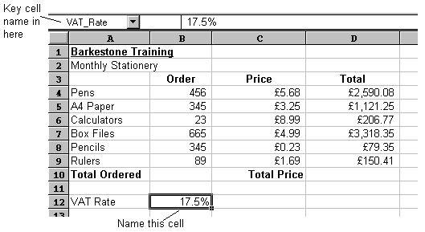Select the cell or cells you want to name.
- Click in the Name box and type a name.
- Press Enter.

Defining names
You will often find that the names you want to use for your cells are the same as the headings you have given them in your worksheet. When this is the case, you can save yourself some typing by using Define Name to set them up. With the Define Name command, Excel looks at the cells around those selected and if it finds a label, it proposes that you use it as your name. You can still overwrite Excel’s proposal if it chooses something inappropriate.
- 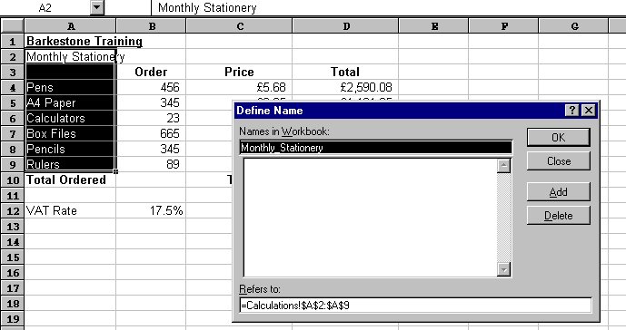Select the cell or cells you want to name.
- From the Insert menu, select Name and then Define. The following dialog box will appear:

The Names in workbook box will contain the name Excel proposes for the selection. The Refers to box (at the bottom of the dialog box) will show the range of the selected cells.
- Click OK to accept Excel’s proposed name and close the dialog box.
or
Type the name you want to use.
Click OK to set the name up and close the dialog box.

Creating multiple names
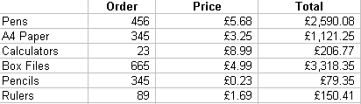
When you want to use column and row headings on a worksheet to set up names for data, you don’t have to do them one by one. In the example below, it would be useful to set up names for the different stationery items and the different column headings. You can create them all at once using Create Names.
- Select the range for which you want to set names up, including the column and/or row headings to be used as names.
- 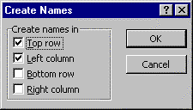From the Insert menu, select Name, and then Create. The following dialog box will appear:
- Excel will guess which edges of the selection contain the labels you want to use. However, you can change the options by checking and unchecking the boxes until the correct edges are selected.
- Click OK to set the names up.
When you select a named range, its name appears in the Name Box.

Selecting names
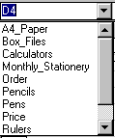Once you have created names in a workbook, you can quickly move to them either using the Name Box or F5 (GoTo key).
- Click the drop-down list arrow to the right of the Name Box.
- Choose the name you want to select by clicking it with the mouse.
- The screen display will jump to the range you chose and select the cells within it.
or
- Press F5 to access the GoTo dialog box.
- Press Tab to select the first item in the GoTo list.
- Use the arrow keys to move the highlight bar up and down the list of defined names.
- Press Enter to move to the selected name.

Names in formulae
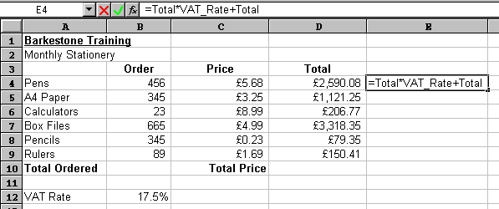Because names make selecting and referring to cells much easier, it makes sense to use them in formulae. The other advantage that they have over cell references is that names are absolute. This means that you don’t have to worry about copying formulae that refer to names.

To use names in a formula:
- 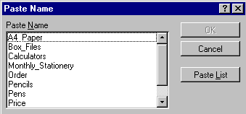Move to the cell where you want the formula and begin typing it – all formulae begin with an equals (=) sign.
- When you want to use the name, press F3 to access the Paste Name dialog box.
- Use the up and down arrow keys to highlight the name you want in your formula.
- Press Enter to close the dialog box and paste the name into the formula.
If you can remember what you called your ranges when you named them, you can simply type the names into the formula.

Applying names
There may be occasions where you already had formulae and functions set up in a workbook before you created any names. This might mean that there are formulae referring to cell references that you have subsequently given names to. You can apply names to formulae even if you created them after the formulae themselves were set up.
- Select the cell or cells containing the formulae whose references you want to replace with names.
- 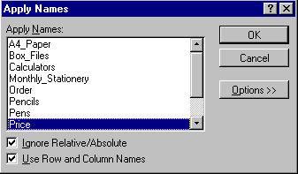From the Insert menu, click Name and then Apply. The following dialog box will appear:
- Excel will pick those names it thinks relevant to your selection, however, you can select or deselect other names in the list by clicking on them.
- When all names to be applied have been selected, click OK to apply the names and close the dialog box. When you look at your formulae, you should find that anywhere there were references to named ranges; Excel has replaced the cell references with the names.

Deleting Names
You can delete names from your workbook if you are no longer using them.
- From the Insert menu, select Name then Define. The Define Name dialog box will appear. Any names in the currently opened files appear listed.
- Click the name you want to delete.
- Click the Delete button then click the OK button to close the dialog box.
- If you delete a name that is being used in formulae, Excel will display #NAME? in the cell containing those formulae. (You can use the Edit|Undo feature to reinstate the name.)

Paste List
You can use the Paste Names dialog box to give you an index of all the names in your workbook. Excel will place this on the workbook wherever the active cell is positioned.
- Select a blank cell where you want the list of names to begin.
- Press F3 to access the Paste Names dialog box.
- Click the Paste List button.
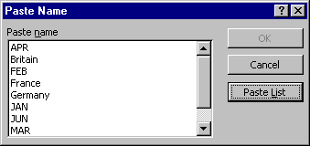
or
press Tab to jump to the Cancel button, then Tab again to select the Paste List button.
The list will appear on the worksheet.
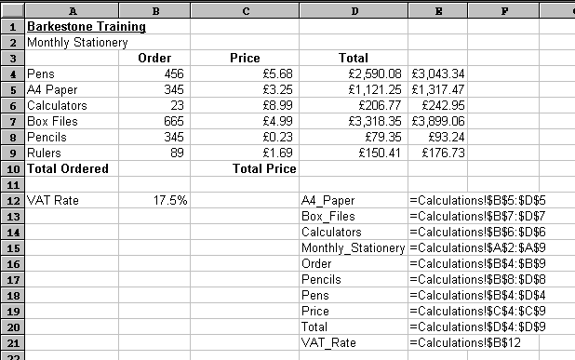When you choose a start cell for your pasted list, make sure there isn’t any data immediately below, as it will get cleared when you paste the list.

Counting and totalling cells conditionally
Occasionally you may need to create a total that only includes certain cells, or count only certain cells in a column or row. The only way you could do this is by using functions that have conditions built into them. A condition is simply a test you can ask Excel to carry out, the result of which will determine the result of the function.

SUMIF()
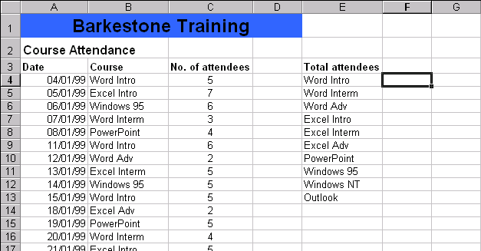You can use this function to say to Excel, “only total the numbers in the Total column where the entry in the Course column is “Word Intro”.

The syntax of the SUMIF() function is detailed below:
=SUMIF(range,criteria,sum_range)

Range is the range of cells you want to test.
Criteria are the criteria in the form of a number, expression, or text that defines which cells will be added. For example, criteria can be expressed as 32, "32", ">32", "apples".
Sum_range are the actual cells to sum. The cells in sum_range are summed only if their corresponding cells in range match the criteria. If sum_range is omitted, the cells in range are summed.
Using the example above the SUMIF() function would be as follows:
=SUMIF(B4:B23,"Word Intro",C4:C23)

COUNTIF()
The COUNTIF function allows you to count those cells that meet a certain condition. The function syntax is as follows:
=COUNTIF(range,criteria)
Range is the range of cells from which you want to count cells.
Criteria are the criteria in the form of a number, expression, or text that defines which cells will be counted. For example, criteria can be expressed as 32, "32", ">32", "apples".
With our example (shown above), the COUNTIF function you could use to determine the number of Word Intro courses run would be:
=COUNTIF(B4:B23, “Word Intro”) or =COUNTIF(B4:B23, E4)

Understanding error messages
Excel may display error messages if your formulae or functions contain mistakes (note that it will not detect all errors in calculations). It is always worth checking the result of your formulae by hand if the formula is at all complex. Excel’s error messages contain a # symbol followed by a diagnostic word (see the table below). In some cases, the cell with an error in it has a small green arrow in the corner. In such cases, if you click in the cell a yellow symbol with an exclamation mark appears. Click the exclamation mark for options to help you to trace the source of the error.
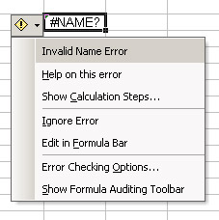
Green triangle Cell containing error message

Yellow symbol with exclamation mark

Options for dealing with error

Typical errors and their causes

###### | The column is not wide enough to display data (for numbers).  Date or time may be negative.
#VALUE! | Occurs when the wrong type of argument is used in a function or formula. For example, there is text in a formula that requires a number or logical value.
#DIV/0! | Occurs when a number is divided by zero.
#NAME? | Occurs when Excel doesn’t recognise text in a formula (e.g. misspelling a function name or cell reference).
#N/A | Occurs when a value is not available to a formula or function – perhaps data are missing.
#REF! | Occurs when a cell reference is not valid – perhaps the cell has been deleted.
#NUM! | Occurs when a number is invalid – perhaps a price has been entered with the £ sign, or a formula results in a number too big or too small for Excel to display.
Circular reference | This happens when the formula points to the cell in which the result is to be displayed, e.g., placing the formula =SUM(A1:A2) into cell A2.

Viewing formulae
Sometimes you may want to view the actual formulae in your worksheet, rather than the numerical results of the formulae. This can be particularly useful if you are getting error messages and need to examine the formulae. To view the formulae:
- From the Tools menu choose Options to reveal the Options window.
- Select the View tab, and click the Formulas check box and OK.
Formulas

- All formulae in the worksheet will display in full as shown below (this can be useful for trouble-shooting if your calculations do not seem to be working – you can print out the formulae for closer inspection). Notice how the columns automatically widen to accommodate the formula.
- You can turn off the formula display using the same check box in the Options window. Notice how the columns shrink again to their original width.

Helpful hint:
Press Ctrl and ` (the open single inverted comma key, usually found to the left of the number 1 key on the top row of your keyboard). You can toggle between formulae and values by pressing Ctrl+` repeatedly.

Learning more

Central IT training
Information Systems runs courses for UCL staff, and publishes documents for staff and students to accompany this workbook as detailed below:
Getting started with Excel | This 3hr course is for those who are new to spreadsheets or to Excel, and wish to explore the basic features of spreadsheet design. Note that it does not cover formulae and functions.
Getting more from Excel (no formulae or functions) | This 3hr course is for users of Excel who wish to learn more about the non-mathematical features of Excel and to work more efficiently.
Using Excel to manage lists | This 3hr course is for those already familiar with Excel who would like to use some of its basic data-handling functions.
Excel formulae and functions | This 3hr course is aimed at introducing users, who are already familiar with the Excel environment, to formulae and functions.
More Excel formulae and functions | This 3.5hr course is aimed at competent Excel users who are already familiar with basic functions and would like to know what else Excel can do and try some more complex IF statements.
Advanced formulae and functions | This 3.5hr course is aimed at competent Excel users who are already familiar with basic functions. It aims to introduce you to functions from several different categories so that you are equipped to try out other functions on your own.
Excel statistical functions | This course aims to introduce you to built-in Excel statistical functions and those in the Analysis ToolPak. The course covers major descriptive, parametric and non-parametric measures and tests.
Excel statistical formulae | This course covers best practise in constructing complex statistical formulae in spreadsheets using common statistical measures as example material.
Excel tricks and tips | This is a 2hr interactive demonstration of popular Excel shortcuts. It aims to help you find quicker ways of doing everyday tasks. This fast-paced course is also a good all-round revision course for experienced Excel users.
Pivot tables | Pivot tables allow you to organise and summarise large amounts of data by filtering and rotating headings around them. This 2hr course also shows you how to create pivot charts.
Advanced Excel – Data analysis tools | This course aims to help you learn to use some less common Excel features to analyse your data.
Advanced Excel – Setting up and automating Excel | Would you like to customise and automate Excel to perform tasks you do regularly? If you are an experienced user of Excel, then this course is for you.
Advanced Excel – Importing data and sharing workbooks | Do you share workbooks with others? Would you like to see who has updated what? Do you know how to import data from text files or databases? This course aims to show you how.

These workbooks are available for students at the Help Desk.

Open Learning Centre
The Open Learning Centre is open every afternoon for members of staff who wish to obtain training on specific features in Excel on an individual or small group basis. For general help or advice, call in any afternoon between 12:30pm – 5:30pm Monday – Thursday, or 12:30pm – 4:00pm Friday.
- If you want help with specific advanced features of Excel you will need to book a session in advance at: www.ucl.ac.uk/is/olc/bookspecial.htm
- Sessions will last for up to an hour, or possibly longer, depending on availability. Please let us know your previous levels of experience, and what areas you would like to cover, when arranging to attend.
- See the OLC Web pages for more details at: www.ucl.ac.uk/is/olc

Online learning
There is also a comprehensive range of online training available via TheLearningZone at: www.ucl.ac.uk/elearning

Getting help
The following faculties have a dedicated Faculty Information Support Officer (FISO) who works with faculty staff on one-to-one help as well as group training, and general advice tailored to your subject discipline:
- Arts and Humanities
- The Bartlett
- Engineering
- Life Sciences
- Maths and Physical Sciences
- Social and Historical Sciences
See the faculty-based support section of the www.ucl.ac.uk/is/fiso Web page for more details.
A Web search using a search engine such as Google (www.google.co.uk) can also retrieve helpful Web pages. For example, a search for “Excel tutorial” would return a useful selection of tutorials.

