UCL
Education & information support division
information systems



Excel 2003

More Excel
(no formulae or functions)

Contents
Introduction 2
Handling large worksheets 1
Split screen 1
Freeze panes 2
Zoom 2
More on formatting 3
Custom number formats 3
Format painter 4
Action buttons 5
Triangle indicators in cells 6
Comments 6
Paste special 7
Transposing data 8
Working with workbooks 9
Managing worksheets 9
Selecting worksheets 11
Entering data 11
Moving between workbooks 12
Moving and copying in workbooks 12
Referencing cells in different worksheets 13
Summarising data held on different worksheets 13
Document links 14
Terminology 14
Creating a link 15
Security 17
Protecting worksheet data 17
Protecting workbooks 20
Hide columns and rows 21
Hiding workbooks and worksheets 22
Learning more 23

Introduction
This workbook has been prepared to help you get more from Excel. It does not cover formulae and functions. These topics are covered on the Introduction to formulae and functions, and More formulae and functions courses. Features used for handling data, e.g., sorting, outlining, views, data forms, and validation, are covered on the Using Excel to manage lists course.
This course is aimed at those who have a good understanding of the basic use of Excel for entering data. It assumes knowledge of moving around a worksheet, formatting cells, controlling worksheet display and printing. These topics are all covered in the Getting started with Excel course.
This guide can be used as a reference or as a tutorial document. To assist your learning, a series of practical tasks are available.
If you with to attempt the exercises contained in the exercise document and you are not using a training account, it is necessary to download the training files used in this workbook from the IS Training website at www.ucl.ac.uk/is/training/exercises.htm. Full instructions on how to do this are provided there.

Handling large worksheets
When you open a workbook, it is displayed in a window, a specific area of the screen. More than one window can be open at a time, and they can be viewed on the screen at the same time, but only one window can be active at any one time.
When working on a large worksheet, it is sometime useful to split it into separate windows, so that separate parts of the same worksheet can be displayed on the screen at the same time.

Split screen
The visible worksheet area is relatively small. If the data with which you are working spans a large number of columns and rows, you may find it difficult to move and copy information between areas, or even to view data in non-adjacent columns or rows on the same screen. Splitting the screen gives you the ability to scroll the data on one side of the split independently of the data on the other side – for example, you could be viewing cells A1 – G16 on one side of your screen, and cells M50 – Z76 on the other.

Splitting the screen horizontally
Position the mouse along the top edge of the pointing arrow at the top of the vertical scroll bar – your pointer should display as a double-headed arrow.
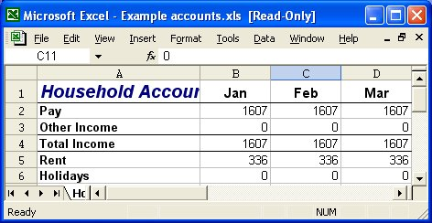
Drag down – you will see a grey bar that follows your mouse down. Release the mouse when the line is at the position you want to split the screen.
Split screen button
Split screen button
or select Window|Split. Drag the bars to the required position.

Splitting the screen vertically
- Position the mouse along the right edge of the pointing arrow at the right of the horizontal scroll bar – your pointer should display as a double-headed arrow.
- Drag left – you will see a grey bar that follows your mouse across. Release the mouse when the line is at the position you want to split the screen.
or select Window|Split. Drag the bars to the required position.
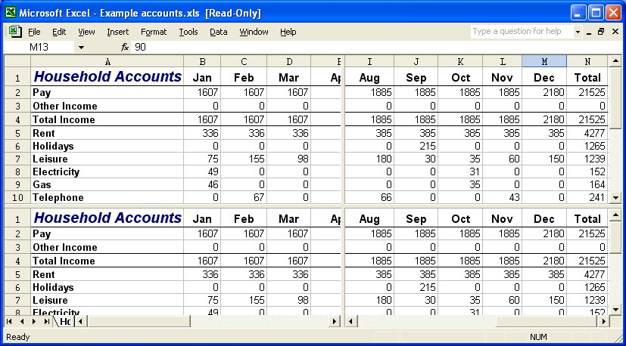
When the screen is split, you get scroll bars in each horizontal and/or vertical section of your window. These can be used to move the display in that particular section.

Removing the split
Double-click on the grey split bar
or
select Window|Remove Split.

Freeze panes
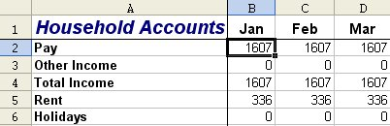
When you want certain rows or columns to remain static on screen while you scroll down or across data on a worksheet, you can use Freeze Panes.
Freeze lines
- Select the cell below and to the right of the cells you want to freeze.
- Select Window|Freeze Panes. You will see solid lines appear below and to the right of the frozen rows and columns.
If you only want to freeze rows, select the cell in column A below the rows you want to freeze. If you only want to freeze columns, select the cell in row 1 to the right of the columns you want to freeze.

Unfreeze panes
Select Window|Unfreeze Panes. If you have both columns and rows frozen, this removes both.

Zoom
Zoom is used to control how much of a worksheet can be seen on the screen. The zoom magnification can be changed using the Zoom Control box, or by selecting Zoom from the View menu.
Excel allows you to specify any percentage between 10 and 400 for viewing on-screen data.

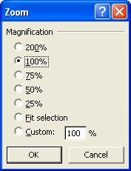
Zooming the screen display
- Select View|Zoom. The Zoom dialog box will appear.
- Select the percentage by which you want to scale the view by clicking one of the option buttons, or drag across the percentage figure currently displayed in the Custom box and type the figure you want to use.
- Click OK to apply the zoom and close the dialog box.

Helpful hint:
If there is a particular range of columns that you need to make visible on one screen without scrolling to the right, you can select them and then use the Fit selection option. Your screen will be scaled so that the selected columns are all visible without scrolling.

More on formatting

Custom number formats
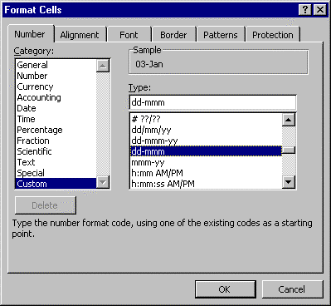There are occasions when you want numeric data to display in a way for which Excel does not have a built-in format. When this happens, you can create a custom format.
- Select the cells you want to format.
- From the Format menu select Cells to access the Format Cells dialog box.
- Click the Number tab if it is not already selected.
- Choose the Custom category (the last option on the Category list). The dialog box will change to show you a list of Type format codes.
- Scroll down the Type list until you find a code similar to the one with which you want to format your data.
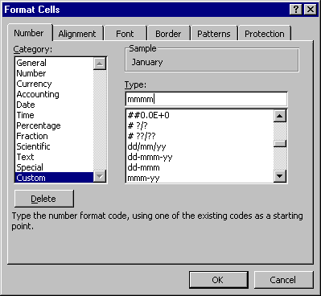
- For example, if you wanted to change a date currently displaying as 01/08/99 to display as “August”, select the format code “mmm-yy” to give you a base to alter – it would initially display your date as “Aug-99”, but you can change it to whatever you want.
- Click in the Type box and amend the code to give the display you want (watch the sample as you do this). For the example mentioned above, you would type “mmmm”.
- When you have the correct code, click OK to close the dialog box and apply the custom number format.

Helpful hints:
Custom formats, once created, only exist in the file in which they were set up. If you want to use them in another workbook, you can copy the format across.
You can copy formats only, using Paste Special (see page 9 for details).

Format Painter
The Format Painter is a tool that you can use to copy the formatting from one area of the worksheet to another. This is particularly useful when you have spent time formatting one group of cells and you decide that another group of cells should have the same format – rather than reapplying the formatting one step at a time, you can paint it onto the new cells with the Format Painter.
- Select the cell with the formatting you want to use.
- Click the Format Painter icon on the Standard toolbar. Your mouse pointer will change to display a paintbrush next to the selection pointer.
- Select all the cells to which you want to apply the formatting by dragging over them. As soon as you release the mouse, the formatting will appear.
- If you want to apply the format to several separate cells, double-click the Format Painter button, and then click in the cells to which you want to apply the formatting. Click on the Format Painter button again to turn it off.
- If you want to keep the cell contents, but remove all the formatting from cells, from the Edit menu, select Clear and then Formats.

Action buttons
At times buttons may appear as you work in your workbook. These buttons are different to the ones in the toolbars.

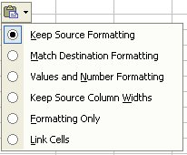
Paste options button
The Paste options button appears just below your pasted selection after you paste text or data. When you click the button, a list appears that lets you determine how the information is pasted into your worksheet.
The available options depend on the type of content you are pasting, the program you are pasting from, and the format of the text where you are about to paste.

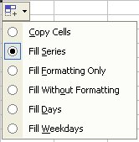
AutoFill options button
The AutoFill options button appears just below the filled selection after you fill text or data in a worksheet. When you click the button, a list appears to give you options for how to fill the text or data.
The available options depend on the content you are filling, the program you are filling from, and the format of the text or data where you are about to fill.
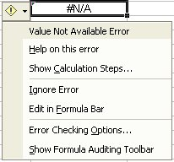

Error checking options button
The Trace Error button appears next to a cell in which a formula error occurs, and a green triangle appears in the upper-left of the cell. When you click the arrow next to Trace Error, a list appears to give you options for error checking.

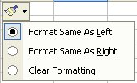
Insert options button
The Insert options button appears next to inserted cells, rows, or columns. When you click the arrow next to Insert options, a list of formatting options appears.

Triangle indicators in cells
Triangles in cell corners indicate formula errors, comments, or Smart Tag options.
A green triangle in the upper-left corner of a cell indicates an error in the formula in the cell. (See Error checking option button on page 6.) Tracing errors in formulae is covered in the Introduction to formulae and functions course.
The purple triangles in the corners of cells on your worksheet indicate Smart Tags. If you rest the mouse cursor over the triangle, Smart Tag Actions appears. Smart tags are beyond the scope of this course and are covered in the Advanced Excel – Data analysis tools course.
A red triangle in the upper-right corner of a cell indicates that there is a comment attached to the cell.

Comments
Comments allow you to add notes separate from other cell content to cells in your worksheet. They can be used, for example, to communicate with colleagues who will be using the same worksheet, and to remind yourself what a particular value in a cell means, or what a calculation does. When you attach comments to cells in a worksheet, they appear in special dialog boxes. Comments can also be printed.

Creating comments
- 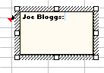Select the cell you want to contain the note.
- On the Insert menu, click Comment.
- Enter the required text in the Comment box and click outside the box when finished.
- A small red corner appears in the top right-hand corner of the cell, and the comment is displayed as the mouse is moved over the cell.
Note: The Reviewing toolbar contains icons for inserting a comment, moving to the next or previous comment, and for showing/hiding one or all comments. To view this toolbar, select Toolbars from the View menu and click on Reviewing.

Displaying comments
As mentioned, moving your mouse pointer over a cell with a red comment indicator will display its comment. However, the comment will disappear when you move your mouse pointer away from the cell.
To display a comment on the screen permanently:
- Click on the Show/Hide Comments button on the Reviewing toolbar. Click on the same button to hide the comment.
To display all comments on a sheet:
- On the View menu, click on Comments, or click on the on the Show All Comments button on the Reviewing toolbar. All the comments in the worksheet will be displayed.

Printing comments
- Select the File menu and Page Setup. The Page Setup dialog box appears.
- Select the Sheet tab and choose Comments in the Print group. Select either At end of sheet or As displayed on sheet.
- Click on the Print button.

Paste special
Normally when we copy and paste data in Excel, we accept that the cell value or formula and any associated formatting or comments will be copied and pasted, along with the value. However, there may be times when we wish to copy the cell value, without the associated formula or formatting, or we may wish to copy formatting without the value in the cell. This is possible using the Paste Special command.
- Highlight the cells you wish to copy and paste, and copy the cell values as normal.
- On the Edit menu choose Paste Special.
- The Paste Special dialog box then offers a range of choices about which part of the copied data you wish to paste.
- In the Paste area, note that the default is All, which will paste all the data from the copied cell. However, it is also possible to paste selected parts of the data by clicking the appropriate options in the Paste area.
- The Paste Values option is one of the most commonly used functions. This is for occasions when you wish to copy the result of a calculation into a cell, without copying the original formula.
Note: the result will no longer change if any of the values used to produce the result changes.
- The Operation area allows you to combine the data in the copied cell arithmetically with the data in the destination cell.
- The Skip blanks option will ignore any empty cells. It can be useful as empty cells can give rise to error messages with mathematical operations such as division.
- The Transpose option allows you to turn a column of data into a row, and vice versa. It is easiest understood by example – you will use the Transpose option in the next task. (See details below.)
- The Paste Link button maintains a link between the original cell value and the copied cell, and the pasted value. If the copied cell value changes, the pasted cell will update automatically. (See page 19 for further details on linking data in cells.)

Transposing data
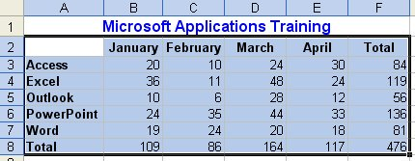
If you need to change the way data is stored in a worksheet, for example, to display rows as columns, and vice versa, you can use the Transpose function. The transposed version of the data cannot overlap the original data (i.e. you need to paste it into another area of the worksheet).
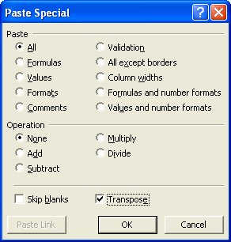
- Select the range you want to transpose and copy it to the Clipboard.
- Move to where the transposed range is to be positioned and click.
- On the Edit menu, select Paste Special.
- Check the Transpose box, and click OK.
The data are now transposed.

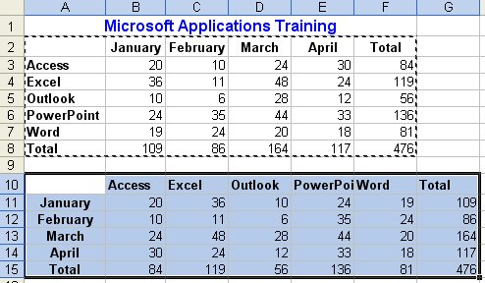
The formats (i.e. borders, bold etc.) will also have been copied. If you do not want the formats transposed, click Values in the Paste section of the Paste Special dialog box.

Working with workbooks
In the Getting started with Excel course, we introduced the concept of spreadsheets, or worksheets as they are known in Excel. In this course we will be looking at workbooks. A workbook is a collection of worksheets stored in the same file. Usually the sheets in a workbook contain related information, such as a departmental budget or a set of experimental results, with each sheet containing the details for a separate budget code or for a set of experiments. By keeping related information together in a workbook, it is easier to manipulate, update and carry out calculations on the data in the worksheets.
It is advisable to build a number of small related worksheets within a workbook, rather than to create one enormous worksheet. It is very easy to use formulae that refer to other worksheets within the same workbook.
- The default workbook contains three sheets – notice the tabs across the bottom of the document window (Sheet1, Sheet2, Sheet3). Sheets can be given names to facilitate navigation.
- Sheets can be added or deleted in a workbook.
- A single worksheet may contain 256 columns and 65,536 rows.
- Besides worksheets, a workbook can contain: chart sheets, dialog box sheets, macro sheets, and Visual Basic module sheets.

Managing worksheets

Moving between worksheets in a workbook
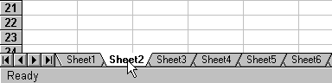
Use the tab scrolling buttons to move between sheets.

Click on the sheet tab to select it.

To move between the different sheets in a workbook, use the tab scrolling buttons.
 | scrolls to the first sheet tab in the workbook |  | scrolls to the next sheet tab in the workbook
 | scrolls to the previous sheet tab in the workbook |  | scrolls to the last sheet tab in the workbook

Changing the default number of worksheets
By default Excel workbooks have three worksheets. It is possible to set your own default number of worksheets.
- Select the Tools menu and Options.
- Select the General tab and specify the number of sheets required in the Sheets in new workbook box.

The next time a new workbook is opened, the specified number of sheets will appear. Existing workbooks will not change.

Inserting a new worksheet
Select the Insert menu and worksheet, or
Use a right mouse-click on the Sheets tab to reveal the shortcut menu and select Insert. Select workbook and click OK.
A new sheet will be inserted in front of the sheet currently selected. Drag and move it to the correct position if necessary.

Deleting a worksheet
- Select the worksheet to be removed.
- Select the Edit menu and Delete Sheet
or
Use a right mouse-click on the sheet tab to reveal the shortcut menu, and select Delete.
Note: If you delete a worksheet, you will not be able to undo this action.

Renaming worksheets
- Select theworksheet which you wish to rename.
- From the Format menu choose Sheet and Rename, and type in the new name,
or
Use a right mouse-click on the sheet tab to reveal the shortcut menu and select Rename,
or
Double-click on the sheet tab, select the sheet name, and type in the new name.
A worksheet name can contain up to 31 characters including spaces, but for referencing purposes it is best to limit the number of characters used and avoid spaces. When a worksheet is renamed, the sheet tab displays the new name.

Changing the colour of the sheet tab
- Right-click on the sheet tab and select the Tab Color option.
- The Format Tab Color window displays. Choose a colour and click OK.

Moving and copying worksheets in a workbook

Drag and drop method
- Click on the sheet tab of the sheet to be moved and, holding down the mouse, drag the sheet to the new location in the workbook. Notice that a little black marker appears to show the new location, and as the mouse is released the sheet is repositioned.
- To copy a worksheet using the above method, hold down the Ctrl key while carrying out the operation.

Menu method
- Right-click the required sheet tab to reveal the shortcut menu and choose Move or Copy.
- The Move or Copy dialog box appears listing all the sheets in the workbook.
- Click in the Create a copy check box to copy rather than move a sheet.
- The options provided enable a sheet to be copied/moved in front of any other sheet or at the end, either in the same or in another workbook.

Selecting worksheets

Selecting a worksheet
Click on the Sheet tab to select a worksheet.

Selecting multiple adjacent worksheets
- Click on the Sheet tab of the first worksheet you want to select.
- Hold down the Shift key and click on the last worksheet tab in the required selection. All the worksheets between your first and last click are selected.
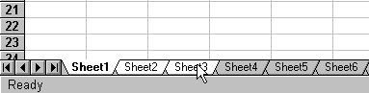
Click on the first sheet tab and holding down the Shift key click on the last worksheet tab.

Selecting multiple non-adjacent worksheets
- Click on the Sheet tab of the first worksheet you wish to select.
- Hold down the Ctrl key and click on the next worksheet you wish to select, repeat this procedure until all worksheets you require have been selected.
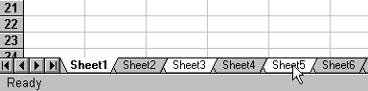
Click on each worksheet while holding down the Ctrl key.

After you select a group of worksheets, such as those illustrated above, the word Group appears in the title bar of the workbook.

Deselecting the group
Click on any sheet tab.
or Right-click to reveal the worksheet tab shortcut menu and select Ungroup Sheets.

Entering data

To enter data in multiple worksheets
Once you have selected more than one sheet, it is possible to enter the same data in all of the selected sheets simultaneously. This is helpful for setting up several worksheets which will store similar information.
- Select the worksheets into which you wish to enter the data. Notice the word Group appears in the Title bar.
- Enter your data into the cells as normal.
- Once the data have been entered, you can click on any of the worksheets to see the updated contents.
WARNING: Ensure the cell(s) in the area of the grouped worksheets in which you are about to enter data are blank. Any data in these cells will be overwritten without warning.

Entering formulae
As with data entry, if worksheet layouts are similar it is possible to enter formulae into several worksheets at once.
- Select the worksheets into which you wish to enter the formula.
- Enter the formula into the cell on the top sheet and copy the formula to the required cells normally.
- Once the formulae have been entered, click in any of the sheets to see the formulae updated.

Moving between workbooks
You can have several workbooks open at one time, although it is advisable to close any workbooks you are not currently using. To select a workbook you need to bring that workbook to the top.
- Select the Window menu – workbooks currently open are listed at the bottom.
- Select the workbook you require. A tick mark appears beside the currently active workbook.

Arranging windows
When working with multiple workbooks, it is useful to be able to arrange them on the screen.
- From the Window menu, choose Arrange All.
- The Arrange Windows dialog box appears as shown.
- Select from the options given to arrange the workbooks either in a tiled fashion, horizontally, vertically, or cascading in front of each other.

Moving and copying in workbooks

Moving or copying data between worksheets
- Select the sheet and data to be moved or copied.
- Cut or copy the data.
- Move to the required workbook, worksheet and cell, and paste the data into the new location.

Moving or copying worksheets between workbooks

To move or copy a sheet to another workbook, ensure both the workbooks are open.

Drag and drop method
- Open the workbooks and arrange them so that they are visible on the screen as described in the Arranging windows section above.
- Select the worksheet to be moved and, holding down the mouse, drag the worksheet to the new location in the other workbook.
- Notice that a little black marker appears to show the new location, and as the mouse is released, the worksheet is repositioned.
- To copy rather than move, hold down the Ctrl key as you carry out the operation. Make sure you release the mouse button before the Ctrl key, or the worksheets will be moved instead of copied.

Menu method
- Right-click on the sheet tab to reveal the shortcut menu, and choose Move or Copy.
- The Move or Copy dialog box appears.
- In the To book box, select the destination workbook.
- In the Before Sheet box, select the destination position of the worksheet within the workbook.
- Remember to check the Create a copy box if you want to leave a copy of the worksheet in the original workbook. Otherwise the sheet will be moved.

Referencing cells in different worksheets
The different sheets in a workbook should be referred to by including the sheet reference as well as the cell reference in a formula. A sheet reference includes the sheet name followed by an exclamation mark, e.g., Sheet2! refers to Sheet 2. To refer to cell A1 on Sheet2 (when working in any sheet other than Sheet2), the reference would be:
Sheet2!A1

Notice that the exclamation mark separates the sheet reference from the cell reference.
If you have named the sheet, simply use the new sheet name (followed by an exclamation mark) and the cell reference. If the sheet name includes spaces you must surround the sheet name with single quotation marks.
To refer to cell A1 on a sheet named Budget, the reference would be:
Budget!A1
To refer to cell A1 on a sheet named Annual Budget, the reference would be:
‘Annual Budget’!A1

Summarising data held on different worksheets
- Create a new worksheet for the summary, and copy or enter the labels you want for the summarised data.
- Click a cell that you want to contain summarised data.
- Type a formula that includes references to the source cells on each worksheet that contains data you want to summarise.
- Repeat steps 2 and 3 for each cell where you want to summarise data.
Helpful hint:
To enter a reference in a formula without typing, enter the formula up to the point where you need the reference, and then click the cell on the worksheet. If the cell is on another worksheet, first click the worksheet tab, and then click the cell.

Consolidation
To assist you with summarising your data, Excel has a Consolidation feature. This feature enables you to summarise data from one or more source areas by consolidating it and creating a consolidation table. The source areas can be on the same worksheet as the consolidation table, on different sheets in the same workbook, or in different workbooks or Lotus 1-2-3 files. This feature is covered in the Advanced Excel – Data analysis tools course.

Document links
A document link is a formula reference to a cell in another document. The reference is live, which means that if the referenced sheets are open, the changes are automatically updated in them, just as they would be if all the data were in the same sheet. The sheet that contains the link is the container document. The document where the data comes from is known as the source document.
Links can be used to consolidate several related worksheets into one. For example, information from several sources can be brought together into one worksheet to show the overall company results from all the divisions.
Embedding is a term that means inserting information. The information becomes part of the worksheet into which it is placed. To use embedding, the source application must support OLE (Object Linking and Embedding). To create links, the source application must support DDE (Dynamic Data Exchange) or OLE.

Advantages of linking data:
- To share information.
- To simplify a complex problem by breaking it down into several separate workbooks.
- To divide work among several people.
- To build models normally too large for memory.
- To add flexibility to workbooks.

Terminology
External reference A reference to another worksheet. The reference can be a single cell, a cell range, or a named cell or range.
External reference formula A formula that contains a reference to a single cell, a cell range, or a named cell or range in another worksheet.
Remote reference A reference to a single cell, a cell range, or a value or field in a document in another application, (e.g. Word or PowerPoint).
Remote reference formula A formula that contains a reference to a single cell, a cell range, or a value or field in another application.
Linking formula A formula that creates a link to another document, either as an external or remote reference.
Container document A worksheet that relies on another document for its values.
Source document The source document containing the values for the linked reference.

Creating a link
There are two ways to create links:
Method one:
- Open both the source document and the container document.
- Select the cell in the container document in which you want to create a link.
- Key in =, then switch to the source document.
- Double-click the cell in the source document that contains the link data.
- Press Enter to complete the formula which should look something like this: =[Test1.xls]Sheet1!$A$1
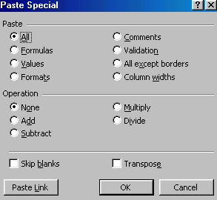Method two:
- Select the cell in the source document that contains the link data, and copy it to the Clipboard in the normal way.
- Switch to the container document and click the destination cell.
- From the Edit menu, select Paste Special and then click the Paste Link button.
- Press Esc to cancel the selection.
As you can see, the difference between a worksheet link and a normal cell is that a link reference includes the source workbook in square brackets, and the sheet name followed by !.
The file specification can include up to 4 parts – the drive, the path, the filename and the extension, (e.g. =[C:\My Document\Expences.xls]Sheet1!$D$4).

Linking a range
- To link a range of cells, open the destination and source workbooks as before. With the source workbook active, select the cell or range of cells required for the link and copy them to the Clipboard.
- Switch to the container worksheet and select the cell (the upper left corner of the range) that will contain the external reference.
- From the Edit menu, select Paste Special and then click the Paste Link button to paste the data into the cells. Press Esc to cancel the selection.
- Functions such as =SUM([Test1]Sheet1!A1:D1) can also be used when linking. In the destination document, select the cell to enter the external formula reference. In the Formula bar of the destination document, paste or type the function to use. Use the mouse to select the range, or type directly into the Formula bar.

Saving and closing linked workbooks
Always save the source workbooks before saving the container worksheets linked to them. This ensures that the workbook names in the external references are current.

Opening and updating linked worksheets
Links can be made to documents that are not open, so long as the destination document has access to the source documents (within the same system, network, or disk).
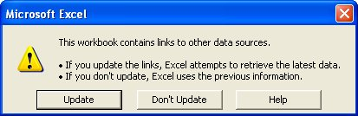
When you open a document with linked information that has been changed, the following message is displayed:
Click Update and the document will be opened with all its links updated. If you click Don’t Update, you can update the links later from the Links dialog box, as shown below.

Finding the source document
If the document on your screen contains linked data, you can check to see which documents it is linked to.
From the Edit menu, select Links. The following dialog box will be displayed:
If the source document is not open, the linked references will include the drive and path, (e.g. [C:\Barkestone\Excel\Test1.xls]).
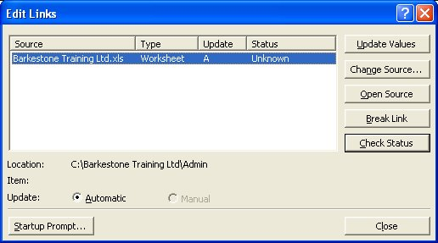
If the source document is open, the linked reference would just be: Test1.xls.
To update values without opening the source sheets, select Links from the Edit menu and click on the Update Values button.

Security

Protecting worksheet data
If you type in a cell that already has an entry, you overwrite that entry as soon as you press Enter. Excel does have an Undo facility, but if you need to delegate data entry to someone who isn’t too familiar with Excel, they could quite easily end up overwriting your carefully constructed formulae. To prevent that happening, you can protect worksheets in workbooks.
Protected sheets can allow access to some cells but not others. Those that are unavailable cannot be edited, formatted or cleared.

Unlocking cells
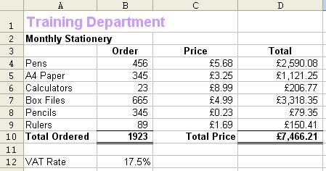
By default, all cells in a worksheet are locked. This doesn’t have any effect on data entry and editing until you switch on the worksheet protection, at which point all locked cells are made unavailable. This means that if you want to have access to certain cells, but not others, you need to unlock those cells first.
Cells contain labels that you want to protect.
Cells contain formulae that you want to protect.

In the diagram above, you would need to unlock the cells B4:C9 so that, when you protect the worksheet, those cells are accessible.
- Select the cells you want to be accessible when you protect the worksheet – you can select cells on multiple sheets using group mode if necessary.
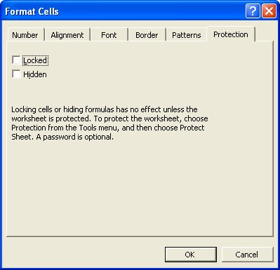
- From the Format menu, select Cells.
- Click the Protection tab.
- Uncheck the Locked box.
- Click OK to close the dialog box and save the setting.

Hiding formulae
You can also hide any formulae that you don't want to be visible.
- Select the cells containing the formulae you want to hide.
- From the Format menu, select Cells.
- Click the Protection tab.
- Select the Hidden check box and click OK.
Remember – the cells are not protected until the Protect worksheet option is switched on (see below for details).

Protecting a worksheet
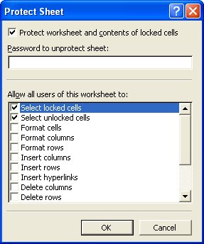
When you protect a chart sheet or worksheet, you can protect or unprotect individual elements of the sheet in the Protect Sheet dialog by selecting or clearing check boxes for each element.
To switch on worksheet protection:
- Ensure that the sheet you want to protect is the active sheet.
- From the Tools menu, select Protection and then Protect Sheet. The following dialog box will appear:
- Type a password to prevent unauthorised users from removing sheet protection. A password is case sensitive, can be up to 255 characters long, and can contain any combination of letters, numbers, and symbols.
The password is optional; however, if you don't supply a password, any user will be able to unprotect the sheet and change the protected elements.
WARNING: If you assign a password, write it down and keep it in a secure place. If you lose the password, you cannot gain access to the protected elements on the worksheet.
- Select the Protect worksheet and contents of locked cells box.
- In the Allow all users of this worksheet to list, select the elements that you want users to be able to change. See the list of options below for details:
Select locked cells: When cleared, prevents users from moving the pointer to cells for which the Locked check box is selected on the Protection tab of the Format Cells dialog box.
Select unlocked cells: When cleared, prevents users from moving the pointer to cells for which the Locked check box is cleared on the Protection tab of the Format Cells dialog box. When users are allowed to select unlocked cells, they can press the Tab key to move between the unlocked cells on a protected worksheet.
Format cells: When cleared, prevents users from changing any of the options in the Format Cells or Conditional Formatting dialog boxes. If you applied conditional formatting before you protected the worksheet, the formatting continues to change when a user enters a value that satisfies a different condition.
Format columns: When cleared, prevents users from using any of the commands on the Column submenu of the Format menu, including changing column width or hiding columns.
Format rows: When cleared, prevents users from using any of the commands on the Row submenu of the Format menu, including changing row height or hiding rows.
Insert columns: When cleared, prevents users from inserting columns.
Insert rows: When cleared, prevents users from inserting rows.
Insert hyperlinks: When cleared, prevents users from inserting new hyperlinks, even in unlocked cells.
Delete columns: When cleared, prevents users from deleting columns. Note that if Delete columns is protected and Insert columns is not also protected, a user can insert columns that he or she cannot delete.
Delete rows: When cleared, prevents users from deleting rows. Note that if Delete rows is protected and Insert rows is not also protected, a user can insert rows that he or she cannot delete.
Sort: When cleared, prevents users from using any of the Sort commands on the Data menu, or the Sort buttons on the Standard Toolbar. Users can't sort ranges containing locked cells on a protected worksheet, regardless of this setting.
Use AutoFilter: When cleared, prevents users from using the drop-down arrows to change the filter on an AutoFiltered range. Users cannot create or remove AutoFiltered ranges on a protected worksheet, regardless of this setting.
Use PivotTable reports: When cleared, prevents users from formatting, changing the layout, refreshing, or otherwise modifying PivotTable reports, or creating new reports.
Edit objects: When cleared, prevents users from:
- Making changes to graphic objects — including maps, embedded charts, shapes, text boxes, and controls — that you did not unlock before you protected the worksheet. For example, if a worksheet has a button that runs a macro, you can click the button to run the macro, but you cannot delete the button.
- Making any changes, such as formatting, to an embedded chart. The chart continues to update when you change its source data.
- Adding or editing comments.
Edit scenarios: When cleared, prevents users from viewing scenarios that you have hidden, making changes to scenarios that you have prevented changes to, and deleting these scenarios. Users can edit the values in the changing cells, if the cells are not protected, and add new scenarios.
Note: If you run a macro that includes an operation that's protected on the worksheet, a message appears and the macro stops running.

- Click OK to close the dialog box and switch on sheet protection.
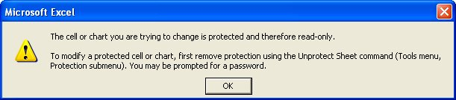
With worksheet protection active, only unlocked cells are available for data entry, editing, formatting and deleting. If you try and type in a locked cell, the following warning appears:
WARNING:
As detailed above, it is possible to hide columns and rows, and then protect the worksheet with a password, so that unauthorised people cannot unhide the hidden columns and/or rows. If you make a copy of the worksheet, (by right-clicking on the worksheet tab) the hidden columns/rows are still protected.
However, if you select the entire worksheet, and then copy, and then paste it into a new worksheet – you will be able to unhide any hidden rows or columns WITHOUT A PASSWORD. By default, cells are not protected when you copy them. The worksheet protection is not copied too.

Unprotect sheets
If you do need access to locked cells, you can switch worksheet protection off, provided you know the correct password.

Switching off sheet protection
- Select the protected sheet.
- From the Tools menu, select Protection and then Protect Sheet…. You will be prompted for the password.
- Type the password and click OK. The sheet is now unprotected.
Excel only lets you protect and unprotect sheets one at a time; that is, you can’t group all the sheets you want to protect or unprotect and change their protection status simultaneously.

Protecting workbooks
You can protect elements on a worksheet, such as cells with formulae, from all users, or you can grant individual users access to the ranges you specify. Granting individual users access rights is covered in the Sharing workbooks section of the Advanced Excel course, but protecting your worksheets and workbooks from all users is covered here.

Limiting changes to an entire workbook
- On the Tools menu, point to Protection, and then click Protect workbook.
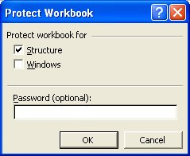
- To protect the structure of a workbook so that worksheets in the workbook can't be moved, deleted, hidden, unhidden, or renamed and new worksheets can't be inserted, select the Structure check box.
- To use windows of the same size and position each time the workbook is opened, select the Windows check box.
- To prevent others from removing workbook protection, type a password click OK, and then retype the password in the Confirm Password dialog box.
Passwords are case sensitive. Type the password exactly as you want to enter it, including uppercase and lowercase letters.
When you assign a password, write it down and keep it in a secure place. If you lose the password, you cannot gain access to the protected workbook elements.

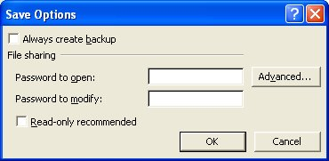
Password-protecting workbooks
To stop changes being made without authority, a password can be added to prevent unauthorised users from opening a workbook, or from opening it as read-only.
To prevent a workbook from being opened by unauthorised users:
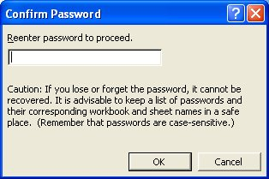
- From the File menu, select Save As, and then click the Tools drop-down list.
- Click on General Options.
- In the Password to open box, enter a password, and click OK.
- Re-enter the password when prompted.
- Click OK.
- Save the workbook, replacing the original if necessary.

Read-only workbooks
A workbook can be made Read-only in a similar way to attaching passwords. A workbook protected with a Password to modify can be opened by anyone (unless also protected by a protection assword), but only those who know the password can save changes made to the workbook under its original name. The workbook can, however, be saved with a different name.

Saving a workbook as read-only
- With the workbook you want to protect open on your screen, select Save As from the File menu, and click the Tools drop-down list.
- Click on General Options.
- Check the Read-only recommended button and then OK.
- Click Save to save the workbook with its original name and then click Yes to confirm that the original workbook will be replaced. Close the workbook.

Opening a read-only workbook
The workbook is opened in the normal way. A dialog box will appear indicating that the workbook is read-only. Clicking No opens the workbook as normal. Clicking Yes opens the workbook as read-only (the workbook can be changed, but cannot be saved under the same name).

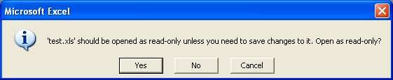
[Read-Only] is displayed after the filename in the title bar.

Adding a password
To stop changes being made without authority, a password can be added.
- From the File menu, select Save As, and then click the Tools drop-down list.
- Click on General Options.
- In the Password to Modify box, enter a password, click OK and re-enter the password. Click OK.
- Save the workbook, replacing the original.

Opening a workbook with a read-only password
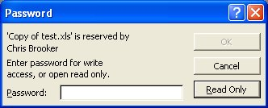
When you attempt to open a workbook that has a read-only password, a dialog box appears indicating that the workbook is reserved. If the correct password is entered, the workbook can be altered and saved as normal.
If Read-Only is selected, the workbook can be changed, but cannot be saved under the same name.

Hide columns and rows
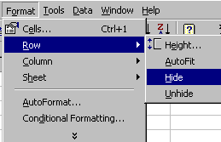You can choose not to display certain rows and columns on your screen. Hiding them also prevents them from printing.
- 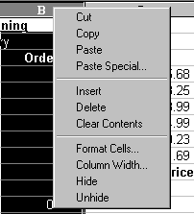Select the column or row you want to hide by clicking on the column or row letters, or, if you want to hide multiple columns or rows, highlight them. (Columns and rows must be hidden separately.)
- From the Format menu, select Row or Column, and then click on Hide.
or Repeat step 1 above and click the right mouse button anywhere over the selection to display the shortcut menu and then select Hide.
or To hide columns, repeat step 1 above and press Ctrl+0.

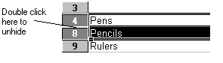Unhide columns and rows
- Select the columns or rows either side of the hidden ones by dragging over the column letters or row numbers with the selection pointer.
- Position the mouse over the row or column intersection between the selected rows or columns and double-click.
or Repeat step 1 above, then from the Format menu, select Row or Column and click on Unhide.
or To unhide columns, repeat step 1 above and press Ctrl+Shift+0.

Hiding workbooks and worksheets
You can hide workbooks and sheets to reduce the number of windows and sheets on your screen and to help prevent unwanted changes. For example, you can hide sheets:
- containing macros or critical data;
- if they contain confidential information and someone that you would not want to see it is near your screen; or
- because you are working on several documents and it makes them easier to work with.
The hidden workbook or sheet remains open, and all sheets in the workbook are available to be referenced from other documents.

Hiding a workbook
From the Window menu, select Hide.

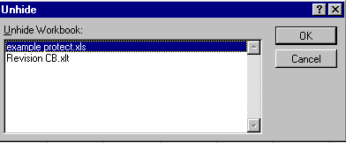Unhiding a workbook
To unhide a workbook, click Unhide on the Window menu; or, if no windows are visible, click Unhide on the File menu.
Select the workbook that you want to unhide and click OK. You can unhide only one workbook at a time.

Hiding a sheet
If the sheet you want to hide isn't active, click the tab that contains the sheet to make it active.
On the Format menu, point to Sheet, and then click Hide.
You must have more than one worksheet in the workbook in order to use this option as you cannot hide the only visible sheet in a workbook. For workbooks with just one worksheet, use the Hide workbook option.

Displaying a hidden sheet
On the Format menu, point to Sheet, and then click Unhide.
In the Unhide Sheet box, click the name of the hidden sheet you want to display.

Learning more

Central IT training
Information Systems runs courses for UCL staff, and publishes documents for staff and students to accompany this workbook as detailed below:
Getting started with Excel | This 3hr course is for those who are new to spreadsheets or to Excel, and wish to explore the basic features of spreadsheet design. Note that it does not cover formulae and functions.
Getting more from Excel (no formulae or functions) | This 3hr course is for users of Excel who wish to learn more about the non-mathematical features of Excel and to work more efficiently.
Using Excel to manage lists | This 3hr course is for those already familiar with Excel who would like to use some of its basic data-handling functions.
Excel formulae and functions | This 3hr course is aimed at introducing users, who are already familiar with the Excel environment, to formulae and functions.
More Excel formulae and functions | This 3.5hr course is aimed at competent Excel users who are already familiar with basic functions and would like to know what else Excel can do and try some more complex IF statements.
Advanced formulae and functions | This 3.5hr course is aimed at competent Excel users who are already familiar with basic functions. It aims to introduce you to functions from several different categories so that you are equipped to try out other functions on your own.
Excel statistical functions | This course aims to introduce you to built-in Excel statistical functions and those in the Analysis ToolPak. The course covers major descriptive, parametric and non-parametric measures and tests.
Excel statistical formulae | This course covers best practise in constructing complex statistical formulae in spreadsheets using common statistical measures as example material.
Excel tricks and tips | This is a 2hr interactive demonstration of popular Excel shortcuts. It aims to help you find quicker ways of doing everyday tasks. This fast-paced course is also a good all-round revision course for experienced Excel users.
Pivot tables | Pivot tables allow you to organise and summarise large amounts of data by filtering and rotating headings around them. This 2hr course also shows you how to create pivot charts.
Advanced Excel – Data analysis tools | This course aims to help you learn to use some less common Excel features to analyse your data.
Advanced Excel – Setting up and automating Excel | Would you like to customise and automate Excel to perform tasks you do regularly? If you are an experienced user of Excel, then this course is for you.
Advanced Excel – Importing data and sharing workbooks | Do you share workbooks with others? Would you like to see who has updated what? Do you know how to import data from text files or databases? This course aims to show you how.

These workbooks are available for students at the Help Desk.

Open Learning Centre
- The Open Learning Centre is open every afternoon for members of staff who wish to obtain training on specific features in Excel on an individual or small group basis. For general help or advice, call in any afternoon between 12:30pm – 5:30pm Monday – Thursday, or 12:30pm – 4:00pm Friday.
- If you want help with specific advanced features of Excel you will need to book a session in advance at: www.ucl.ac.uk/is/olc/bookspecial.htm
- Sessions will last for up to an hour, or possibly longer, depending on availability. Please let us know your previous levels of experience, and what areas you would like to cover, when arranging to attend.
- See the OLC Web pages for more details at: www.ucl.ac.uk/is/olc

Online learning
There is also a comprehensive range of online training available via TheLearningZone at: www.ucl.ac.uk/elearning
A Web search using a search engine such as Google (www.google.co.uk) can also retrieve helpful Web pages. For example, a search for “Excel tutorial” would return a useful selection of tutorials.

Getting help
The following faculties have a dedicated Faculty Information Support Officer (FISO) who works with faculty staff on one-to-one help as well as group training, and general advice tailored to your subject discipline:
- Arts and Humanities
- The Bartlett
- Engineering
- Life Sciences
- Maths and Physical Sciences
- Social and Historical Sciences
See the faculty-based support section of the www.ucl.ac.uk/is/fiso Web page for more details.

