UCL
Education & information support division
information systems



Effective File
Management

Document No. IS-069 v4
Contents
Understanding file storage on your PC 1
What is Windows Explorer? 2
Starting Windows Explorer 3
The Windows Explorer environment 3
The file management structure 4
Drives and filestores 4
File and folder icons 5
Navigating in Windows Explorer 6
Changing views 7
File properties etc. 8
File names and extensions 8
File properties 8
File attributes 9
Working with files 10
Creating a new file 10
Selecting files 10
Sorting files 11
Moving and copying files 12
Deleting files 13
Working with folders 14
Creating a new folder 14
Renaming a file or folder 14
Deleting a folder 14
Virus-checking 15
Finding files 16
Compressing / zipping files 19
Creating zip files 19
Extracting zip files 20
Hints about sending files by e-mail 20
Learning more 21
Getting help with managing your files 21

Introduction

This manual has been prepared to help you manage your computer files in a Windows environment. This guide can be used as a reference or tutorial document. To assist your learning, a series of practical tasks are available in a separate document. You can download the training files used in this workbook from the IS training website at: www.ucl.ac.uk/is/training/exercises.htm

Understanding file storage on your PC
Files can be stored on a floppy disk, a CD, a DVD, a hard disc (either local or networked) or a memory stick / flash drive.
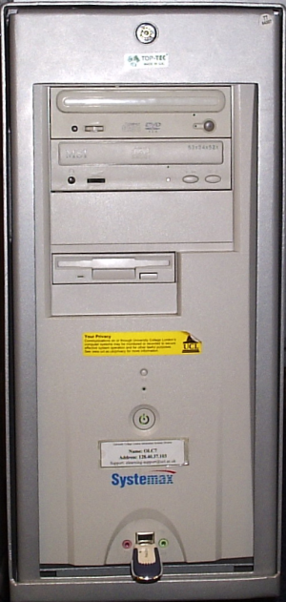
Hard discs usually live inside PCs, although external ones do exist.
DVD drive
CD-writer
USB memory stick

Internal hard drive
Floppy drive
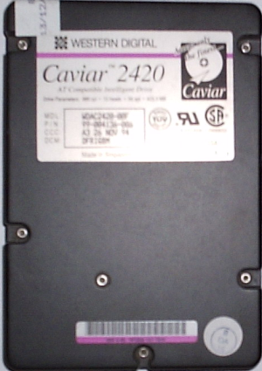

All discs, including hard discs, last only a finite amount of time. Make sure you keep copies (backups — see Moving and copying files on page 12) of data you keep on them (unless somebody else is doing so, as in the case of the N:, R: and S: drives mentioned in the Drives and filestores section on page 4).
Disc sizes are measured in Megabytes (Mb); Gigabytes (Gb) for big ones. Note that giga rhymes with bigger NOT tiger.
A byte consists of eight bits (the smallest unit of information a computer can use — a 1 or 0) and patterns one character, which can be a letter, number or symbol.
1,000,000 bytes = 1,000Mb =1Gb
A floppy disc stores 1.44Mb, a typical memory stick about 64Mb – 2Gb, a CD 750-800Mb, a DVD several gigabytes and a modern PC hard disc about 10Gb – 150Gb.
Helpful hint:
There is a difference between CDs which are writable to once (marked R) and those that may be written to repeatedly (marked RW).

What is Windows Explorer?
Windows Explorer is a file management tool that allows you to manage files, folders and drives. It enables you to manage your work by creating, deleting, moving, copying and renaming files and folders.
File: A file can contain anything, for example a word-processed document, a program, a graphic, a spreadsheet, a database etc. Different icons represent different types of files.
Folder: A folder is a collection of files kept together for a common purpose. These are the same as directories which you may be familiar with from experience with other operating systems, such as DOS or Windows 3.1. A folder can contain many subfolders.
Drive: A disk drive is a storage area, where files and folders are stored.
File (e.g. events.doc)

Folder (e.g. Memo)
Subfolders (e.g. Jan, Feb)
Drive (e.g. R:)
- The cabinet represents a drive e.g. the R: drive.
- The cabinet has a number of drawers, each of which can be thought of as a folder, e.g. the top drawer maybe a folder called Memo.
- Each drawer can be organised into further folders or subfolders, e.g. the Memo folder may have further folders inside, e.g. Jan, Feb, Mar etc.
- Inside each folder files can be stored, e.g. the file events.doc may be stored inside the Jan folder.

Starting Windows Explorer
- Use the menu sequence Start | Programs | Accessories | Windows Explorer.
- Windows Explorer will then open.
Windows Explorer also has a button on the Quick Launch bar near your Start button:

The Windows Explorer environment
In Windows Explorer the main window is split into two panels. The left-hand side displays all the available drives and their associated folders.
(There is another environment where it is possible to carry out basic file management tasks
— My Computer. However, it is a one-pane environment, and so more difficult to use.)
When you select a drive or folder in the left panel, its contents (folders and files) appear in the right-hand panel. By default you will see your own personal filestore. Students at UCL have one filestore – the R: drive. Staff have access to the R: drive and an additional drive, the N: drive.
Folder
File
Up one level
Menu bar
Current drive or folder
Drives
Status bar

Drag to adjust the size of the panes.

The file management structure
Windows Explorer enables the creation of folders and subfolders on a particular drive to facilitate the organisation of files. Many different structures can be adopted but it is usual to separate different types of files in different folders in much the same way as paper documents are filed in a filing cabinet.
The following diagram represents an example of how work can be organised into folders:

Excel

Access

PowerPoint
Templates
Downloads

R:
WordDocuments
MyWork
wts

Drives and filestores
In the left-hand panel of the Windows Explorer window you will find a list of the drives to which you have access. Note that the drives visible depend on the configuration of the machine and the type of IS Managed account you are using. The table below shows a list of commonly available drives:
Commonly available drives:
 | A$ on ‘Client’ [A:] | Floppy disk drive
 | C$ on ‘Client’ [C:] | Hard drive – for systems use only; you cannot access this area
 | D$ on ‘Client’ [D:] | Zip drive
 | E$ on ‘Client’ [E:] | CD-ROM drive
 | F$ on ‘Client’ [F:] | USB device (e.g. memory stick or digital camera)
 | Applications [P:] | Network drive – for systems use only; you cannot access this area
 | Filestore [R:] | Network drive – (students and staff) your password-protected area on the central file store
 | Filestore [N:] | Network drive – (staff only) your password-protected area on the central file store
 | Filestore [S:] | Network drive – (some staff only) departmental shared area on the central file store
¹ Drives labelled Client are local machine specific drives.
² Depending on the machine, the E: drive may be an additional hard drive and F: the CD-ROM.
The filestore (R: for students, N: or R: for staff) is the recommended drive to which to save your work while working on WTS. A default folder structure has been set up for your use. A folder called MyWork has been created, which contains a number of folders including Access, Downloads, Excel, PowerPoint and WordDocuments and a subfolder, Templates. This is a suggested basic file structure to use when saving your Office documents.
Helpful hint:
Files saved in the N:, R: and S: filestores are backed up overnight by Information Systems and archived for 18 months.

File and folder icons
Different types of icon represent files and folders in Windows Explorer. The folder icon shown in the table below represents all folders. Files are represented by different icons depending on the file type. For example, the icon which represents a Word file, differs from that which represents an Excel file as shown in the table below:
File Type | Icon | File Extensions
Folder
MS Word Documents  Rich Text Format* |  | .doc  .rtf
MS Excel Documents |  | .xls
MS Access Documents |  | .mdb
MS PowerPoint Documents |  | .ppt
HTML Files* |  | .htm  .html
Text documents |  | .txt
Unassociated files
*This may vary depending on your local set up.
Helpful hint:
Icons are subject to change depending on the version of the software and the local configuration.

Navigating in Windows Explorer
The Explorer window is organised into two panes. The drives and folders available are shown in the left-hand pane. A drive or folder may be selected by clicking on it, and its contents will be displayed in the right-hand pane. Clicking once in the left-hand pane opens a folder. It is necessary to click twice to open a folder in the right-hand pane.
Selected drive
Contents of selected drive
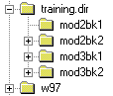
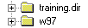
The + signs next to the drives and folders in the left pane can be used to obtain an expanded view of any subfolders in the left pane (known as branches). Once the view has been expanded, the + sign turns to a - sign and can be used to collapse the view again.
Branch collapsed
Branch expanded
The Address bar shows the currently selected drive and folder names (referred to as the path). If it is not displayed, use View | Toolbars | Address Bar to display it.
If you know the path of a folder you can enter this in the Address bar to go straight to that folder.

Changing views
There is a choice of four views: Large Icons, Small Icons, List and Details. Different views display varying levels of file information. Only the Details view displays file property information. Some versions of Windows have additional views, e.g. Thumbnails view (for displaying thumbnails of picture and other files).
On the View menu, select from Large Icons, Small Icons, List or Details. To display all file information choose the Details option (this is probably the most useful one).

Changing the default view
- Select the default view that you want in any folder.
- Go to Tools | Folder Options.
- Click the View tab.
- Select Like Current View.

Selecting a single file
When the required file is displayed in the right-hand panel, simply click once on the file to select it.

Opening a file
When a file has been correctly associated with its parent application (see File names and extensions) and the required software is available, double-clicking in the icon will fire up the application and open the selected file. It will be opened in the application which was used to create it, if that application is available on the computer. If the application is unavailable, you will be prompted to choose an application with which to open the file.

File properties etc.

File names and extensions
The name of a file is specified by the creator of the file and is usually a description of the file contents. A file name is made up of two parts, a name and an extension. The name is separated from the extension by a full stop (pronounced “dot”) as shown below:
Filename.ext
The correct use of file extensions means that a file can be associated automatically with its application. A correctly associated file can be opened simply, by double-clicking on the required file. This is particularly useful if you receive files as attachments with your e-mail. An experienced user familiar with file naming conventions can identify the type of file by its extension.
Helpful hint:
You are strongly recommended, where possible, to use the default file extensions given in most applications. This is particularly important if you are sharing files with other users e.g. via e-mail.
File names and folder names follow exactly the same naming rules:
Filenames
Maximum characters* | 256
Characters allowed* | All  including spaces
Exceptions | ? * < > | : \ / .
* See the hint below.

Helpful hint:
Older operating systems such as Windows 3.1 only allow 8.3 filenames such as myfile.doc. Longer file names or files which have capitalised text may become truncated on such systems e.g. longfilename.doc may become longfi~1.doc.

File properties
All files have a number of different properties or attributes as shown below:
Name Always displayed alongside the file icon.
Size Displays the size of the file in bytes.
Type The type of file e.g. Word document.
Modified Displays the date and time the file was last changed.
This information is saved with the file. When a file is changed and saved again, the file properties may be changed. The file information can be displayed alongside the file name in the right-hand pane. It may be necessary to change views if this information is not already displayed.

File attributes
Further file attributes indicate whether a file is read-only, hidden, a system file or an archive copy (i.e. whether the file has changed since a backup copy was made). To view this information:

- Select the required file, and on the File menu click Properties.
Select the General tab if necessary.
- The file’s properties and attributes are displayed in the Properties dialog box.

File information e.g. type, location, size etc. is displayed for the selected file together with the attributes of the file.

Working with files

Creating a new file
Files are created by many different applications. They are used to store data in an identifiable location. Different applications enable different types of file to be created.

Creating a file in Notepad
- From the Start button point to Programs and Accessories and then click Notepad.
The Notepad application starts with a new window ready for input.
- Enter the required text in the window.
- On the File menu click Save. The Save As dialog box appears.
- In the Save in box select the required drive and folder.
- Double-click folders to open them.
- Use the Up arrow if you are too far down in the structure.
Select the required drive.
Enter the filename.
- In the File name box enter the required file name and click on Save.
The file is now created and can be found on the specified drive in the specified folder.

Selecting files
To select a single file, click on it once.

Selecting non-adjacent files
- Click once on the first file in the list that you want to select.
- Hold down the Ctrl key and click on the remaining files to be selected. (When using this method always ensure that the mouse button is released last.)

Selecting ranges of files
- Click once on the first file in the list.
- Hold down the Shift key and click once on the last file in the list. (When using this method always ensure that the mouse button is released last.)

Selecting all files in a folder
- Click on any file in the folder.
- Go to Edit | Select All (or press Ctrl-A).

Sorting files
In Changing views we saw how to change the view in Windows Explorer to present files as a list or to show all file details. In either of these views, normally files will be sorted into alphabetical order. However, it is also possible to sort files in a folder into date order, so that recent files appear at the top (or bottom) of the list, or into order of increasing (or decreasing) size, or into file types.
Labels

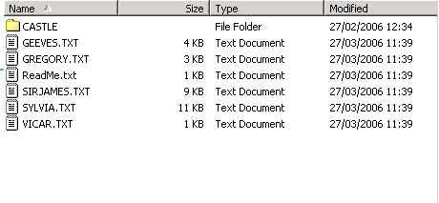

In order to do this all file details should be displayed:
- On the View menu choose Details.
- In the right-hand panel, click in the column heading displaying the file attribute label (i.e. Name, Size, Type, Modified) on which you wish to sort.
Or
On the View menu choose Arrange Icons and choose from the options by Name, by Type, by Size and by Date.
- The files should now be reorganised into the specified order.

Moving and copying files
Moving and copying files can be done in the same way as moving and copying data in other Microsoft applications.

The Edit menu (as shown on the right) can be used to move and copy files.

Moving a single file
- Select the file.
- On the Edit menu choose Cut or use the Ctrl+X keyboard shortcut.
Note that the file will not disappear until you have pasted it into the relevant folder.
- Select the drive and folder to which you want the file to be moved.
- On the Edit menu choose Paste or use the Ctrl+V keyboard shortcut. The file will now appear in the selected folder.

Copying a single file
- Select the file.
- On the Edit menu choose Copy or use the Ctrl+C keyboard shortcut.
- Select the drive and folder to which you want the file to be copied.
- On the Edit menu choose Paste or use the Ctrl+V keyboard shortcut. The file will now appear in the selected folder.

Moving and copying multiple files
You may find that you have more than one file to move or copy to the same folder. These files may be below each other or randomly scattered within your folder.
- Select the drive and folder where the files are located.
- Select the required files:
- To select nonadjacent files use the Ctrl key method as described in Working with files.
- To select a range of files use the Shift key method as described in Working with files.
- To select all files, select any file in the folder and then press Ctrl-A.
- On the Edit menu choose Cut / Copy (Ctrl-X / Ctrl-C).
(If you are moving the file, it will not disappear until you have pasted it into the relevant folder).
- Select the drive and folder to which you want the file to be moved/copied.
- On the Edit menu choose Paste (Ctrl-V). The files will now appear in the selected folder.

Click and drag method
An alternative way to move or copy files is to drag them from one folder to another.
- Open the folder that contains the file you want to move or copy (the files will be displayed in the window on the right of your screen).
- Make sure you can see the folder you want to move or copy your file to in the Folders window on the left.
- Select the file you want to move.
- Hold the left mouse button down and drag your file(s) over the folder you want to place them in.
- Hold the mouse steady for a few seconds (to ensure you are over the correct folder) before releasing the left mouse button.
Helpful hints:
If you are dragging a file to a folder on the same drive, the file will be moved. Holding the Shift key down whilst you drag the file will copy the file to your selected folder.
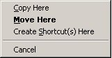
If you are dragging a file to a folder on a different drive, the file will be copied. Holding the Shift key down whilst you drag the file will move the file to your selected folder.
Dragging the file whilst holding down the right mouse button will display a shortcut menu when you release the mouse button. This will allow you to choose whether to move or copy your file, or create a shortcut to it in your selected folder.

Deleting files
It is good practice regularly to tidy up your file structure on all drives to remove redundant files and release file space.

Deleting a file
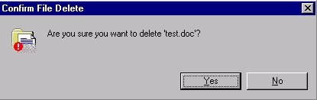
- Select the required file.
- Press the Delete key on your keyboard.
The Confirm File Delete dialog box will appear as shown:
- Click Yes to delete the specified file.

Deleting multiple files
- Select the required files:
- To select non-adjacent files use the Ctrl key method as described in Working with files.
- To select a range of files use the Shift key method as described in Working with files.
- Press the Delete key on your keyboard.

Backing up files
Files may be copied to a USB memory stick, writable CD or floppy disk for backup purposes or to enable files to be moved around e.g. to take files to work at home.
Helpful hints:
All files stored on the N:, R: and S: drives at UCL are automatically backed up every night. Files stored on local drives remain the responsibility of the owner.
The USB memory stick needs to be inserted in the USB port before you login to WTS. Do not remove it whilst you are transferring data! If you do, you run the risk of losing not only the data, but the entire contents of the memory stick.

Working with folders

Creating a new folder
- Select the required drive.
- On the File menu click New and then Folder.
- A folder icon will appear in the right-hand side of the screen labelled New Folder. While the label New Folder is highlighted, type the new name. This will automatically delete the default name and replace it with the new one. Press Enter to confirm the name you have given to the folder.
Note that the same naming conventions apply to folders as to files.

Creating a subfolder
The procedure is the same as above, except that you need to open the required drive and folder.

Renaming a file or folder
- Select the file or folder to be renamed.
- Click on the selected name (take care not to click on the associated icon or you may inadvertently open the file) or press F2.
- A box appears around the file or folder name and the text is highlighted. Typing a new name will automatically overwrite the existing name.
- Type in the new name of the file/folder and its extension e.g. test.doc.
- Press Enter to confirm the file’s or folder’s new name.
Don’t forget to include a file’s extension e.g. .doc.

Deleting a folder
When you delete a folder, you delete the entire contents of that folder including subfolders and files.
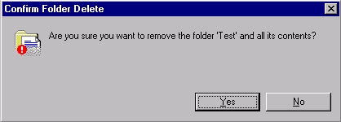
- Select the relevant folder.
- Press the Delete key on your keyboard.
The Confirm Folder Delete dialog box will appear.
- Click Yes to delete the specified folder.
Helpful hints:
Although it is possible to delete multiple subfolders by deleting the parent folder it is not possible to delete multiple folders on the same branch level.
If you have used a stand-alone workstation or laptop, you may have used the Recycle Bin to retrieve deleted files. This function is NOT available on WTS.

Virus-checking
Many systems have real time virus-checking functionality that alerts you if you receive an infected file by e-mail or try to open one. However, it is good practice periodically to check for infected files.
There are many anti-virus programs, but the procedure is roughly the same with all of them. Either open the program and check the relevant drive (A: for floppy, C: for hard disk etc. — see Drives and filestores above). Some programs also let you right-click the drive or folder in Windows Explorer and select a virus-scan option.
Helpful hint:
WTS scans automatically for viruses in e-mails and on the N:, R: and S: drives, but at present has no way of scanning other drives.

If you are checking a drive with many gigabytes of data on it, the process may take a long time.
If the program finds infected files, it will offer options such as:
- quarantining the files (i.e. moving them to a safe area)
- disinfecting them (i.e. removing the virus)
- deleting them (if it is not possible to remove the virus)
- renaming them (if the file is being used and so cannot be deleted).
Use the last option if all else fails, as it may be possible to remove the virus next time the antivirus program is run. Make a note of the folder in which the infected files are found, so that you only have to scan there rather than the whole drive, if a second scan is necessary.
PCs and laptops often come with antivirus programs installed, but with a limited, e.g. one year, subscription to the program. It is often better to download a program from www.ucl.ac.uk/fsecure (also available on disc at the UCL shop at a reasonable price), remove the preinstalled program and replace it with the downloaded one. It is best not to be connected to the Internet for the short time that you have no antivirus program installed, so that no virus can sneak past you.
Helpful hints:
You must not have two antivirus programs installed on a machine at the same time. That may cause your machine not to start at all.
Keep an eye on your antivirus program:
- If there are, for example, warning messages about its virus definitions being out of date, you will need to update them.
- If there are warning messages about the program not running — it could have been knocked out by a virus or file corruption — remove and reinstall it.

Finding files
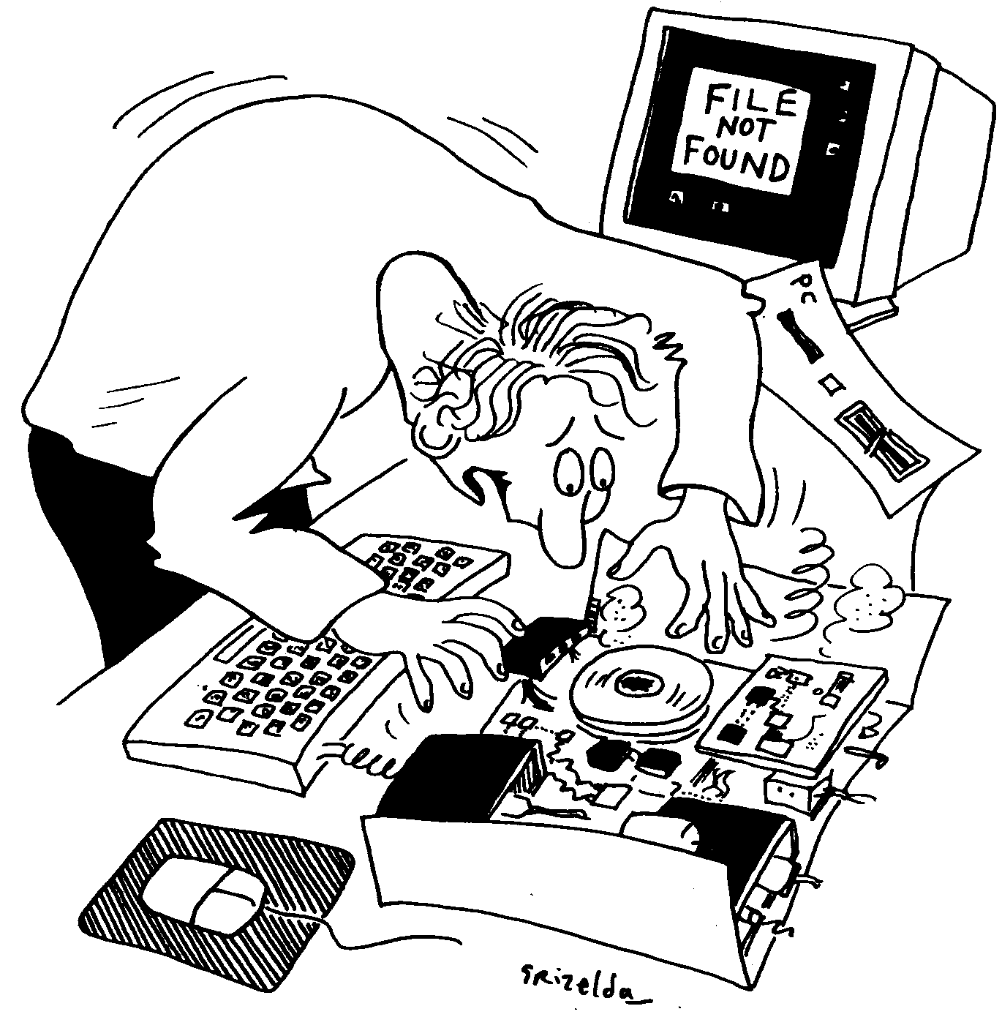
When you are saving your work you must always be aware of:
- The drive it is saved on.
- The folder it is placed in.
- The file name.
In an attempt to be helpful, many applications automatically specify default drives, folders and even file names. Be aware of these specified defaults and accept them, or specify your own location and file name when saving files. If you follow these simple rules it will make finding your files much easier.
If you lose a file, you can use the Search button in Windows Explorer to look for the file.
The search feature is fairly sophisticated and will allow you to search on a number of different criteria:
- Name
Toolbar tip

Search
- Date
- Type
- Size
- Containing text
- Advanced options.
The more specific you are the more effective the search will be.
- Click on the Search button (or press Ctrl-F).
- The left-hand pane in Windows Explorer is taken over by the Search pane.

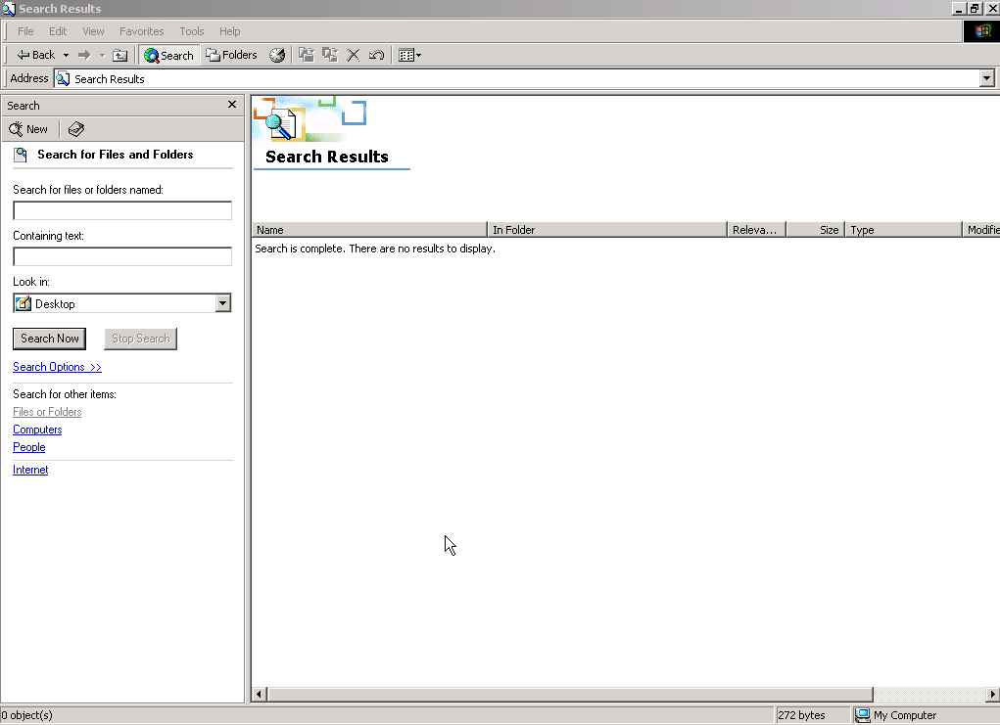
- You can enter a file name (if you know it) in the Search for files or folders named box.
- You can use the Look in box to select particular drives and folders to search. By default it will look below any drive or folder selected before you clicked Search.
- You can enter a string of text that you know occurs within the file in the Containing text box. Careful — this can take a long time!
- You can click Search Options to specify additional criteria (date, type, size or advanced options).
- When you have set your search criteria, click the Search button.
- A list of all files fitting all the criteria you specify will appear in the right-hand pane.

Searching by name and location
If you know the name of the file or if you know where you saved the file, this is the option to select. Simply enter the file name in the Search for files or folders named box. If you cannot remember the exact file name or perhaps you do not know the extension, wildcards can be used. Wildcards are symbols that can be used to substitute for one or more characters.
Wildcard | Matches
* | Any character or number of characters
? | Any single character

For example to find a file called myfile which has an extension you cannot remember you can type: myfile.*
This would match myfile.doc, myfile.xls, myfile.txt etc.
To find a file with an extension .doc you can type: *.doc
This will match all files with a .doc extension e.g. memo.doc, agenda.doc, test.doc and report.doc.
al*.* would find all files with file names starting with al.

Searching by date
You can search for a file by the date it was created or last modified, or between two dates.
There is also the option to find files modified within a previous number of months or days.
- Select the Date box. In the drop-down box select either files Modified, files Created or files Last Accessed.
- Specify the dates and click the Search button.

Searching by file type
You can search for a file by its type. This is done by selecting the Type box and choosing the type of application in the drop-down box that appears.

Searching by size
You can search for a file by size. The search can be carried out by the options of at least or at most in kilobytes (Kbs).
For example, to search for files larger than 1 megabyte, select at least and enter 1000 in the KB box.

Advanced options
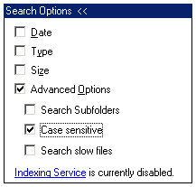
An advanced search allows you to search for a file including subfolders, slow files (files on removable storage media, such as optical or tape backup which may need to be copied to a faster storage medium before the contents can be searched) and case sensitive file names.

Compressing / zipping files
Compressed (or zipped) files are a special sort of file because they are an archive of other files and folders – all the information in the files and folders is copied into one single file, and it is compressed so that it takes up less space. Zip files are commonly used for two purposes:
- To store archives of information long-term, for example, old student data which is not likely to be needed, but has to be kept for some reason.
- To bundle a set of files and folders into one single, small file so that it can be easily sent across the Internet. Often when you download software from the Internet, you only need to download one file, because all the software’s files are compressed into one zip archive.
Getting files and folders back out of a zip archive is called extracting.

Creating zip files
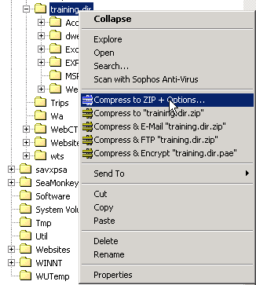
To create a zip file you will need a file compression program such as WinZip or PowerArchiver. Whichever you use, the process will probably be very similar to that described here (based on PowerArchiver, available on WTS). If you do not have a compression program on your PC, you can download PowerArchiver from: www.powerarchiver.com.
- Copy the files to be compressed to a folder.
- Right-click the folder and click Compress to folder name].zip*.
- Rename the zip file if necessary.
- You will find the zip file created in the folder above the one you compressed.

Helpful hint:
The first time you create a zip file in your WTS account, you need to start PowerArchiver first (by going to Start | Program Files | Software I-P | PowerArchiver). Then close it. Otherwise, the useful right-click options in Windows Explorer don’t work.

*If you choose Compress to ZIP + Options instead the following options are available:

Compression
Most archiving programs allow you to select how much compression to use. With no compression or low compression, the zip file will not be as small as it could be. Selecting high or full compression will mean that the file is as small as possible, but it may take a few seconds longer.

Set password
If you would like a zip file to be a secure archive (so that a password is needed before it can be accessed, extracted, or modified), this option is available. Do not use this unless you’re sure the password can be made available for people to access the file in future!

Save Relative folder info / Save Full folder info
When you add files to a zip archive – for example, if we added the folder named films shown in the picture – they can be stored in three ways:
- Without any folder information. All the files inside the films folder will be put into the archive, and then when they are extracted later there will be no information about where the files should go – no record is kept of the films folder. They will all end up in the same folder.
- With relative folder information. All the files inside the films folder will be put into the archive, but this time the information about the films folder will also be stored. When the archive is extracted, the files will be put into a films folder. This is the option that is used unless you specify one of the others.
- With full folder information. In the above example the full path to the desired folder is R:\training.dir\explorer\films, and if the third option is used, not only would the archive record that the files were in the films folder, but also that the films folder was in the explorer folder, and that the explorer folder was in the training.dir folder. Extracting a file from the archive would cause it to be put in the subfolders training.dir\explorer\films (these folders will be created anew if they don’t exist).

Extracting zip files
- Create a folder to extract the files into.
- Move the zip file into the folder.
- Right-click the zip file.
- Click Extract here.

Hints about sending files by e-mail
If you need to send a document (that is not confidential) to someone who has access to a shared area of a network drive, save your file in a suitable folder on the shared drive and just let the person know where it is. This reduces the traffic on the e-mail server and speeds up general e-mail performance.
If you have no shared area, check the size of the file (see Sorting files) and zip it if it is large.
If you are sending images, you may need to zip JPEG versions of them if they are large. Use the File | Save As function in an image-editing program such as Fireworks, IrfanView, Paint Shop Pro or Photoshop Elements.
Helpful hint:
If you work regularly with images, you may be interested in attending the Photoshop Elements courses run by Information Systems. See www.ucl.ac.uk/is/training for full details.

Learning more

Open Learning Centre
- You can drop in for help with file management any time between 12:30–5:30 Mon. –Thurs. (12:30–4:00 on Fri.).
- See the OLC Web pages for more details at: www.ucl.ac.uk/is/olc

Online learning
There is also a comprehensive range of online training available via TheLearningZone at: www.ucl.ac.uk/elearning

Getting help with managing your files
The following faculties have a dedicated Faculty Information Support Officer (FISO) who works with faculty staff on one-to-one help, as well as group training, and general advice tailored to your subject discipline:

Arts & Humanities
Bartlett
Engineering
Life Sciences
Maths & Physical Sciences
Social & Historical Sciences

See www.ucl.ac.uk/is/fiso for more details.

