UCL
Education & information support division
information systems



PowerPoint 2003

Graphics, diagrams and animations

Document No. IS-041 v2
Contents
Slide layouts 1
Diagrams and organisation charts 2
Creating a diagram or chart using content layouts 2
Organisation charts 3
Tables 4
Creating a basic table slide 4
Creating a complex table 5
Table borders 5
Rows and columns 6
Merge or split cells in a table 6
Position or align text in a table 7
Create an embedded Word table 7
Insert Excel worksheet cells into a presentation 8
Adding a picture to a table 8
Charts 9
Creating charts from a layout 9
Working with charts 9
Link or embed an Excel chart 11
Drawing tools 12
Drawing lines 12
Drawing basic shapes 13
Drawing freehand 15
Flowcharts 15
Working with objects 16
Aligning and distributing objects 16
Stacking objects 17
Rotating or flipping objects 18
Grouping and ungrouping objects 19
Incorporating graphics 20
Using Clip Art 20
Inserting images from a file 21
WordArt 22
Inserting WordArt 22
Animations 23
Applying an animation 23
Removing an animation 23
Customising text animation 24
Adding more customisation 24
Slide transitions 25
Hyperlinks 26
Absolute and relative links 26
Creating a hyperlink to another slide in the slide show 26
Creating a hyperlink to another slide show 27
Action buttons 28
Creating an action button 28
Sound clips and videos 29
Inserting a sound or video clip from the Clip Gallery 29
Inserting a sound from another location 29
Adding a sound clip to an object or existing text 29
Activating the clip during the slide show 29
Learning more 30

Introduction

This workbook has been prepared to help those with prior experience of using PowerPoint to incorporate graphics and animation into their presentations. The guide can be used as a reference or tutorial document. To assist your learning, a series of practical tasks are available in a separate document. You can download the training files used in this workbook from the IS training web site at: www.ucl.ac.uk/is/training/exercises.htm.
Many of the skills covered on this course (e.g. drawing tools, handling objects) can be used in other Microsoft applications such as Word, Excel etc.

Slide layouts
When creating graphics or diagrams in PowerPoint you should choose the most appropriate slide layout for your needs. If you are going to have a slide with a flow chart or diagram that you are going to create and design yourself, you should choose a blank slide, so that there are no text boxes or other objects getting in the way. If you want PowerPoint to assist you on inserting an object, you might like to use a content layout, where it prompts you to insert an object. If you would like to include texts around your objects, then you might like to look at the Text and Content layouts. All of these layouts can be viewed on the Slide Layout task pane. Go to the View menu, then Task pane, now change the task pane view to Slide Layout by clicking on the drop down arrow.
A description of different slide layouts is listed below.

Content layouts
When a content layout is chosen, a group of icons will be placed on the slide. Each icon enables you to insert one of the following objects:
Insert Clip Art
Insert Media clip
Insert Chart
Insert Diagram or organisation chart
Insert Picture
Insert Table
- Table
- Chart
- Clip art
- Picture
- Diagram or organisation chart
- Media clip
By pointing the cursor at each icon, a tag will be displayed to show you the details of the option, i.e., what type of object it represents. Click on the relevant icon to choose the object you wish to insert. PowerPoint will assist you when you insert an object by displaying a toolbar and giving you a prompt to insert an object.

Text and content layouts
Use these layouts if you want to insert an object listed above with a text box.

Other layouts
These options allow you to include media clips, rotated texts, organisation charts and graphs.

Blank slide layout
In addition to the slide layout types specified, you also have a Blank slide option. This will create a slide with no placeholders at all. This should be used if you want to create images or diagrams from scratch.

Diagrams and organisation charts
If you want to include a diagram or organisation chart in your presentation, you should consider using the content layouts that PowerPoint provides. If you would like to learn how to create a diagram or organisation chart from scratch, please see the Drawing tools section on page 18.
There are several pre-designed diagrams and organisation charts in PowerPoint:
- Organisation charts – to represent an organisation’s structure or hierarchy
- Cycle diagram – to show a process with a continuous cycle
- Radial diagram – to show relationships to a core element
- Pyramid diagram – to show foundation relationships
- Venn diagram – to show areas of overlap between elements
- Target diagram – to show steps towards a goal.

Creating a diagram or chart using content layouts
- To insert a diagram or chart into your slide, you should choose an appropriate content layout by clicking on the thumbnails in the Slide Layout task pane. For example, in the 2-content layout, you will have two charts or objects next to each other. Text and Content layout lets you have a text box next to your chart, diagram or object.
2 content layout allows you to have 2 objects side by side. There are other combinations of layout you can use, see the Diagram Gallery window on the left.
- Alternatively, if you have already inserted your slide, you can go to the Insert menu and choose Diagram.
- The Diagram Gallery window will be displayed as shown opposite:
- Choose a suitable diagram type from the six diagram types provided, and then click OK. You can click on any of the diagram types to view the name and description of the diagram.
- After you clicked OK, a diagram is added to the slide, and the Diagram toolbar appears.
- Add text to the diagram by clicking on the shapes and entering your text.

Adding to diagrams
- To add more shapes to the diagram, select the closest shape and click Insert Shape on the Diagram toolbar.
- The new shape will be added to the diagram.

Changing a diagram type
- To change the type of a diagram (e.g. from Cycle to Venn), use the Change to button on the Diagram toolbar.
- You may be prompted to turn on AutoFormat in order to do this.

Changing the appearance of the diagram objects
You can change the format of the boxes and text in the diagrams by using the options from the Drawing toolbar (e.g. fill colour, line style etc.).

Organisation charts
- The organisation chart shown below was created by using the Organisation Chart layout.
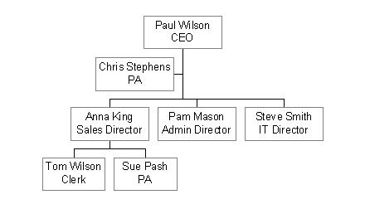

- PowerPoint automatically sets up four members of staff for you.
- The Organisation Chart toolbar also appears. The Organisation Chart toolbar allows you to:
- Insert new shapes – subordinates, co-workers or assistants
- Modify the layout – including fitting the chart to fill in the available space
- Select parts of the chart – by branch (vertically) or level (horizontally).
- To edit the Organisation Chart, click inside the box, and type in the text (e.g. a member of staff’s name and job title).
Organisation Chart toolbar
Organisation Chart edit area

Subordinates/Co-workers/Assistants
To add subordinates, co-workers or assistants to your organisation chart:
- Select a shape and click on the Subordinate/Co-worker/Assistant option on the Insert Shape menu from the Organization Chart toolbar.
- A subordinate/co-worker/assistant is then added. Type in the details.

Tables
There are several ways to create a table in a PowerPoint presentation. You can create tables inside PowerPoint, or you can insert a table from another program as a linked object or an embedded object. When you use PowerPoint, you can create a simple table, or one with more complex formats. You can include fills and border colours in the presentation colour scheme.
If you want a larger table or more powerful formatting capabilities than those provided by PowerPoint, you can create an embedded Microsoft Word table. For example, Word provides more options for formatting lists, tabs and indents, as well as individual cells. You can also embed an Excel worksheet or an Access table.
When you are working on an embedded table, the menus and buttons of the original program will appear, integrated with the PowerPoint menus. Information about how to modify tables is available from the Help menu of the original program on your menu bar.
Please note that texts in tables will not appear in the Outline tab, and therefore can not be modified in the Outline view.

Creating a basic table slide
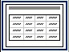
- Add a new slide.
- Apply the table layout to the slide by selecting the Title and Table layout from the Other Layouts area of the Slide Layout task pane.
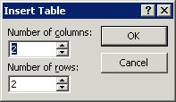
- Double click on the table icon in the middle of the slide and you will be asked for the number of rows and columns you need for the table.
- After typing in the number of rows/columns, click on OK. The slide takes on the following appearance for a 3 row by 3 column table, and a Tables and Borders toolbar appears.
- You can then type the contents into the table cells.

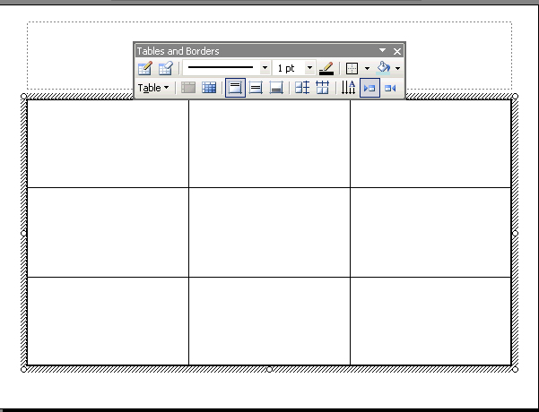

Creating a complex table
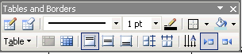
To create a more complex table:
- Display the Tables and Borders toolbar by clicking on the Tables and Borders button on the Standard toolbar.
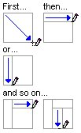
- Click on the Draw Table button.
- The pointer changes to pencil shape.
- To define the outer table boundaries, drag diagonally to the size you need. Then drag to create the column and row boundaries.
- To erase a line, click Eraser and then click on the line.

Table borders
Use this process to modify PowerPoint tables. (Use the original program's Help for information about modifying tables created with external programs.)
To change the borders of the table created within PowerPoint:
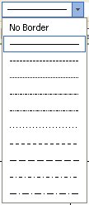
If the Tables and Borders toolbar is not displayed, click on the Tables and Borders button on the Standard toolbar.

Change the style of the border
- Click the arrow next to Border Style, and then select the style you want. To remove a border, click No Border.
- The pointer changes to pencil shape.
- Click on the borders to make changes.
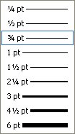

Change the width of the border
- Click the arrow next to Border Width and then select the appropriate width.
- The pointer changes to pencil shape.
- Click on the borders to make changes.

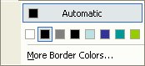
Change the colour of the border
- Click Border Colour and then select a colour.
- The pointer changes to pencil shape.
- Click on the borders to make changes.

Rows and columns

Add rows or columns to a table
Use this process to modify PowerPoint tables. (Use the source program's Help for information about modifying tables that were created with external programs.)
- Select the row(s) below the position where you want to insert new rows, or select the column(s) to the left of the position where you want to insert new columns. Select the same number of rows or columns as the number of rows or columns you want to insert.
- To select rows, columns, or the entire table, drag across the rows, columns, or the entire table.
- To select a column, click just outside the top border of the column, when the pointer is in the form of a down-facing arrow.
- Right-click on the selected row(s) or selected column(s) and then click Insert Rows or Insert Columns on the shortcut menu.
- To add a row at the end of a table, click into the last cell of the last row and then press the Tab key.
Helpful hint:
You can also use the Draw Table tool on the Tables and Borders toolbar to draw the row or column in the position you want.

Delete table rows or columns
Use this process to modify PowerPoint tables. (Use the original program's Help for information about modifying tables created with another program.)
- Select the rows or columns you want to delete.
- To select rows, columns, or the entire table, drag across the rows, columns, or the entire table.
- To select a column, click just outside the top border of the column, when the pointer is in the form of a down-facing arrow.
- Right-click on the table and then click Delete Rows or Delete Columns on the shortcut menu.

Merge or split cells in a table
Use this process to modify PowerPoint tables. (Use the source program's Help for information about modifying tables created with external programs.)
On the Tables and Borders toolbar:
- To merge two cells, the easiest way is to click Eraser , and then click the cell boundaries you want to remove.
- To split a cell, select the cell, and then click Split Cell.
- To merge multiple cells, select them and click Merge Cells.

Position or align text in a table
Use this process to modify PowerPoint tables. (Use the original program's Help for information about modifying tables created with external programs.)

Align text on top, centre, or bottom of a cell
- Display the Tables and Borders toolbar.
- Select the cells you want to change.
- Click Align Top , Center Vertically , or Align Bottom.

Align text on the right or left, or in the centre of a cell
- Select the cells you want to modify.
- On the Format menu, point to Alignment, and then click Align Left, Center, Align Right, or Justify.

Change cell margins
- Select the cells you want to modify.
- On the Format menu, click Table, and then click the Text Box tab.
- Adjust the measurements in the Internal margin option.

Insert a tab in a table cell
To insert a tab in the cell, just press Ctrl+Tab.

Rotate text in tables
Use this process to modify PowerPoint tables. (Use the original program's Help for information about modifying tables created with external programs.)
- Click the table cell containing the text you want to modify.
- On the Format menu, click Table, and then click the Text Box tab.
- Select the Rotate text within cell by 90 degrees check box and click OK.

Create an embedded Word table
- On the Insert menu, click Object.
- In the Insert Object dialog box, click Create New.
- In the Object type box, select the Microsoft Word Document, and then click OK.
- Use the commands on the Table menu to create the table.
- Click outside the table to return to PowerPoint.
When you work on a Word table, a Word menu and Word buttons appear integrated on the PowerPoint menus, so that you can modify the tables from within PowerPoint. Information about how to work with Word tables is available from the Help menu on your menu bar while you are working on a Word table.

Insert Excel worksheet cells into a presentation
You can copy cells from an Excel worksheet and paste them onto a slide in your PowerPoint presentation.
To link data in the Excel worksheet to your presentation (so that if the data changes in Excel, the data in your slide will update automatically):
- In Excel, select the range of cells you want to link to, and then select Copy from the Edit menu, or press Ctrl + C.
- Switch to PowerPoint, and then click the slide or notes page where you want to insert the linked copy of worksheet cells.
- On the Edit menu, click Paste Special.
- Select Paste link.

Adding a picture to a table
When you add a picture to a table, it is a layer on top of the table — it does not become part of the table. After you’ve added the picture, you can resize it to make it look as if it fits. To resize a picture, drag the picture's sizing handles to a new position.
When you add a picture as a fill effect, it is resized to fit the cell, and may be distorted. To eliminate the distortion, you can resize the cell or table. To resize a cell, drag a column or row boundary to a new position. To resize the table, drag the table's sizing handles to a new position.

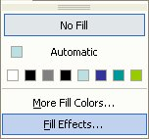
Adding a picture to a cell as a fill effect
You can use the Fill Color tool to add a fill to any cell in your table.
To add a picture to a cell as a fill effect:
- Select the cell in which you want to place the picture in.
- On the Tables and Borders toolbar, click on the arrow next to Fill Color.
- Click Fill Effects, and then click the Picture tab.
- Click on the Select Picture button and locate the picture you want to insert.
- Click Insert followed by OK to close the dialog boxes and insert your picture.

Remove a fill
- Click inside the cell, and click on the Fill Color button on the Tables and Borders toolbar
- Select the No Fill option.
- Your picture will be removed from the cell.

Charts
You can create a chart from scratch in PowerPoint, or you can import an Excel worksheet or chart.
PowerPoint relies on a separate program – Microsoft Chart – to create charts. Please note that Microsoft Chart is also used in Word. This program enables you to create over 80 different types of charts which can be used to present numerical information in a graphical form.
PowerPoint charts can be created in a number of ways. The simplest method is to choose the layout that has been set up for charts. The second option is to click on the chart icon on the Standard toolbar, located at the top of the screen.

Creating charts from a layout
- Create a new slide.
- From the Slide Layout task pane choose either the Title, Text and Chart or the Title and Chart layout.

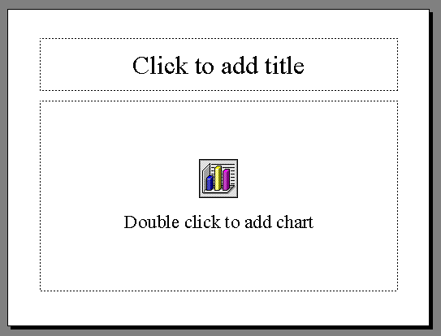
- The following slide is displayed:
- Type in a title for the chart.
- Double-click on the chart icon in the middle of the slide to enter chart mode where you can input the data for the chart.

Placing a chart within an existing slide
If you want to create a chart within an existing slide, rather than creating a new slide:
- On the Insert menu click Chart.
- This will take you into chart mode in which you can input the data.

Working with charts
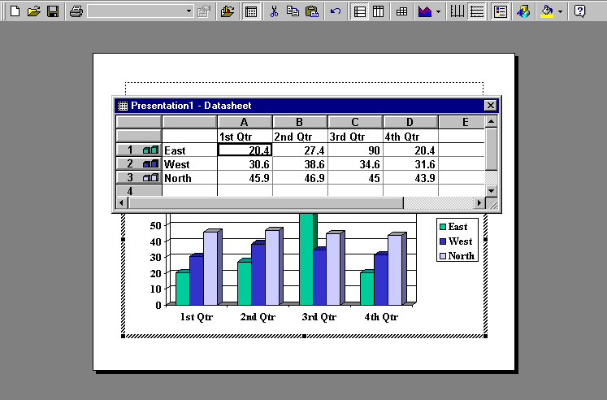
When you create a chart, PowerPoint generates a dummy set of data and constructs a default chart from those data. You will need to replace the dummy data with your own data.
Dummy data
Chart based on dummy data

Changing the data generated
- You can clear the dummy data by clicking the grey area to the top and left of the data to select all of it, and pressing Delete.
- Now click inside the datasheet at the point where you wish to add your own data.
- Type in the data. Continue until the datasheet reflects the detail required.
- New information can be added at the end of the rows or columns.
- The chart sitting behind the datasheet will update as soon as you change the information.

Clearing or deleting columns or rows of data
- To clear a column or row, click on the column letter (e.g. letter C) or row number and press the Delete key on the keyboard.
- To delete a column or row, either right-click on the column/row and press Delete, or from the Edit menu choose Delete.
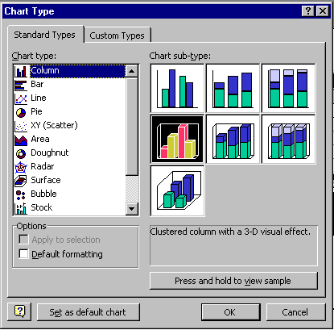

Changing the chart type
- From the Chart menu choose Chart Type. The following window will be displayed.
- Select the required chart and, if needed, the required sub-type, and then click OK. The chart should now be updated.
- Once the chart has been completed, click on the slide itself to come out of chart mode to view the chart placed on the slide.
- To go back to the slide and make changes, double-click the chart on the slide.

Modifying the chart
- Double-click the chart area to access the Chart program.
- From the Chart menu chose Chart Options. The Chart Options window appears.
- This window has a number of tabs which allow modification of Titles, Axes, Gridlines, Legend, Data Labels, and the Data Table.

Helpful hint:
To learn more about creating and working with charts, see the Excel Charts course and workbook.

Link or embed an Excel chart
Instead of using PowerPoint’s default Chart program, you can use Excel to create your chart.

Creating a new embedded Excel chart
- Click on the slide where you want to place the embedded object.
- On the Insert menu, click Object.
- Click Create new.
- In the Object type box, click Microsoft Excel Chart, and then click OK.
- A chart with sample data will be added to the slide.
- Click Sheet1 tag to replace the sample data.

Creating a linked or embedded Excel chart from an existing file
- Click in the text box of the item where you want to place the linked or embedded object.
- On the Insert menu, click Object.
- Click Create from file.
- In the File box, type the name of the file from which you want to create a linked or embedded Excel chart, or click Browse to select from a list.
- To create a linked object, select the Link check box.
When you create a linked or embedded object from an existing Excel workbook, the entire workbook is inserted into your slide. Only one worksheet is displayed at a time. To display a different worksheet, double-click the Excel object, and then click a different worksheet.

Copy Excel data into a presentation
Alternatively, you can copy and paste an existing Excel chart into your presentation.
- In Excel, select the chart you want to copy, and then click Copy.
- Switch to PowerPoint, and then click the slide or notes page where you want to insert the chart.
- On the Edit menu in PowerPoint, click Paste Special.
- Click either Paste or Paste Link (depending on whether or not you want your chart to be updated should the Excel chart change).
- To paste the chart as an embedded object, so that you can edit in Microsoft Excel, click Microsoft Excel Worksheet Object and click OK.

Drawing tools
The judicious use of diagrams can add interesting effects and clarity to your presentation. PowerPoint has a range of drawing tools which are similar to those available in other Microsoft applications. PowerPoint’s drawing tools are to be found on the Drawing toolbar. If the toolbar is not already displayed, you can display it in the way as follows:
- On the View menu click on Toolbars.
- Click on Drawing.
- The Drawing toolbar will normally appear docked at the bottom of the screen. If it appears as a floating toolbar, you can move it by clicking on and dragging its title bar.
The Draw and AutoShapes menus available from the Drawing toolbar offer further options for creating and manipulating drawing objects:
Draw menu
AutoShapes
Menu

Drawing lines
- From the Drawing toolbar, click on the Lines button. The cursor changes shape into a cross +, so that you can draw with it.
- Click and drag with the mouse to draw your line and then release.
Helpful hint:
To draw a perfectly straight line, hold down the Shift key while drawing the line. Release the mouse button before you release the Shift key.

Moving a line
- Click the line to select it.
- Move the mouse over the line. The mouse pointer should change to a four-headed arrow.
- Hold down the mouse button and drag the line to its new position and then release the mouse button.

Formatting lines
- Make sure that the line is selected.
- From the Format menu select AutoShape. The Format AutoShape window appears.
- Select the Colours and Lines tab.
- In the Line box select the required colour, style and weight, and click OK.

Drawing basic shapes
- Click on the AutoShapes menu, select a category (e.g. Lines, Basic Shapes, etc) and then click on an appropriate button.
- The pointer changes shape into a cross + so that you can draw with it.
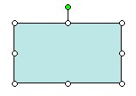
- Click and drag with the mouse to draw your shape and then release the mouse button. The AutoShape is added to the slide.
handles
Rotate handle
Note that the AutoShape is initially selected allowing you to further manipulate the shape. This is indicated by the white circles (called handles) around the shape. An AutoShape MUST be selected before you can manipulate it in any way. There is also a green handle which can be used to rotate the object.
Helpful hints:
To create a square you need to use the Rectangle AutoShape, and then press the Shift key whilst you click and drag to constrain the AutoShape to form a perfect square.
To create a circle you need to select the Oval AutoShape, and then press the Shift key whilst you click and drag to constrain the AutoShape to form a perfect circle.

Moving AutoShapes – within the same slide
- Select the AutoShape. The pointer changes to a four-headed arrow.
- Click and drag the shape to its new position.

Moving AutoShapes – to another slide
- Select the AutoShape.
- From the Edit menu select Cut.
- Go to the required slide.
- From the Edit menu select Paste.

Copying AutoShapes – within the same slide
- Select the AutoShape.
- Hold the Ctrl key and with the left mouse button drag the copy to its new position.
or
Use Ctrl+D to duplicate the object (you will need to move the duplicated object to the desired position).

Copying AutoShapes to another slide
- Select the AutoShape that you wish to Copy.
- From the Edit menu choose Copy or press Ctrl+C.
- Move to the required slide.
- From the Edit menu select Paste or press Ctrl+V.

Resizing AutoShapes
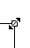
An AutoShape is resized by clicking and dragging on its handles.
- Make sure that the AutoShape is selected.
- Move the mouse pointer over a handle until the pointer changes to a double-headed arrow.
- Click and drag the required handle to resize the AutoShape and release the mouse button.

Formatting AutoShapes
It is possible to change the line weight, style and colour, and to add a fill colour to an AutoShape.
- Select the AutoShape.
- On the Format menu click on AutoShape to reveal the Format AutoShape Window.
- Select the Colours and Lines tab.
- In the Line area select the required line colour, style and weight.
- In the Fill, Color box, click on the drop-down arrow to select a colour, or use the Fill Effects option to access the Fill Effects dialog box. This allows you to apply colour gradients, patterns, textures and other effects. Select your fill effect and click OK to close the Fill Effect dialog box.
- Click on OK to close the Format AutoShape window and apply the chosen formats.

Shadows
To apply a shadow to an AutoShape:
- Select the shape that is to have a shadow.
- Click on the Shadow icon on the Drawing toolbar. The Shadow menu appears.
- Select the required shadow option.
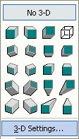
- To remove the effect, click No Shadow.

3-D settings
To apply a 3-D effect to an AutoShape:
- Select the shape that is to have a 3-D effect.
- Click on the 3-D Style icon on the drawing toolbar. The 3-D menu appears.
- Select the required 3-D effect.
- To remove the effect, click No 3-D.

Changing a 3-D effect
To change a 3-D effect — for example, its colour, rotation, depth, lighting, or surface texture:
- Select the object to which you wish to add the effect.
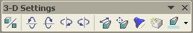
- Click on the 3-D Style icon on the Drawing toolbar. The 3-D menu appears.
- Click 3-D Settings to display the 3-D settings toolbar.
- Click the options you want on the 3-D Settings toolbar.
Helpful hint:
To add the same 3-D effect to several objects at one time — the same lighting, for example — select or group the objects before you add the effect.

Drawing freehand
PowerPoint also allows you to draw freely without any constraints. To draw a freehand line:
- From the AutoShapes menu on the Drawing toolbar select Lines.
- From the menu displayed:
Scribble
Freeform
Curve
    - select the Scribble icon to draw completely freehand,
    - the Curve icon to produce smooth curves,
    - or the Freeform icon to produce shapes defined by clicking to create vertices.
Helpful hint:
When using the Curve or Freeform tools, click once to change direction, and double click to end the line.

Flowcharts
To create a flowchart, you can use the Flowchart and Connector options from the AutoShapes menu.
- Choose a suitable shape from the Flowchart AutoShapes menu and click on the slide.
- The shape is added to the slide.
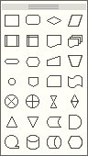
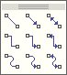
- Add a second shape.
- Now use the Connectors menu to select a suitable connector to join the two shapes together.
- First click on one of the shapes, and then on the other. Notice that as you move the mouse over either shape, the shape is highlighted with blue squares to inform you that, if you click now the connector will join the two together.
- Note that if you move one of the shapes, the connector shifts with it.

Working with objects
Most objects on a slide can be moved, copied, aligned, rotated, stacked, grouped and ungrouped. Moving and copying objects were covered in previous sections. In this section we will look at aligning and distributing objects using view guides, rotating and flipping objects, stacking objects, grouping and ungrouping objects.
Objects can be selected by clicking on them. To select more than one object at a time, hold the Ctrl key down whilst you click on them or use the select tool from the Drawing toolbar to draw a box around all the objects you want to select.

Aligning and distributing objects
There are several ways to align objects.
- You can align them with other objects, for example, with their sides, middles, or top or bottom edges of objects.
- You can align them in relation to the entire slide, e.g., at the top or left edge of a slide.
- You can also align objects by using guides to align them visually, or by using the grid to align them with a corner on the grid as you draw or move the objects.
- You can arrange (or ‘distribute’) objects so they are equally distanced from each other, either vertically or horizontally, or in relation to the entire slide.

Aligning objects with other objects
To align by their left, right, top or bottom edges:
- Select the objects you want to align.
- On the Drawing toolbar click the Draw menu.
- Point to Align or Distribute.
- Ensure Relative to Slide is NOT selected.
- Click Align Left, Align Right, Align Top, or Align Bottom.

To align objects horizontally by their centres:
- Select the objects you want to align.
- On the Drawing toolbar click the Draw menu.
- Point to Align or Distribute.
- Ensure Relative to Slide is NOT selected.
- Click Align Centre.

To align objects vertically by their centres:
- Select the objects you want to align.
- On the Drawing toolbar click the Draw menu.
- Point to Align or Distribute.
- Ensure Relative to Slide is NOT selected.
- Click Align Middle.

Align objects in relation to the slide
- Select the objects you want to align.
- On the Drawing toolbar click the Draw menu.
- Point to Align or Distribute.
- If Relative to Slide is selected, click the alignment option you want.
- If Relative to Slide isn't selected, click it, click the Draw menu again, point to Align or Distribute, and then click the option you want.

Align objects with guides
- Drag a guide to position it where you want to align the objects.
- If the guides aren't displayed, click Guides on the View menu to display them.
- Drag each object near the guide so its centre or edge automatically aligns with the guide.

Align objects on a grid
- On the Drawing toolbar, click the Draw menu.
- Point to Grid and Guides.
- To automatically align objects on an invisible grid, click To Grid.
- To automatically align objects with grid lines that go through the vertical and horizontal edges of other shapes, click To Other Objects.
Helpful hint:
To override temporarily settings for the grids and guides, hold the Alt key down as you drag or draw an object.

Arrange objects to be equally distanced from each other
- Select the objects you want to arrange.
- Unless you arrange the objects in relation to the entire slide, you must select three or more objects.
- On the Drawing toolbar, click the Draw menu.
- Point to Align or Distribute.
- To arrange objects to be equally distanced from each other click Distribute Horizontally or Distribute Vertically. (Ensure Relative to Slide is NOT selected.)
- To arrange objects to be equally distanced from each other in relation to the entire slide, click Relative to Slide. Click the Draw menu again, point to Align or Distribute, and then click Distribute Horizontally or Distribute Vertically.

Stacking objects
Objects can be thought of as pieces of overlaying paper. Objects sometimes overlap, covering important information. The order of objects on a slide can be changed easily.
To change the order of objects:
- Select the object and then click on the Draw menu on the Drawing toolbar.
or
Right-click on the object to display the shortcut menu.
- Select Order.
- Select either Bring to Front, Send to Back, Bring Forward, or Send Backwards.

Rotating or flipping objects
You can rotate an object 90 degrees to the left or right or to any other angle. You can also flip an object horizontally or vertically. You can flip or rotate one object, a set of objects, or a group of objects. If you rotate or flip an AutoShape with text attached, the text rotates or flips with the shape.
Helpful hint:
Some pictures, graphs, and organisational charts that you import can't be rotated or flipped because they were not created in PowerPoint. If you can ungroup an imported object and then regroup its components, you might be able to flip or rotate it. You will not be able to flip or rotate bitmaps in PowerPoint. However you can either use external editing tools (e.g. Microsoft Paint) to modify the bitmaps, or convert bitmaps to jpeg or gif files with external graphic editing tools.

Rotating an object 90 degrees to the left or right
- Select the object you want to rotate.
- On the Drawing toolbar, click the Draw menu.
- Point to Rotate or Flip, and then click Rotate Left or Rotate Right.

Rotating an object to any angle
- Select the object you want to rotate.
- On the Drawing toolbar, click Free Rotate.
- Drag a corner of the object in the direction you want to rotate it.
- Click outside the object to set the rotation.
Helpful hint:
To constrain the rotation of the object to a 15-degree angle, hold down the Shift key while you use the Free Rotate tool.
To rotate the object around the handle opposite the handle you're using, click Ctrl while you use the Free Rotate tool.

Flipping an object horizontally or vertically
- Select the object you want to flip.
- On the Drawing toolbar, click the Draw menu
- Point to Rotate or Flip, and then click Flip Horizontally or Flip Vertically.

Grouping and ungrouping objects
When you group objects, you combine them so you can work with them as though they were a single object. You can flip, rotate, and resize or scale all objects in a group as a single unit. You can also change the attributes of all objects in a group at once. For example, you might change the fill colours or add a shadow to all objects in the group. You can also create groups within groups to help you build complex drawings.
You can ungroup a group of objects at any time, and you can easily regroup them by selecting those previously grouped.

Grouping objects
- Select the objects you want to group.
- On the Drawing toolbar, click the Draw menu, and then click Group.

Ungrouping objects
- Select the group you want to ungroup.
- On the Drawing toolbar, click the Draw menu, and then click Ungroup.

Regroup objects
- Select any one of the objects that was previously grouped.
- On the Drawing toolbar, click the Draw menu, and then click Regroup.

Incorporating graphics
Graphics (Clip Art or images) can be incorporated into PowerPoint presentations from the Microsoft Clip Gallery, or from existing files (obtained from a scanner, a digital camera or the Internet). You can use the layout options with a new slide to include images or you can add images from the Insert menu. Both methods are described below.

Using Clip Art
Clip Art is Microsoft’s library of images and diagrams. There are several ways of inserting Clip Art, including using the Clip Art task pane (similar to Word and Excel), or using Autolayouts designed for Clip Art.

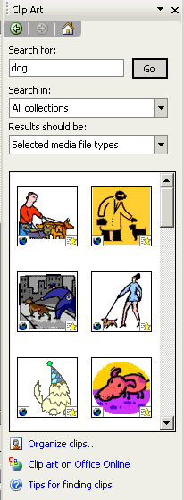
Using the Clip Art task pane
You can insert Clip Art into any slide using the Clip Art task pane shown here.
- Enter search keyword(s) into the Search for: box and click Go.
- The task pane will now display those related Clip Art images.
- Click on an image to insert it onto the current slide.

Using layouts for Clip Art
If you use the Content layout options, or the layouts with Clip Art in the title such as Title, Clip Art and Vertical Text, you can then insert pictures from Microsoft's Media Gallery:
- Insert a new slide and select an appropriate layout option from the slide layout task pane (examples of Clip Art and Content layouts are shown below).
Clip Art button
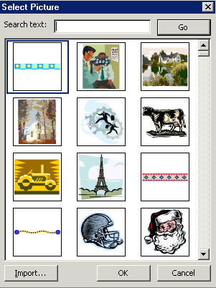

- If you have selected a Content layout click on the Insert Clip Art button. If you have selected a Clip Art layout, double-click the Clip Art thumbnail to reveal the selected picture dialog box.
- Enter the search keyword(s) in the Search text: box and click Go.
- The window will now display suitable Clip Art images.
- Click on an image to insert it into the current slide.

Inserting images from a file
It is possible to insert images in a variety of formats into PowerPoint presentations.
Helpful hint:
Image files can be large, and may significantly increase the document file size. One way of avoiding inefficient large file size, is to resize the images to appropriate scales in external photo editing tools and save them as jpeg files, rather than re-sizing them inside PowerPoint.
To insert images that are not in the Media Gallery (e.g. those that have been saved from the Internet, a scanner or a digital camera):
Insert Picture
Either:
- Insert a new slide and select a Content layout option from the Slide Layout task pane.
- Click the Insert Picture icon on the drawing toolbar, usually at the bottom of your screen, to reveal the Insert Picture window.
Or, to insert an image into an existing slide:
- Choose Insert Picture from File to reveal the Insert Picture window.
Thumbnails of the images shown, rather than just filenames as in List view.

- Select the file you wish to insert and click Insert to insert the image into your slide.

Editing graphics
Graphics can be moved, rotated and resized. They can also have borders placed around them.
- To move a graphic, simply click, drag and drop it.
To re-size a graphic:
- click on a handle in the corner, keep pressing the left button on your mouse, move around to adjust height and width, and then release.
- click on a handle on the top or bottom, keep pressing the left button on your mouse, move up and down to adjust the height, and then release.
- click on a handle on the right or left, keep pressing the left button on your mouse, move left and right to adjust the width, and then release.
Colour
Less Contrast
Less Brightness
Rotate
Recolor Picture
Set Transparent Color
Reset Picture
Insert Picture
More Contrast
More Brightness
Crop
Line Style
Compress Picture
Format Object

Picture toolbar
Once you have inserted an image or Clip Art into your presentation, the Picture toolbar appears, offering options for modifying the graphic as indicated.

WordArt
WordArt enables you to apply special formats to text.

Inserting WordArt
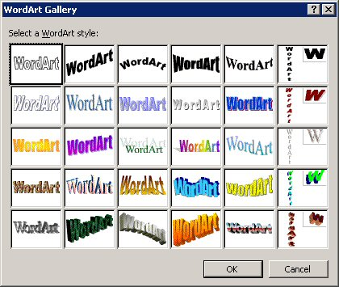
- On the Insert menu, select Picture, and then select WordArt from the submenu,
Or
Click the Insert WordArt button on the Drawing toolbar.
- The WordArt Gallery is then displayed.
- Select the style you want to use and click OK.

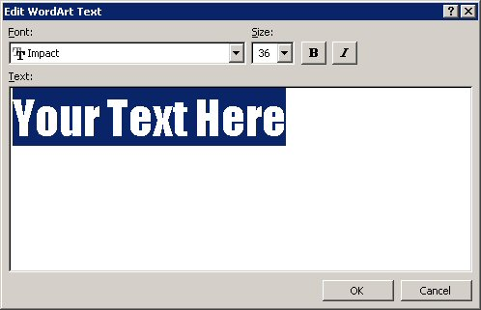
- Select your choice of font in the Font box.
- Select the point size you require in the Size box.
- Click the Bold and/or Italics buttons if required.
- Key in the text in the Text area.
- Click OK.

WordArt toolbar
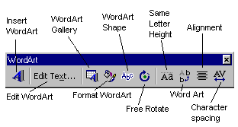Once the text has been inserted onto your slide, the WordArt toolbar appears on your screen. Use these buttons to format your text further.
To display the WordArt toolbar manually:
On the View menu, select Toolbars, then select WordArt.

Animations
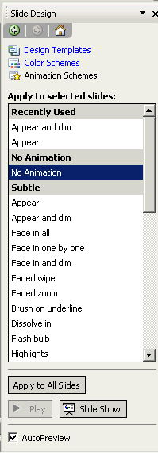
Animations (known as Builds in previous versions of PowerPoint) apply to the contents of slides. Animations allow the text or other objects on a slide to appear either after a specified time or when the presenter clicks on the mouse. The purpose of having animations, especially on bullet lists, is to prevent the audience from reading ahead.

Applying an animation
Animations may be applied to the current slide, to all slides, or to selected slides. To select specific slides you may either use Slide Sorter view, or you can select them from the Slide tab on the left of the Normal view window.
- View the slide(s) in Normal or Slide Sorter view.
- View the Slide Design – Animation task pane. This task pane offers a range of effects, from ‘subtle’ to ‘exciting’.
- Click on an effect to see a preview. This effect will now apply to the selected slide(s).
- You can click the Slide Show button at the bottom of the task pane to start the slide show at the current slide.
- Click the Apply to All Slides button to apply the effect to the entire presentation (recommended for consistency).

Removing an animation
Display the Slide Design task pane.
- Click on the No Animation option (at the top of the list).
- Click Apply to All Slides if you wish to remove the effects from all slides.

Customising text animation
You will notice that when you use the approach above, all of the second and third level bullet points appear at the same time as the first level bullets. There may be occasions you would like those lower-level bullet points to appear after a sequence of mouse clicks, rather than grouped with their ‘parent’ bullet point. It can be done for either individual slides, or the whole presentation by working on the Master slide. The process is much easier when you make changes on the Master Slide, and it will avoid the possible inconsistency of the presentation.
- From the Master slide, apply the effect by using the Animation Schemes task pane.
- Now display the Custom Animation task pane – your master slide should now have numbers next to the different bullet points showing their position in the animation sequence. In the example below, the entire lower level bullet points will appear together with the first level bullet – they are all labelled ‘1’.
- To force the bullet points to appear one by one in a sequence, go to the Custom Animation task pane, click Text2: Click to Edit, and choose Start on Click.
- Now the labels for the different level bullets should have changed to 2, 3, 4 etc. as shown here.

Adding more customisation
- Select an object on a slide and click the Add Effect button from the Custom Animation Task Pane to reveal the Add Effect menu.
- You can use the options in the Add Effect menu to control the entrance of objects, the type of emphasis to apply (font size, spinning etc.), how objects exit, and how they move on the slide. Once you have added an effect to an object, the button changes to a Change button.
- You can also modify the options to control the speed and timing of the animation. The animated objects are listed in the order of which they will appear, and can be re-ordered using the arrows.
- You can modify the animation effects by clicking the arrows on the right of the listed animated object.
- From this menu select Effect Options to display the window shown here. Note the window is labelled with the selected effect (‘Fly In’ in this case).
- Use the Effect tab to control the type of effect.
- Use the Timing tab to control the timing (delay, speed).
- Use the Text Animation tab to control the paragraphs that are grouped together.

Slide transitions
PowerPoint offers a number of stylised ways of moving from one slide to the next. Transitions determine how a slide appears on screen. For instance you may want to have the first slide within your presentation to fade into the screen. You might want second and subsequent slides to ‘box in’. Used judiciously, these effects can add impact to your presentation. It is advisable to use the same transition effect for all slides, in order to keep the consistency of the entire presentation.
To apply a transition:
- View the slide(s) either in Normal or in Slide Sorter View.
Helpful hint:
If you are in Slide Sorter view you can select several sides at once to add the effect to.
- From the Slide Transitions task pane select an appropriate transition effect.
- The selected slide(s) will momentarily display the transition.
- You can use the options at the bottom of the task pane to modify the speed of the transition, whether sound is applied (not advisable), how to progress to the next slide (automatically after a set time, or on mouse clicks), and whether to apply the effect to the whole presentation.
- Once you have added a transition, a symbol appears underneath the slide when viewed in Slide Sorter view.
- Switch to the Slide Show view to see the transition in action.

Slide number
Transition symbol
Helpful hint:
Avoid using too many different effects as they can be distracting for the audience. If you would like to use the same effect for every slide in the presentation you need to click on the Apply to all slides button.

Hyperlinks
PowerPoint hyperlinks allow you to branch off during your presentation to a variety of locations. You can create a hyperlink to take you to a specific slide within your presentation, a Custom Show*, or another presentation altogether. You can link to a Word document, an Excel spreadsheet, a company intranet, or, if you are connected to the Web, an address on the Internet. You can create a hyperlink from any text or object.
Text that represents a hyperlink appears underlined and in a colour that co-ordinates with the colour scheme. The colour changes after a hyperlink is clicked, so you can tell which hyperlinks you've already viewed. If you have text within a shape, you can set up separate hyperlinks for the shape and the text.
Clicking on the hyperlink, or holding the mouse over it, activates the hyperlink. You can also associate two actions with the text or object. For example, you can move the mouse over an object to play a sound and then click the object to jump to another slide.
Hyperlinks only become active when you actually run your slide show, not when you are in the editing mode.
Helpful hint:
When you set up a hyperlink, it's best to select the mouse-click method. If you select the mouse-over method, it's possible to jump when you don't really want to. The mouse-over method is good for feedback, for example, playing a "more information" message.

Absolute and relative links
When you create a hyperlink, you can set the path to its destination as an absolute link (a fixed file location that identifies the destination by its full path name, e.g., C:\training\ppt\schedule.doc). Alternatively, if you plan to move the destination files at any time, you can set the path as a Relative link, i.e., the location of the destination file will be relative to the file containing the hyperlink.
Helpful hint:
If you set up a hyperlink to another slide (either in the same presentation, or another one, also add a hyperlink on that slide so you can return to the original one).

Creating a hyperlink to another slide in the slide show
- 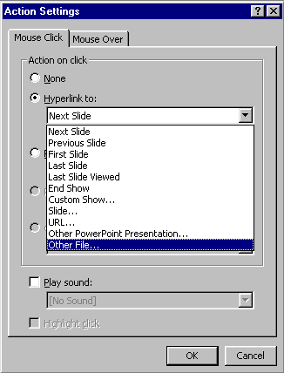Ensure the presentation you want to insert the hyperlink in has been saved. You cannot create a relative link if you insert the hyperlink before the presentation is saved (simply because the file does not yet exist on your drive, if you have not saved it).
- Select the text or object you want the Hyperlink to be added to. (You can also create an action button to activate the hyperlink – see page 40.)
- From the Slide Show menu, select Action Settings.
- To jump by clicking the selected object, click the Mouse Click tab; or to jump by moving the mouse over the object, click the Mouse Over tab.
- Click the Hyperlink to: button.
- Select the slide you want to jump to from the list displayed.
- Add a sound if you wish by clicking the Play sound: button and selecting an appropriate sound.
- Click OK.

Creating a hyperlink to another slide show
- Ensure the presentation in which you want to insert the hyperlink in has been saved. You cannot create a relative link if you insert the hyperlink before the presentation is saved.
- Select the text or object you want to represent the hyperlink. (You can also create an Action Button to activate the hyperlink – see page 40.)
- On the Slide Show menu, select Action Settings.
- To jump by clicking the selected object, click the Mouse Click tab, or to jump by moving the mouse over the object, click the Mouse Over tab.
- Click the Hyperlink to button.
- Select Other PowerPoint Presentation from the list displayed.
- Use the Look in box to locate the folder containing the file you want to link to.
- Select the file and click OK.
- 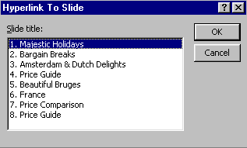In the Hyperlink to Slide dialog box, select the slide to which you want to link and click OK.
- The link will be Absolute unless you click the Use relative path for hyperlink checkbox. (See section above on the Absolute and Relative links.)
- You can also add sounds by clicking the Play sound button and selecting the sounds.
- Click OK to apply the changes.

Editing a hyperlink
- In Normal view, select the text or object that represents the hyperlink you want to edit.
- On the Slide Show menu, select Action Setting.
- Make the changes you want, and then click OK.

Removing a hyperlink
- In Normal view, select the text or object that represents the hyperlink you want to remove.
- On the Slide Show menu, select Action Setting.
- Click None, then click OK.

Action buttons
You can add action buttons to a slide and then define how you want them to function and behave during the slide show (e.g., jump to another slide). They appear pressed in when you press them. There are action buttons that contain arrows and other common symbols.

Creating an action button
- 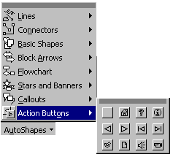From the Slide Show menu, select Action Button.
Or
- Click the AutoShapes button on the Drawing toolbar and select Action Buttons.
- Choose a button from those displayed.

- The Action Settings dialog box is displayed automatically.

- Set up the action for your Action Button as required.

Sound clips and videos
PowerPoint comes with music, sounds and videos that you can play during your slide shows. Depending on how your system has been set up, other sounds, as well as music and videos, may be available in the clip gallery.

Inserting a sound or video clip from the Clip Gallery
- On the Insert menu, choose Movies and Sounds.
- Click either Movie from Gallery or Sound from Gallery.
- Select either the Sound or Video tab.
- Select the clip you want to use and click the Insert button.
- The sound symbol , or the video clip will appear on your slide.

Inserting a sound from another location
- On the Insert menu, point to Movies and Sounds.
- Select Sound from File.
- Locate the folder that contains the sound, and then double-click the sound you want.
- The sound symbol , or the video clip will appear on your slide.

Adding a sound clip to an object or existing text
- 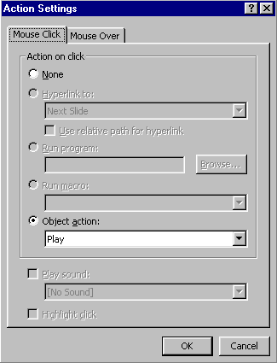In Normal view, select the object or text to which you want to attach the sound clip to.
- From the Slide Show menu, select Action Settings.
- Select either the Mouse Click tab, or the Mouse Over tab.
- Click the Play Sound button and click the drop-down arrow to display a list of available sounds.
- Select an appropriate sound.
- Click OK.

Activating the clip during the slide show
You can insert a piece of music, sound, or video clip on a slide where you want it to be played during a slide show. By default, the sound or video starts when you click its icon during a slide show. You can change this default so that the clip is activated when you pass the mouse pointer over the symbol whilst running the slide show, instead of having to click.
Helpful hint:
You can associate two actions with a symbol. You can move the mouse over the symbol to play a sound, and then click on it to jump to another slide.
To change how the clip starts or to add a hyperlink to the clip:
- Select the sound symbol or video clip and from the Slide Show menu, select Action Settings.
- Select the Mouse Click tab, or Mouse Over tab as required.
- Click the Object action button, set it to Play and click OK.
Note: You will need a soundcard and speakers on your system in order to play music, sounds, and videos (with sound). To find out what has been installed and what settings are in use, check both the Multimedia and Sounds categories in the Windows Control Panel or consult your system administrator.

Learning more

Central IT Training
Information Systems publishes documents and run courses to accompany this one as detailed below:
Getting started with PowerPoint | This 3hr course is for those who would like to learn to create tailor-made presentation materials. It is suitable for those with very little or no prior experience with PowerPoint.
Getting more from PowerPoint | This 3hr course is for those who already have experience using PowerPoint, and want to learn how to make changes to the presentation design, create templates and fine tune the presentation delivery. It is not suitable for those with little or no prior experience of PowerPoint.

Training for WebCT Designers

The Learning Technology Support Service also offers courses specifically aimed at content designers wishing to place accessible content into their e-Learning within a virtual learning environment such as WebCT.
Impatica for PowerPoint | This 1hr course introduces you to Impatica for PowerPoint, which is a compression tool for converting PowerPoint presentations into a web-friendly format. You will learn how to compress your presentations and tips for good PowerPoint design. You are encouraged to bring along your own presentations.
Scenario-based learning using PowerPoint | Scenario-based learning (SBL) puts the student in a situation or context and exposes them to issues, challenges and dilemmas and asks them to apply knowledge and practice skills relevant to the situation. In this 3hr course you will use PowerPoint to develop an interactive exercise that enables students to make choices and obtain feedback.

Details on training courses run by the Learning Technologies Support Service can be found at: http://www.ucl.ac.uk/learningtechnology/training

Open Learning Centre
- The Open Learning Centre is open every afternoon for those who wish to obtain training on specific features in PowerPoint on an individual or small group basis. Please let us know your previous levels of experience, and what areas you would like to cover, when arranging to attend.
You will need to book a session in advance at http://www.ucl.ac.uk/is/olc/bookspecial.htm
and sessions will last for an hour or possibly longer, depending on availability.

Online learning
- There is also a comprehensive range of online training on Web-related topics, available via TheLearningZone at: www.ucl.ac.uk/elearning

Getting Help
- A Web search using a search engine such as Google (http://www.google.co.uk/) can also retrieve helpful Web pages. For example, a search for "PowerPoint tutorial" would return a useful selection of tutorials.

* Custom Shows are covered in the Getting More from PowerPoint course.

