UCL
Education & information support division
information systems



PowerPoint 2003

Getting Started with PowerPoint

Document No. IS-037 v2
Contents
Using PowerPoint for presentations 1
Guidelines for producing presentations 1
Style considerations 1
The PowerPoint environment 2
Views 2
Task panes 4
Getting help 5
Creating presentations 6
Creating a new presentation 6
Adding new slides and choosing layouts 7
Choosing a layout 7
Applying a different slide layout 7
Entering text 8
Entering text within a placeholder 8
Entering text in a text box 8
Entering links to Web pages 8
Editing your presentation 9
Spellcheck 9
Formatting slides 10
Basic formatting options 10
Text box formatting 12
Modifying the bullet style 12
Using design templates 13
Applying a design to a new presentation 13
Applying a design to an existing presentation 13
Editing and moving slides 14
Using the outline tab 15
Entering text using the Outline tab 15
Working in the Outline tab 15
Incorporating graphics 16
Using Clip Art 16
Inserting image from a file 17
Running a presentation 18
Controlling the presentation manually 18
Slide show controls 19
Applying animations or builds 20
Applying slide transitions 21
Printing 22
Page Setup 22
Printing slides 22
Learning more 23

Introduction

This workbook has been prepared to help those with minimal experience of using PowerPoint to develop simple presentations, including some simple graphics. The guide can be used as a reference or tutorial document. To assist your learning, a series of practical tasks are available in a separate document. You can download the training files used in this workbook from the IS training Web site at: www.ucl.ac.uk/is/documents/

Using PowerPoint for presentations
PowerPoint is a presentation package that will enable you to produce slides, notes and handouts for any talks, lectures or presentations. It allows you to vary the format and media for your presentation between A4 acetates, 35mm slides and on-screen slide shows.
There are a number of useful formatting tools included in the package which, used judiciously, can enhance the look of your presentation. PowerPoint also offers a range of options for animating and customising your presentations.
PowerPoint is relatively easy to learn, particularly if you have experience using a word processing package, and it is surprisingly easy to create colourful presentations with a plethora of fancy animations and other effects. Be aware that throwing in effects may be fun initially, but will not lead to a very professional looking result.
In the next section you are encouraged to think through the content of your presentation before worrying about the fancy effects and formats you may want to include. You will need to think through what it is you want to say, consider your audience, and marshal your content into a logical order.

Guidelines for producing presentations
With any presentation, the aim is to convey a message of some sort. Unfortunately, PowerPoint presents the opportunity to create presentations where the medium clouds the message. The following hints are offered as guidelines for keeping your presentation attractive and your message clear:
- Spend the majority of your time concentrating on the contents and order of your presentation before you switch your computer on. You may have to resort to pen and paper to accomplish this.
- Include a title slide, followed by a slide giving an overview of your presentation. The audience will be better able to follow the presentation if presented with a "route map" at the outset.
- Use brief bullet points — don't write in sentences. Keep the text to a minimum for maximum impact and visibility. If you present large amounts of text, the audience will try to read (and possibly write down) each word, and won't be able to concentrate fully on what you have to say.
- Use images and diagrams where appropriate - a picture may be worth at least a few tens of words.
- Create crib notes using PowerPoint's notes facility - if necessary you can keep the whole script here. This should mean that you are less inclined to include large amounts of text in the slides.
- Consider the background of your audience and avoid including too much/too little detail.

Style considerations
- Don’t use more than 3 typefaces in a presentation unless you have good reason.
- Make sure that your text is large enough to be legible. It is frustrating to sit in a darkened auditorium squinting at small text.
- Be consistent in your use of styles and headings. In particular, make sure that you develop a consistent hierarchy of headings and sub-headings.
- Keep the text on each slide to a minimum (this will tend to happen anyway if you use a large enough typeface). Again, it is frustrating to sit in a darkened auditorium looking at a dense wall of text.
- Be careful when using colour. If you feel uncertain about combining colours, stick to black and white.
- Don’t use more than 3 different colours in a presentation except when needed for diagrams.
- Illustrations are useful, but make sure that they are meaningful.
- If you use illustrations, make sure that any accompying labels and accompanying text are legible.

The PowerPoint environment
To launch PowerPoint, use Start | Programs | PowerPoint. Your screen should look the same as the one below – this is known as the Normal view. The slide itself is shown in the centre. Below it is a Notes pane for adding speaker notes. To the right is the Task pane which allows you to carry out certain basic operations or choose selected options. On the left are the Slide and Outline tabs which let you quickly switch to different PowerPoint views.
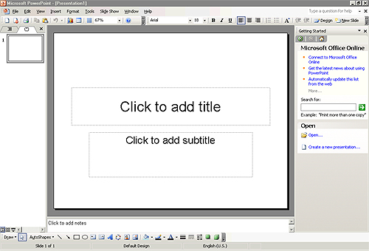
Drawing toolbar
Menu bar
Toolbar
Slides tab
Outline tab
Slide
Notes pane
Task pane
Shortcut
view icons
The Menu bar, and Toolbar (which includes Standard and Formatting tools) should be visible at the top of the screen, and the Drawing toolbar should be visible at the bottom of the screen. Users of PowerPoint97 should note that the Common Tasks toolbar has been replaced by two new tools on the toolbar: Design (for slide design options) and New Slide (with slide layout options).

Views
Views allow you to see presentations in a number of different ways. The available views are Normal, Slide Sorter, Notes Page and Slide Show. They are easiest to understand using an existing PowerPoint presentation.
To change a view, either choose one of the four options from the top part of the View menu (shown on the right), or use one of the three shortcut icons at the bottom of the PowerPoint window (below).
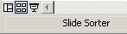
Normal view
Slide
Sorter
Slide
Show

Normal view
The Normal view is the most common view, and is where most editing takes place. It shows the slide in the centre of the window, with a small notes pane at the bottom, and the choice between viewing an outline of the presentation text or slide thumbnails at the left of the window. You may switch between outline and thumbnails using the Outline and Slide tabs.
Outline tab

Slide tab
Outline view is visible in the left-hand part of the Normal view window, and is useful for creating text-only slides. In Outline view, when you type in text and press Enter, a new text slide is created automatically. Pressing the tab key demotes the text (i.e. turns a title into bullet point, or indents an existing bullet point). Pressing Shift+Tab has the reverse effect (i.e. promotes a bullet point).
Text on Slide

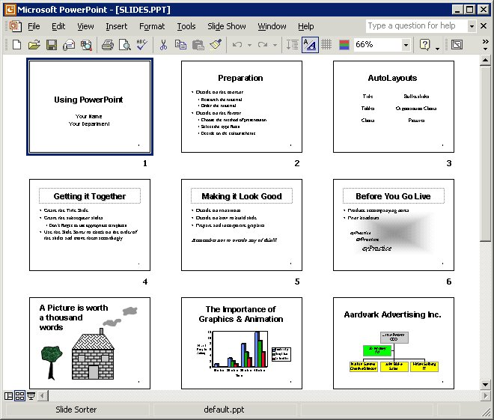
Slide Sorter view
Slide Sorter view displays your presentation slides as thumbnails as shown. This view is useful for reorganising (copying, moving and deleting) slides.

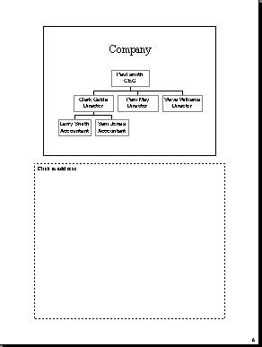
Notes Page view
Notes Page view displays the current slide at the top of A4 portrait paper, with the lower part blank. This enables you to type in text to accompany the slide. This text is used as a memory aid for the speaker. The notes pages can be printed.

Task panes
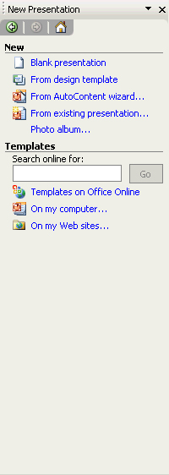
All of the Microsoft Office XP applications have a feature called the Task Pane (visible in the right-hand part of the screen). This feature is a Web-style command area which is an alternative to a dialog box, and allows you to carry out certain basic operations or choose selected options. PowerPoint contain the following task panes: New File/Presentation/Document (the name varies with the application), Clipboard, Search and Insert ClipArt.
Other Task Panes arrow
If the task pane is not visible at the right-hand side of the application window, you can display it using View | Task Pane. The task pane, as shown here, will display — this example shows the New Presentation task pane.
To change the task pane click on the Other Task Panes arrow to display the options shown, and select the required option.
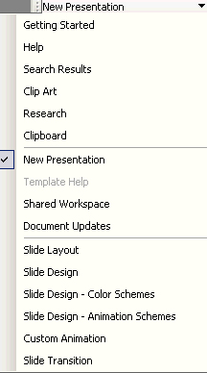

Getting help
There are several ways to obtain help in PowerPoint: the Help pane and the Ask a Question list are described here. In Microsoft PowerPoint 2003, the online help features have been embedded into the task pane on the right-hand side of the window, which allows more intelligent and up-to-date help.

The Help pane
- Use Help | Microsoft PowerPoint Help to display the help pane in the task pane area, as shown. Select the type of help you require from the Assistance, Table of Contents or Microsoft Office Online links.
- Assistance – to enter questions in the box labelled Search For. Sub-topics based on your response will be shown below. The corresponding help pages will be displayed in a pop-up window (Microsoft Office online help).
- Table of Contents – to find instructions about broad categories, organised like a book’s table of contents. As you chose top-level contents, you can see a list of more detailed sub-topics from which to choose. The resulting help pages display in the right of the Help window.
- Microsoft Office Online – to locate specific topics, provide online training and tutorials. You can click the links to go to the Microsoft Office Online help pages. The online training will be helpful if you want to learn the office applications systematically. Also, the online community allows you to interact with real people, ask questions and provide answers, or take part in the online discussions.
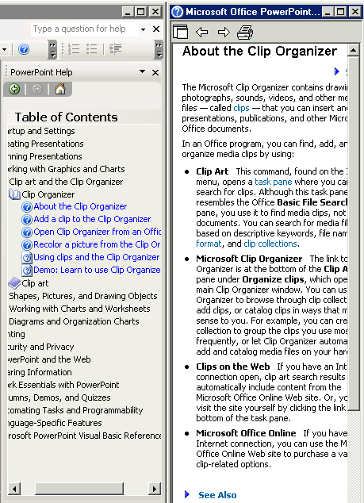
Auto Tile: Arranges the Help window next to the main PowerPoint window.
Back and Forward: To move to previously visited Help options.
Print: To print the Help information.

The Ask a Question list
This box is displayed in the upper-right corner of the PowerPoint window. Simply enter a question in plain English and press Enter.

Creating presentations
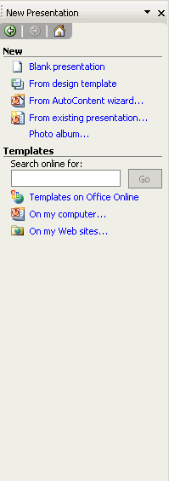
Various options for creating presentations are offered in the New Presentation task pane. You may also base new presentations on existing presentations or on templates.

Blank presentation
This may be a good choice as you can choose to apply your own formatting and colour schemes to personalise the presentation.

Design template
The Template option offers you a choice of set looks or Designs for your presentation, including predefined colours and layouts for your slides, without suggesting what content to include. This is often useful (but remember that these set looks are available to all PowerPoint users, and so lack individuality).

AutoContent
The AutoContent wizard offers a selection of pre-determined frameworks for presentations based around common topics (examples include "Organisation Overview", "Thanking a Speaker" and "Business Plan"). This can be a labour-saving device, although the range of topics is orientated towards executive briefings. Your presentation will probably be more focused and effective if you plan out the content and organisation yourself. These are also available from the General Templates option (choose the Presentations tab).

New from existing presentation
This option will open an existing presentation which you can edit as required
before saving with a new file name. Use this if you need to create a presentation complying with UCL’s new Corporate Identity. First download the presentation from: www.ucl.ac.uk/corporate-identity.

New from Template
This option allows you to select a template file on which to base you presentation. The template may be one you created previously, or it may be one of PowerPoint’s pre-defined Design templates.

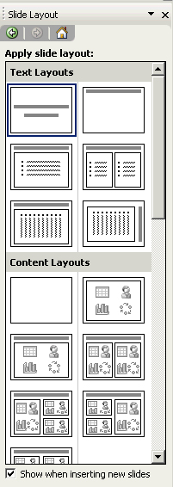
Creating a new presentation
Title slide
- In the New Presentation task pane, select the Blank Presentation option. The task pane switches to the Slide Layout task pane. This offers a number of slide layouts – ToolTips will tell you what each layout is designed for. You should choose the Title Slide option for the first slide in a presentation.
- A new blank slide appears. This slide has placeholders ready for you to enter a title and sub-title for the presentation. To enter text, simply click inside the placeholder and type.

Adding new slides and choosing layouts
To insert a new slide, use Insert | New Slide or click the New Slide button , or hold down Ctrl and press n. The new slide appears after the current slide. Again, the Slide Layout task pane appears offering a selection of AutoLayouts.

Choosing a layout
The type of layout you choose depends on the type of slide that you wish to design. For example a chart slide, bulleted slide, two-column text, etc.

Text layouts
There are several layouts for text based slides. These include Title Slide, Title and Text slide and Title Only Slide. The Title and Text slide is the most common for presenting text.

Content layouts
You are offered a combination of bullet points and clip art or media clips which allow you to create a combination of text, objects and images. When a content layout is chosen, an icon is placed on the slide. On double-clicking the icon, you will be presented with further options.
Content layouts can be used to create chart or graph slides. When a chart slide layout is chosen a small chart icon will appear on your slide and you will be asked to double-click on the icon to create the chart.
Content layouts also enable you to create a table on your slide. When you double-click the icon, you are taken into Microsoft Word and prompted to choose the number of rows and columns for the table, and to enter text into the table.

Other layouts
These options allows you to include Media clips, rotated text, organisation charts and graphs.

Blank slide layout
In addition to the slide layout types specified, you also have a blank slide option . This will create a slide with no placeholders at all. This is useful, for example, if you want a large or full screen image on a slide.

Applying a different slide layout
PowerPoint lets you change the format of the slide that you are working on without losing your data. For instance you might be working on a Title Slide layout and decide that it would look better on a Bulleted Slide. To change the AutoLayouts of the current slide:
- Choose Slide Layout from the Slide Design task pane, or select Format | Slide Layout. The Slide Layout task pane option appears.
- Choose the alternative layout and click the icon. Note that when you hold the cursor over one of the layouts an arrow appears; this gives an option to apply the layout to any selected slides.

Entering text
Text is normally entered within the placeholder in Normal view, but text may also be entered in a text box that you draw on the slide. Finally, the Outline view offers an efficient way of entering text – this will be covered in a later section.

Entering text within a placeholder
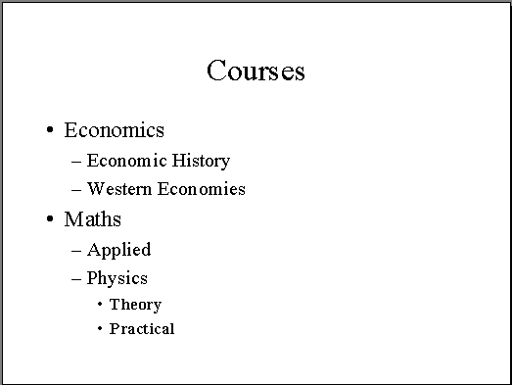
- In Normal view, empty placeholders contain a ‘click to enter text’ message.
- Click in the placeholder. The message will disappear and a vertical insertion cursor appears in the text box. The shading around the text box changes to indicate that it has been selected.
- To insert bulleted text click in the placeholders. Type the text, pressing Enter when you wish to add another bullet.
- When finished, click outside the bullet area.
Note: You can choose to use numbers rather than bullets using the Numbering button on the toolbar.

Promoting and demoting bullets
- To demote (indent) a bullet press the Tab key or use the Increase Indent button .
- To promote a bullet hold down the Shift key and press the Tab key once or use the Decrease Indent button .

Moving bullets up and down
You can change the order of the bullet points once you have entered the text. To move a bullet point up (or down) press the arrow facing up (or down) on the Outlining toolbar.

Entering text in a text box
- Click on the Text Box icon on the drawing toolbar at the bottom of the screen, and then click on the slide where you wish to enter the text.
- Type the text and then click outside the text box.

Entering links to Web pages
It is possible to type a Web address or URL into a PowerPoint slide, and use that link to connect to that Web page during your presentation.
- Enter the Web address (e.g. www.ucl.ac.uk), or copy the link address from the address bar in your browser window.
- When you press Enter or hit the spacebar after typing the web address, you may notice that PowerPoint automatically underlines the web address – it has converted it into a hyperlink.
- When you view the slideshow, you can click on the link, and the Web page will be loaded in a browser window (provided you are connected to the Internet). To return to the presentation, simply minimise the browser window.

Editing your presentation
If you wish to cut, copy, delete or change the appearance (formatting) of text you first need to select it. This is achieved in a variety of ways:
- To select a single word, double-click on the word.
- To select all the text on the same line within the placeholder, triple-click.
- To select an irregular amount of text or a single character, click and drag the mouse over the text.
- To select all text within a placeholder, click on the border of the placeholder.

Cut
Select the text that you wish to move and choose Edit | Cut (Ctrl + X) or . The selected text will then disappear.

Copy
Select the text that you wish to copy and choose Edit | Copy (Ctrl + C) or .

Paste
After you have cut or copied the text:
- Click at another point within the placeholder to which you wish the text to be copied or moved to, or click elsewhere on the slide to create another text box.
- Choose Edit | Paste (Ctrl + V) or .
The text will then appear in the new position. If you have created a new text box, the text will appear in the centre of the slide.

Delete
To delete text within a text box, select the text to be deleted and press the Delete button on the keyboard.

Spellcheck
The Spellchecker will check for any spelling mistakes within your presentation within titles, bulleted lists and in text boxes. It will not check for spelling within embedded objects such as Charts or text within images. It will check the entire presentation regardless of which slide you are currently looking at.
- Choose Tools | Spelling and Grammar.
- For each word that is displayed in the Not In Dictionary box, click the appropriate button, see below.
Leave the word unchanged.
Leave the word unchanged throughout the whole presentation.
Accept the spelling suggested or replace the misspelled word in the Change To box.
Accept the spelling suggested or replace the misspelled word in the Change To box and change all occurrences of the misspelled word in the presentation.
Add the word to the custom dictionary.
Searches the dictionary and suggests alternative words.
Add the misspelled word and its correction to the AutoCorrect list.

Formatting slides
Text formatting governs the shape, appearance, size and colour of the text. The text has to be selected before formatting can be applied.

Basic formatting options
The most common formatting options are to be found on the Formatting toolbar just above the slide, or as in the case with text colour, on the Drawing Toolbar at the bottom of the screen.
Font box
Font size box
Increase font size
Decrease font size

Emboldening, italicising and underlining text
- Select the text to be formatted.
- Click on the required formatting button, i.e. Bold, Italic or Underline.
- To turn off formatting on selected text, simply click again on the required button.

Changing font type
A font (sometimes referred to as a typeface) governs the shape of the character. Fonts can enhance a presentation but too many can detract from it. To change the font of text:
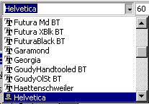
- Select the text whose font you wish to change.
- Click on the down-arrow to the right of the Font box on the toolbar. A list of available fonts will be displayed. You can use the scroll bar to scroll through the list.
- Click on the font that you wish to use. The selected text should then change to the required font/typeface.
- Click anywhere on the slide to de-select the text.

Changing font size
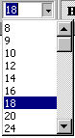
It is possible to apply an incremental change in font size to all text in a placeholder using the Increase or Decrease Font Size buttons on the Formatting toolbar.
Alternatively you can apply a font size change to selected text using the Font Size box.
- Select the text whose size you wish to change.
- In the font size list select the required size (i.e. 16), or type in the required size.
- The selected text should then change to the required font size.
- Click anywhere on the slide to de-select the text.

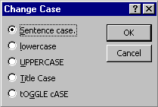
Changing case
- Select the text whose case you wish to change.
- From the Format menu, choose Change Case. The following dialog box is then displayed:
- Select as appropriate and click OK.

Changing text colour
- Select the text whose colour you wish to change
- Click on the down-arrow to the right of the Font colour box and select the required colour.
- Click anywhere on the slide to de-select the text. It should have changed to the required colour.

Applying other effects to text
It is possible to apply a variety of other effects (emboss, shadow, superscript, subscript) to text using the Font dialog box:
- Select the text to be formatted.
- Choose Format| Font. The Font dialog box is displayed as shown.
- Select the desired effect from the Effects area and click OK.

Subscript and superscript
Subscript text is text that is reduced in size and moved half a line down, for example: H₂O
Superscript is text that is reduced in size and moved half a line up, for example: x².

Aligning text
 | Align Left |  | Align Centre
 | Align Right
- Select the text to be aligned.
- From the Format menu choose Alignment.
- Select the required alignment.
Note: The text may not be aligned on the slide, but is aligned within its text box.

Line spacing
The appearance of a text slide can be enhanced by adjusting the spacing between paragraphs and or lines of text.
- Select the lines of text.
- Choose Format | Line Spacing. The Line Spacing dialog box is displayed:
- In the Line Spacing dialog box type in an appropriate dimension and click OK.
- De-select the text – the text should now be aligned as required.
You can also increase/decrease line spacing using toolbar buttons (please note these buttons are hidden by default):
Increase Paragraph Spacing
Decrease Paragraph Spacing

Text box formatting
By default, text boxes do not have lines around them. However, you can add lines of varying thickness, style and colour.

Adding lines to text boxes
Line/Line Color
Line Style
Dash Style
- Select the text box that is to have a line around it.
- Choose Format | Format Placeholder and the Color and Lines tab.
- Choose a line colour, weight/style or dash style and click OK.

Changing the fill colour of a text box
By default the fill colour of a text box is transparent, but you can fill the box with colour.
- Select the text box whose colour you wish to change.
- Click on the Fill button , or, choose Format | Format Place Holder or double-click on the box border. Choose the Colors and Lines tab.
- In the Fill section of the dialog box select a colour and click OK.

Modifying the bullet style
- Select the text that makes up the bulleted list. You will not be able to select the actual bullets themselves.
- Choose Format | Bullets and Numbering.

The Bullets and Numbering dialog box is displayed:
- Choose the bullet you require and if necessary change the colour and size.

- By selecting the Customize button at the bottom of the dialog box, the symbols palette is displayed where you can click on the desired bullet or symbol.
- Click OK.

Using design templates
The easiest way to apply wholesale changes to the appearance of all aspects of a presentation (text, layout and colour scheme) is to apply a different Design Template. This will alter the colour scheme and the title and slide masters, which means that the text layout and formatting for all slides will also change. You can select a template or design when you first create a presentation, or you can apply a template to an existing presentation.
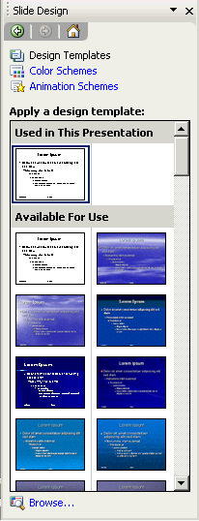

Applying a design to a new presentation
- From the New Presentation task pane select the From design template option.
- The Slide Design task pane appears. Select an appropriate design and click to apply it to the new presentation.

Applying a design to an existing presentation
- From the New Presentation task pane select the From design template option or click the Design button.
- The Slide Design task pane appears. Select an appropriate design and click to apply it to the presentation.

Note: If you have previously created any templates of your own then you should choose the On my computer option from the New Presentation task pane. This will reveal the Templates window which lists the blank presentation and your own customised templates. The rest of Microsoft's design templates are held in the Design Templates tab. The Presentations tab contains the AutoContent Wizard presentations.
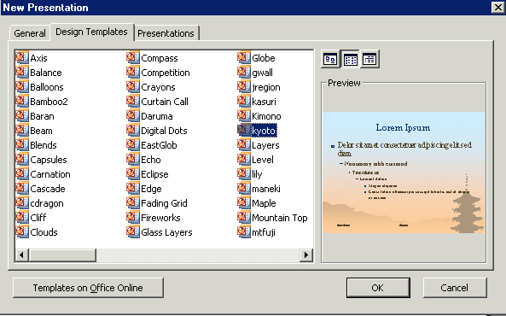
Presentation Design icons
General tab
Preview of presentation design

Editing and moving slides

Adding new slides
To add a new slide, choose Insert | New Slide, or use the New Slide icon on the toolbar , or press Ctrl-M.

Duplicating slides
It is possible to insert a duplicate of an existing slide into a presentation.
- Choose Insert | Duplicate Slide.
- The new slide is inserted after the original, and the insertion point is now in the new slide.

Deleting slides
- To delete the current slide, choose Edit | Delete Slide.

Moving between slides
- To move between slides within your presentation you can use the Page Up key to move one slide back and the Page Down key to move one slide forward.
- The Home key will take you to the first slide and the End key to the last one.
- Alternatively, you can use the vertical scroll bar.

Using Slide Sorter view
Slide Sorter view is useful for reorganising (copying, moving and deleting) slides.
Before you can reorganise slides in Slide Sorter view, it is necessary to select the slide(s) by clicking on them.
- To select multiple slides, hold down the Ctrl key and click to select the individual slides.
- To select a block of slides, click the first slide in the block, then hold down the Shift key and click the last slide.
- To select all slides press Ctrl+A.
It is possible to move or copy slides by selecting and using the Edit | Cut or Edit | Copy followed by Edit | Paste, or by click-dragging the slides.
To delete slides, select the slide(s) to be deleted and press the Delete key.

Using the outline tab
You can use the Outline tab to view all of the text from all of your slides on the same screen, which helps show how your points flow from slide to slide.
Outline tab

Slide icon
Each slide title has a slide icon next to it, and a slide number. The text in the body of the slides is shown indented, and the amount of indentation reflects the level of the bullet points.
You should display the Outlining toolbar when using the Outline tab (View | Toolbars | Outlining) – it will appear vertically, to the left of the Outline tab.

Entering text using the Outline tab
It is possible to enter text into a number of slides very efficiently using the Outline tab.
You can type text in next to the slide icon to create a slide title, and the text you enter will appear in the main slide window. Pressing Enter will produce another new slide and any text you enter will appear in the title placeholder. If you don't want a new slide, but just want to create bullet points in the existing slides, you can either press Tab on the keyboard, or use the Demote button on the Outlining toolbar, to indent the text.
It is important to realise that pressing Enter creates a new paragraph just like the preceding one. Therefore, if the last thing you typed was a slide title, the next item will be a slide title, on a new slide. If the last thing you typed was a bullet point, then pressing Enter will create a fresh bullet on the same slide.

Working in the Outline tab
- 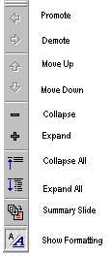You can use the Promote button on the toolbar to turn a bullet point into a slide title.
- To create a series of slides using bullet points from a single slide as titles, select those bullet points and click Promote.
- You can use the Demote button to turn a slide title into a bullet point, or to make a first-level bullet point into a second-level bullet point.
- Move Up and Move Down will move selected text up and down through the presentation.
- Collapse will hide the bulleted text, just leaving slide titles.
- Expand will reveal all slide text.
- If you select your slides and click Summary Slide, a single slide is created containing all of the slide titles.
- Show Formatting shows or hides the font etc. of the slides in Outline view.

Incorporating graphics
Graphics (Clip Art or images) can be incorporated into PowerPoint presentations from the Microsoft Clip Gallery, or from existing files (obtained from a scanner, a digital camera or the Internet). You can use the Autolayout options with a new slide to include images or you can add images from the Insert menu. Both methods are described below.

Using Clip Art
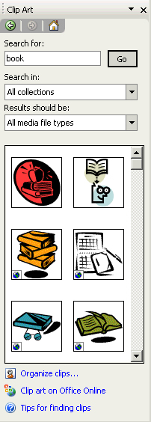
Clip Art is Microsoft’s library of images and diagrams. There are several ways of inserting Clip Art, including using the Clip Art task pane (common to Word and Excel), or using Autolayouts designed for Clip Art.

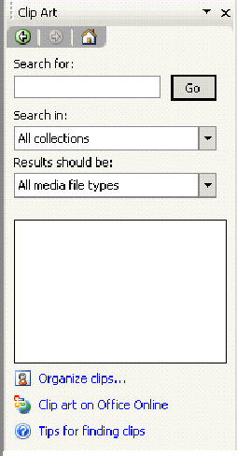
Using the Clip Art task pane
You can insert Clip Art into any slide using the Clip Art task pane shown here.
- Enter a search term into the box and click Search.
- The task pane will now display suitable Clip Art images.
- Click on an image to insert it into the current slide.

Using Autolayouts for Clip Art
If you use the Content Autolayout options, in the Slide Layout task pane , or the Autolayouts with Clip Art in the title such as Title, Clip Art and Vertical text, you can then insert pictures from Microsoft's Media Gallery:
- Insert a new slide and select an appropriate layout option from the slide layout task pane (examples of Clip Art and Content layouts are shown below).
Clip Art button

- If you have selected a Content Autolayout click on the Insert Clip Art button. If you have selected a Clip Art layout, double-click on the Clip Art icon to reveal the select picture dialog box.
- Enter a search term into the box and click Search.
- The window will now display suitable Clip Art images.
- Click on an image to insert it into the current slide, and click on the OK button to insert the selected graphic.

Inserting image from a file
It is possible to insert images in a variety of formats into PowerPoint presentations.
Note: Image files can be large, and may significantly increase the file size.
To insert images that do not appear in the Media Gallery (e.g. those that have been saved from the internet or saved via a digital camera):
Either
- Insert a new slide and select a Content layout option from the slide layout task pane.
Insert Picture
- Click the Insert Picture icon to reveal the Insert picture window.
Or, to insert an image into an existing slide:
- Choose Insert | Picture | From File to reveal the Insert picture window.
- Select the file you wish to insert and click Insert to insert the image into your slide.
Here previews of the images are shown rather than just filenames as in list view.

Views menu: select Preview from the view menu to show the previews if necessary.

Editing graphics
Graphics can be moved, rotated and re-sized. They can also have borders placed around them.
- To move a graphic, click and drag it.
To re-size a graphic:
- click on a handle in the corner to adjust height and width
- click on a handle on the top or bottom to adjust the height
- click on a handle on the right or left to adjust the width.
Colour
Less contrast
Less bright-ness
Rotate
Recolor picture
Set Transparent Colour
Reset picture
Insert picture
More contrast
More bright-ness
Crop
Line style
Compress picture
Format picture

Picture toolbar
Once you have inserted an image or Clip Art into your presentation, the Picture toolbar appears, offering options for modifying the graphic as indicated:

Running a presentation
When you run a PowerPoint presentation or slide show, each slide takes up the full screen — none of the toolbars are visible.
A slide show can be started in several ways. One way is to save a presentation in such a way that whenever you open it, it always starts as a slide show. Another way is to start a slide show from within PowerPoint. Alternatively, you can create a shortcut on your desktop and start the slide show from there.
You may either start the slide show from the beginning of the presentation (slide 1) or from the current slide. You can also set up a self-running presentation, at a kiosk or booth, for example, that will run in an ever-repeating loop.

Starting the slide show from the beginning
Choose View | Slide Show or press the F5 key on the keyboard.
The slide show will commence at slide 1.

Starting the slide show from the current slide
With your presentation open on your screen, ensure you are positioned on the slide you want to start with.
Click the Slide Show button in the lower-left corner of the presentation window .

Starting a Slide Show from your desktop
In My Computer or Windows Explorer, locate the file you want to open as a slide show.
Right-click the file name, and then click Show or create a shortcut on your desktop and start the show from there.

Save a presentation to always open as a slide show
- Open the presentation you want to save as a slide show.
- From the File menu, click Save As.
- In the Save As type list, click PowerPoint Show.
The extension for a file saved as a slide show is .pps. When you open this type of file, either from within PowerPoint or from your desktop, it will automatically start as a slide show. If you start the show from your desktop, PowerPoint closes when the show ends, and you return to the desktop. If you start the show from within PowerPoint, the presentation remains open when the show ends and can be edited.

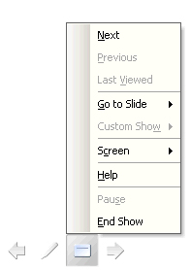
Controlling the presentation manually
Once your slide show is running, you can move on to the next slide by:

- Clicking with your mouse,
- Pressing Enter, PageUp, or → on the keyboard,
- Pressing the Space Bar on the keyboard,
- Pressing and N (for next),
- Clicking the arrow symbol at the bottom left of your screen, or right-clicking with your mouse over the slide to reveal the shortcut menu.

To move back to the previous slide:
- Press Backspace, PageDown, or (← on the keyboard,
- Press P (for previous),
- Right-click with the mouse to display the shortcut menu and select Previous.

Slide show controls
When you’re running a slide show, you have the following controls:
To Do this
Advance to the next slide Click the mouse
Return to the previous slide Press Backspace
Go to a slide Type the slide number, and then press Enter
Black or unblack the screen Press B
White or unwhite the screen Press W
Show or hide the arrow pointer Press A
Stop/Restart Automatic Show Press S
End slide show Press Esc
Erase drawing on-screen Press E
Go to next slide, if it's hidden Press H
Rehearse with new timings Press T
Rehearse with original timings Press O
Rehearse with mouse-click advance Press M
Return to the first slide Hold both mouse buttons down for two seconds
Change pointer to pen Ctrl+P
Change pen to pointer Ctrl+A
Hide pointer and button Ctrl+H
Hide pointer and button always Ctrl+L
Display shortcut menu Right mouse click
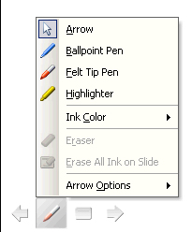
Helpful Hint:
You can press F1 during a slide show to see the list of controls.
You can select the pointer, pen and ink colour by clicking the arrow symbol at the bottom-left of your screen, or right-click with your mouse over the slide to reveal the shortcut menu.

Applying animations or builds
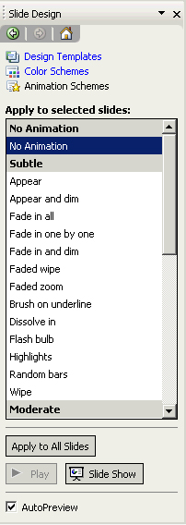
Animations (known as Builds in older versions of PowerPoint) apply to the content of slides. Animations allow the text or other objects on a slide to appear either after a specified time or, more usually, when the presenter clicks on the mouse. The purpose of having animations, especially on bullet lists, is to prevent the audience reading ahead.

To apply an animation
Animations may be applied to the current slide, to all slides, or to selected slides. To select specific slides you may either use Slide Sorter view, or you can select them from the Slide tab to the left of the Normal view window.
- View the slide(s) in Normal or Slide Sorter view.
- View the Slide Design - Animation task pane. This task pane offers a range of effects, from ‘subtle’ to ‘exciting’.
- Click on an effect to see a preview. This effect will now apply to the selected slide(s).
- You can click the Slide Show button at the bottom of the screen to start the slide show at the current slide.
- Press the Apply to All Slides button to apply the effect to the entire presentation (recommended for consistency).

To remove an animation
- Click on the No Animation option (at the top of the list).
- Click Apply to All Slides unless you only wish to remove the effect from the current or selected slides.

Applying slide transitions
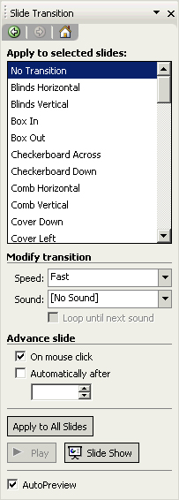
PowerPoint offers a number of stylised ways of moving from one slide to the next. Transitions determine how a slide appears on screen. For instance you may want to have the first slide within your presentation to fade into the screen. You might want second and subsequent slides to ‘box in’. Used judiciously, these effects can add impact to your presentation. It is advisable to use the same transition effect for all slides.
To apply a transition:
- View the slide(s) either in Normal or in Slide Sorter View.
Note: If you are in Slide Sorter view you can select more than one slide(s) to which you wish to add the effect.
- From the Slide Transitions task pane select an appropriate transition effect.
- The selected slide will momentarily display the transition.
- You can use the options at the bottom of the task pane to modify the speed of the transition, whether sound is applied (not advisable), how to advance to the next slide (automatically after a set time, or on mouse click), and whether to apply the effect to the whole presentation.
- Once you have added a transition, a symbol appears underneath the slide when viewed in Slide Sorter view:
- Switch to the Slide Show view to see the transition in action.

Note: Avoid using too many different effects as they can be distracting for the audience. If you would like to use the same effect for every slide in the presentation, you need to click on the Apply to all slides button.

Printing
In PowerPoint you can print out slides, speaker’s notes, outlines and handouts in a range of different formats. First set the Page Setup options.

Page Setup
- Choose File | Page Setup.
- Select the size from the Slides sized for option, or specify a size using the Width and Height boxes.
- Specify the paper Orientation for Slides, and for Notes, Handouts and Outlines. Normally slides will be in Landscape orientation for on-screen delivery.

Printing slides
- Choose File | Print to display the Print dialog box.
- Select the correct printer in the Name box.
- Specify the slide range you want to print in the Print range section.
- Specify how many copies you want in the Copies box.
- The Print what box allows you to choose to print your presentation in the following formats:
Slides — to print with one slide per page (normally landscape). You may print the whole presentation, the current slide or specify slide numbers. You can choose whether to have any animations printed or not (printing with animations is not recommended as each build within each slide will be printed on a separate sheet).
Handouts — for the audience. They are a snapshot of the slides within your presentation. You can specify whether to have two, three, six or more slides per printed page.
Notes — Notes pages will print each slide together with the speaker notes.
Outline View - Outline prints each slide in a list format, text only.
- If you are using and black and white printer, click the Pure Black and White checkbox.
- Click OK.

Printing in black and white
You can view a black and white or greyscale version of your colour presentation, to get an idea of how it will appear printed in black and white, by clicking the Color/greyscale view button on the Standard toolbar. To revert to colour, use the same button again.

Learning more

Central IT training
Information Systems publishes documents and runs courses to accompany this one as detailed below:
Getting more from PowerPoint | This 3hr course is for those who already have experience of using PowerPoint, and want to learn how to make changes to the presentation design, create templates and fine-tune the presentation delivery. It is not suitable for those with little or no prior experience with PowerPoint.
Graphics, diagrams and animations in PowerPoint | This 3.5hr course is for users of PowerPoint who would like to include content such as drawings, flow charts, graphs and other objects in their presentation. The course will also cover how to animate such content for a more engaging, interactive presentation.

Training for WebCT Designers

The Learning Technology Support Service also offers courses specifically aimed at content designers wishing to place accessible content into their e-Learning within a virtual learning environment such as WebCT.
Impatica for PowerPoint | This 1hr course introduces you to Impatica for PowerPoint, which is a compression tool for converting PowerPoint presentations into a web-friendly format. You will learn how to compress your presentations and tips for good PowerPoint design. You are encouraged to bring along your own presentations.
Scenario-based learning using PowerPoint | Scenario-based learning (SBL) puts the student in a situation or context and exposes them to issues, challenges and dilemmas and asks them to apply knowledge and practice skills relevant to the situation. In this 3hr course you will use PowerPoint to develop an interactive exercise that enables students to make choices and obtain feedback.

Details on training courses run by the Learning Technologies Support Service can be found at: www.ucl.ac.uk/learningtechnology/training

Open Learning Centre
- The Open Learning Centre is open every afternoon for those who wish to obtain training on specific features in PowerPoint on an individual or small group basis. Please let us know your previous levels of experience, and what areas you would like to cover, when arranging to attend.
You will need to book a session in advance at www.ucl.ac.uk/is/olc/bookspecial.htm
and sessions can last for an hour or possibly longer, depending on availability.

Online learning
- There is also a comprehensive range of online training in Web-related topics available via TheLearningZone at www.ucl.ac.uk/elearning
- Microsoft Office On-line tutorials and trainings: office.microsoft.com/en-gb/training/default.aspx

Getting help
- A Web search using a search engine such as Google (www.google.co.uk) can also retrieve helpful Webpages. For example, a search for "PowerPoint tutorial" would return a useful selection of tutorials.

