UCL
Education & information support division
information systems



PowerPoint 2003

Getting more from PowerPoint

Document No. IS-039 v2
Contents
Making overall changes to your presentation 1
Using the Slide Master 2
Editing the Slide Master 2
Closing the Slide Master 2
Adding a Header or Footer 3
Inserting a slide footer 3
Formatting your footer 3
Colour Schemes 4
Backgrounds 5
Changing the slide background 5
Removing different backgrounds 5
Creating Design Templates 6
Applying a design to an existing presentation 6
Creating your own Design Template 7
Customising animation effects for text 8
Applying a basic animation 8
Customising text animation 8
Adding more customisation 9
Inserting slides from another presentation or outline 10
Slides from files 10
Slides from outlines 10
Hyperlinks 11
Absolute and relative links 11
Creating a hyperlink to another slide in the slide show 11
Creating a hyperlink to another slide show 12
Action Buttons 13
Custom Shows 14
Adding or removing slides in a Custom Show 14
Removing Custom Shows 14
Running a Presentation 15
Starting a slide show from within PowerPoint 15
Start a slide show from your desktop 15
Save a presentation as a Slide Show 15
Hiding slides 16
Rehearsing timings 17
Setting up a Slide Show 18
Slide orientation 18
Controlling the presentation manually 19
Slide show controls 19
Self-running presentations 20
Slide timing 20
Annotation pen 21
Creating notes during a slide show 22
Learning more 23
Introduction
This guide is intended for those who already have experience using PowerPoint and want to learn how to make effective use of some of its more advanced features. It covers the creation of templates and the use of Slide Master designs to make overall changes to presentations, the use of hyperlinks to slides within a presentation and to external files or Websites, the application of animation effects to text, and tools for rehearsing and controlling the delivery of presentations.
This guide can be used as a reference or tutorial document. To assist your learning, a series of practical tasks are available in a separate document. You can download the training files used in this workbook from the IS website at: www.ucl.ac.uk/is/documents
There is also a comprehensive range of online training in PowerPoint available via TheLearningZone at www.ucl.ac.uk/elearning

Making overall changes to your presentation
The introductory manual explained how to apply formatting changes to a presentation on a slide-by-slide basis. However, it is often preferable to make consistent changes throughout a presentation. This is possible using Masters, Headers and Footers, Design Templates and Colour Schemes.
Slide Masters
The Slide Masters contain a background design and default text formatting for the slide titles and other text items. They can also contain graphics (such as company logos), and footer information such as slide numbers and the date.

Headers and Footers
These contain information that appears on every slide, such as the presentation title and date, or the slide number.

Design Templates
Also referred to as Designs, these contain predefined colour schemes and graphics, and text layout and formatting choices. You can create your own template, or apply one of PowerPoint's off-the-peg designs.

Colour Schemes
PowerPoint offers a selection of background colours and complementary text and drawing colours. You can choose one of the predefined schemes, or create you own.
The following sections cover these in turn.

Using the Slide Master
Slide Masters enable you to place the same object on every slide in your presentation and to apply consistent formatting to text and other objects. For instance you could have the title text on each slide in a particular size or font, or you could choose to apply the same style for all bullet points on every bulleted slide. You can also add headers and footers containing, say, the presentation title, your name, a logo, and the slide number.
The Slide Master can save you a great deal of effort, and will result in a consistent appearance for the presentation, which should help ensure that the message that you are hoping to convey is not clouded by the medium.
Helpful hint:
There is a separate Slide Master for use with title slides, known as the Title Master. Both Slide Master and Title Master are used in exactly the same way.
- To access the Slide Master choose View | Master | Slide Master, or hold down the Shift key while clicking the Normal View button at the bottom of the window . The screen will look something similar to the one below.
- Placeholders mark the positions of the Title, Object and Footer (Date, Footer and Number) areas. The Slide Master View toolbar allows you to return to Normal View by clicking on Close Master View.
Slide Master toolbar
Editing areas available in the Slide Master
Bulleted text levels

Editing the Slide Master
Once you are in Slide Master view you can start to edit the different parts of the Slide Master just as you would any other slide: You can move and resize placeholders, apply text formatting and modify bullets, and include images or Clip Art which you want to show on every slide.

Closing the Slide Master
- Choose View | Slide, click Close Master View, or click the Normal View button at the bottom of the screen.
- You are returned to Normal View.

Adding a Header or Footer
Headers and footers contain text that appears at the top or bottom of every slide. For instance, you might want your name, or the presentation title, or the date to appear at the bottom of each slide. Footers may be applied to slides individually, or may be added in the Slide Master. Usually you will want to display information at the bottom, i.e. in a footer, rather than in a header.
Headers and footers can be added either in the Slide Master, or in Normal View. The only difference is that when you use the Slide Master to add a header/footer, the choices you make will automatically apply to all slides. When in Normal View you can choose to apply the changes just to the current slide if you wish.

Inserting a slide footer
To insert a slide footer:
- From the View menu choose Header and Footer. The Header and Footer dialog box is displayed:
Slide number
Footer text
Date and Time

- To display a date you need to check the Date and time box, and you need to specify whether the date updates automatically, or is a fixed date which you must type in.
- If you want a slide number to appear on every slide check the Slide number box.
- To have text appear at the bottom of every slide, type your text in the Footer box.
- You can also choose not to display the footer on the title slide, if you wish.
- Click on Apply to All to apply the footer to all slides, or Apply to apply changes to just the current slide.

Formatting your footer
You can control the position and appearance of the text in the footer using the Slide Master view:
- From the View menu choose Master and Slide Master.
- Select the appropriate placeholder (Date Area, Footer Area or Number Area).
- Move the placeholder to the desired location.
- Choose text formatting options on the Formatting toolbar.
- Close the Slide Master to view the result of your changes in Normal View.

Colour Schemes
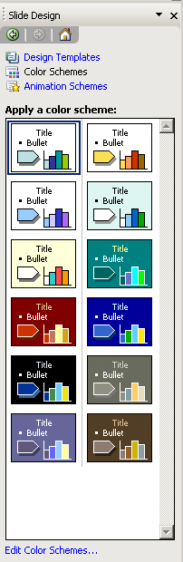
Colour schemes offer a co-ordinated set of eight colours for the background and other parts of your slides.
- Select the Colour Scheme task pane.
- A number of colour schemes are displayed. When you hover the mouse over the colour scheme a downward arrow appears offering choices to apply to all slides, apply to selected slides, or show a large preview.
- The Edit Colour Schemes button at the bottom of the pane will reveal the Edit Colour Scheme window which allows you to modify the standard colour schemes or create custom ones.
- Click on the Standard tab to display the basic range of colours schemes. Click on the Custom tab to develop your own colour scheme (double-click on any of the colours to display a palette of alternative colours).
- Choose a colour and click OK.
- Click on the Apply button to apply the chosen colour scheme.
- The slides in your presentation will then be formatted with the same colour or fill scheme. The new colour scheme will also be added to the gallery of colour schemes in the task pane.

Backgrounds
As well as the choice of colour schemes, you can also apply textured backgrounds or have an image as the background.

Changing the slide background
To change the slide background:
- From the Format menu, choose Background to display the Background dialog box.
- Click on the selection box arrow to display a list of colours and options. Choose a colour, or click on the More Colours or Fill Effects options for more choices.
- Click on the Apply To All button to apply the chosen colour to all slides in the presentation, or on the Apply button to apply it to the current slide. The slides in your presentation will then be formatted with the same colour or fill scheme.
Selection box
Click here for more colours
Click here for more Fill Effects

Removing different backgrounds
Note that in order to remove a texture fill effect, and perhaps replace it with a standard colour scheme, you must firstly replace the fill with a solid plain colour using the Background window. Only then will you be able to apply one of the preset colour schemes.

Creating Design Templates
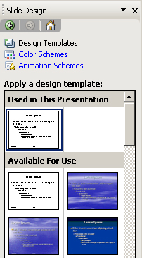
As seen in the ‘Getting Started with PowerPoint’ manual, the easiest way to apply wholesale changes to the appearance of all aspects of a presentation is to apply a different Design Template. This will alter the colour scheme and the Title and Slide Masters, which means that the text layout and formatting for all slides will also change. You can select a template or design when you first create a presentation, or you can apply a template to an existing presentation using the Slide Design task pane.
In this section you will learn how to create and apply your own design templates, but first a reminder of how to apply an existing design template.

Applying a design to an existing presentation
- From the New Presentation task pane select the From Design Template option or click the Design button.
- The Slide Design task pane appears. Select an appropriate design and click to apply it to the presentation.
Helpful hint:
If you have previously created any templates of your own, you should choose the On My Computer… option from the lower section of the New Presentation task pane. This will reveal the Templates window which lists the blank presentation and your own customised templates. The rest of Microsoft's design templates are held in the Design Templates tab. The Presentations tab contains the Autocontent Wizard presentations.

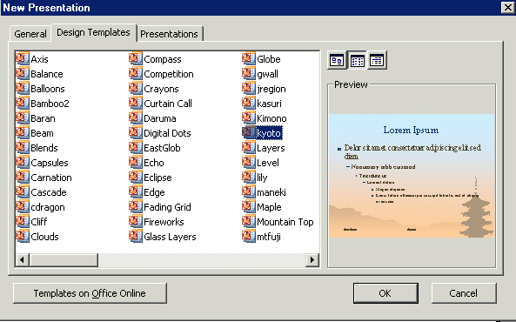
Presentation design icons
General tab
Preview of presentation design

Creating your own Design Template
If you have customised a presentation, perhaps using colour schemes, Slide Masters and Headers and Footers, and would like to be able to apply it to subsequent new presentations, you may want to create and save your own design template based on the formatting of the presentation.
To create a Design Template:
- Open the presentation on which you want to base your template, or start a new presentation and make any changes to the colour scheme or design.
- Edit the Slide Master to define the appearance of text, include logos, or add header/footer information.
- Close the Slide Master to return to Normal View.
- Delete any existing slides/text (unless you want them to appear in every presentation based on this template).
- Choose File | Save As.

- From the Save as type box choose the Presentation Template (*.pot) option.
- Locate the folder in which you want to save the template. (It is usually best to accept the default location as PowerPoint will look to this location when you try to apply a template.) In the File name box enter a name for the template and click Save.
- From now on, the design you have created will appear in the Design Template task pane in the “Available for use” category.
Helpful hint:
If you are a WTS user, you will not be able to save the template in the same folder as PowerPoint's own templates. By default, WTS will save template files together with any Word templates in either N:\MyWork\WordDocuments\templates\ (Staff WTS) or R:\WTS\mywork\word\template\ (Cluster WTS). You should save your template in this location.

Customising animation effects for text
Animations (known as Builds in older versions of PowerPoint) apply to the content of slides. Animations allow the text or other objects on a slide to appear either after a specified time or, more usually, when the presenter clicks on the mouse. The purpose of having animations, especially on bullet lists, is to prevent the audience from reading ahead.

Applying a basic animation
To apply a basic animation:
- View the slide in Normal View.
- From the Animation Schemes task pane select an effect, and click Apply to All.
- When you run the slide show, your main bullet points will now appear point by point, when you click the mouse.

Customising text animation
You will notice that when you use the approach above, all of the second and third level bullet points appear at the same time as the first level bullets. There may be times when you want these lower-level bullet points to appear on a mouse click rather than grouped with their ‘parent’ bullet point. It is possible to achieve this both for an individual slide, or for the whole presentation by working on the Slide Master, in Master view.
To customise text animation:
- In the Slide Master, apply the effect you require using the Animation Schemes task pane.
- Now display the Custom Animation task pane – your Slide Master should now have numbers next to the different bullet points showing their position in the animation sequence. In the example below, all of the lower level bullet points will appear together with the first level bullet – they are all labelled ‘1’.
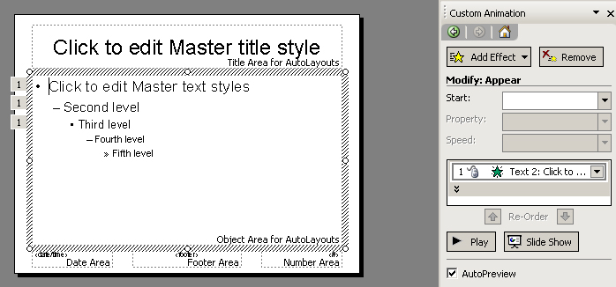
- To force the bullet points to appear one by one, in the Custom Animation task pane click Text2: Click to Edit and choose Start on Click.
- Now the labels for the different level bullets should have changed to 2, 3, 4 etc. as shown here.

Adding more customisation
- Select an object on a slide and click the Add Effect button to reveal the Add Effect menu.
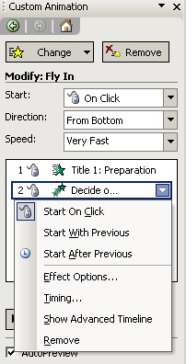
- You can use the options in the Add Effect menu to control the entrance of objects, the type of emphasis to apply (font size, spinning etc.), how objects exit, and how they move on the slide. Once you have added an effect to an object, the button becomes a Change button.
- You can use the options in the Custom Animation task pane to control the speed and timing of the animation. The animated objects are listed in the order in which they will appear, and can be re-ordered using the arrows.
- You can modify the animation effects by clicking the drop-down arrow to the right of the animated object in the list.

- From this drop-down menu select Effect Options to display the window shown here. Note the window is labelled with the selected effect (Fly In in this case).
Use the Effect tab to control the type of effect.
Use the Timing tab to control the timing (delay and speed).
Use the Text Animation tab to control how paragraphs are grouped together.

Inserting slides from another presentation or outline

Slides from files
You can insert slides from another presentation into the one in which you are working in very easily. To do this:
- From the Insert menu choose Slides from Files.
- The Slide Finder window appears. Click the Browse button and choose the PowerPoint file containing the slides you wish to include.
- Select individual slides by clicking on them and click Insert (or Insert All if you want to insert them all).

Slides from outlines
You can also insert outlines (lists created in Word, Excel or using a simple text editor) – individual items on the list become titles of individual slides when inserted in this way.
- From the Insert menu choose Slides from Outline.
- An Insert Outline dialog box appears – choose the file containing the list of items which you want to use as slide titles.
The example below shows how a list in Word is converted into a series of slides in PowerPoint.

Hyperlinks
PowerPoint Hyperlinks allow you to branch off during your presentation to a variety of locations. You can create a hyperlink to take you to a specific slide within your presentation, a Custom Show, or another presentation altogether. You can link to a Word document, an Excel spreadsheet, or the Internet. You can create a hyperlink from any text or object.
Text that represents a hyperlink appears underlined and in a colour that co-ordinates with the colour scheme. The colour changes after you jump from a hyperlink, so you can tell which hyperlinks you've already viewed. If you have text within a shape, you can set up separate hyperlinks for the shape and the text.
You can set it so that either clicking on the hyperlink, or holding the mouse over it, activates the hyperlink. You can also associate two actions with the text or object. For example, you can move the mouse over an object to play a sound and then click the object to jump to another slide.
Hyperlinks only become active when you run your slide show, not when you are creating the show.
Helpful hint:
When you set up a hyperlink, it's best to select the mouse-click method. If you select the mouse-over method, it's possible to jump when you really don't want to. The mouse-over method is good for feedback, for example, displaying a message with more information.

Absolute and relative links
When you create a hyperlink, you can set the path to its destination as an absolute link (a fixed file location that identifies the destination by its full path name, e.g., C:\training\powerpoint\schedule.doc). Alternatively, if you plan to move the destination files at any time, you can set the path as a relative link, i.e., the location of the destination file will be relative to the file containing the hyperlink.
Helpful Hint:
If you set up a hyperlink to another slide (either in the same presentation, or another one), also add a hyperlink on that slide to return you to the original one.

Creating a hyperlink to another slide in the slide show
- 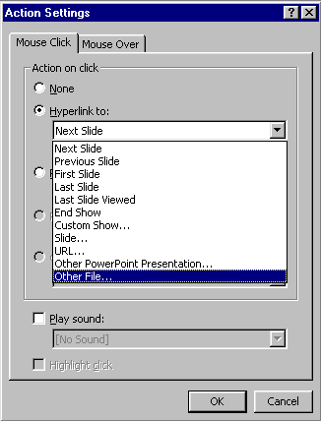Ensure the presentation in which you want to insert the hyperlink has been saved. You cannot create a relative link if you insert the hyperlink before the presentation is saved.
- Select the text or object you want to represent the hyperlink. (You can also create an Action Button to activate the Hyperlink. )
- From the Slide Show menu, select Action Settings.
- To jump by clicking the selected object, click the Mouse Click tab.
Or
To jump by moving the mouse over the object, click the Mouse Over tab.
- Click the Hyperlink to: button.
- Select the slide to which you want to jump from the list displayed.
- Add a sound if you wish by clicking the Play sound: button and selecting an appropriate sound.
- Click OK.

Creating a hyperlink to another slide show
- Ensure the presentation in which you want to insert the hyperlink has been saved. You cannot create a relative link if you insert the hyperlink before the presentation is saved.
- Select the text or object you want to represent the hyperlink. (You can also create an Action Button to activate the hyperlink.)
- From the Slide Show menu, select Action Settings.
- To jump by clicking the selected object, click the Mouse Click tab, or to jump by moving the mouse over the object, click the Mouse Over tab.
- Click the Hyperlink to: button.
- Select Other PowerPoint Presentation from the list displayed.
- Use the Look in: box to locate the folder containing the file you want to link to.
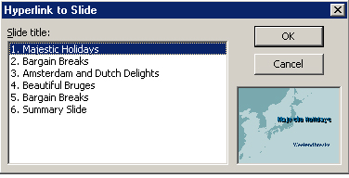
- Select the file and click OK.
- In the Hyperlink to Slide dialog box, select the slide to which you want to link to and click OK.
- The link will be absolute unless you click the Use relative path for hyperlink checkbox. (See the section above on absolute and relative links.)
- Add a sound if you wish by clicking the Play sound: button and selecting an appropriate sound.
- Click OK.

Editing a hyperlink
To edit a hyperlink:
- In Normal View, select the text or object that represents the hyperlink you want to edit.
- From the Slide Show menu, select Action Setting.
- Make the changes you want, then click OK.

Removing a hyperlink
To remove a hyperlink:
- In Normal View, select the text or object that represents the hyperlink you want to remove.
- From the Slide Show menu, select Action Setting.
- Click None, then click OK.

Action Buttons
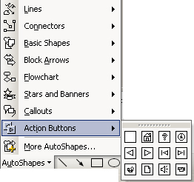
You can add an Action Button to a slide and then define how you want to use it during the slide show, for example, to jump to another slide. They appear pressed in when you use them. There are Action Buttons that contain arrows and other common symbols.
To create an Action Button:
- From the Slide Show menu, select Action Button.
Or
Click the AutoShapes button on the Drawing Toolbar and select Action Buttons.
- Choose a button from those displayed.
- The Action Settings dialog box is displayed automatically. Set up the action for your Action Button as required.
Action buttons can be used to play a sound or movie. Adding sound clips and videos are covered on the PowerPoint Graphics, diagrams and Animation course.

Custom Shows
PowerPoint's Custom Shows feature allows you to create a presentation within a presentation. Instead of creating multiple, nearly identical presentations for different audiences, you can group together and name the slides that differ and then jump to these slides during your presentation.
For example, you might want to give a presentation to two groups that work at two different sites. The slide show includes slides 1 through 10, which are identical for both groups, and two Custom Shows, each specific to one of the sites. You can show the first 10 slides to both groups and then jump to a Custom Show named "Site 1" for the first group and to a Custom Show named "Site 2" for the second group.
You can jump to a Custom Show by using the Action Settings dialog box (Slide Show menu) to set up a hyperlink to the show. Or, during a presentation, you can right-click, point to Go on the shortcut menu, point to Custom Show, and then click the show you want.
After you create a custom show, you can edit it by adding or removing slides from the show.
To create a Custom Show:
- 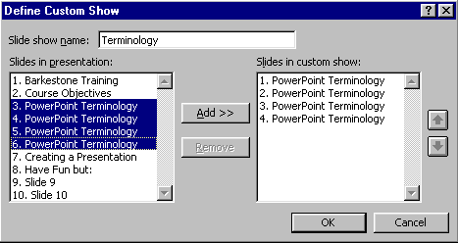From the Slide Show menu, select Custom Shows | New.
- Under Slides in presentation, select the slides you want to include in the custom show, and then click Add.
(To select multiple slides, hold down Ctrl as you click the slides.)
- To change the order in which slides appear, select a slide, and then click one of the arrows to move the slide up or down in the list.
- 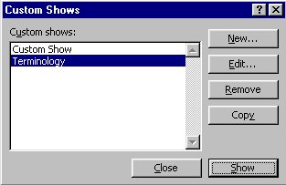Type a name in the Slide show name box, and then click OK.

Previewing a Custom Show
To see a preview of a custom show:
- From the Slide Show menu select Custom Shows.
- Select the name of the show in the Custom Shows box and click Show.

Adding or removing slides in a Custom Show
- From the Slide Show menu, click Custom Shows.
- Select the name of the Custom Show you want to change, and then click Edit.
- Add or remove the slides, and then click OK.

Removing Custom Shows
To remove an entire Custom Show, select its name in the Custom Shows dialog box, and then click Remove.
This removes the Custom Show, but the actual slides remain in the presentation.

Running a Presentation
A slide show can be started in several ways. One way is to save a presentation in such a way that whenever you open it, it always starts as a slide show. Another way is to start a slide show from within PowerPoint. Alternatively, you can create a shortcut on your desktop and start the slide show from there.
You can also set up a self-running presentation, at a kiosk or booth, for example, that will run in an ever-repeating loop.

Starting a slide show from within PowerPoint
- With your presentation open on your screen, ensure you are positioned on the slide you want to start with (usually slide one).
- Click the Slide Show button in the lower-left corner of the presentation window ,
or, from the Slide Show menu, click View Show,
or, on the View menu, click Slide Show.
Helpful hint:
There is also a useful keyboard shortcut to start a show: F5

Start a slide show from your desktop
- In My Computer or Windows Explorer, locate the file you want to open as a slide show.
- Right-click the file name, and then click Show, or create a shortcut on your Desktop and start the show from there.

Creating a shortcut on your desktop
To create a shortcut:
- Locate the file in My Computer or Windows Explorer.
- Use the right mouse button to drag the file to your Desktop.
- When you release the mouse button, click Create Shortcut Here.

Save a presentation as a Slide Show
Once you have created your slide show and are confident that you don’t want to make any further changes you may wish to save it as a PowerPoint Show (the filename takes on a .pps extension). When you open a PowerPoint Show file it launches straight into the SlideShow view, and once the show is over, the file closes automatically. This can present a smoother more professional impression than opening a normal PowerPoint file.
- First save the file as normal.
- Then, from the File menu choose Save As.
- In the Save as Type box choose the PowerPoint Show (*.pps) option.
When you open this type of file from your Desktop, it will automatically start as a slide show. If you start the show from your desktop, PowerPoint closes when the show ends, and you return to the Desktop. If you open the show from within PowerPoint you may edit it.

Hiding slides
It is possible to hide slides, so that they are not shown automatically when you run the Slide Show. This can be useful if you want to have additional slides up your sleeve in preparation for questions, or if you are forced to shorten an existing presentation.
- To hide slides, on the Slide Show menu, choose Hide Slide or in the Slide Sorter view click the Hide Slide button on the toolbar .
- When viewed in Slide Sorter view, hidden slides have a Hidden Slide icon.
Hidden slide icon

Revealing hidden slides during a slide show
- If you want to view a hidden slide in the middle of a slide show, make sure that you are at a slide before the hidden slide.
- Right-click the mouse and from the Go To menu, then choose the hidden slide.

Un-hiding slides
To reveal hidden slides when editing your presentation, from the Slide Show menu choose Hide Slide again, or click the Hide Slide button again .

Rehearsing timings
If you wish for your slide show to run at a set rate, you can rehearse and record the time taken to present each slide. To record the times, you need to run the slide show as normal, advancing through each slide, whilst PowerPoint’s Rehearse Timings tool records the time that each slide stays on screen. When the slide show is finished you may either keep the times or dispense with them.
To record times:
- From the Slide Show menu, select Rehearse Timings, or click the Rehearse Timings icon.
Play button
Pause button
Time elapsed for current slide
Time elapsed for whole show
- The first slide in your presentation appears on the screen along with the Rehearsal toolbar:
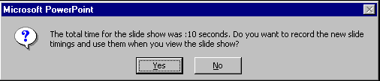
- Click on the Play button to advance through the presentation, or simply click on the mouse or press Enter or Page Down as usual. The times elapsed for the current slide, and for the entire slideshow are displayed. When your presentation has finished you will see the following message box:

Recorded timing

- Choose Yes to keep the times or No to discard them. The slides will have the on-screen times displayed under the slide in slide sorter view.

Running the timed slide show
- From the Slide Show menu choose View Show.
- The show will run from the first to the last slide automatically, at the rate determined by the recorded times.
To stop the show before the end, press the Esc key.
To turn off the automatic timings on the Slide Show menu click Set Up Show and choose to advance slides manually.

Setting up a Slide Show
It is possible to turn slide show special effects (builds, transitions and timings) on and off using the Set Up Show dialog box. This dialog box also enables you to run the show within a single window, rather than taking up the entire screen, and to loop the presentation continuously (useful for exhibitions).
- From the Slide Show menu, choose Set Up Show.
The Set Up Show dialog box appears.
- Click in the tick boxes to tailor the presentation as required and click OK.

Slide orientation
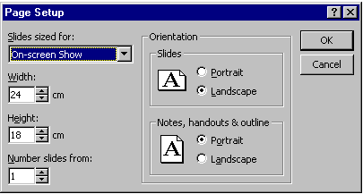
There are several options for presenting the slide show. Most users will present the slides using the computer, but it is also possible to print slides onto acetate sheets, or onto 35mm slides, or indeed onto paper of various sizes. The Page Setup dialog box allows you to select the mode, and orientation of the presentation. Orientation is the way in which the slide is displayed on screen or printed on paper. There are two options – Landscape (the usual) or Portrait.

Set the slide orientation for an on-screen show
The default orientation for screen is landscape. To change the orientation to portrait:
- From the File menu, select Page Setup. The Page Setup dialog box is displayed.
- Click on the down-arrow on the Slides sized for box and choose On-Screen Show.
- Change the slide orientation to Portrait.
- Click on OK.

Set the slide orientation for for printing
The default orientation for printing slides is landscape. To change the orientation to portrait:
- From the File menu, select Page Setup.
- Click on the down-arrow on the slides sized for box and choose A4 paper.
- Change the slide orientation to Portrait.
- Click on OK.

Controlling the presentation manually
Once your slide show is running, you can move on to the next slide by:
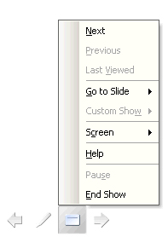
- Clicking with your mouse,
- Pressing Enter on the keyboard,

- Pressing the Space Bar on the keyboard,
- Typing an N (for next),
- Clicking the arrow symbol at the bottom left of your screen.

To move back to the previous slide:
- Pressing Backspace on the keyboard,
- Typing a P (for previous)
- Right-click with the mouse to display the shortcut menu and select Previous.

Slide show controls
When you’re running a slide show, you have the following controls:
To | Do this
Advance to the next slide | Click the mouse
Return to the previous slide | Press Backspace
Go to a slide | Type the slide number, and then press Enter
Black or unblack the screen | Press B
White or unwhite the screen | Press W
Show or hide the arrow pointer | Press A
Stop/Restart Automatic Show | Press S
End slide show | Press Esc
Erase drawing on-screen | Press E
Go to next slide, if it's hidden | Press H
Rehearse with new timings | Press T
Rehearse with original timings | Press O
Rehearse with mouse-click advance | Press M
Return to the first slide | Hold both mouse buttons down for 2 seconds
Change pointer to pen | Ctrl+P
Change pen to pointer | Ctrl+A
Hide pointer and button | Ctrl+H
Hide pointer and button always | Ctrl+L
Display shortcut menu | Right mouse-click

Helpful hint:
You can press F1 during a slide show to see the list of controls.

Self-running presentations
If you have a booth, kiosk, or other location where you want to run an unattended slide show, you can set up the show to run with most menus and commands unavailable and to restart automatically after each showing. A self-running presentation restarts when it's been idle on a manually advanced slide for longer than 5 minutes.
To set up a self-running show:
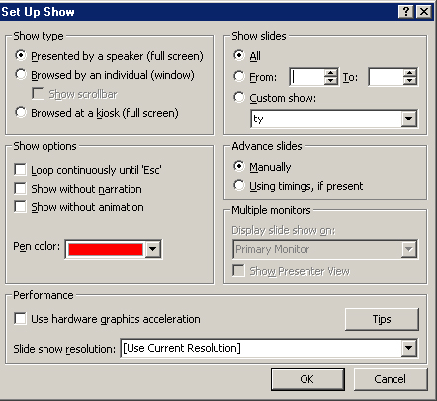
- From the Slide Show menu, select Set Up Show.
- Click Browsed at a kiosk (full screen). When you click this option, Loop continuously until "Esc" is automatically selected.
- Ensure the appropriate option is selected in the Advance slides section of the dialog box. You can then set the slide show to run by itself with your timings (Using timings), or you can set it so users can move through the show at their own pace by using the mouse to click buttons (Manually). Mouse-clicks are ignored unless they're on objects you've created hyperlinks to.
- Start the presentation in the normal way.
- Press Esc to end the show.

Slide timing
To run a slide show manually instead of using the set timings:
- On the Slide Show menu, click Set Up Show.
- Under Advance slides click Manually, and then click OK.
You can then run the slide show manually, but the timings are still set if you want to switch back to using them later.

Annotation pen
PowerPoint allows you to write or draw on (annotate) your slides, either whilst working on your slides, or when running the slide show.
To annotate slides during a slide show:
- Click the right mouse button to display the slide show shortcut menu.
- Click Pen to change the pointer to a pen (or press Ctrl+P).
- Hold down the mouse button as you draw or write on your slide.
- Select Arrow from the shortcut menu to change the pen back to the pointer (or press Ctrl+A).
To hide the slide show pen or pointer:
- During a slide show, click the right mouse button to display the slide show shortcut menu.
- Point to Pointer Options, and then click Hide Now or Hide Always
or
press Ctrl+H for Hide Now or Ctrl+L for Hide Always.
Hide Now turns the icon off until you move the mouse.
Hide Always turns the icon off for the rest of the slide show.

Erasing annotations
During a slide show, press the letter E to erase annotations.
Helpful hint:
If you don’t erase annotations while the slide is showing, the annotations automatically disappear when you move to the next slide.

Changing the annotation pen colour
You can change the colour of the pen you use to annotate your electronic presentation while you work on it or while you give a slide show.
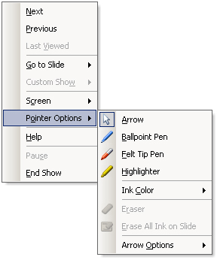
To change the annotation pen colour during the slide show:
- During a slide show, click the right mouse button to display the slide show shortcut menu.
- Point to Pointer Options, then to Pen (or Ink) Colour, and click a Colour.
To change the annotation pen colour whilst working in PowerPoint:
- From the Slide Show menu, select Set Up Show.
- From the Set Up Show dialog box, click the drop-down list under Pen colour
- Select a colour and close the dialog box.

Creating notes during a slide show
During a slide show, you can use Speaker Notes to take minutes, add notes to your notes pages. If you choose to take notes during a presentation conference, Speaker Notes appear on your screen. Participants in the conference see only the slide show.
Helpful hint:
The Meeting Minder feature (available in previous versions of PowerPoint) is no longer available in PowerPoint 2003.

Making notes during a slide show
- During a slide show, click the right mouse button, and then select Screen / Speaker Notes.
- Type in the space provided on the tab and click Close.
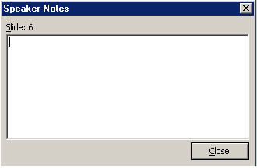

Learning more

Central IT training
Information Systems publish documents and run courses to accompany this one as detailed below:
Getting started with PowerPoint | This 3hr course is for those who would like to learn to create tailor-made presentation materials. The course is suitable for those with very little or no prior experience with PowerPoint.
Graphics, diagrams and animations in PowerPoint | This 3.5hr course is for users of PowerPoint who would like to include content such as drawings, flow charts, graphs and other objects in their presentation. The course will also cover how to animate such content for a more engaging, interactive presentation.

Training for WebCT designers

The Learning Technology Support Service also offers courses specifically aimed at content designers wishing to place accessible content into their e-Learning within a virtual learning environment such as WebCT.
Impatica for PowerPoint | This 1hr course introduces you to Impatica for PowerPoint, which is a compression tool for converting PowerPoint presentations into a web-friendly format. You will learn how to compress your presentations and tips for good PowerPoint design. You are encouraged to bring along your own presentations.
Scenario-based learning using PowerPoint | Scenario-based learning (SBL) puts the student in a situation or context and exposes them to issues, challenges and dilemmas and asks them to apply knowledge and practice skills relevant to the situation. In this 3hr course you will use PowerPoint to develop an interactive exercise that enables students to make choices and obtain feedback.

Details on training courses run by the Learning Technologies Support Service can be found at: http://www.ucl.ac.uk/learningtechnology/training

Open Learning Centre
The Open Learning Centre is open every afternoon for those who wish to obtain training on specific features in PowerPoint on an individual or small group basis. Please let us know your previous levels of experience, and what areas you would like to cover, when arranging to attend.
You will need to book a session in advance at www.ucl.ac.uk/is/olc/bookspecial.htm
and sessions last for an hour or possibly longer depending on availability.

Online learning
There is also a comprehensive range of online training in Web-related topics available via TheLearningZone at www.ucl.ac.uk/elearning

Getting help
A Web search using a search engine such as Google (www.google.co.uk) can also retrieve helpful Web pages. For example, a search for "PowerPoint tutorial" would return a useful selection of tutorials.

