UCL
Education & information support division
information systems

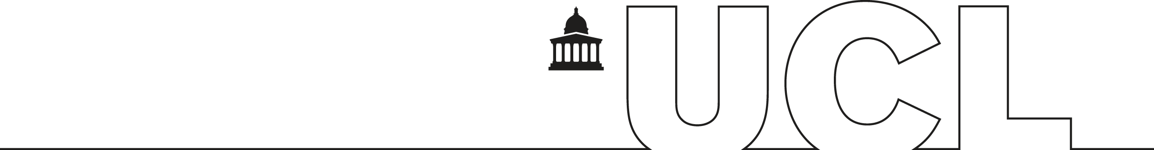

SPSS v12

Using SPSS

Contents
About SPSS and the course 1
Starting SPSS 1
Getting help 2
Quitting SPSS 2
Data organisation and the Data Editor 3
Opening a data file 3
Terminology 4
Moving inside the Data Editor 5
Types of value 7
Defining variables and entering data 8
Saving SPSS data 10
Importing Excel data files 11
Inserting, deleting and moving variables and cases 12
Sorting cases 12
Selecting a subset of data 13
Labelling variables and values 14
Missing values 15
Recoding variables 17
Recoding string variables 17
Automatic Recode 18
Recoding data into categories 19
Computing new data 21
The Case Summaries command 23
The Viewer window 24
Saving the output 24
Printing SPSS output 25
The Frequencies command 26
Descriptives 28
Crosstabulating data 30
The Means command 33
T Tests 34
Independent-Samples T Test 34
The Paired-Samples T Test 35
Correlation 37
Regression 39
Further graphics 40
Printing graphs 44
Further reading: books and Web resources 46
Books 46
Web resources 46

Introduction

Prerequisites
It is assumed in this workbook that you have the requisite keyboard skills and knowledge of a PC including file handling and data storage. It is also assumed that you are familiar with Windows and know how to use a mouse. Some knowledge of basic statistical terms is desirable to benefit from the course.

Availability of SPSS
SPSS can be accessed from UCL Information Systems (IS) PC Workstations running WTS (the managed PC service). It is assumed in this workbook that you are a registered user (i.e. you have an IS user ID and password) using a PC on the Information Systems WTS Service.

How to use this workbook
This guide can be used as a reference or tutorial document. To facilitate the learning process, a series of practical tasks is contained within the text. It is recommended that to assist your learning, you try each of these tasks as you progress through the workbook. For further practice and as a means of self-assessment, a number of additional staged exercises with solutions are available as a separate document. These should be attempted where recommended in the workbook.

Training Files
The training files are located at: http://www.ucl.ac.uk/is/training/exercises.htm
It is recommended that you copy them into your SPSS folder using Windows Explorer. Users of Cluster WTS will find their SPSS folder inside their WTS folder on the R: drive. Users of Staff WTS may use the SPSS folder found inside the MyWork folder on the N: drive or the SPSS folder on the R: drive.

About SPSS and the course
SPSS is a well established statistical and data analysis program with a range of facilities for data manipulation and offers many procedures for statistical analysis. The aim of this course is to provide a simple introduction to SPSS for Windows.
The course includes a basic guide to creating an SPSS file and creating, recoding and computing new variables, followed by basic analytical commands to display simple descriptive statistics, frequencies, crosstabulations, means, t-tests, correlation and regression. The production of simple graphics and dealing with missing values within your data are also covered.
WARNING!!!
Like all statistical packages, SPSS is just a tool for statistical and data analysis. It is very easy to produce results which have no meaning at all! Before performing any statistical analysis with this package it is strongly advised that you ensure you have a good understanding of the statistical procedures involved. If necessary, consult a good statistics text book or an experienced statistician.

Starting SPSS
Click the Start button, Programs, the relevant software group, SPSS, and click on the SPSS icon.
The initial SPSS screen should appear, showing the Data Editor window, with the Data View window on top, and a tab at the foot of the screen giving access to the Variable View window. This is superimposed by a smaller window headed SPSS for Windows which you can temporarily discard by clicking on the Cancel button. You can switch between Data View and Variable View by clicking the appropriate tab.
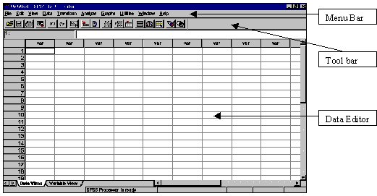

Getting help
You can obtain help on SPSS at any time during your SPSS session. Features such as being able to search for specific topics are included. To access the online help system, click on the Help menu and Topics to display the following window:

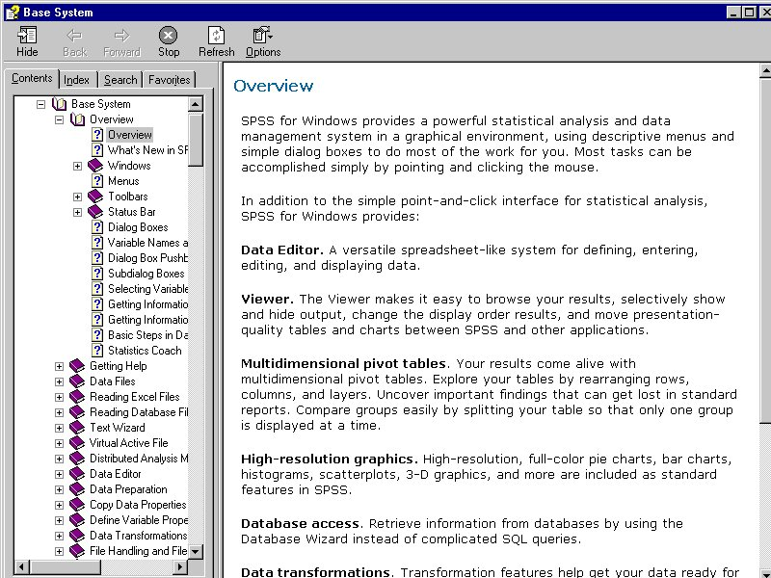

The Contents panel contains a list of broad topics, represented by icons of books. Double-clicking on any book will expand the contents. Selecting any one of these topics by double-clicking will provide you with the information in that topic.
If you know exactly what you want, or you wish to refer to a statistical term or a specific piece of jargon, you may prefer to use the Index tab. An alphabetic list of terms and topics will appear, and you can enter a term to search for. If too many similar topics are shown, use the vertical scroll bar to view the rest of the list, and double-click the topic you want.
Use Search to locate a Help topic. Within the Search box, enter a keyword that you would like to find help on. All Help topics that contain the keyword will be displayed, not just topics that begin with that word (as in the Index).

Quitting SPSS
Before we start looking at data organisation, it is important to know how to exit from SPSS. The process is similar to quitting from most other Windows applications:
- Select File from the main SPSS menu bar, and then Exit.
SPSS will ask you if you want to save any unsaved files. At this point there should not be any need to save any work, but consult the relevant sections of this workbook on saving files if there are any open files.
Restart SPSS so that you can continue with the rest of this workbook.

Data organisation and the Data Editor

Opening a data file
The first task will be to retrieve a simple data file to see how data is organised within SPSS. To do this using the menu:
- From the File menu, select Open, then select the Data from the resulting sub-menu.
The following dialog box will appear:
In the dialog box pictured opposite, you select the file from the list of files. You can select different drives and directories by clicking the drop-down arrow next to the Look in box.
You can retrieve files created by software packages such as Excel by selecting one of the file types from the pull down list in the Files of Type box. This will be covered later in the course. The first file we are going to use is called beer.sav.
- Select this file and click the Open button.
The Data View window will contain the following data:

Terminology
The data used for this example is based on a survey on various types of beer. The survey obtained the following information about each of the beers:
Variables
- the name of the beer
- the alcoholic content (in percent)
- if the beer can be classified as ‘light’
Each of these different types of information is known as a Variable in SPSS and has been given the name beer, alcohol and light respectively. Each variable can be seen running down a column, for instance, in the following example:

The rows contain the information for each individual beer tested. The information for each row is known as a case:

Each point of data within a cell is a value. For example:

To summarise:
A case: is a single set of data, in this example the details of one particular beer from the beer survey. Other examples of a case are: one reading from an experiment, the response from one person in a questionnaire, or a set of exam results for one pupil at school.
A variable: is a collection of data of the same type. For instance, in our example there are three variables which are the beer name, alcohol content, and whether the beer is light or regular. Other examples of variables are: the amount of drug administered or the temperature in an experiment, the answer to a question in a questionnaire, or the marks for maths and the names of pupils in school exams.
A value: is a single item of data which is the intersection between a case and a variable. In our example a value would be, say, the alcoholic content for the third beer surveyed (e.g. 4.9), whether the fifth beer was light or regular, or the name of the 20th beer surveyed.

Moving inside the Data Editor
Now that some data have been retrieved, you can experiment moving around inside the Data Editor. First there are some points to note:
- The currently selected cell has a thicker border;
- the cell value and co-ordinates appear in the top left-hand corner of the Data Editor;
- the area which shows the current cell value is also the area where new cell values are written or edited by typing in the new value.
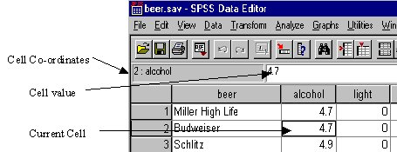
For straightforward data-entry:
- Use the arrow key → to move across variables for the first line of data;
- use the Tab key at the end of the first line to go to the second line;
- then use the Tab key to continue with the rest of the data-entry.
The following table is a summary of the key commands in SPSS for Windows for reference.
Helpful hint:
in the table (DE)=Data Editor and (text)=for all text.

Key | Plain | Shift | Ctrl | Alt
F1 | Help | Menu-bar help
F2 | Edit in cell (DE) | Label pop-up (DE)
F3 | Stop processor
F4 | Tile documents |  | Close window | Exit SPSS
F5 | Search (text) | Replace (text) | Cascade | Search (data)
F6 |  |  | Next window | Next window
F7 | Use sets
F8 | Extend selection | Multi-selection
F10 | Activate menu bar
Insert | Insert/Overtype | Paste | Copy
Delete | Delete | Cut
Home | Beginning of line | Select to beginning | First cell (DE)
End | End of line | Select to end | Last cell (DE)
PgUp | Page up | Select up
PgDn | Page down | Select down
→ | Char right | Select right | Last var (DE)
← | Char left | Select left | First var (DE)
 | Up |  |  | Select in drop-down
↓ | Down |  |  | Open drop-down list
Esc | Cancel |  | Task list | Next application
BkSpc | Del char left |  |  | Undo (DE)
Tab | Next control | Previous control |  | Previous application
PrtSc | Screen capture |  |  | Window capture
Space | "Click" control | Select case (DE) | Select variable (DE) | Application control menu

The other method of navigating SPSS is to use the mouse:
- You can select any visible cell with the mouse.
- You can use the horizontal and vertical scroll bars to view areas of the Data Editor which are not currently visible.
- You can select various areas of the Data Editor by clicking a particular cell, and whilst holding the mouse button, dragging the mouse cursor over the desired cells.
- You can right-click the mouse for pop-up menus.

Types of value
In the Data Editor you will notice that the data consists of both letters and numbers. The values within the variable beer are all letters and are used for the names of each beer. The variable beer is known as a string variable (or string). A string variable will accept most text input, including both letters and numbers.
The other two variables, alcohol and light only contain numbers. These variables are known as numeric variables. Numeric variables will only accept numbers (including decimal points) and will not accept any other type of character.
One other point to note: the variable light only contains the values ‘0’ and ‘1’. This is because light is a categorical variable where the values ‘0’ and ‘1’ represent regular beer and light beer respectively. A categorical variable takes a limited range of levels or ranks (ordinal) as opposed to a continuous variable (like alcohol) which can take an indefinite range of values. Other examples of categorical variables are days of the week, or a yes/no response from a questionnaire. These are nominal variables. The following table shows the different types of measurement, with examples:
Nominal | Category | Discrete | Eye colour
Ordinal | Ranking (rating) | Discrete | Likert Scale, e.g. 1-5, for example:  Excellent-good-fair-poor-terrible
Interval | Scale | Continuous | Temperature
Ratio | Scale | Continuous | Age, years of education

A categorical variable can be a string variable or a numeric variable but it is recommended that categorical variables should be numeric (see note below).
To summarise, the two main types of variables are string and numeric. You can also have other types of variable which include date/time, scientific notation and currency variables. These will not be covered during this course.
Helpful hint:
You will be unable to perform many of the SPSS commands with string variables, because strings contain letters which cannot be numerically analysed. It is recommended that, where possible, you use a numbering scheme instead of letters when coding and entering data, e.g. use ‘1’ for ‘yes’ and ‘0’ for ‘no’ instead of ‘Y’ and ‘N’ if you have a Yes/No type question on a questionnaire.

Defining variables and entering data
In the following exercise, we will add a new variable called rating to the data file. Each beer was rated according to quality and was given a value as follows:
1 – Very good
2 – Good
3 – Fair
To start with, we need to define the new variable:
- Either click on the Variable View tab, or double-click on the word var at the top of the fourth column (and scroll up a little).

- In the fourth row, type the variable name rating in the Name column (note: all variable names are limited to 8 characters), click in the Type cell, and click the grey button. This opens the Variable Type dialog box:
This is where the variable type can be changed from numeric to string if desired. We want this variable to be numeric, but the variable rating only needs to be of length 1 with no decimal places. To change this:
- Change the Width box value to 1
- Change the Decimal Places box value to 0
- Click on the OK button.
You have now defined the minimum amount of information needed for the variable rating and can now start entering the data.
The table below contains the values for the variable rating for each beer. To enter data:
- Click on the Data View tab.
- Go to the first case of the variable rating, and enter its value (i.e. 1).
- Press the Enter key ↵. This will enter the value and advance you to the next case.
- Repeat this until all 30 values for rating have been entered.

Case | Beer | Rating |  | Case | Beer | Rating
1 | Miller High Life | 1 |  | 16 | Strohs Bohemian Style | 2
2 | Budweiser | 1 |  | 17 | Miller Light | 2
3 | Schlitz | 1 |  | 18 | Budweiser Light | 2
4 | Lowenbrau | 1 |  | 19 | Coors | 2
5 | Michelob | 1 |  | 20 | Olympia | 2
6 | Labatts | 1 |  | 21 | Coors Light | 2
7 | Molson | 1 |  | 22 | Michelob Light | 2
8 | Henry Weinhard | 1 |  | 23 | Dos Equis | 2
9 | Kronenbourg | 1 |  | 24 | Becks | 2
10 | Heineken | 1 |  | 25 | Kirin | 2
11 | Anchor Steam | 1 |  | 26 | Scotch Buy (Safeway) | 3
12 | Old Milwaukee | 2 |  | 27 | Blatz | 3
13 | Schmidts | 2 |  | 28 | Rolling Rock | 3
14 | Pabst Blue Ribbon | 2 |  | 29 | Pabst Extra Light | 3
15 | Augsberger | 2 |  | 30 | Hamms | 3

The information for five more beers came in and this data needs to be added to the data file. Go to the last case in the Data Editor and enter the following information (you don’t need to enter the case numbers).
Case # | Beer | Alcohol | light | rating
31 | Heilemans Old Style | 4.9 | 0 | 3
32 | Tuborg | 5.0 | 0 | 3
33 | Olympia Gold Light | 2.9 | 1 | 3
34 | Schlitz Light | 4.2 | 1 | 3
35 | St Pauli Girl | 4.7 | 0 | 3

Once all the data has been entered you are ready to save the file.

Saving SPSS data
Now that you have entered your data into the SPSS Data Editor, it is important to save the data permanently. From the File menu either:
- select Save if you want to save the file using the current name, or
- select Save As if you want to specify a different file name (we will do this for demonstration purposes).
If you select Save As or if you select Save for a new data file, the following dialog box will appear:

- We are going to save the updated data in a file called beerfull.sav (you don’t need to type the .sav extension), so type this name in the File Name box and click on the Save button.
The updated file should now be saved with the new file name. You can retrieve this file at any time using the procedure outlined on page 4.

Importing Excel data files
Open a file in the usual way:
- Select Open from the File menu, followed by Data.
This gives the following dialog box:
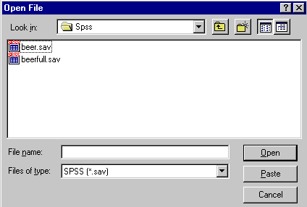
- Click on the down-arrow to the right of the Files of type box.
- Scroll down and select Excel (*.xls).
- Select the drive, folder and file, for example beerxls.xls and click on the Open button. This opens the Opening Excel Data Source dialog box:
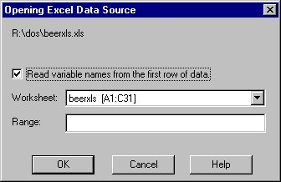
- If your spreadsheet has column names at the start of each column, then select the Read variable names from the first row of data option to keep these as the variable names in SPSS. If you leave this blank, the whole spreadsheet will be imported.
- To import part of a spreadsheet, in the Range box, enter the range of cells from the spreadsheet that you want to import. Specify the starting column letter and row number, a colon and the end column letter and row number, e.g. A1:K14.
- Click on the OK button.

Inserting, deleting and moving variables and cases
Normally new variables appear to the right of existing data in the Data Editor, and new cases are added underneath the last case. However, you may sometimes prefer to have them in a different position, which can be achieved as follows:
Inserting a variable:
- Right-click the variable name to the right of the new variable.
- Select Insert Variables.
Deleting a variable:
- Right-click the name of the variable.
- Press the backspace key on the keyboard.
Inserting a case:
- Right-click the case number below the new case.
- Select Insert Cases.
Deleting a case:
- Right-click the case number on the left of the Data Editor.
- Press the backspace key on the keyboard.
Moving a variable:
- Click the name of the variable to be moved.
- Drag and drop the variable to the column on the right of the red line which appears.

Sorting cases
You may wish to sort your data in a different order, which you can do as follows:
- From the Data menu select Sort Cases. The following dialog box opens:
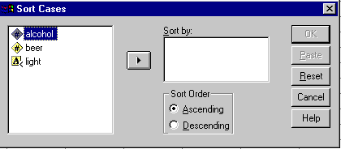
- Paste the variable on which you wish to sort into the Sort by box.
- If you wish to sort on another variable within the specified variable, paste that across, and so on.
- If you need to sort in descending order click Descending.
- Click on OK.

Selecting a subset of data
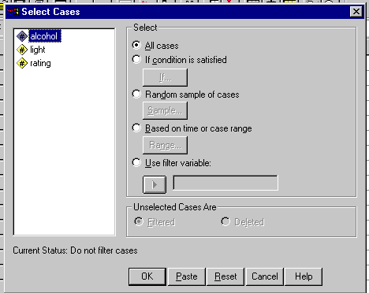
In order to look at only the beers rated very good, i.e. the variable rating coded 1 in the file beerfull.sav:
- From the Data menu select the option Select Cases to produce the following dialog box:
The options displayed in the Select Cases dialog box are as follows:
- All cases: Uses all cases in the file.
- If condition is satisfied: A case is selected if the expression is true.
- Random sample of cases: Select either a specified number of cases or a specified percentage of the cases at random.
- Based on time or case range: Processes only those cases falling within a range of specified dates.
- Use filter variable: You can select a numeric variable to filter cases. Cases are selected when the numeric variable is not zero or missing.
The box entitled Unselected Cases Are gives the following options:
- Filtered: This provides a switch which can be turned off to select all cases. The switch in this case is a variable called filter_$, which has the value 1 if a case has been selected and the value 0 for unselected cases. Any subsequent analyses will only be performed on those with a filter_$ value of 1.
- Deleted: This option will delete any unselected variables. Be careful in choosing this option, because saving the file after performing this could mean that your data will be permanently lost.
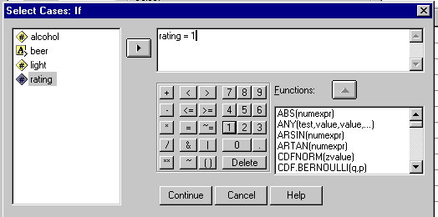
- Click on If condition is satisfied followed by the button marked If to produce the following dialog box, and type rating=1 into the equation box on the right to select only these cases:

- Click on the Continue button, followed by OK.
- To resume analysis on all cases, use Data | Select Cases again and click on All cases.

Labelling variables and values
As variable names are limited to a maximum of eight characters, this sometimes means that they are not very meaningful. It is possible to give labels to variables which can make the names more meaningful. We can also label values so that the coding system for categorical variables (e.g. rating and light in the beer data) is more meaningful than just relying on the numbered codes. Labels are not initially visible within the Data Editor. The main benefit of labelling is when you produce statistical output, which will include labels instead of codes where applicable.
In the following exercise, we will be giving labels to the two categorical variables within the data file beerfull.sav, so open this file from the Training Files (NOT the Answers).
- Click on the Variable View tab and click in the Label column for the variable light and type Light or Regular.
- Click in the Values column for the variable light, then click the grey button to the right of the cell. This opens the Value Labels dialog box:
- Click in the Value box and type 0.
- Click in the Value Label box below and type Regular.
- Click on the Add button.
The first label will be added to the list box.
- Click in the the Value box again and type 1.
- Click in the Value Label box and type Light.
- Click on the Add button again.
- The completed dialog box should now look like this:
If there are any mistakes you can select the label from the list (by clicking with the mouse) and correct them by clicking on the Change button.
- When you have finished, click on OK.
- Perform the same process for the variable rating. The labels you should give are:
Variable Label: Quality of Beer
Value Labels: 1 – Very Good
2 – Good
3 – Fair
- Once you have defined the labels for rating, the Value Labels dialog box should look like this:

- Save the file. This time you can use the same name ( i.e. beerfull.sav).

Missing values
There will be occasions when, for one reason or another, you will have missing values within your data.
For instance, in the following example, a survey was done in a shopping precinct to ask 30 shoppers whether or not they believed in Santa Claus. Each respondent was given an individual ID, had their gender recorded and was asked for their age and whether or not they believe in him. However, during the survey some people refused either to give their age or say whether or not they believed in him.
All of this information was recorded in the file santa.sav including the missing information which had been left blank.
To see how SPSS copes with missing values:
- Open the SPSS data file santa.sav and look down the Data Editor to see where the missing values are (you should find missing values in cases 4, 12, 14, 20, 23 and 25).
- Select the menus items Analyze, Descriptive Statistics and finally Frequencies.
- Select age and believe and click on the large arrow pointing to the right, and click OK.
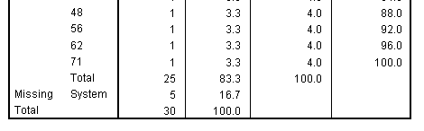
If you look at the output window and use the scroll bar to view the last part of the Frequencies table for the variable age, you will see the following:
The Frequencies table for the variable age displays the number of cases for each age in the file. However, as can be seen from the above, SPSS has five counts of missing ages. The number of missing cases has also been indicated in the small table at the top of the output.
If you do not enter a value for a numeric variable, SPSS will automatically generate a missing value (shown in the Data Editor by a dot).
SPSS will also generate a missing value if it generates an invalid number whilst calculating data for a new variable (e.g. dividing by 0).
Let’s look at the Frequencies output for the variable believe.
As you can see, missing values have not been indicated (there should be two missing values). Instead SPSS interprets spaces as actual text values when reading text or string variables.
The missing values we have just discussed for the variable age are known as System Missing Values, because the SPSS system has interpreted the missing values that way. Users can specify certain values to be regarded as missing values if required, which will overcome the problem shown by the believe variable, where spaces are read into string variables. These missing values are known as User Missing Values.
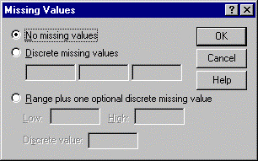
In order to enter missing values into the Data Editor we first need to define what the missing values are going to be. We will start with the variable age:
- Click the Variable View tab in the Data Editor.
- In the row for age click the cell in the Missing column.
- Click on the grey button to produce the following box:
We must decide what value we are going to use as a missing code. You should always choose a value that you know will not occur in the data. For the variable age we will use 0 to represent a missing value, as there is little chance of anyone responding who has just been born. In this case, you could also use a negative value or a very large value.
At this point you could also decide to have several missing values or a whole range of missing values. For this example, however, we will just use one missing value.
- Next, click on the option Discrete Missing Values.
- In the first box on the left type the value 0.
- Click on Continue and then OK to return to the Data Editor.
A missing value has now been defined for the variable age. The process has to be repeated for the variable believe; this time we will use the letter X for missing.
- Open up the Missing Values box as previously for the variable believe.
- Select Discrete Missing Values and enter X in the first box and return to the Data Editor.
You can now enter the missing values in the Data Editor.
- Go down the variables age and believe entering the values 0 and X respectively wherever you find a blank space.
- Select the menu items Analyze, Descriptive Statistics, Frequencies and click on OK again, to see how SPSS will cope with the missing values now.
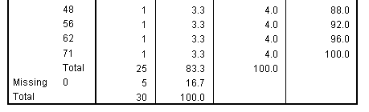
The bottom of the Frequencies output for age now looks like this. Compare this output with the previous output for system missing values for age:
The missing value is now indicated by a 0, but overall there is not much difference in the output.
The Frequencies output for the believe variable is as follows:
The number of missing cases is correctly indicated at the bottom of the output and the Valid Percent column is correctly given.

Recoding variables
Recoding variables is useful if you want to convert string variables to numbers or collapse or combine your data into categories. It is possible to recode values within existing variables or create new variables containing the recoded values of existing variables. We would recommend recoding into a new variable wherever possible, so that your original values are retained. It is also possible to recode on a certain specified condition.

Recoding string variables
You should code variables numerically where possible, but if you have files that contain categorical string variables, these can be recoded.
In the file santa.sav the variable sex has been coded as M and F. We can change these to 1 and 0 as follows:
- From the File menu select Open and Data and choose the file santa.sav.
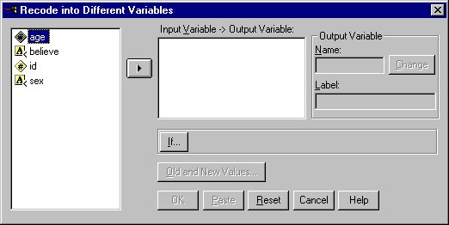
- From the Transform menu select Recode, and then Into Different Variables:
- Paste sex into the Input Variable −> Output Variable box.
- Type gender into the Output Variable Name box.

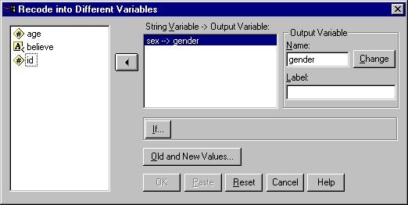
- Click on the Change button, so that the dialog box now looks like this:

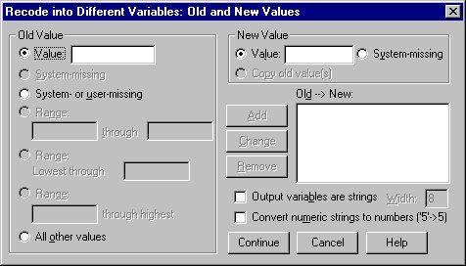
To define the new values which will be recoded:
- Click on the Old and New Values button to bring up the next dialog box:
- Under Old Value select Value and type M.
- On the right, under New Value, select Value and type 1.
- Click on the Add button.
- The old and new values are shown.
- Next, under Old Value, select Value and type F.
- Under New Value type 0.
- Click on the Add button.
- For string variables, the missing values option does not apply, but if numeric variables are being recoded and any missing values codes have been specified (missing values will be covered later in the course) select the System- or user-missing option and then System-missing on the right or a value which you then define as missing. System-missing should be recoded in the same way.
- If you have any other values, select the option All other Values and add a new value for these or select Copy old value(s).
Continue the procedure until all variables you wish to recode have been entered with their new values.
- To change the new variable from string to numeric format select Convert numeric strings to numbers by clicking in the small box above the Continue button.
- Click on Continue and then on OK.

Automatic Recode
You can save time when you wish to convert string variables by using Automatic Recode. This creates a new numeric variable containing consecutive integers, e.g. 1, 2, 3, etc, to represent each value in the original variable.
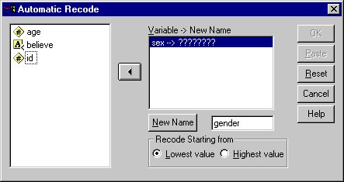
For example, in the file santa.sav which has the values M and F for male and female in the variable sex, these will appear in the new recoded variable as 1 and 2.
- From the Transform menu choose Automatic Recode:
- Paste across the variable name to be recoded.
- In the small box below, click and type in the name for the new recoded variable to be created, in this case gender, and click the New Name button.
- Lowest value means that numbers will be assigned in alphabetic order of the original values, e.g. female will be 1, and male will be 2. If you wish the coding to be in the reverse order, click on Highest value.
- Click on OK.
A new variable gender is created containing the numeric codes 1 for female and 2 for male, as Lowest value was selected.

Recoding data into categories
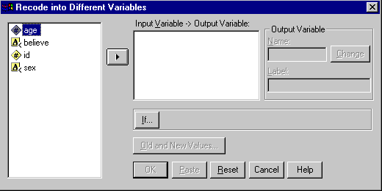
In the following example, in the file santa.sav a new variable agegrp is to be created, based on the variable age. For instance up to 25 is age group 1; 25 to 50 is age group 2; and so on. The initial dialog box can be obtained from the menu options Transform, followed by Recode, then Into Different Variables.
- Click on the Reset button to clear any contents in the boxes.
- The first stage is to paste age into the box Input Variable|Output Variable.
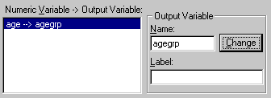
- The name of the new variable (in this case agegrp) is typed into the Name box, and a label if required, is typed into the Label box.
- After clicking on the Change button the box looks like this:
To define the new values which will be recoded to create the variable agegrp, click on the box marked Old and New Values... which will bring up the dialog box shown in the next example.
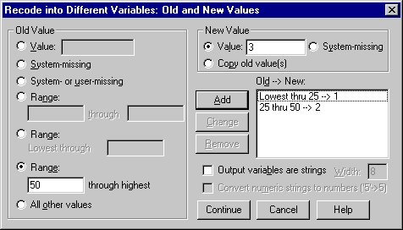
In the above example two codings have already been entered, and can be seen in the box marked
Old --> New.

To enter a new coding, do the following:
- In the Old Value box click to select the value, missing or range type required. Lowest means from the lowest value in the file, and highest means to the highest value in the file.
- In the appropriate box enter the value, or the range of values, you wish to be recoded.
- In the box marked New Value, click to select Value and type the new value.
- Click on the Add button to paste the coding into the Old --> New box.
- For string variables, the missing values option does not apply, but if numeric variables are being recoded and any missing values codes have been specified (missing values will be covered later in the course) select the System- or user-missing option and then System-missing on the right, or a value which you then define as missing. System-missing should be recoded in the same way.

To copy all the remaining values across to the new variable:
- Click on All other values.
- Click on Copy old values, and click on the Add button.
If you need to convert string values to numeric values, select Convert numeric strings to numbers by clicking in the small box above the Continue button.
- Click on Continue and then click on OK.
If you want to recode on a certain specified condition, click on the If button in the initial Recode into Different Variables dialog box. This will take you to the If Cases dialog box, where you can specify the appropriate condition by selecting Include if case satisfies condition and pasting in the variable name and the numeric expression specifying the condition.

Computing new data
It is possible to compute a new variable within SPSS based on existing variables. New variables can be computed by using mathematical expressions and/or various built-in functions.
We will illustrate these by calculating the mean of the three exam results for each pupil in the file results.sav in two different ways.
- Open the file results.sav.
- Select the menu option Transform, followed by Compute. to open the following dialog box:
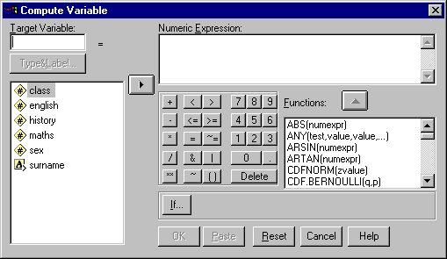

On the left you can see a list of the current variables. Just above the variables box is an area where the name of the new variable to be computed is written (called Target Variable). Existing variables can be pasted into the Numeric Expression box on the top right.
The expression is built up by adding numerical operations to the box using the calculator-like pad, or by pasting in one of the functions in the list on the right-hand side.
First we will compute a new variable called resmean1 which uses the expression (english + history + maths)/3 to compute the variable.
- Type a new variabe name resmean1 into the Target Variable box.
- Click on the () button in the calculator pad (brackets).
- Type or paste in the expression english + history + maths inside the brackets.
- Type or paste in /3 on the right, outside the brackets.
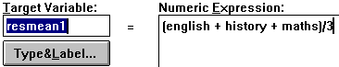
You should have something like this:
- Click on OK.

A new variable resmean1 has been created in the Data Editor and appears on the right after all the other variables in the file.

We will now compute a new variable called resmean2 which is again the mean of all three results, but this time we use a different calculation. We use the SPSS function MEAN(english, history, maths) for the computation.
- Select the menu options Transform, Compute.
- Click on the Reset button to clear the contents of the boxes.
- Type resmean2 into the Target Variable box.
- Scroll down the Functions box to find the function
MEAN(numexpr,numexpr,...)
- Click on this function and click on the large arrow pointing upwards.
- Delete all of the contents inside the functions brackets.
- Type or paste english,history,maths inside the brackets.
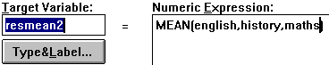
You should have something like this:
- Click on OK.

You will see that the new variable resmean2 has been created to the right of resmean1 in the Data Editor.
We can similarly compute a new variable called highest to compute the largest result that each pupil obtains (Hint: there is a function called MAX).
After you have computed the new variables, save the file as rescomp.sav.

The Case Summaries command
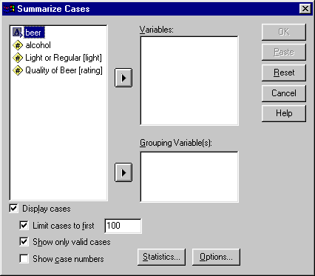
The Case Summaries command allows you to display some or all of the data from your file. It allows you to choose which variables to display, and if desired you can also group cases according to some variable. The output is a well-formatted display of your data, which you may wish (for example) to include in a report.
To list the contents of the file:
- Open the file beerfull.sav.
- Select the Analyze menu on the menu bar.
- Select the Reports menu option. This will produce a second sub-menu.
- Finally, select the Case Summaries option to display the following dialog box:
The variables to be listed need to be selected from the list on the left and be placed in the list on the right. To do this:
- Select the first variable, alcohol, so that it is highlighted.
- Click on the large arrow pointing towards the Variables panel. The variable alcohol is transferred to the list on the right as shown:
(Note: The direction of the large arrow has changed which means that you could remove the variable alcohol from the list.)
To list all the cases you could select each variable in turn and paste it into the list, but this might be time consuming. Alternatively:
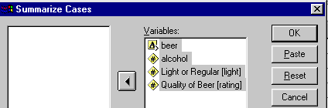
- Click on the top variable in the list (i.e. beer) and drag the mouse down the list until all the variables are highlighted, and then click on the large right arrow.
All the variables will be pasted in the list.
- When you are ready to proceed, click on the OK button.

The Output Viewer window will become the active window and show a full listing of the data. You can view the contents of the output window in full by using the cursor keys PageUp, PageDown or the mouse and scroll bar. Instructions on how to save and print from the Viewer window will be given later.

The Viewer window
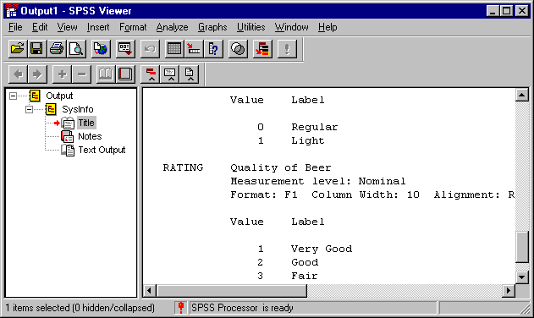
The Viewer window is where all the results from any analyses you perform will be produced. This section will discuss how you can save and print the results from the Viewer window. The following example shows what the Viewer window looks like:

The information contained in the Viewer window can be copied into a word processor or text editor. Alternatively, editing can be done within the Viewer window.
The buttons on the icon bar will not be discussed within the course. However, you can consult the Help section on icon bars if you wish to find out more about the buttons on the icon bar.

Saving the output
Saving the SPSS output is a similar process to saving SPSS data, with a few differences.
With the Viewer window as the current window, from the File menu either:
- select Save if you want to save the file using the current file name, or
- select Save As if you want to specify a different file name (we will do this for demonstration purposes).
If you select Save As or if you select Save for a new output file, a dialog box similar to the Save Data dialog box will appear. Again, like other dialog boxes used for file operations, the Save As dialog box allows you to choose the drive, directory or an existing file name. We are going to save the output using the file name beer1.spo so type this into the File Name box and click on the Save button.
The updated file should now be saved with the new file name. You can retrieve this file by selecting the menu options File | Open | Output and then selecting the file using a procedure similar to the one outlined on page 4.

Printing SPSS output
Within SPSS you have the choice to print either a selection or all of the output. To print all of the output:
- Make sure that the Viewer window is the current window.
- Select the menu option File, followed by Print to produce the following dialog box:

At this point you can ensure that the printer is set up correctly by clicking on the Properties button, although this shouldn’t be necessary at the moment. You can also increase the number of copies if desired.
- Click on OK when you are ready to print.
- The output will be sent to the selected printer.

To print a selected part of the output:
- Highlight the desired area of the output. This can be done by clicking once on a table of results or a graph. From the menu select File | Print.
- Select the option marked Selection.
- Click on OK when the other options are set.
- This time only the selected output will be printed.

The Frequencies command
The Frequencies command is used to report on the frequency distribution of the data, and can produce graphical output such as bar charts and histograms. This example uses the beer data. The Frequencies command can be found under the Analyze | Descriptive Statistics menus.
In this example we will use frequencies to count the number of occurrences within the subgroups of the variable rating.
- Select the menu Analyze, then Descriptive Statistics | Frequencies.
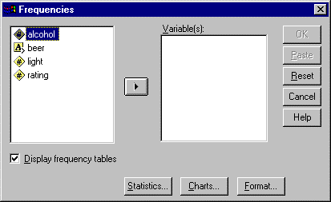
- The Frequencies dialog box will appear:
- Paste the variable rating into the Variable(s) box and click on OK.

The output for the variable rating is shown below:
The number of occurrences for each rating is shown in the above output including the percentages of the sampled population. For instance, 14 beers were rated as Good, which is 40% of all of the sampled beers.
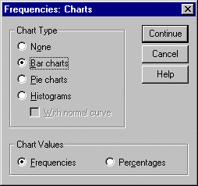
Like most other commands in SPSS, the Frequencies command has extra options, which include being able to produce descriptive statistics and high resolution graphics. In the next example we will add options on the Frequencies command for rating to produce a bar chart of the data.
- Produce the Frequencies dialog box again.
- Click on the Charts button.
The Charts box will appear:
- Select the Bar charts option and click on Continue.
- Click on OK in the Frequencies dialog box.
The Frequencies command will run the same as before, but is followed by a bar chart:
The bar chart pictured in the above example shows graphically how the beers are rated, displaying a count of each of the categories within the variable rating. It is possible to produce the same graph showing percentages instead of frequencies. A histogram can be produced for continuous data.

Descriptives
The Descriptives command will calculate basic statistics including means, variance, standard deviation, maximum and minimum. This is used mainly on continuous variables, but can be used on scales of five points or more.
To calculate descriptives on the beer data, make sure the file beerfull.sav is open, and do the following:
- Select the Analyze menu option.
- Select the sub-menu Descriptive Statistics followed by Descriptives.
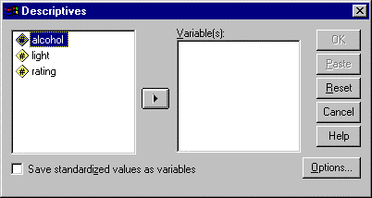The following dialog box will appear:

- Paste all three variables into the Variable(s) box (i.e. highlight all three variables and click on the large right arrow). Note: You cannot select the variable beer because it is a string variable and therefore does not have numbers on which to do calculations.
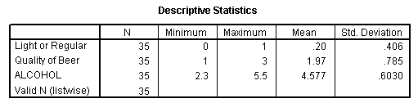
- Click on OK.
The following table will appear in the Output Viewer dialog box:

The default statistics shown in the table are the mean, standard deviation, minimum and maximum values, and the number of cases (N).
- Although statistics have been produced for the variables rating and light the values are not very meaningful because the numbers in these variables are categorical. The values are not a quantitative measure but are used to classify the data into groups (i.e. the rating tells us if the beer is very good, good or just fair).
It is possible to produce other univariate statistics using the Descriptives command.
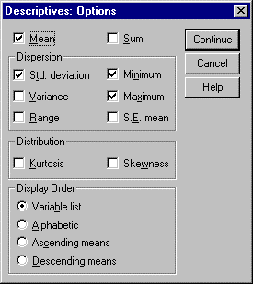
- Open up the Descriptives dialog box (i.e. select the menu options Analyze | Descriptive Statistics | Descriptives). The dialog box will appear with all the variables previously selected in the Variable(s) box.
- Click on the Options button. The following box will appear:
This shows various options which can be selected to produce additional statistics. For this example we will request the skewness and kurtosis options only, which give an indication of how close to the normal distribution your data is. Kurtosis shows whether the curve is steeper than the ‘Normal’ bell-shaped curve (positive) or flatter (negative); skewness shows if it leans to the right (negatively skewed) or to the left (positively skewed); both of these are beyond the normal range if they are approximately greater than 1 or less than –1.
- Deselect the Mean, Std Deviation, Minimum and Maximum boxes.
- Select the Kurtosis and Skewness options.
- Click on Continue to return to the initial Descriptives dialog box.

Before continuing we should remove the variables light and rating from the analysis as they are categorical variables and will not produce meaningful results.
- Highlight the variables light and rating in the Variable(s) box.
- Click on the large arrow pointing left.
- Click on OK.
The results produced now look like this:
This time the kurtosis and skewness values for just the variable alcohol have been produced. These are not close to 0, indicating that a normal distribution is unlikely.

Crosstabulating data
Sometimes you might want to know the relationships between two categorical variables. For instance, with the results data, how do the females compare with the males? The Crosstabs command can be used to count the number of cases for each combination of values for the variables class and sex. To perform a crosstabulation:
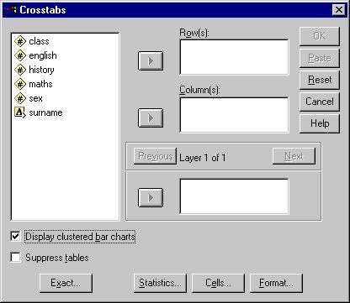
- Call up the Crosstabs dialog box by selecting the menu options Analyze | Descriptive Statistics | Crosstabs.
The Crosstabs dialog box will appear as shown in the next example:
- Paste the variable sex into the Column(s) box and the variable class into the Row(s) box and click on OK.

The output for the Crosstabs command follows:
The Crosstabs command organises the data into a table. The cross-point between each response of the two variables is called a cell (e.g. 10 females in Class A, but no males).
The totals at the side and the bottom of the table show the frequencies within one variable, e.g. overall, there were 10 pupils in each class, and 15 of each sex. The bottom right corner shows the totals for the whole table.
The Cells subcommand has options to include the percentages for the row, column and whole table, as well as the expected and residual values for each cell.
The next example uses the command previously built to produce extra values for the row, column and total percentages, and also the expected values.
- Call up the Crosstabs dialog box again. The same variables will remain selected.
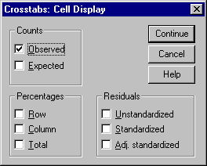
- Click on the Cells button to produce the following box:
- Select the following boxes: Expected, Row, Column and Total. Then click on Continue and OK.
The third row in each cell gives the percentage of all cases in a row that fall into that cell. For instance, 100% of pupils in Class A were females.
The fourth row in each cell gives the percentage of all cases in a column that fall into that cell. For instance, 66.7% of females were in Class A.
The fifth row in each cell gives the percentage of all the cases in the table that fall into that cell. For instance, 33% of all pupils were in Class A.
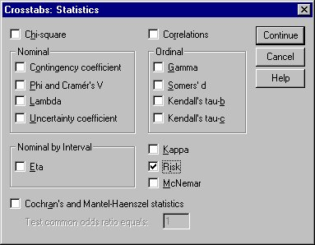
It is also possible to display various statistics for the crosstabulation including the chi-square statistic and its significance level. To do this:
- Click on the Statistics button to produce the dialog box:
- Select Chi-square by clicking in the small box at the top left.
- Click on Continue, and then on OK.

The following additional table appears:
The chi-square significance level shows whether you can reject the null hypothesis that there is no association between the two categorical variables. If too many cells have low expected values according to the footnote, it will be necessary to group categories, for instance by using Recode.
A clustered bar chart showing the same information graphically can be produced by selecting Display clustered bar charts.
Also, it is possible to add another variable in the last window to produce effectively a three-way crosstab giving a two-way table for each level or category of this variable. This is illustrated in the exercise.

The Means command
This command can be used to find the means and standard deviations of one or more continuous variables for sub-populations in a sample. For instance with the beer data, you might want to know the mean alcohol value for each different rating of beer. To do this:
- Select Analyze | Compare Means | Means to produce the dialog box:
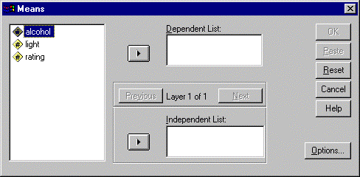
- Paste the variable alcohol into the Dependent List.
- Paste the variable rating into the Independent List.
The results are:
The mean alcohol content for the entire population is 4.577. Of the rating categories, the beer rated Very Good has the highest mean alcohol content, whilst the Fair beer has the lowest mean alcohol content.
There are other options available for the Means command. Clicking on the Option button in the Means dialog box will allow you to display various statistics for a sub-population, or you can perform a one-way analysis of variance or a test of linearity.

T Tests

Independent-Samples T Test
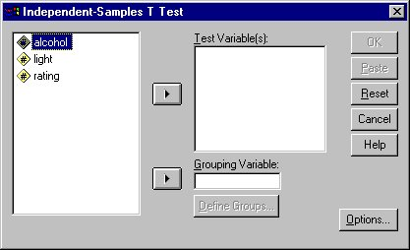
If you wish to compare the means of a continuous variable for two groups, for example the alcohol content of light and regular beers in the file beerfull.sav, you can run the Independent-Samples T Test as shown:
- On the Analyze menu select Compare Means and then Independent-Samples T Test. This opens the dialog box:
- Paste alcohol to the Test Variable(s) panel on the right.
- Paste light to the Grouping Variable panel below:
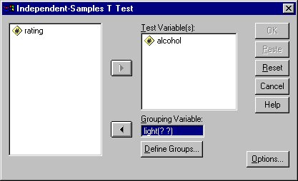

- Click on the Define Groups button, which opens a dialog box to define the groups:
- Type 0 into the Group 1 box, and 1 into the Group 2 box.
- Click the Continue button, and then OK.
This produces the following tables:

- The first small table shows the means and standard deviations of alcohol for the light and regular beers.
- In the main T Test table first the Levene’s Test for Equality of Variances is run to test if the variances of the two groups are equal. If the significance (column headed ‘Sig.’) of the F test is less than 0.05 then use the second line of the T Test table; otherwise use the top line.
- The column headed Sig. (2-tailed) shows there is a significant difference in alcohol content between light and regular beers.

The Paired-Samples T Test
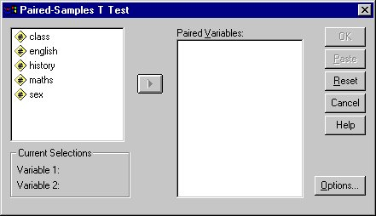
The Paired-Samples T test is used to test whether one continuous variable has a significantly higher mean value than another for the same cases in the same data file. To perform this test on the variables english and maths in the file results.sav open the file, then:
- Select Analyze|Compare Means|Paired-Samples T Test.

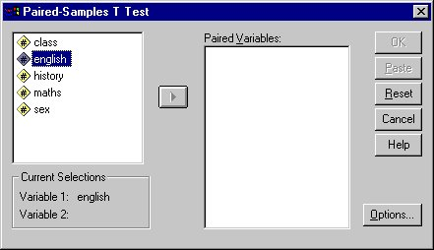

- When you select english, it is moved into the Current Selections list:

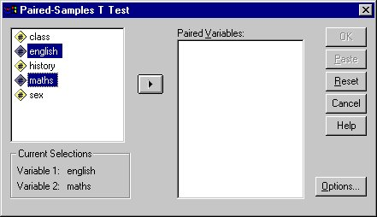

- Selecting maths also moves this into Current Selections, so the variables are paired:

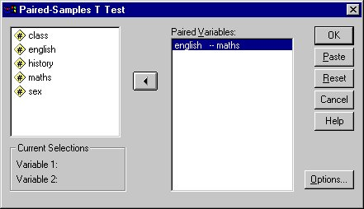

- Now click the arrow to move the pair into the Paired Variables panel.

- Click on OK.
Statistics are shown on the differences between the two variables.
- First the means of English and Maths are shown, with their standard deviations.
- The second table shows the correlation between English and Maths, which in this case is not significant.
- The last table is the Paired Samples Test between English and Maths, which shows a significant result, i.e. there is a statistically significant difference between the English and Maths results.

Correlation
To measure the strength of an association between two continuous variables, or scale measurements, use the correlation coefficient and its significance, and a scatter plot.
- Open the file results.sav.
- Select Analyze|Correlate|Bivariate to produce the following dialog box:
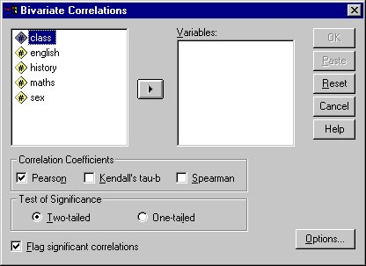

- Paste english and history across to the Variables panel on the right.
- Click on OK.
The following table is produced:
This shows that there is a high correlation between history and english, which is statistically significant (a perfect correlation coefficient has a value of 1).
The corresponding scatter plot is produced as follows:
- From the Graphs menu select Scatter to produce the initial Scatterplot dialog box.
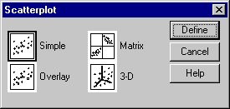

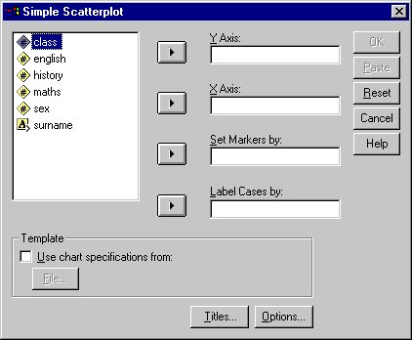
- We want the Simple plot, which is the default, so we just need to click on the Define button. This brings up the following dialog box:
- Paste history to the Y Axis box and english to the X Axis box.
- Click on OK.

The following scatter plot is produced:

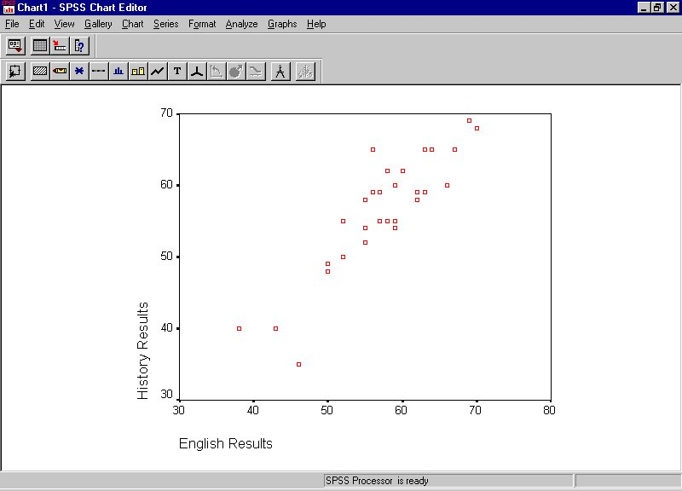
The two variables appear to have a linear relationship.
To fit a regression line we can edit the chart as follows.
- Double-click on the chart to bring up the SPSS Chart Editor.

- Select from the menu Chart|Options to produce the following dialog box:
- Select Total in the Fit Line box.
- Click on OK
- Close the SPSS Chart Editor by clicking on the x at the top right.

The plot now looks like this:

Regression
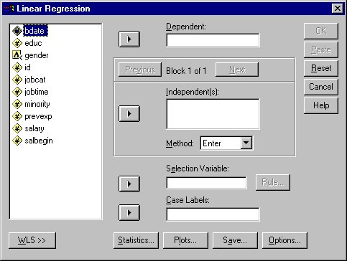
To perform a linear regression to predict history results from English results, from the Analyze menu select Regression and Linear to open the dialog box:
- Paste history to the Dependent box, and english to the Independent(s) box.
- Click OK.

The following output is produced in the Viewer window:
The high value of R Square, the slope of the line (coefficient B) and its high significance and the significant value of F in the Analysis of Variance table confirm the strong linear relationship that can be seen on the scatter plot and show that the English results are a good predictor for the history results.

Further graphics
This section shows you how to generate more specific graphics, modify and print them.
We will first produce a pie chart showing how the beers were rated in the file beerfull.sav, so after opening the file again:
- Select the Graphs menu followed by Pie.
The following intermediate box will appear:
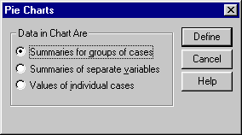
The slices for the pie chart can be represented in three different ways:

Summaries for groups of cases | Graphically displays data for each category within a variable, i.e. each category will represent a pie slice. | e.g. Class A, Class B and Class C in class in file results.sav
Summaries of separate variables | Graphically displays data for each variable selected, i.e. each variable selected will represent a pie slice. | e.g .variables english and history in file results.sav
Values of individual cases | Graphically displays data for each case within a variable, i.e. each case will represent a pie slice. | e.g. each pupil’s result for english in results.sav

Most of the different types of graph open a dialog box before proceeding to the main graph dialog box. If you are in doubt as to which option to choose, select the Help button, as this shows what the graph might look like.
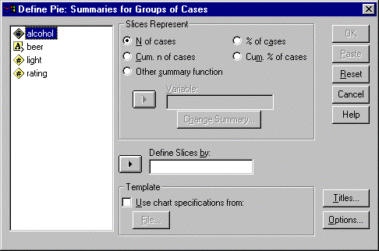
- As we want to look at categorical data, click on Define with the first option still selected. The next dialog box will appear:

- Paste the variable rating into the Define Slices by box and click OK.

This shows graphically the same results we produced for the Frequencies command. The chart as it is, however, lacks detail and could be enhanced with a title and some annotations.
- Double-click on the chart.
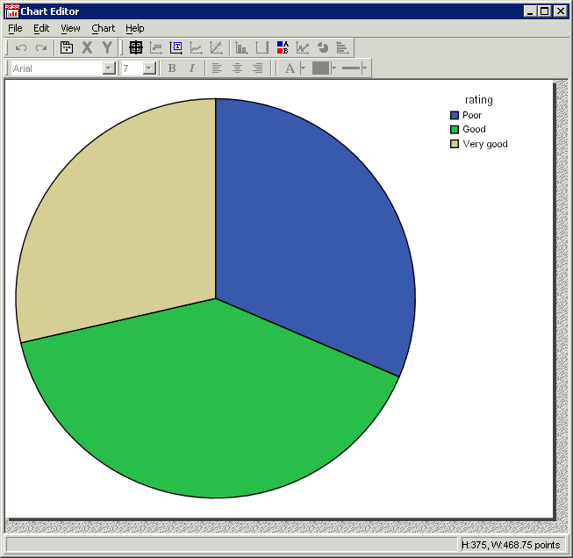
The SPSS Chart Editor appears with a new menu bar as shown in the next example:

In order to add labels to the slices we must first select the pie. Click once within the area of the pie to select it (its outlines will become highlighted) and then select the menu option Chart|Show Data Labels to produce the following box:
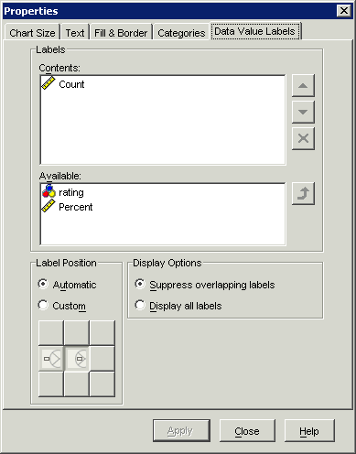
- The upper of the two boxes tells SPSS which labels it should add. By default, SPSS chooses to show the “Count” – the number of cases within each category. Also available are the percentage, and the variable value (rating in this example).
- To decide which of these will appear, you can select them and then press either the upwards arrow to move them from “Available” to being displayed, or press the cross button to remove them from being displayed. You can display more than one of these choices – in which case you might like to rearrange them using the up/down arrows just next to the Contents box. In our example we will include all three (rating, Count, and Percent).
- You can also choose whether the labels are positioned inside or outside the pie slices. To do this, select Custom in the Label Position panel, and then select the icon representing the option you require.
- To apply these preferences, click on Apply, and then Close.

Finally, let us add a title to the pie chart:
- Select the menu options Chart|Add Data Element|Text Box which will add a text box with the default text Textbox, as shown in the next example:
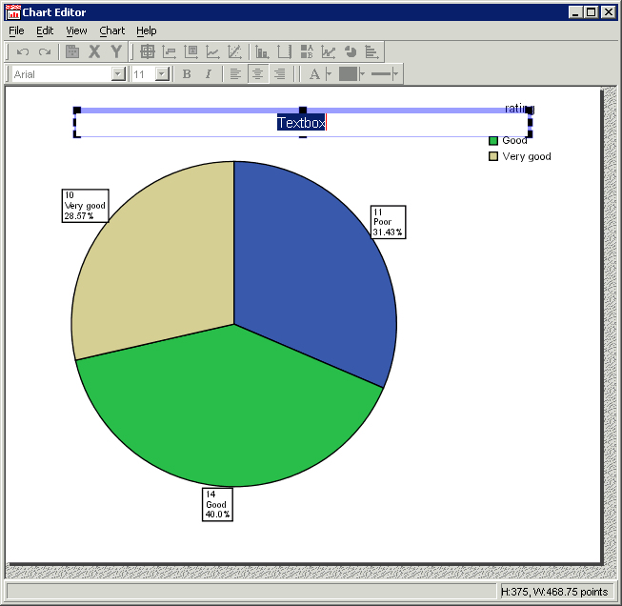
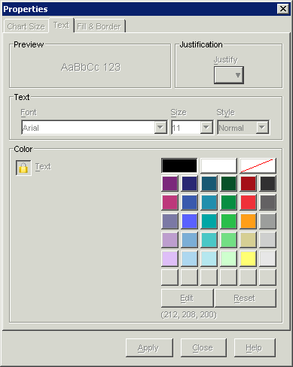

- The text box has automatically been positioned as if it were a title, and is in editing mode, so you can simply type an appropriate title. For this example type:
Chart Showing Beer Ratings
- Press Enter to commit your text.
- You can now use the Properties window which has also appeared, to set the text colour, font, size, etc., if you so wish. If not, close the Properties window.
- You can simply click and drag to reposition the text box, if needed.
In our example, because we have added labels to the pie slices, the legend at the right-hand side is now superfluous, so we can remove it by choosing the menu option Chart|Hide Legend.
When you are satisfied with the chart’s appearance, click on the cross at the top right to close the Chart Editor.

The final pie chart can be seen below:

Printing graphs
After producing a graph, you may need to print it.
- Select the chart.
- From the File menu choose Print to produce the Print dialog box:
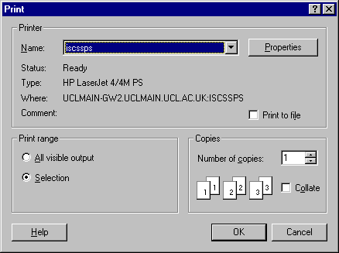

You can change the orientation from portrait to landscape by clicking on the Properties button or by first clicking on File | Page Setup. Here you can also change the size by clicking on the Options button and the Options tab. You can look at the graph in File | Print Preview, and click on Print, or on Close to change the size again first.
- When you have set up all the options and are ready to print click on OK.
If you would like SPSS to produce monochrome charts for black and white printing, using patterns rather than colours to fill the chart areas, edit the graphics options as follows:
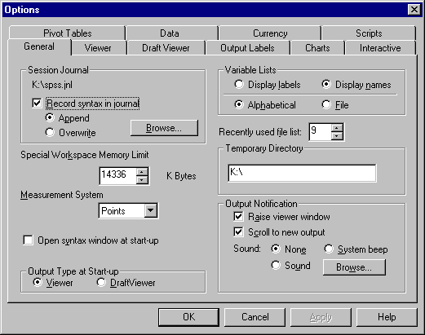
- Select Edit|Options to produce the Options dialog box:

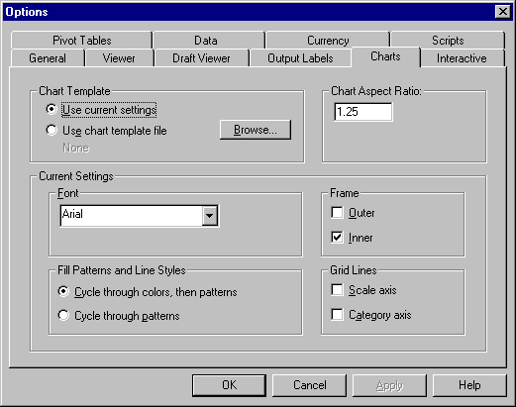
- Click on the Charts tab to see the next dialog box:
- Click on the option Cycle through patterns.
- Click on OK.

You may need to regenerate your chart for this option to apply.

Further reading: books and Web resources
The following books and websites have been recommended by SPSS training staff within UCL, covering either SPSS or statistics more generally. Further suggestions for references to include here would be welcome.

Books
Discovering statistics using SPSS for Windows / A.P. Field. - Sage, 2000
How to design and report experiments / A.P. Field and G. Hole. - Sage, 2003
SPSS 12 made simple / P.R. Kinnear and C.D. Gray. - Hove: Psychology Press, 2004
Statistics without tears : an introduction for non-mathematicians / D. Rowntree. - London: Penguin, 1991

Web resources
SPSS training from the SPSS company:
https://secure.spsstraining.com/index1.html

Concepts and applications of inferential statistics:
http://faculty.vassar.edu/lowry/webtext.html

Resources to help you learn and use SPSS:
www.ats.ucla.edu/stat/spss/

