UCL
Education & information support division
information systems



Access

Designing and Developing Databases

Exercises

Content
Practical Exercises (Access 2002) 1
Exercise 1: Creating fields 1
Exercise 2: Modifying design and primary keys 1
Exercise 3: Importing from Excel 1
Exercise 4: Field properties 2
Exercise 5: Lookup fields 2
Exercise 6: Preparing to create relationships 3
Exercise 7: Creating relationships 3
Exercise 8: Testing referential integrity 3
Exercise 9: One-to-One relationships 4
Exercise 10: Many-to-Many relationships 4
Pen and Paper Exercises 5
Exercise 11: Defining fields 5
Exercise 12: Normalising tables 6
Exercise 13: Planning a database 7

Practical Exercises (Access 2002)

If you complete the following tasks in the order they are given you will gradually build up an Access database. You don’t need to use any additional files unless explicitly stated. However, if you wish to do the exercises in a different order or you have not completed earlier exercises correctly, you can use the database with the appropriate name to complete any given exercise in isolation. For example, you could complete Exercise 3 using exercise03.mdb. Files can be downloaded from the web page: www.ucl.ac.uk/is/documents/

Exercise 1: Creating fields
- Create a new database called Staff.mdb in the r:\training.dir\access\developing-access folder.
- Create a new table in design view. Define the fields listed below. Set an appropriate data type* for each field and add descriptions where you think this would be helpful. Fields to be created are as follows:
Name | Data Type | Description

First_Name

Last_Name

DOB

Job_Title

Dept_Name

Telephone

Salary

Nationality

Disability

Notes

- Leave the table open in design view and do not attempt to save it at this stage.

*In particular, note that the Disability Field is to indicate whether the person does or does not have a disability (no other information will be stored) and the Notes Field is for any additional information that may be relevant and needs to be of unlimited size.

Exercise 2: Modifying design and primary keys
- Add in an additional field at the beginning called Staff_ID with a data type of Number.
- Add in another new field after Salary called Start_Date.
- Set the Staff_ID field as the primary key for the table.
- Save the table with the name tbl_Employees and switch to datasheet view.

Exercise 3: Importing from Excel
- Import the spreadsheet employees.xls into your staff.mdb database as a new temporary table with a name of your choice.
- Copy and paste all of the records from the temporary table into the tbl_Employees table.

Exercise 4: Field properties
- Add the following properties to fields in the tbl_Employees table:
Field | Property | Details
Staff_ID | Format | 00000
Last_Name | Field size | 25 characters
DOB | Format | Medium Date
DOB | Caption | Date of Birth
Salary | Decimal places | 0
Nationality | Default | British

- Switch to datasheet view and see how the changes to the properties have affected the table.
- Return to design view and add the following properties to the tbl_Employees table:
Field | Property | Details
Last_Name | Required | Yes
Salary | Validation Rule | <50000
Salary | Validation Text | Too much money!

- Switch to datasheet view and add two new records with details as follows:
Staff_ID | 29 | 30
First_Name | Rhys | Arnold
Last_Name |  | Schwarzenegger
Job_Title | Finance Assistant | Chief Executive
Dept_Name | Finance
Salary |  | £1,000,000

- What happens when you try to add the records and why? Do not add the records.
- Use the Help menu to look up information on field sizes for number fields. What is the difference between Integer and Single or Double field sizes?

Exercise 5: Lookup fields
- Create a new table called tbl_Ethnicity.
- Define a single field called Ethnicity.
- Make this field the Primary Key.
- Enter the following data in this field: Asian, Black, White, Not provided.
- Close and save the table.
- Open the tbl_Employees table.
- Create a new field called Ethnicity.
- Create a Lookup field for Ethnicity using the Lookup Wizard. Link it to the tbl_Ethnicity table.
- Open the tbl_Employees in datasheet view and enter data in the Ethnicity field using (a) the drop down list; and (b) typing ahead.
- Close the database.

Exercise 6: Preparing to create relationships
- Open the database exercise06.mdb from the r:\training.dir\access\developing-access folder.
- In the following exercise, you will create the following relationships
Primary table | Subsidiary table | Common field
tbl_Departments | tbl_Employees
tbl_Employees | tbl_Salaries
The purpose of this exercise is to ensure that everything is set up correctly beforehand.
- For each relationship to be created, ensure that there is a common field in both tables.
- Ensure that the data types of the common field in each table are compatible.
- Ensure that the common field in the primary table is designated as the primary key (or at least has a unique index).

Exercise 7: Creating relationships
- Use exercise06.mdb (as in the previous exercise).
- Open up the Relationships Window.
- Create a relationship between the tbl_Departments table and the tbl_Employees table. Enforce referential integrity.
- Create a relationship between the tbl_Employees table and the tbl_Salaries table. Enforce referential integrity.

Exercise 8: Testing referential integrity
- Use exercise06.mdb (as in the previous exercise).
- Open up the tbl_Employees table and add the following new record:
Staff_ID | 29
First_Name | Stephen
Last_Name | Fry
DOB | 24/08/1957
Job_Title | Customer Services Assistant
Dept_ID | 700

- What happens when you try to save the record? Remember that you can use the Esc key on the keyboard to undo data changes.
- Open up the tbl_Departments and add the following new record:
Dept_ID | 700
Dept_Name | Customer Services
Dept_Add1 | Office Block
Dept_Add2 | Station Road
Dept_Town | Swindon

- Try to add the new record specified in 1. above once again. Were you successful this time?

Exercise 9: One-to-One relationships

Some employees (but not all) are also members of a staff football team. tbl_Five_A_Side records which staff members are members of which teams.
- Use exercise09.mdb.
- Create a relationship between the tables tbl_Employees and tbl_Five_A_Side. What three things should you check before creating a relationship?
- Enforce referential integrity. What type of relationship is created? How does Access know it should create this type of relationship rather than any other type?

Exercise 10: Many-to-Many relationships

In the staff database, tbl_CourseInfo contains records of each type of course that the Personnel department runs (e.g. the Access Beginners course: ACC01) and tbl_Courses records each specific occurrence of each type of courses (e.g. ACC01 on 23/5/03). You need a table which will record what course participation i.e. which employees attended a specific occurrence of a course.
- Use exercise09.mdb (as in the previous exercise).
- Create a junction table to link the tbl_Employees table with the tbl_Courses table. Which fields do you need to include? Call the table tbl_Training.
- Set a primary key for the tbl_Training table.
- Create a relationship between the tbl_Employees and the tbl_Training tables. Enforce referential integrity. What type of relationship is created?
- Create a relationship between the tbl_Courses and the tbl_Training tables. Enforce referential integrity. What type of relationship is created?
Pen and Paper Exercises

Exercise 11: Defining fields
Scenario
You have been asked by the HR Department to come up with a table to store employee details. These details are entered on a paper form by each new employee. A sample form is given below.

Tasks
Using a pen and paper define the fields to be included in the table:
- Identify the information (data) to be stored.
- Break it down into suitable individual fields.
- Decide on appropriate names and data types for each field (see page 7 of the guide for more details).
- Decide on a Primary Key field.

NEW EMPLOYEE FORM
EMPLOYEE
The following details should be completed by the new employee:
Full Name
Date of Birth
Do you have a Disability? Yes / No
Ethnicity (select one Only): Asian Black White Not Provided

LINE MANAGER
The following details should be completed by the line manager:
First date of employment
Department
Job Title
Starting Salary
Telephone No.

I have seen an original/photocopy of a valid UK passport

If not a UK Citizen, please give Nationality

Any additional comments

HR/PAYROLL USE ONLY
Received: Staff ID:

Exercise 12: Normalising tables
This exercise uses exercise12.mdb.
Scenario One
It has been decided to add additional departmental information to the Employees table, in addition to the Dept_Name field (see screen capture below and/or tbl_Employees_Departments):

Tasks
- Why is this not good database design?
- Imagine you are going to redesign the database and create an additional table to store department information:
- list the fields you would include in the new table
- identify a suitable primary key field
- decide how you would create a relationship between the two tables.
Helpful hint: think about which table is on the ‘One’ side and which is on the ‘Many’ side. Will you use the Primary Key from tbl_Employees in the Departments table or vice versa?
tbl_Employees showing Departmental information:
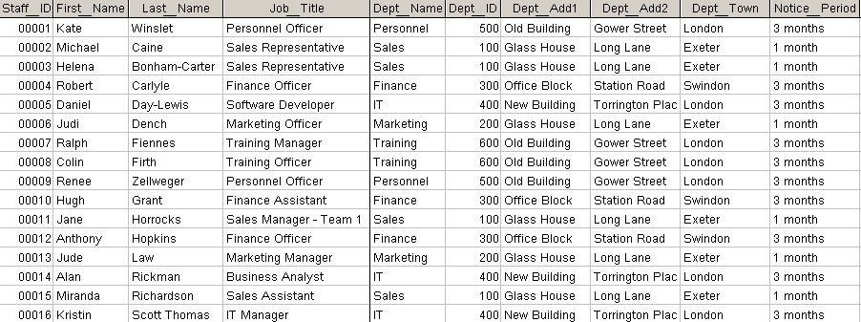

Scenario Two
Rather than just listing each employee’s salary, historical salary information will be kept for each employee, listing the date their salary changed and their new salary (see screen capture overleaf and/or tbl_Employees_Salaries).

Tasks
- Why is this not good database design?
- Imagine you are going to redesign the database and create an additional table to store salary information:
- list the fields you would include in the new table
- decide how you would create a relationship between the two tables. (Which table is on the ‘One’ side and which is on the ‘Many’ side?)
- create a Primary Key for the new table
Helpful hint: you can create a composite Primary Key from more than one field if the combination of values in those fields will be unique for any given record.
tbl_Employees showing Salary information:
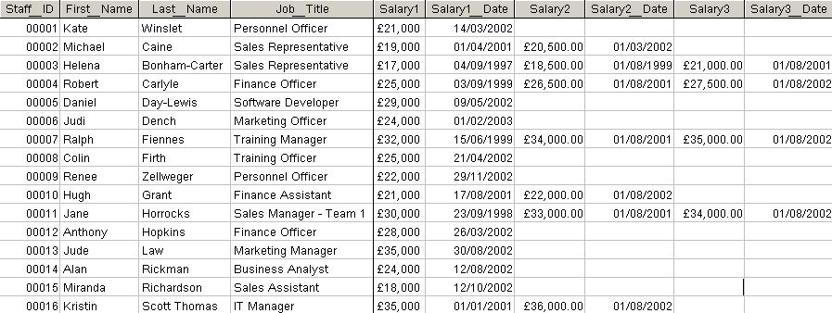

Exercise 13: Planning a database
Scenario
You work for a clinic and have been asked to design a database for a clinical trial of a new drug which is being carried out on patients from several different hospitals.
- The referring hospital department has provided you with some personal information for each patient (name, hospital number, DOB, symptoms of their condition).
- You will need to post a report back to a particular person in the referring hospital department to inform them of the progress of any patients referred by that department.
- Each patient will have a named nurse at your clinic that they can contact if they have any questions but when they visit the clinic they may see a different nurse depending on who is on duty at that time.
- A nurse at the clinic will conduct an initial interview with the patient at which he or she will measure and record their weight, blood sugar level, blood pressure, height and known allergies.
- The patients are divided into three groups (A, B and C), two of which will take the drug and one of which will take a placebo.
- Each patient will come in to the clinic three more times and on each occasion a nurse will measure and record their weight, blood sugar level and blood pressure again.
- If it is considered that a patient’s health is at serious risk, they may be withdrawn from the trial early.
- A random sample of patients has been chosen to be asked a series of additional questions relating to diet, exercise and lifestyle.

Tasks
- What are the ‘entities’ involved in this scenario? Each entity should have a separate table. What would you call each of these tables?
List the names of these tables as headings from left to right across the page.
- What are the individual pieces of ‘data’ or information you need to record in your database? Each of these will need to be stored in a field in the appropriate table it ‘belongs’ to.
List the fields you think will need to be created in each table under the appropriate table heading.

- How does each table relate to the other tables in your database?
Create any common fields as necessary to create these relationships. You may wish to use another piece of paper to arrange your tables and draw lines between them to show the relationships. You don’t need to include all the fields but do include any linked fields in this diagram.

