UCL
Education & information support division
information systems

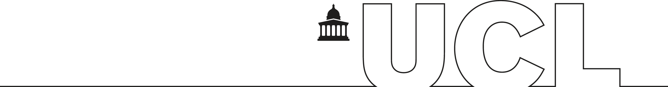

Word 2003

Sharing and Reviewing Documents

Exercises

Content

Task One – Tracking Changes 3
Task Two – Accept and Reject Changes 3
Task Three – Protecting the Document 3
Task Four – Comparing and Merging Documents 3
Task five – Versions 4

Task One – Tracking Changes
- Open up the File R:\training.dir\Wordp1\UCL-1.doc
- Turn on Track Changes.
- Highlight all of the Headings in Bold. (Main heading and dates)
- Delete the word Scottish from the Paragraph headed 1825.
- Correct the spelling of February under the heading 1826.
- Add a comment to the following sentence ‘The University of London (now UCL) was formally founded on 11th February’ under the heading 1826.
- Whilst keeping track changes on, remove the revisions from the screen.
- Move the Paragraph headed 1827 to its correct position in the text
- Show the revisions on the screen (check to see if the last revision worked)
- Save the File with the same name.
- Close the file.

Task Two – Accept and Reject Changes
- Open the file R:\training.dir\Wordp1\UCL-1.doc
- With the final mark-up showing, accept the first two revisions.
- Reject the third revision.
- Accept the remainder of the revisions in one go.
- Check the original version to see if the revisions are in place.

Task Three – Protecting the Document
- Open the file R:\training.dir\Wordp1\UCL-1.doc
- Protect the document for Tracking Changes.
- Set the password to your first name.
- Close the document and then re-open it.
- Check the track changes button is greyed out.
- Unprotect the document.
- Save the file with the same name.

Task Four – Comparing and Merging Documents
- Open the file R:\training.dir\Wordp1\part1.doc
- Re-save the file with the name part1a.doc
- Delete the first paragraph from the file.
- From the tools menu choose Compare and Merge
- Select the file R:\training.dir\Wordp1\part1.doc
- Check to see if the merge worked.

Task five – Versions
- Open the file R:\training.dir\Wordp1\part1a.doc
- Delete the first paragraph from the file.
- Save this as the first version.
- Add a comment to explain what you have just done.
- Add the following text to the end of the document. ‘Bentham may soon be watched each day with the aid of a webcam’
- Save this as the second version.
- Add a comment to explain what you have just done.
- Open the second version and check to see if there are differences (navigate to the bottom of the file).
- Close the second version
- Delete the first version.
- Save the file with the same name.

